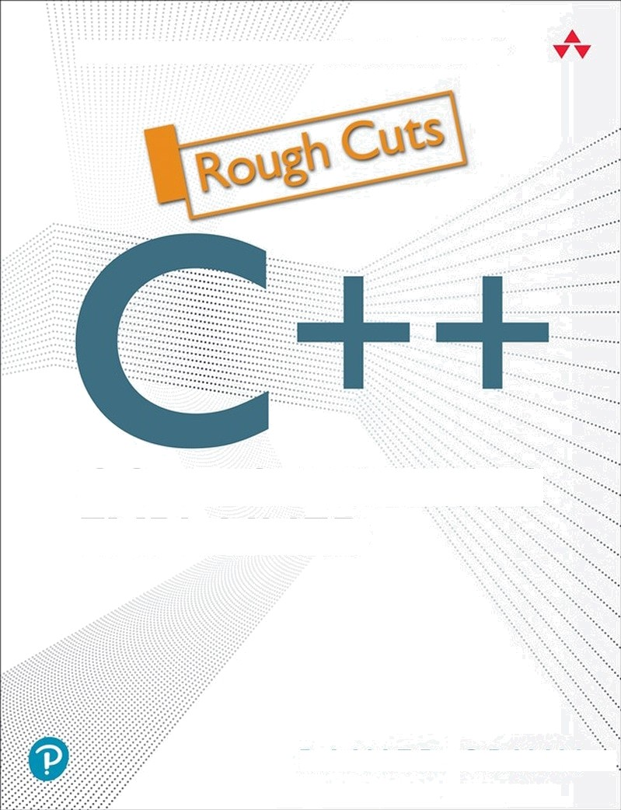[1]Best Practices for Modern G++

CORE GUIDELINES

EXPLAINED

R A I N E R G R I M M ””

# C++ Core Guidelines

**Rainer Grimm**



## Table of Contents

Foreword Preface

Acknowledgments About the Author Part I. The Guidelines

Chapter 1. Introduction

Chapter 2. Philosophy

Chapter 3. Interfaces

Chapter 4. Functions

Chapter 5. Classes and Class Hierarchies Chapter 6. Enumerations

Chapter 7. Resource Management Chapter 8. Expressions and Statements Chapter 9. Performance

Chapter 10. Concurrency Chapter 11. Error Handling

Chapter 12. Constants and Immutability

Chapter 13. Templates and Generic Programming Chapter 14. C-Style Programming

Chapter 15. Source Files

Chapter 16. The Standard Library Part II. Supporting Sections Chapter 17. Architectural Ideas Chapter 18. Non-Rules and Myths Chapter 19. Profiles

Chapter 20. Guideline Support Library Part III. Appendix

Appendix A. Enforcing the C++ Core Guidelines Appendix B. Concepts

Appendix C. Contracts

## Contents

Foreword Preface

Conventions Why guidelines? Pantha rhei

How to read this book?

Acknowledgments About the Author Part I. The Guidelines

Chapter 1. Introduction Target readership Aim

Non-aims Enforcement Structure Major sections Distilled

Chapter 2. Philosophy

P.1. Express ideas directly in code P.2: Write in ISO Standard C++ P.3: Express intent

P.4: Ideally, a program should be statically type safe P.5: Prefer compile-time checking to run-time checking

P.6: What cannot be checked at compile-time should be checkable at run-time P.7: Catch run-time errors early

P.8: Don’t leak any resources P.9: Don’t waste time or space

P.10: Prefer immutable data to mutable data

P.11: Encapsulate messy constructs, rather than spreading through the code P.12: Use supporting tools as appropriate

1. 3: Use support libraries as appropriate

Distilled Chapter 3. Interfaces

I.2: Avoid non-const global variables I.3: Avoid singletons

Making good interfaces

I.13: Do not pass an array as a single pointer

I.27: For stable library ABI, consider the Pimpl idiom Related rules

Distilled Chapter 4. Functions

Function definitions Parameter passing: in and out

Parameter passing: ownership semantic Value return semantics

Other functions Related rules Distilled

Chapter 5. Classes and Class Hierarchies Summary rules

Concrete types

Constructors, assignments, and destructors Class hierarchies

Overloading and overloaded operators Unions

Related rules Distilled

Chapter 6. Enumerations

Enum.1: Prefer enumerations over macros

Enum.2: Use enumerations to represent sets of related named constants Enum.3: Prefer enum classes over “plain” enums

Enum.5: Don’t use ALL_CAPS for enumerators Enum.6: Avoid unnamed enumerations

Enum.7: Specify the underlying type of an enumeration only when necessary Enum.8: Specify enumerator values only when necessary

Related Rules

Distilled

Chapter 7. Resource Management General rules

Allocation and deallocation Smart pointers

Related Rules Distilled

Chapter 8. Expressions and Statements General

Declarations Expressions Statements Arithmetic Related Rules Distilled

Chapter 9. Performance Wrong optimizations Wrong assumptions Enable optimization Related Rules Distilled

Chapter 10. Concurrency General guidelines Concurrency Parallelism Message passing

Lock-free programming Related Rules

Distilled

Chapter 11. Error Handling Design Implementation

If you can’t throw Related Rules Distilled

Chapter 12. Constants and Immutability

Con.1: By default, make objects immutable Con.2: By default, make member functions const

Con.3: By default, pass pointers and references to consts

Con.4: Use const to define objects with values that do not change after construction Con.5: Use constexpr for values that can be computed at compile-time

Distilled

Chapter 13. Templates and Generic Programming Use

Interfaces Definition Hierarchies Variadic templates Metaprogramming Other rules Related Rules Distilled

Chapter 14. C-Style Programming CPL.1: Prefer C++ to C

CPL.2: If you must use C, use the common subset of C and C++, and compile the C code as C++

CPL.3: If you must use C for interfaces, use C+ + in the calling code using such interfaces

Distilled

Chapter 15. Source Files

Interface and implementation files Namespaces

Distilled

Chapter 16. The Standard Library Containers

Text

In- and output Related Rules Distilled

Part II. Supporting Sections

Chapter 17. Architectural Ideas

A.1: Separate stable code from less stable code A.2: Express potentially reusable parts as a library A.4: There should be no cycles among libraries

Chapter 18. Non-Rules and Myths

NR.1: Don’t insist that all declarations should be at the top of a function NR.2: Don’t insist to have only a single return-statement in a function NR.3: Don’t avoid exceptions

NR.4: Don’t insist on placing each class declaration in its own source file NR.5: Don’t use two-phase initialization

NR.6: Don’t place all cleanup actions at the end of a function and goto exit NR.7: Don’t make all data members protected

Chapter 19. Profiles

Pro.type: Type safety Pro.bounds: Bounds safety Pro.lifetime: Lifetime safety

Chapter 20. Guideline Support Library Views

Ownership pointers Assertions

Utilities Part III. Appendix

Appendix A. Enforcing the C++ Core Guidelines Visual Studio

clang-tidy Appendix B. Concepts Appendix C. Contracts

## Foreword [This content is currently in development.]

**This content is currently in development.**

## Preface

This preface serves one purpose: giving you, dear reader, the necessary background to get the most out of this book. This background includes technical details about me, my writing style, my motivation for writing this book, and the challenges for writing such a book. If you want to skip this section, fine, but read at least the Acknowledgments section.

### Conventions

I promise, only a few conventions.

### Rules versus guidelines

The authors of the C++ Core Guidelines often refer to them as rules. So do I. In the context of this book, I use both terms interchangeably.

### Special fonts

Monospace Code, instructions, keywords, names of types, variables, functions, and classes are displayed in monospace font.

### Boxes

I use boxes with a bullet list for the distilled information concluding each chapter.

#### Distilled

* Get the distilled information at the end of each chapter.
* The essential information is represented as a bullet list.

#### Further information

This box serves a simple purpose: it should give you additional information to get the most out of the guidelines. This additional information may include a typical danger or trap in C++.

### Source code

I dislike using-directives and declarations because they hide the origin of the library functions. Due to the limited length of a page, I have to use them from time to time. I use them in such a way, that the origin can always be deduced from the using-directive ( using namespace std;) or the using-declaration (using std::cout;). Not all headers are displayed in the code snippets.

Boolean values are displayed with true or false. The necessary I/O manipulator

std::boolalpha is mostly not part of the code snippets. Three dots (...) in the code snippets stand for missing code.

When I present a complete program as code example, you will find the name of the source file in the first line of the code. I assume that you use a C++14-Compiler. If the example needs C++17 or C++20 support, I mention the required C++ standard after the name.

I often use markers such as // (1) in the source file to ease my explanations. If possible, I write the maker in the cited line, if not, one line before. The markers are not part of the more than 100 source files that are part of the book. For layout reasons, I often adjusted the source code in this book.

When I use examples from the C++ Core Guidelines, I often rewrite them for readability by adding namespace std if it is missing, or unify the layout.

### Why guidelines?

This subjective observation is mainly based on more than 15 years of experience as a trainer for C++, Python, and software development in general. In the last years, I was responsible for the team and the software deployed on defibrillators. My responsibility included regulatory affairs for our devices. Writing software for a defibrillator is extremely challenging because they can cause death or serious injury for the patient and the operator.

I have a question in mind that we should answer as a C++ community. This question is: Why do we need guidelines for modern C++? Here are my thoughts which consist of simplicity reasons of three observations.

### Complex for novices

C++ is, in particular for beginners, an inherently complex language. Mainly, because the problems we want to solve are inherently complicated and often complex as well. When you teach C++, you should provide a set of rules that work for your participants in at least 95% of all use-cases. I think about rules such as

* let the compiler deduce your types,
* initialize with curly braces,
* prefer tasks over threads,
* and use smart pointers instead of raw pointers.

I teach rules such as the ones mentioned in my seminars. We need a canon of best practices or rules in C ++. These rules should be formulated positively and not negatively. They should declare how you should write code and not what should be avoided.

### Challenging for the professionals

I'm not worried about the sheer amount of new features that we get with each new C++ standard

every three years. I'm worried about the new ideas that modern C++ supports. Think about event- driven programming with coroutines, lazy evaluation, infinite data streams, or function composition with the ranges library. Think about concepts, which introduce semantic categories to template parameters. It can be quite challenging to teach C-programmers object-oriented ideas. When you shift, therefore, to these new paradigms, you have to rethink and presumably change the way you solve your programming challenges. I assume that this plethora of new ideas will, in particular, overwhelm professional programmers. They are the one who are used to solve the problems with their classical techniques. With high probability, they fall into the *hammer- nail trap*.

### Used in safety-critical software

In the end, I have a strong concern. In the safety-critical software development, you often have to stick to guidelines. The most prominent is MISRA C++. The current MISRA C++:2008 guidelines were published by the *Motor Industry Software Reliability Association* . They are based on the *MISRA C* guidelines from the year 1998. Initially designed for the automotive industry, they became the de facto standard for the implementation of safety-critical software in the aviation, military, and medical sectors. As MISRA C, MISRA C++ describes guidelines for a safe subset of C++. But there is a conceptional problem. MISRA C++ is not state of the art for modern software development in C++. It's four standards behind! Here is an example: MISRA C++ doesn't allow operator overloading. For example, I teach in my seminars that you should use user-defined literals to implement type-safe arithmetic: auto constexpr dist = 4 * 5_m + 10_cm - 3_dm. To implement such type-safe arithmetic, you have to overload the arithmetic operators and the literal operators for the suffixes. To be honest. I don't believe that MISRA C

++ will ever evolve in lockstep with the current C++ standard. Only community-driven guidelines such as the C++ Core Guidelines can face this challenge.

##### MISRA C++ integrates AUTOSAR C++14

However, there is hope. MISRA C++ integrates AUTOSAR C++14. *AUTOSAR C++14* is based on C++14 and should become an extension of the MISRA C++ standard. I'm highly skeptical that organization-driven guidelines can keep in lockstep with the dynamic of modern C++.

### My Challenge

Let me cite the essential lines of my e-mail discussion in May 2019 with Bjarne Stroustrup and Herb Sutter telling them that I wanted to write a book about the C++ Core Guidelines: "I'm an absolute fan of the value which is inside the C++ Core Guidelines because my strong belief is that we need guidelines for the correct/safe usage of modern C++. I often use examples or ideas from the C++ Core Guidelines in my C++ classes. The format reminds me of the MISRA C++ or AUTOSAR C++14 rules which is presumably intentional, but this is not the ideal format for a big audience. I think that more people would read and reason about the guidelines if we had a second document which describes the general ideas of the guidelines."

I want to add a few remarks to this citation from previous conversations. In the last years, I wrote in my German and English blogs more than a hundred posts about the C++ Core Guidelines.

Additionally, I write for the German *Linux-Magazin* a series on the C++ Core Guidelines. I do

this for two reasons: first, the C++ Core Guidelines should become better known and second, I want to present them in a readable form, extended with background information if necessary.

Here is my challenge: The C++ Core Guidelines have about 600 pages and about 500 guidelines, most of the time, just called rules. These rules are designed with static analysis in mind. Many of the rules are lifesaving for a professional C++ software developer, but also many of the rules are quite special, often incomplete or redundant, and sometimes the rules even contradict. My challenge is to boil these very precious rules down to a readable, even entertaining story of about 300 pages, removing the esoteric stuff and filling the gaps if necessary. In the end, the book should contain the rules that are mandatory for a professional software developer in C++.

***Pantha rhei***

*Pantha rhei* or everything flows from the Greek philosopher *Heraclitus* stands for the challenge I'm faced with while writing this book. The C++ Core Guidelines is a *GitHub-hosted* project with more than 200 contributors. While writing this book, the origin of my writing may have changed.

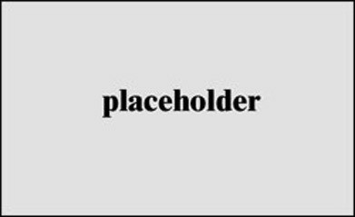

##### Figure P.1 The C++ Standards

The guidelines already include C++ features, which may become part of an upcoming standard such as contracts in C++23. To reflect this challenge, I made a few decisions.

1. I provide links to the mentioned guidelines of the C++ Core Guidelines. So, you can quite easily refer to their origins.
2. My focus is on the C++17 standard. If appropriate, I include guidelines targeting the C++20 standard such as concepts.
3. The C++ Core Guidelines evolve constantly, in particular as new C++ standards are published. So will this book. My idea is to update this book accordingly.

### How to read this book?

The structure of this book represents the structure of the C++ Core Guidelines. It has the corresponding major sections and partially the supporting sections. Additionally to the C++ Core Guidelines, I included an appendix, which provides concise overviews to missing topics,

including C++20 or even C++23 features.

I still have not answered one question, how to read this book? Of course, you should start with the major sections, best from top to toe. The supporting sections provide additional information and introduce, in particular, the guidelines support library. Use the appendix as a kind of reference to get the necessary background information to understand the major sections. Without this additional information, this book would not be complete.

## Acknowledgments [This content is currently in development.]

**This content is currently in development.**

## About the Author

**Rainer Grimm** has worked as a software architect, team lead, and instructor since 1999, and offered seminars on C++, Python, and proprietary software since 2002. He writes regularly on C++, Python, and Haskell, speaks at conferences on programming issues, and blogs weekly in English ([modernescpp.com](http://modernescpp.com/)) and German ([www.grimm-jaud.de/index.php/blog](http://www.grimm-jaud.de/index.php/blog)). Now an independent instructor, he offers seminars on modern C++ and Python. He has authored several books on modern C++, concurrency, and related topics.

# Part I. The Guidelines

### Table of Contents

* 1. Introduction

Target readership Aim

Non-aims Enforcement Structure Major sections Distilled

* 1. Philosophy
  2. Express ideas directly in code P.2: Write in ISO Standard C++ P.3: Express intent

P.4: Ideally, a program should be statically type safe P.5: Prefer compile-time checking to run-time checking

P.6: What cannot be checked at compile-time should be checkable at run-time P.7: Catch run-time errors early

P.8: Don’t leak any resources P.9: Don’t waste time or space

P.10: Prefer immutable data to mutable data

P.11: Encapsulate messy constructs, rather than spreading through the code P.12: Use supporting tools as appropriate

P.13: Use support libraries as appropriate Distilled

* 1. Interfaces
     1. 2: Avoid non-const global variables I.3: Avoid singletons

Making good interfaces

I.13: Do not pass an array as a single pointer

I.27: For stable library ABI, consider the Pimpl idiom

Related rules Distilled

* 1. Functions

Function definitions Good names

F.4: If a function may have to be evaluated at compile-time, declare it constexpr

F.6: If your function may not throw, declare it noexcept

F.8: Prefer pure functions Parameter passing: in and out

F.15: Prefer simple and conventional ways of passing information

F.16: For “in” parameters, pass cheaply-copied types by value and others by reference to const

F.17: For “in-out” parameters, pass by reference to non-const

F.20: For “out” output values, prefer return values to output parameters F.21: To return multiple “out” values, prefer returning a struct or tuple

Parameter passing: ownership semantic Value return semantics

When to return a pointer (T*) or a lvalue reference (T&)

F.45: Don’t return a T&& and F.48: Don’t return std::move(local)

F.46: int is the return type for main()

Other functions

Lambdas

F.51: Where there is a choice, prefer default arguments over overloading F.55: Don’t use va_arg arguments

Related rules Distilled

* 1. Classes and Class Hierarchies Summary rules

C.1: Organize related data into structures (structs or classes)

C.2: Use class if the class has an invariant; use struct if the data members can vary independently

C.3: Represent the distinction between an interface and an implementation using a class

C.4: Make a function a member only if it needs direct access to the representation of a class

C.5: Place helper functions in the same namespace as the class they support

C.7: Don’t define a class or enum and declare a variable of its type in the same statement

C.8: Use class rather than struct if any member is non-public C.9: Minimize exposure of members

Concrete types

C.10: Prefer concrete types over class hierarchies C.11: Make concrete types regular

Constructors, assignments, and destructors Default operations

Constructor Copy and move Destructors

Other default operations Class hierarchies

General rules Designing classes Accessing objects

Overloading and overloaded operators Conventional usage

C.164: Avoid implicit conversion operators

C.162: Overload operations that are roughly equivalent and C.163: Overload only for operations that are roughly equivalent

C.168: Define overloaded operators in the namespace of their operands Unions

C.180: Use unions to save memory C.181: Avoid “naked” unions

C.182: Use anonymous unions to implement tagged unions Related rules

Distilled

* 1. Enumerations

Enum.1: Prefer enumerations over macros

Enum.2: Use enumerations to represent sets of related named constants Enum.3: Prefer enum classes over “plain” enums

Enum.5: Don’t use ALL_CAPS for enumerators Enum.6: Avoid unnamed enumerations

Enum.7: Specify the underlying type of an enumeration only when necessary Enum.8: Specify enumerator values only when necessary

Related Rules Distilled

* 1. Resource Management General rules

R.1: Manage resources automatically using resource handles and RAII (Resource Acquisition Is Initialization)

R.3: A raw pointer (a T*) is non-owning and R.4: A raw reference (a T&) is non- owning

R.5: Prefer scoped objects, don’t heap-allocate unnecessarily Allocation and deallocation

R.10: Avoid malloc() and free()

R.11: Avoid calling new and delete explicitly

R.12: Immediately give the result of an explicit resource allocation to a manager object

R.13: Perform at most one explicit resource allocation in a single expression statement

Smart pointers

Basic usage Function parameters

Related Rules Distilled

* 1. Expressions and Statements General

ES.1: Prefer the standard library to other libraries and to “handcrafted code” ES.2: Prefer suitable abstractions to direct use of language features

Declarations

Names

Variables and their initialization Macros

Expressions

Complicated expressions Pointers

Order of evaluation Conversions

Statements

Iteration statements Selection statements

Arithmetic

Arithmetic with signed/unsigned integers Typical arithmetic errors

Related Rules Distilled

* 1. Performance

Wrong optimizations Wrong assumptions Enable optimization

Per.7: Design to enable optimization Per.10: Rely on the static type system

Per.11: Move computation from run time to compile-time Per.19: Access memory predictably

Related Rules Distilled

* 1. Concurrency

General guidelines

CP.1: Assume that your code will run as part of a multi-threaded program CP.2: Avoid data races

CP.3: Minimize explicit sharing of writable data CP.4: Think in terms of tasks, rather than threads CP.8: Don’t try to use volatile for synchronization

CP.9: Whenever feasible use tools to validate your concurrent code Concurrency

Locks Threads

Condition variables CP.42: Don’t wait without a condition) Data sharing

Resources

Overlooked Danger (CP.44: Remember to name your lock_guards and

unique_locks) Parallelism

Message passing

Sending a value, or an exception Sending a notification

Lock-free programming

CP.100: Don’t use lock-free programming unless you absolutely have to CP.101: Distrust your hardware/compiler combination

CP.102: Carefully study the literature Related Rules

Distilled

* 1. Error Handling Design

Communication Invariants

Implementation Dos Don’ts

If you can’t throw Related Rules Distilled

* 1. Constants and Immutability

Con.1: By default, make objects immutable Con.2: By default, make member functions const

Con.3: By default, pass pointers and references to consts

Con.4: Use const to define objects with values that do not change after construction Con.5: Use constexpr for values that can be computed at compile-time

Distilled

* 1. Templates and Generic Programming Use

T.1: Use templates to raise the level of abstraction of code

T.2: Use templates to express algorithms that apply to many argument types T.3: Use templates to express containers and ranges

Interfaces

T.40: Use function objects to pass operations to algorithms

T.42: Use template aliases to simplify notation and hide implementation details T.43: Prefer using over typedef for defining aliases

T.44: Use function templates to deduce class template argument types (where feasible)

T.46: Require template arguments to be at least Regular or SemiRegular T.47: Avoid highly visible unconstrained templates with common names T.48: If your compiler does not support concepts, fake them with enable_if

Definition

T.60: Minimize a template’s context dependencies T.61: Do not over-parameterize members

T.62: Place non-dependent class template members in a non-templated base class Alternative implementations with specializations

Hierarchies

T.80: Do not naively templatize a class hierarchy

T.83: Do not declare a member function template virtual Variadic templates

Perfect forwarding Variadic templates

Metaprogramming

Template metaprogramming Type-traits library

Constant expressions Other rules

T.140: Name all operations with potential for reuse

T.141: Use an unnamed lambda if you need a simple function object in one place only

T.143: Don’t write unintentionally nongeneric code T.144: Don’t specialize function templates

Related Rules Distilled

* 1. C-Style Programming CPL.1: Prefer C++ to C

CPL.2: If you must use C, use the common subset of C and C++, and compile the C code as C++

Entire source code available Entire source code not available

CPL.3: If you must use C for interfaces, use C++ in the calling code using such interfaces

Distilled

* 1. Source Files

Interface and implementation files

SF.1: Use a .cpp suffix for code files and .h for interface files if your project doesn’t already follow another convention

SF.2: A .h file may not contain object definitions or non-inline function definitions SF.5: A .cpp file must include the .h file(s) that defines its interface

SF.8: Use #include guards for all .h files

SF.9: Avoid cyclic dependencies among source files SF.10: Avoid dependencies on implicitly #included names SF.11: Header files should be self-contained

Namespaces

SF.6: Use using namespace directives for transition, for foundation libraries (such as std), or within a local scope (only)

SF.7: Don’t write using namespace at global scope in a header file SF.20: Use namespaces to express logical structure

SF.21: Don’t use an unnamed (anonymous) namespace in a header and SF.22: Use an unnamed (anonymous) namespace for all internal/nonexported entities

Distilled

* 1. The Standard Library Containers

SL.con.1: Prefer using STL array or vector instead of a C-array

SL.con.2: Prefer using STL vector by default unless you have a reason to use a different container

SL.con.3: Avoid bounds errors

Text

SL.str.1: Use std::string to own character sequences SL.str.2: Use std::string_view to refer to character sequences SL.str.4: Use char* to refer to a single character

SL.str.5: Use std::byte to refer to byte values that do not necessarily represent characters

SL.str.12: Use the s suffix for string literals meant to be standard-library strings

In- and output

SL.io.1: Use character-level input only when you have to SL.io.2: When reading, always consider ill-formed input SL.io.3: Prefer iostreams for I/O

SL.io.10: Unless you use printf-family functions call

ios_base::sync_with_stdio(false)

SL.io.50: Avoid endl

Related Rules Distilled

## Chapter 1. Introduction

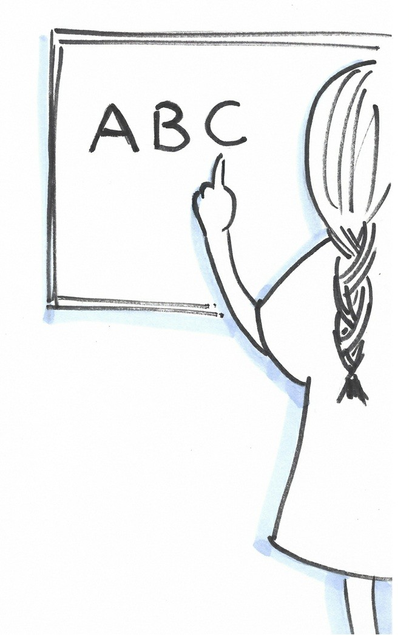

##### Figure 1.1. Cippi learns the basics

Before I dive in the next chapters into the details of the C++ Core Guidelines, I want to provide a short introduction.

### Target readership

The target readership for the C++ Core Guidelines are all C++ programmer, including programmers who might consider C.

### Aim

The rules of the guidelines promote modern C++ and aim to achieve a more uniform style. Of course, not all rules can be applied to legacy code, in particular. This means, you should apply these rules to new code but also to legacy code which is broken or has to be refactored. The focus is on type safety and resource safety. They are not just about “don’t do that”; they are prescriptive and often checkable. Their designs allows gradual adoption.

### Non-aims

Now, we know what the aim of the rules is. The non-aims are also interesting. The guidelines are not meant to be read serially or be a replacement for a tutorial. Additionally, they provide no recipes to convert old C++ to modern C++, or are they so precise that you can follow them blindly, or are that they a safe subset of C++.

### Enforcement

Without enforcement, the guidelines are not manageable in large code bases. For this reason, each rule has an enforcement section. The enforcement can be a code review, dynamic or static code analysis. Related rules are grouped into profiles. The C++ Core Guidelines define profiles to protect from type violations, bounds violations, and lifetime violations.

### Structure

The rules follow a typical structure:

* Reason - a rationale for the rule
* Example - code snippet, which shows good or bad code regarding the rule
* Alternative - alternative for a “don’t do this” rule
* Exception - reasons to not apply the rule
* Enforcement - how can the rule be checked
* See also - a rule often refers to other rules
* Note - additional notes to a rule
* Discussion - references to additional rationales or examples

### Major sections

The C++ Core Guidelines consist of 16 major sections. I listed them for a short overview.

* Introduction
* Philosophy
* Interfaces
* Functions
* Classes and class hierarchies
* Enumerations
* Resource management
* Expressions and statements
* Performance
* Concurrency and parallelism
* C-style programming
* Source files
* The Standard Library

### Distilled

##### Important

* The target readership are all C++ programmers.
* Its aim of the C++ Core Guidelines is to adopt more modern C++ and to achieve an universal style.
* The rules are neither a tutorial nor precise enough to follow them blindly.
* Each rule has an enforcement section.

## Chapter 2. Philosophy



##### Figure 2.1. Cippi thinks deeply

The *philosophical rules* have a general focus and are, therefore, not checkable. The philosophical rules provide the rationale for the following concrete rules. Due to the fact that there are only 13

philosophical rules, I can cover all of them in this chapter.

### P.1. Express ideas directly in code ifadeleri kodda doğrudan belirtin

A programmer should express his ideas directly in code because code can be checked by compilers and tools. The two following methods make this rule obvious.  
ifadelerinizi koda doğrudan yazmalısınız.  
örnek:

class Date {

// ... public:

Month month() const; // Doğru int month(); //Yanlış

// ...

};

The second member function month() expresses neither that it is constant, nor that it returns a month. The same argument holds typically for loops such as for or while compared to the algorithm of the Standard Template Library (STL). The next code snippet makes my point.  
ikinci ifade hem constant değil hemde Month tipinde değil. Ikinci olarakta for while döngüsü kullanımı ile STL algoritmasının kıyaslanması.

int index = -1; //Yanliş

for (int i = 0; i < v.size(); ++i) { if (v[i] == val) {

index = i; break;

}

}

auto it = std::find(begin(v), end(v), val); // dogru

A professional C++ developer should know the *algorithms of the STL*. By using them, you avoid the usage of explicit loops, and your code becomes easier to understand, easier to maintain and, therefore, less error-prone. There is a proverb in modern C++: “When you use explicit loops you don’t know the algorithms of the STL.”.  
Profesyonel bir C++ geliştiricisi STL algoritmalarını bilmek zorundadır. Bunları kullanırken, varsayılan loop kullanımı yoksaymalasınız, böylece kodunuzun bakımı, anlaşılması daha kolay hale gelir, buda hata takibini kolaylaştırır. Modern C++’ta bir atasözü vardır; varsayılan loopları kullanıyorsanız, STL algoritmalarını bilmiyorsunuz demektir.

### P.2: Write in ISO Standard C++ ISO Standartlarında C++ Kodu Yazın

Okay, this rule is a no-brainer. To get a portable C++ program, the rule is quite easy to understand. Use a current C++ standard without compiler extension. Additionally, be aware of undefined or implementation-defined behavior.  
Bu kural çok akıllıca gelmesede, portable bir C++ için kesinlikle anlaşılırdır. C++ standartını compiler uzantıları hariç kullanın. Ek olarakta;

* **Undefined behavior**: All bets are off. Your program can produce the correct result, the wrong result, crashes during run-time, or may not even compile. That behavior might change when porting to a new platform, upgrading to a new compiler or as a result of an unrelated code change.  
  **Undefined Behavior:** Programınız, doğru, yanlış run-time anında çökme yada compile bile edilmeyebilir. Bu **behavior** kodunuzu yeni bir platforma taşırken, yeni bir compiler’a güncellerken yada alakası olmayan bir kodun sonucu olabilir.
* **Implementation-defined behavior**: The behavior of your program may vary between various implementations. The implementation must document each behavior.  
  **Implementation-defined behavior:** Uygulamanızın davranışları çeşitli implementation lara bağlı olabilir. Her bir implementation’nın her davranışı döcümente etmelisiniz.

When you have to use extensions that are not written in ISO Standard, encapsulate them in a stable interface.  
ISO standartı dışında bir uzantı kullanıyorsanız, bunu stable bir arayüze encapsulate edin.

##### Catch-fire semantic Yanmaya başlamak

There is a proverb in the C++ community describing undefined behavior. When your program has undefined behavior, your program has catch-fire semantic. This means, your computer can catch fire.

C++ topluluğunda bir atasözü vardır; Eğer Programınız undefined bir behavior sergiliyorsa, programınız catch-fire semantic’tir. Bunun anlamı, bilgisayarınız catch-fire’dır.

### P.3: Express intent Açık olmak

What intent can you derive from the following implicit and explicit loops?  
Aşağıdaki doğrudan ve dolaylı olarak kullanılan loopların hangisi niyetlenebilirsiniz?

for (const auto& v: vec) { ... } // (1)

for (auto& v: vec) { ... } // (2)

std::for_each(std::execution::par, vec, [](auto v) { ... }); // (3)

(1) does not modify the elements of the container vec. This does not hold for the range-based for loop  
(1) vec container içerisinde elementleri modifiye etmez. Range-based for loopta böyle birşey yok.

(2). The algorithm std::for_each (3) performs its job in parallel ( std::execution::par). This means that we don’t care in which order the elements are processed.  
(2) std::for_each algoritması (3) (std::execution::par) işini paralel olarak yapar. Bunun anlamı hangi elementlerin işlenme sırasına dikkate alınmaz

Express intent is also an important guideline for good documentation of your code. Documentation should state, what should be done and not, how it should be done.  
Açık niyetli olmak iyi bir dökümantasyon için çok önemlidir. Döküman durumları, bir yapılıp yapılmadığını yada nasıl yapıldığını anlatmalıdır.

### P.4: Ideally, a program should be statically type safe Ideal olarak, program staticlly type safe (Static Tür Güvenliği)

C++ is a statically typed language. Statically typed means that the type of the data is known to the compiler. Statically type safe additionally states that the compiler detects type errors. Due to existing problematic areas, this goal cannot always be achieved, but there is a cure against unions, casts, array decays, range errors, or narrowing conversions:  
C++, statik tipde dildir. Yani compiler tüm deşiken yada ifadelerini tipini bilmek zorundadır. Bu problemli bir alan olmasından dolayı, her zaman doğru kullanamayız. Fakat çok açık bir şekilde unions, casts, array decay, range errors yada veri türlerinin dönüştürülmesi gibi.

* With C++17, you can use *std::variant* as a type-safe replacement for a union.  
  C++17’de, unionlar dönüşümü için *std::variant ‘*tı günvenli tip dönüşümü olarak kullanabilirsiniz.
* Generic code based on templates reduces the need for casting and, therefore, for type errors.  
  tip hataları için generic code tabanlı templatelar, casting ihtiyacınızı düşürür.
* Array decay happens when you invoke a function with a C-array. The function takes the array via a pointer to its first element and its length. This means, you start with a type-rich data structure C-array and end with a type-poor pointer to its first element. The cure is part of C++20: *std::span*. std::span automatically deduces the size of a C-array and also protects you from range errors. If you don’t have C++20, use the implementation provided by the Guidelines Support Library.  
  C dizilerinde array decay, diziyi gösteren bir pointeri ifade eder. Fonksiyonlar diziyi pointer ile alırken ilk elemanı ve uzunluğunu alır. Bunun anlamı; elinize çeşitli verileri içeren bir C structure var iken, pointer sadece bu verinin başlangıç adresini gösteren bir basit bir veridir. C++20: *std:span* otomatik olarak C-array’nızın size’nı çıkarır ve aralıkta oluşabilecek hatalardan sizi korur. Eğer C++20 kullanmıyorsanız bu uygulamayı sağlayan bir kütüphane kullanın.
* Narrowing conversion is an implicit conversion of arithmetic values including a loss of accuracy.  
  Veri dönüşümleri; veri kaybı yaratan dolaylı dönüşümlerdir.

int i1(3.14); int i2 = 3.14;

The compiler detects narrowing conversion if you use the { } - initializer syntax.  
compiler, {} syntaxını kullanırsanız veri dönüşümünü tespit eder.

int i1{3.14};

int i2 = {3.14};

### P.5: Prefer compile-time checking to run-time checking run-time checking yerine compile-time checking tercih edin.

What can be checked at compile-time, should be checked at compile-time. This is idiomatic for C++. Since C++11, the language supports static_assert. Thanks to static_assert, the compiler evaluates an expression such as static_assert(size(int) >= 4) and produces, eventually, a compiler-error. Additionally, the type-traits library allows you to formulate powerful conditions: static_assert(std::is_integral<T>::value). When the expression in the static_assert call evaluates to false, the compiler writes a human-readable error message.  
compile-time anında ne check edilebiliyorsa hep check edilmelidir. Bu C++ için idiomatictir. C++11’den itibaren dil, *static_assert* destekler. *Static_assert* sayesinde compiler ifadeyi kontrol eder örneğin: *static_assert(sizeof(int) >= 4)* ifadesinde compiler compile-time anında hata üretir. Ek olarak, type-traits kütüphanesi sizin bazı veri formule etmenizi sağlar; *static_assert(std::is_integral<T>::value)* gibi. *static_assert* içerisinde ki ifadeyi kontrol eder ve eğer *false* döndürürse compiler sizin okuyabileceğiniz şekilde metin üretir.

### P.6: What cannot be checked at compile-time should be checkable at run-time compile-time anında check edilemeyen, run-time anında check edilmelidir.

Thanks to the dynamic_cast, you can safely convert pointers and references to classes up, down, and sideways along the inheritance hierarchy. If the casting fails, you get back a nullptr in case of a pointer and a std::bad_cast exception in case of a reference. Read more details in the section dynamic_cast.  
*dynamic_cast* sayesinde,pointer ve referansları günvenli olarak birbirine çevirebilirsiniz. Eğer çeviri başarısız olursa *dynamic_cast* size *nullptr* pointerlar için *nullptr* döndürür, referanslar için *std::bad_cast* exception throw olur. Daha fazlası için *dynamic_cast* bölümüne bakın.

### P.7: Catch run-time errors early run-time hataları daha önce yakalayın

Many countermeasures can be taken to get rid of run-time errors. As a programmer, you should take care of pointers and C-arrays by checking their range. Of course, the same holds for conversions which should be avoided if possible and, of course, for narrowing conversions.

Checking input also falls into this category.  
run-time anındaki hatalardan kaçınmak için birçok önlem vardır. Programcı olarak, pointerların ve C-Array tiplerinin uzunluğunu kontrol ederken dikkatli olun. aynı durum tip dönüşümleri içinde geçerlidir.

### P.8: Don’t leak any resources Herhangi bir kaynak sızıntısı olmasın

Resource leaks are, in particular, very critical for long-running programs. A resource may be a memory but also file-handles or sockets. The idiomatic way to deal with resources is RAII. RAII stands for **R**esource **A**cquisition **I**s **I**nitialization and means essentially, that you acquire the resource in the constructor and release the resource in the destructor of a user-defined type. By making the object a scoped object, the C+ + run-time takes automatically care of the lifetime of the resource. C++ uses RAII heavily: locks take care of mutexes, smart pointers take care of raw memory or containers of the STL take care of the underlying elements.  
Kaynak sızıntısı uzun vadeli çalışan programlar için çok kritik bir öneme sahiptir. Bu hafıza, socket yada dosya yönetimi olabilir.idiomatic olarak kaynak yönetimi şekli RAII dir. Açılımı Resource Acquisition Is Initialization dir. Constructor anında kaynak kullanırsınız ve bu kaynağı destructor içerisinde release etmeniz gerekmektedir. C++’da eğer nesneniz scope içerisinde ise otomatik olarak destroy edilir. RAII nin kullanıldığı yerler ağırlıklı olarak lock mutex, smart pointers ve STL containerlarıdır.

### P.9: Don’t waste time or space Zamanınızı yada boşluğunuzu boşa harcamayın

Saving time or space is a virtue. The reasoning is quite short: This is C++. Do you spot the issues in the following loop?  
Zamandan yada boşluktan tasarruf etmek idealdir. Sebebi çok basittir; aşağıdaki hatayı gözlemleyebiliyormusunuz?

void lower(std::string s) {

for (unsigned int i = 0; i <= std::strlen(s.data()); ++i) { s[i] = std::tolower(s[i]);

}

}

Using the algorithm std::transform from the STL makes a one liner out of the previous function.  
Yukarıdaki loop yerine *std::transform* kullanmalısınız.

std::transform(s.begin(), s.end(), s.begin(),

[](char c) { return std::tolower(c); });

In contrast to the function lower, the algorithm std::transform automatically determines the size of its string. Consequently, you don’t have to specify the length of the string using std::strlen.  
*lower* fonksiyonun yerine *std::transform* kullanarak otomatik olarak *string* size’nı belirleyebilirsiniz. Sonuç olarak string length’ni belirlemek için *str::len* ifadesini kullanmak zorunda kalmazsınız.

Here is another typical example, often found in production code. Declaring copy semantic (copy constructor and copy assignment operator) for a user-defined data-type suppresses the automatically defined move-semantic (move constructor and move assignment operator).

Ultimately, the compiler can never use cheap move-semantic if applicable but always relies on expensive copy-semantic.  
başka bir örnektede, çoğunlukla kullanıcı tarafından declare edilen copy semantic, otomatik olarak üretilen move semantic tanımlamasını engeller. Nihayetinde compiler move semantic kullanamaz ve her zaman daha fazla işlem gerektiren copy semantic kullanır.

struct S {

std::string s_; S(std::string s): s_(s) {}

S(const S& rhs): s_(rhs.s_) {}

S& operator = (const S& rhs) { s_ = rhs.s_; return *this; }

};

S s1;

1. s2 = std::move(s1); // makes a copy instead of moving from s1.s_

If this examples scares you, read more in the section to default operations.  
Eğer bu örnek sizi korkuttuysa, default operation ile ilgili kısmı okuyunuz.

### P.10: Prefer immutable data to mutable data mutable veri yerine immutable data tercih edin

There are many reasons to use immutable data. First, it is easier to verify your code when you use constants. Constants also have higher optimization potential. But first and foremost, constants provide a big advantage in concurrent programs. Constant data is data-race free by design because mutation is a necessary condition for a data-race.  
immutable veri kullanma gereksiniminin bir çok sebebi vardır. Ilk olarak constant kullanırsanız kodunuzu doğrulamanız kolaylaşır. Potansiyellere karşı yüksek optimisazyon sağlar. En önemlisi; constant veriler concurrent programlarda büyük avantaj sağlar. Constant data-race engeller. Çünkü mutable veriler data-race için gereklidir.

### P.11: Encapsulate messy constructs, rather than spreading through the code Constructlar içerisinde Dağınık kodları encapsulate edin.

Messy code is often low-level code, which hides bugs and is, therefore, error-prone. If possible, replace your messy code with a high-level construct from the STL such as a container or algorithms of the STL. If this is not possible, encapsulate the messy code in a user-defined type or a function.  
dağınık kod çoğu zaman hataları gizleyen low-level koddur ve hatalara açıktır. Eğer mümkün ise STL high-level constructlarını yada containerlar yada STL algoritmaları kullanarak değiştirin. Eğer mümkün değilse fonksiyonlar ile encapsulate ederek contstructlar içerisinde dağınıklığı giderin.

### P.12: Use supporting tools as appropriate Uygun araçları kullanın

Computers are better than humans at doing boring and repetitive tasks. That means that you should use static analysis tools, concurrency tools, and testing tools to automate these verifying steps. Compiling your code with more than one C++ compiler is often the easiest way to verify your code. An undefined behavior which may not be detected by one compiler may cause another compiler to emit a warning or produce an error.  
Bilgisayarlar sıkıcı ve tekrarlayan işleri yaparken daha iyidir. Bunun anlamı, kodunuzun doğrulama adımlarını otomatize ederken; static analysis tool, concurrency tool ve testing tool larını kullanınız. Kodunuzu birden fazla compiler ile compile etmek kodunuzu doğrulamanızı kolaylaştırır. Tanımlanamayan bir davranış tek bir compiler tarafından tespit edilemeyebilir.

### P.13: Use support libraries as appropriate uygun kütüphaneleri kullanın

That is quite easy to explain. You should go for well-designed, well-documented, and well- supported libraries. Therefore, you will get a well-tested and a nearly error-free library and highly optimized algorithms from the domain experts. Outstanding examples are the C++ standard library, the Guidelines Support Library , or the *boost* libraries.  
bunun açıklaması oldukça basit; iyi tasarlanmış, iyi dökümente edilmiş ve iyi desteklenen kütüphaneleri kullanmanız. Böylece, iyi test edilmiş, neredeyse hatasız ve çok iyi optimize edilmiş algoritmalar kullanmış olursunuz. Örneğin STL, GuideLine Support Library yada boost kütüphanesi.

### Distilled

##### Important

* The philosophical rules (or meta-rules) provide rationales for the following concrete rules. Ideally, the concrete rules can be derived from the philosophical rules.
* Express intent and ideas directly in code.
* Write in ISO Standard C++ and use support libraries and supporting tools.
* A program should be statically type-safe and should, therefore, be checkable at compile-time. When this is not possible, catch run-time errors early.
* Don’t waste resources such as space or time.
* Encapsulate messy constructs behind a stable interface.

## Chapter 3. Interfaces

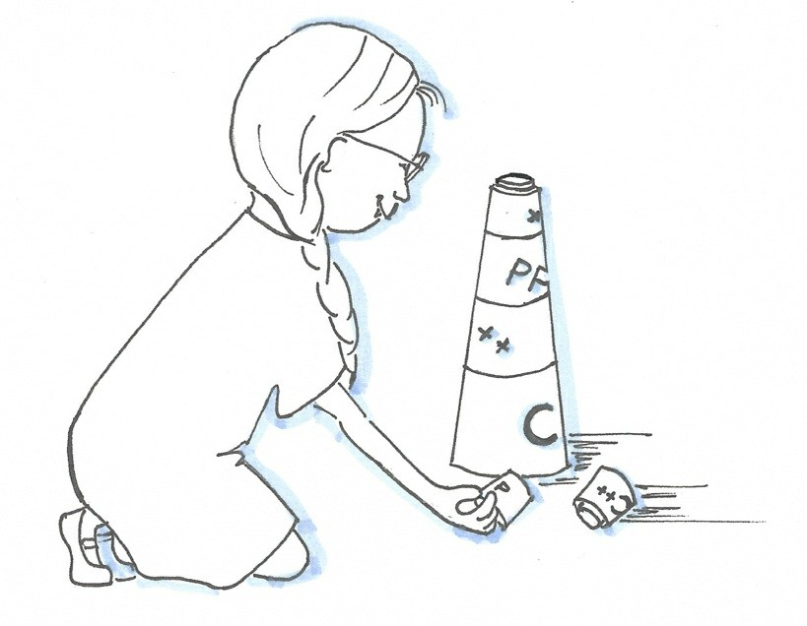

##### Figure 3.1. Cippi assembles components

An interface is a contract between a service provider and a service user. *Interfaces* are according to the C++ Core Guidelines “probably the most important single aspect of code organization”.

The section on interfaces has about twenty rules. Four of the rules are related to contracts, which didn’t make it in the C++20 standard.  
Interface, servis kullanıcısı ve servis sağlayıcısı arasındaki bir contract gibidir. C++ Core Guidelines’a göre kod organisazyonuna göre en önemli konulardan biridir. Bu Kısım bu konuyla alakalı 20 kuraldan oluşur. Bu kuralların 4 tanesi C++20 de yok.

A few rules related to interfaces use contracts, which may be part of C++23. A contract specifies preconditions, postconditions, and invariants for functions, that can be checked at run-time. Due to the uncertainty of the future, I ignore these rules. The appendix provides a short introduction to contracts.  
interface için kullanılan contract ların bazıları C++23ün bir parçası olabilir. Contract, ön kuralları, son kuralları ve değişken olmayan fonksiyonların run-time anında check etmemize olanak tanır. Bu kurallar gelecekte var olup olmayacağı kesin olmadığından dolayı, şimdilik yok sayıyoruz. Bu yüzden Contract lara kısa bir giriş yapacağız.

Let me end this introduction with my favorite quote from Scott Meyers:

Make interfaces easy to use correctly and hard to use incorrectly.

Scott Meyers’in dediği gibi, Arayüzü yaparken kullanımı kolay ve hata yapması zor olacak şekilde tasarlanmalıdır.

### I.2: Avoid non-const global variables non-*const* global değişken kullanmaktan

Of course, you should avoid non-const global variables. But why? Why is a global variable, in particular when it is non-constant, bad? A global injects a hidden dependency into the function, which is not part of the interface. The following code snippet makes my point:  
non-const global variablelar kullanmamalısınız. Fakat neden? Global variable lar niçin non-const olduklarında kötüdür? Interface bir parçası olmayan global variable lar fonksiyonlarınızın çalışmasını kolaylıkla etkileyebilir. Aşağıdaki örnekteki gibi;

int glob{2011};

int mutiply(int fac) { glob *= glob; return glob * fac;

}

The execution of the function multiply changes, as a side-effect, the value of the global variable glob. Therefore, you can not test the function or reason about the function in isolation. When more threads use multiply concurrently, you have to protect the variable glob. There are more drawbacks to non-const global variables. If the function multiply had no side-effects, you could have stored the previous result and reuse the cached value for performance reasons.  
*multiply* fonksiyonunu yürütürken değişime uğramasının sebebi, bir değerin global variable olmasıdır. Bu şekilde kodu test edemezsiniz yada fonksiyonu izole edemezsiniz. Eğer birden fazla thread *multiply* kullanmaya çalışırsa, *glob* variable’ı korumanız gerekecek. Daha başka sorunlarda oluşacaktır. Mesela *multiply* fonksiyonunu bir kere bile çalıştırsanız *glob* varialble’ı ilk değerini bir yere saklamanız gerekmektedir.

##### The curse of non-const global variables non-const variable tedavisi

Using non-const globals has many drawbacks. First and foremost, non-const globals break encapsulation. This breaking of encapsulation makes it impossible to think about your functions/classes (entities) in isolation. The following bullet points enumerate the main drawbacks of non-const global variables.  
non-const global variable bir çok kullanım sorununa yok açar. Ilk ve en önemlisi encapsulation yapmanızı engeller. Bu fonksiyonlarda ve class lar çalışma mantığını takip etmenizi zorlaştırır. Devam eden maddeler non-const global variable ların ana sorunlarıdır.

* **Testability**: You can not test your entities in isolation. There are no units and, therefore, no unit testing. You can only perform system testing. The effect of your entities depends on the state of the entire system.  
  **Test Edebilme:** girişleriniz izole içerisinde test edemezsiniz. Herhangi bir birim yoktur, bu yüzden birim-testi de yoktur. Sadece sistem testini uygulayabilirsiniz. Girişinizin testi bütün sistemin durumuna bağladır.
* **Refactoring**: It is quite challenging to refactor your code, because you cannot reason about your code in isolation.  
  **Refactoring:**  kodunuzu yeniden düzenlerken zorluk çıkartır. Çünkü izole iken bir değişiklik yapamazsınız.
* **Optimization**: You cannot easily rearrange the function invocations or perform the function invocations on different threads because there may be hidden dependencies. It’s also extremely dangerous to cache previous results of function calls.  
  **Optimisazyon:** fonksiyonların yada fonksiyonları kullanan threadlerin sıralı çağırımını takip edemezsiniz çünkü gizli bir bağımlılığınız var. birde fonksiyonların bir önceli sonuçlarını saklamanız çok tehlikelidir.
* **Concurrency**: The necessary condition for having a data race is a shared, mutable state. Non-

const global variables are shared and mutable.

**Concurrency:** shared ve mutable durumlarda, data-race durumunda ek kurallara ihtiyaç duyulur. Non-const global variable lar shared ve mutable dır.

### I.3: Avoid singletons Singletons lardan kaçının

Sometimes, global variables are very well disguised.  
Bazen, global variable lar çok iyi gizlenmiştir.

// singleton.cpp class MySingleton {

public:

MySingleton(const MySingleton&)= delete;

MySingleton& operator = (const MySingleton&)= delete;

static MySingleton* getInstance() { if ( !instance ){

instance= new MySingleton();

}

return instance;

}

private:

static MySingleton* instance; MySingleton()= default;

~MySingleton()= default;

};

MySingleton* MySingleton::instance= nullptr;

int main() {

std::cout << MySingleton::getInstance() << “\n”; std::cout << MySingleton::getInstance() << “\n”;

}

A singleton is just a global, and you should, therefore, *avoid singletons*, if possible. A singleton gives the straightforward guarantee that only one instance of a class exists. As a global, a singleton injects a dependency, which ignores the interface of a function. This is due to the fact that singletons as static variables are typically invoked directly: Singleton::getInstance() as shown in the two lines of the main function. The direct invocation of the singleton has a few serious consequence. You cannot *unit test* a function having a singleton, because there is no unit. Additionally, you cannot fake your singleton and replace it during run time, because the singleton is not part of the function interface. To make it short: singletons break the testability of your code.  
Singleton global olduğundan dolayı mümkünse kullanmayın. Singleton bir class tan oluşan sadece bir nesnenin var olduğunu garanti eder. Global olarakta singleton fonksiyonlarına bağımlılık gerektirir. Main fonksiyonun 2 satırında *Singleton::getInstance()* doğrudan invoke edilebilen bir static variable olduğundan dolayıdır. Singletonun doğrudan çağrımından dolayı bazı ciddi sonuçlar ortaya çıkar. Singleton fonksiyonun da birim testi yapamazsınız çünkü birim yoktur. Singleton bir kopyasını alamaz ve run-time anında değiştiremezsiniz çünkü Interface bir parçası değildir. Sonuç olarak Singleton test edilebilmeyi engeller.

Implementing a singleton seems like a piece of cake but is not. You are faced with a few challenges:  
singleton uygulaması bir parça keke benzeyebilir ama değildir çünkü bazı problemlerle karşılaşırsınız.

* Who is responsible for destroying the singleton?  
  Singleton nesnesinin yıkıcısı kimdir?
* Should it be possible to derive from the singleton?  
  Singletondan derive yapılabilir mi?
* How can you initialize a singleton in a thread-safe way?  
  thread-safe yönetimi içerisinde nasıl initialize yapılır?
* In which sequence are singletons initialized, when they depend on each other and are in different translation units? To scare you. This challenge is called the *static initialization order problem*.  
  Singleton diğerine bağlıysa ve farklı dönüştürme biriminde ise hangi sıralamaya göre initialize olur. Bu *static initialization order problem* dir.

The bad reputation of the singleton is, in particular, due to an additional fact. Singletons were heavily overused. I see programs that consist entirely of singletons. There are no objects because the developer wants to prove that they apply design patterns.  
Singleton bazı diğer durumlardan dolayı kötü bir itibara sahiptir. Singletonlar ağırlıklı olarak kullanılır. Bazı programlar sadece singletondan ibaret. Hiç bir nesne yok çünkü geliştirici bu design patterni uygumak istiyor sadece.

##### Dependency injection as a cure Bağımlılık injeksiyonun tedavisi

When an object uses a singleton, it injects a hidden dependency into the object. Thanks to

dependency injection, this dependency is part of the interface, and the service is injected from the outside. Consequently, there is no dependency between the client and the injected service.

Typical ways to inject dependencies are constructors, setter members, or template parameters. The following program how you can replace a logger using dependency injection.  
eğer nesne bir singleton ise, içinde bir gizli bağımlılık enjecte edilmiştir. Bu enjekte edilmeden dolayı bağımlılık Interface in bir parçası olur, servis dışardan müdahaleye açık hale gelir.

// dependencyInjection.cpp

#include <chrono> #include <iostream> #include <memory>

class Logger { public:

virtual void write(const std::string&) = 0; virtual ~Logger() = default;

};

class SimpleLogger: public Logger {

void write(const std::string& mess) override { std::cout << mess << std::endl;

}

};

class TimeLogger: public Logger {

using MySecondTick = std::chrono::duration<long double>; long double timeSinceEpoch() {

auto timeNow = std::chrono::system_clock::now(); auto duration = timeNow.time_since_epoch(); MySecondTick sec(duration);

return sec.count();

}

void write(const std::string& mess) override { std::cout << std::fixed;

std::cout << “Time since epoch: “ << timeSinceEpoch()

<< “: “ << mess << '\n';

}

};

class Client { public:

Client(std::shared_ptr<Logger> log): logger(log) {} void doSomething() {

logger->write(“Message”);

}

void setLogger(std::shared_ptr<Logger> log) { logger = log;

}

private:

std::shared_ptr<Logger> logger;

};

int main() {

std::cout << '\n';

Client cl(std::make_shared<SimpleLogger>()); // (1) cl.doSomething(); cl.setLogger(std::make_shared<TimeLogger>()); // (2) cl.doSomething();

cl.doSomething();

std::cout << '\n';

}

The client cl supports the constructor (1) and the member function setLogger (2) to inject the logger service. In contrast to the SimpleLogger, the TimeLogger includes the time-since-epoch in its message.  
cl nesnesinin *contructor* var olduğundan ve bir *setLogger* member üyesi olduğundan logger servisi enjekte edilebilir. *SimpleLogger* tersine *TimerLogger* ayrıcı time-since-epoch bilgiside mesajında içerir.

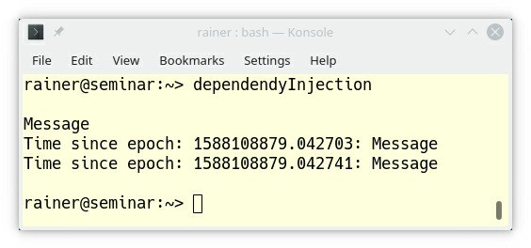

**Figure 3.2. Dependency injection**

### Making good interfaces İyi bir Interface Yapma

Functions should not communicate via global variables but through interfaces. Now, we are in the core of this chapter. According to the C++ Core Guidelines, here are the recommendations for interfaces. Interfaces should follow these rules:  
fonksiyonlar global variable ile doğrudan haberleşmemeli sadece Interface ile yapmalıdır. Şimdi bu kısım en önemli yerindeyiz. C++ Core Guidelines göre, Interface için bazı öneriler bulunmaktatır.

* Make interfaces explicit: (I.1)  
  Interface doğrudan oluşturun
* Make interfaces precise, and strongly typed: (I.4)  
  Interface kesin ve belli tiplerle olmalır.
* Keep the number of function arguments low: (I.23)  
  fonksiyon argumanlarını az sayıda tutun.
* Avoid adjacent unrelated parameters of the same type: (I.24)  
  Aynı türden bitişik ilgisiz parametrelerden kaçının.

The first function showRectangle breaks all mentioned rules for interfaces:  
aşağıdaki *showRectangle* fonksiyonu bütün bu kuralları ihlal ediyor.

void showRectangle(double a, double b, double c, double d) { a = floor(a);

b = ceil(b);

...

}

void showRectangle(Point top_left, Point bottom_right);

Although the first function showRectangle should only show a rectangle, it modifies its arguments. Essentially, it does two purposes and has, as a consequence, a misleading name (I.1). Additionally, neither does the function signature provide any information, what the arguments should be, nor in which sequence the arguments must be given (I.23 and I.24). Further one, the arguments are doubles without a constraint value range. This constraint must, therefore, be established in the function body (I.4). In contrast, the second function showRectangle takes two concretes points. Checking if a Point has valid value is the job of the constructor of Point. This responsibility should not be the job of the function.  
ilk fonksiyon sadece rectangle göstermesine rağmen, kendi argumanlarına modifiye ediyor. Esasen iki fonksiyon kullanıyor ve sonuç olarak yanıltıcı isimler kullanıyor. Ek olarak, hem argumanlarının ne olucağı hakkında bilgi, hemde hangi sırayla kullanılması gerektiği hakkında blilgi verilmemiş. Birde argumanlar herhangi bir sınırlaması yok. Bu durumdan dolayı bu sınırlamaların fonksiyon gövdesinde oluşturulması gerekmektedir. Diğer *showRectangle* fonksiyonu iki parametre içerir. Işte bu Point lerin doğruluğu Point constructoru içerisinde kontrol edilir. Işte bu kontrol mekanizması fonksiyonun görevi olmamalıdır.

I want to elaborate more on the rules *I.23*, and *I.24* and the function *std::transform_reduce* from the Standard Template Library. First, I need to define the term callable. A callable is something that behaves like a function. This can be a function but also a function object, or a lambda expression. If a callable accepts one argument, it is called unary callable; if it takes two arguments, it is called a binary callable.  
I.23 ve I.24 kurallarını ve STL kütüphanesinden *std::transform_reduce* fonksiyonuna daha fazla detaylandıralım. Öncelikle çağrılabilir bir tanımlama yapıyorum. Bu bir fonksiyon gibi davranan bir tanım. Bu fonksiyon yada fonksiyon nesnesi, yada lambda ifadesi olabilir. Eğer çağrılan bir arguman yapıyor ise Unary, birden fazla arguman kabul ediyorsa Binary dir.

std::transform_reduce first applies a unary callable to one or a binary callable to two ranges and then a binary callable to the resulting range. When you use std::transform_reduce with a unary lambda expression, the call is easy to use correctly:  
*std::transfrom_reduce* önce teki için Unary yada 2 aralık için Binary çağırır ve sonuçladırmak içinde binary çağırır. *Std::transfrom_reduce* unary lambda ile çağırılırsa, çağırım oldukça basit ve doğru olur.

std::vector<std::string> strVec{“Only”, “for”, “testing”, “purpose”};

std::size_t res = std::transform_reduce( std::execution::par, strVec.begin(), strVec.end(), 0,

[](std::size_t a, std::size_t b) { return a + b; },

[](std::string s) { return s.size(); }

);

std::transform_reduce transforms each string onto its length ([](const std::string s) { return s.size(); } and applies the binary callable ([](std::size_t a, std::size_t b) { return a + b; }) to the resulting range. 0 is the initial value for the summation. The whole calculation is performed in parallel: std::execution::par.  
*std::transform_reduce* her string uzuluğunu Unary lambda ile geri döndürür ve son olarakta *[](std::size_t a, std::size_t b){return a + b;}* ile son toplama işleminide Binary olarak sonuçlandırır. Bunu *std::executation::par* ilede bunu paralel olarak yapar. Başlangıç olarakta 0 değerini kullanır.

When you use the overload which accepts two binary callables, the declaration of the function becomes quite complicated and error-prone. Consequently, it breaks the rules *I.23*, and *I.24*.  
2 adet binary callable ifadeyi overload ederken, fonksiyon declarasyonu daha karmaşık ve hataya açık oluyor. Sonuç olarak, bu I.23 ve I.24 kuralları ihlal eder.

template<class ExecutionPolicy,

class ForwardIt1, class ForwardIt2, class T, class BinaryOp1, class BinaryOp2>

1. transform_reduce(ExecutionPolicy&& policy,

ForwardIt1 first1, ForwardIt1 last1, ForwardIt2 first2,

T init, BinaryOp1 binary_op1, BinaryOp2 binary_op2);

Calling this overload would require six template arguments and seven function arguments. Using the binary callables in the correct sequence may also be a challenge.  
bu overload çağırırken 6 adet template argumanı ve 7 fonksiyon argumanına ihtiyaç duyar. Binary callable sıralı kullanımında zorluk çıkartabilir.

**transform | reduce**

The main reason for the complicated function std::transform_reduce is that two function are combined into one. Defining two separate functions transform and reduce and supporting function compisition via the pipe operator would be a better choice: transform | reduce.  
*std::transform_reduce* karmaşık olan sebeblerinden biri iki fonksiyonu bir araya getirmesidir. *transform* ve *reduce* iki farklı fonksiyonunun komposizyonunu alırken pipe yöntemini kullanır ve buda *std::transform_reduce* fonksiyonun en iyi tercih olduğu söylenebilir.

### I.13: Do not pass an array as a single pointer Dizileri bir pointer olarak göndermeyin

The guideline that you should not pass an array as a single pointer is special. I can tell you from experience that this rule is a common cause of undefined behavior. For instance, the function copy_n is quite error-prone.  
Klavuza göre dizilerin tekil pointerlarını özellikler göndermemelisiniz. Bu bilinmeyen bir davranışın ortak bir sebebidir. Böylece *copy_n* kesinlik hataya açıktır.

template <typename T>

void copy_n(const T* p, T* q, int n); // copy from [p:p+n) to [q:q+n)

...

int a[100] = {0, };

int b[100] = {0, };

copy_n(a, b, 101);

Maybe you had an exhausting day and you miscounted by one. The result is an off-by-one error and, therefore, undefined behavior. The cure is simple. Use a container from the Standard Template Library such as std::vector and check the size of the container in the function body. C++20 offers std::span, which solves this issue more elegantly. A std::span is an object that can refer to a contiguous sequence of objects. A std::span is never an owner. This contiguous memory can be an array, a pointer with a size, or a std::vector.

Belki kötü bir gün geçirdiniz ve bir sayıyı yanlış saydınız. Böylece sonu sadece bir hata yüzünden tanımlanmayan bir davranışa sebep olur. Çözüm basit; STL kütüphanesinden container kullanın, std::vector gibi yada C++20 kullanıyorsanız *std::span* kullanın. C++20 *std::span* önerir ve böyle bir sorunu kolaylıkla çözer. *std::span* sürekli sıralı objeleri referans alır. Objelerinde sahibi olmaz. Bu devam eden hafıza; array, size ile pointer, yada std::vector olabilir.

template <typename T>

void copy(std::span<const T> src, std::span<T> des);

int arr1[] = {1, 2, 3};

int arr2[] = {3, 4, 5};

...

copy(arr1, arr2);

copy doesn’t need the number of elements. Hence, a common cause of errors is eliminated with

std::span<T>.

*copy* element sayılarına ihtiyaç duymaz. Böylece ortak bir problemin sebebi kolaylıkla *std::span* ile elimine edilebilir.

### I.27: For stable library ABI, consider the Pimpl idiom Stable bir ABI kütüphanesi için Pimpl idiom Kullanın

An application binary interface (ABI) is the interface between two binary programs.  
Bir uygulamanın binary interfaci (ABI) iki farklı Interface in binary sinden oluşabilir.

Thanks to the Pimpl idiom, you can isolate the users of a class from its implementation and, therefore, avoid recompilation. Pimpl stands for **P**ointer to **impl**ementation and is a programming technique in C ++ that removes implementation details from a class by placing them in a separate class. This separate class is accessed by a pointer. This is done because private data members participate in class layout, and private member functions participate in overload resolution. These dependencies mean that changes to those implementation details require recompilation of all users of a class. A class holding a pointer to implementation (Pimpl) can isolate the users of a class from changes in its implementation at the cost of an indirection.  
Pimpl Idiom sayesinde kullanıcı sınıfının implementasyonlarını izole edebilirsiniz ve, tekrar tekrar compile etmezsiniz. Pimpl açılımı Pointer Implementasyonun kısaltmasıdır ve class implementasyonlarını ayrı bir class a taşıyarak implementasyonu gizleyen C++ da uygulanan bir metotdur. Bu ayrı sınıfa bir pointer ile ulaşılır. Bu böyle yapılır çünkü private data üyeleri class düzenine katılabilir ve private fonksiyonlarının overload edilebilir. Bu bağımlılık tüm kullanıcı sınıflarının içerisinde yeniden compile edilmesine gerek görmez. Class tuttuğu pointer ile implementasyonları kullanıcı class larının yük getiren dolaylı implementasyonlarından izole eder.

The C++ Core Guidelines shows a typical implementation.

* Interface: Widget.h

class Widget { class impl;

std::unique_ptr<impl> pimpl; public:

void draw(); // public API that will be forwarded to the implementation Widget(int); // defined in the implementation file

~Widget(); // defined in the implementation file, where impl is a complete type Widget(Widget&&) = default;

Widget(const Widget&) = delete;

Widget& operator = (Widget&&); // defined in the

// implementation file Widget& operator = (const Widget&) = delete;

};

* Implementation: Widget.cpp

class Widget::impl {

int n; // private data public:

void draw(const Widget& w) { /* ... */ } impl(int n) : n(n) {}

};

void Widget::draw() { pimpl->draw(*this); } Widget::Widget(int n) : pimpl{std::make_unique<impl>(n)} {} Widget::~Widget() = default;

Widget& Widget::operator = (Widget&&) = default;

[*cppreference.com*](http://cppreference.com/) provides more information about the Pimpl idiom. Additionally, the rule “C.129: When designing a class hierarchy, distinguish between implementation inheritance and interface inheritance” shows how to apply the Pimpl idiom to dual inheritance.

### Related rules

I present the rule *I.10: Use exceptions to signal a failure to perform a required task* in the chapter on error handling, the rule *I.11: Never transfer ownership by a raw pointer (T*) or reference (T&)* in the section on functions, the rule *I.22: Avoid complex initialization of global objects* in the chapter on expressions and statements, and the rule *I.25: Prefer abstract classes as interfaces to class hierarchies* in the chapter on classes and class hierarchies.

### Distilled

##### Distilled: Interfaces

* Don’t use global variables. They introduce hidden dependencies.
* Singletons are global variables in disguise.
* Interfaces and in particular functions should express their intent.
* Interfaces should be strongly typed, have few arguments that cannot be easily be confused.
* Don’t take a C-array by pointer but use a std::span.
* If you want to separate the users of a class from its implementation, use the Pimpl idiom.

## Chapter 4. Functions



##### Figure 4.1. Cippi uses functions to solve the challenge

Software developers master complexity by dividing complex tasks into smaller units. After the small units are solved, they put the smaller units together to master the complex task. A function is a typical unit and, therefore, the basic building block for a program. Functions are “the most critical part in most interfaces...” (C++ Core Guidelines about functions).  
Yazılım geliştiricileri karmaşık taskları daha küçük birimlere bölerler. Bu küçük birimleri oluşturduktan sonra karmaşık task’a geri koyarlar. Fonksiyon tipik olarak bir birim ve program içinde bir block olur. Fonksiyonlar çoğu Interface için kritik bir öneme sahiptir.(C++ Core Guidelines )

The C++ Core Guidelines have about 40 rules for functions. They give very valuable advice to the definition of functions, how you should pass the arguments (e.g. by copy or by reference) and what that means from the ownership semantics. They also state rules about the semantic of the return value and to other functions such as lambdas. Let’s dive into them.  
C++ Core Guidelines fonksiyonlar hakkında 40 adet kuralı var. Fonksiyonların tanımı, argümanların nasıl geçirileceği(kopya yada referans) ve semantik sahipliği ne anlama gelir gibi çok değerli tavsiyelerde bulunur. Birde geri dönüş değerlerinin semantiği ve lambda gibi kurallar da içerir.

### Function definitions Fonksiyon Tanımları

Presumably, the most important principle for good software is good names. This principle is often ignored and holds in particular true for functions.  
Muhtemelen, en önemli prensiplerden bir taneside iyi bir yazılımın iyi isimleri vardır. Bu prensipler bazen yok sayılır ve kısmı olarak bazı fonksiyonlar için tutulur.

### Good name

The C++ Core Guidelines dedicates its first three rules to good names: F.1: “Package” meaningful operations as carefully named functions, F.2: A function should perform a single logical operation, and F.3: Keep functions short and simple.  
C++ Core Guidelines ilk 3 kural iyi bir isme sahiptir. Bunlar; F.1: “Package” operasyonlar; dikkatlice isimlendirilmiş fonksiyonlar gibi, F.2: Bir fonksiyon tek bir mantık yürütmeli, F.3 Fonksiyonu kısa ve basit tutmalı.

Let me start with a short anecdote. A few years ago, a software developer asked me: “How should I call my function?”. I said to him, give the function a name such as verbObject. In case of a member function a verb may be fine, because the function already operates on an object.

The verb stands for the operation which is performed on the object. The software developer replied that this is not possible, because the function must be called getTimeAndAddToPhonebook or just processData because the functions perform more than one job (single-responsibility principle). When you don’t find a meaningful name for your function (F.1), that’s a strong indication that your function does more than one logical operation (F.2) and that your function isn’t short and simple (F.3). A function is too long if it does not fit on a screen. A screen means roughly 60 lines by 140 characters but your measure my differ. Now, you should identify the operations of the function, and package these operations into carefully named functions.  
Kısa bir anektod ile başlayalım. Bir kaç yıl önce, yazılım geliştiricinin bana sorusu; “Fonksiyonumu nasıl çağırmalıyım?”. Ona dedim ki, fonksiyona önce *verbObject* ismini ver. Bu durum da üye fonksiyonun adı *verb* çok iyi olurdu, çünkü fonksiyon zaten *verbObject* üzerinde işlem yapacak. Verb nesne üzerinde gerçekleşecek işlemi ifade eder. Yazılım geliştiriciler, *getTimeAndDate* yada *processData* gibi fonksiyonların birden fazla işlem yaptığını belirtirek mümkün olmadığını belirttiler(single responsibility principle). Eğer fonksiyonunuza iyi bir isim bulamıyorsanız, birden fazla logic işlemler yapıyor ise ve fonksiyonunuz kısa ve basit değildir. Eğer fonksiyonunuz ekrana sığmıyorsa çok uzundur. Ekrandan kastım 140 karakter belki sizin için farklılık gösterebilir. Şimdi fonksiyonlarınızı işlemlerini tanımlamanız ve işlemleri package yaparken fonksiyonlara dikkatlice isimler vermelisiniz.

The Guidelines present an example for a bad function:  
kötü bir fonksiyon uygulamasına bakalım:

void read_and_print() { // kötü int x;

std::cin >> x;

// check for errors std::cout << x << '\n';

}

The function read_and_print is bad for many reasons. The function is tied to a specific input and output and cannot be used in a different context. Refactoring the function in two functions solves these issues and make it easier to test and to maintain:  
Fonksiyon *read_and_print* bir çok sebepten dolayı kötü. Fonksiyon özel girişler ve çıkışlara bağladır. Bu fonksiyonu 2 fonksiyon şeklinde yazacak olursak hem test yapmamız kolaylaşır hemde bakımı kolaylaşır.

int read(std::istream& is) { // iyi

int x;

is >> x;

// check for errors return x;

}

void print(std::ostream& os, int x) { os << x << '\n';

}

### F.4: If a function may have to be evaluated at compile-time, declare it constexpr Eğer Fonksiyonunuz compile-time evulate edilebiliyor ise fonksiyonunuzu *constexpr* olarak tanımlayın.

A constexpr function is a function that has the potential to run at compile-time. When you invoke a constexpr function within a constant expression, or you take the result of a constexpr with a constexpr variable, it runs at compile-time. You can invoke a constexpr function with arguments that can only be evaluated at run-time, too. constexpr functions are implicit inline.  
*constexpr* fonksiyonlar compile-time anında çalışırlar. Eğer fonksiyonunuzu *constexpr* ile ifade ederserniz ve geri dönüş değerini *constexpr* olarak isterseniz, bu compile-time anında çalışır. Yanlızca run-time anında değerlendirilebilecek fonksiyonlarıda invoke edebilirsiniz. *Constexpr* fonksiyonlar dolaylı olarak inline dır.

The result of constexpr evaluated at compile-time is stored in the ROM (read-only memory). Performance is, therefore, the first big benefit a of constexpr function. The second is that constexpr functions evaluated at compile-time are const and, therefore, thread-safe.  
compile-time anında *constexpr*  tarafından işlenip döndürülen veri ROM hafızada saklanır. Bunun en büyük avantajlarından bir tanesi performanstır. Ikinci olarakta *constexpr* ifadeler compile-time anında işlenirken const olduğundan, thread-safe’dir.

As a result of the calculation is made available at run-time as a constant in ROM.  
Sonuç çalışma anında kullanılmak üzere ROM bellekte saklanır.

// constexpr.cpp

constexpr auto gcd(int a, int b) { while (b != 0) {

auto t = b; b = a % b; a = t;

}

return a;

}

int main() {

constexpr int i = gcd(11, 121); // (1) int a = 11;

int b = 121;

int j = gcd(a, b); // (2)

}

The following image shows the output of Compiler Explorer and depicts the assembly code generated by the compiler for this function. I used the Microsoft Visual Studio Compiler 19.22 without optimization.  
Aşağıdaki resim, bu fonksiyon için oluşturulmuş assembly kodudur. MSVC 19.22 optimisazyon olmadan oluşturuldu.

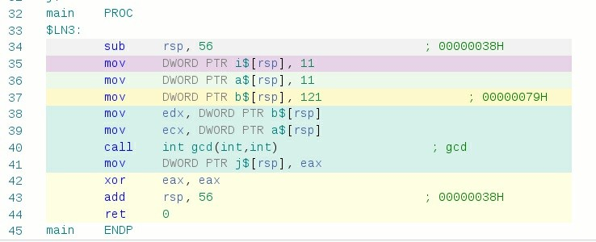

**Figure 4.2. Assembler instructions to the program constexpr.cpp**

Based on the colors, you can see that (1) in the source code corresponds to the line 35 in the assembler instructions and (2) in the source code corresponds to the lines 38 - 41 in the assembler instructions. The call constexpr int i = gcd(11, 121); boils down to the value 11, but the call int j = gcd(a, b); results in a function call.  
Renklere bakarsak, Koddaki (1) satır, resimde 35ci satırda görebilirsiniz ve (2) satır kodda 38-41 arasına denk gelmektedir. *Constexpr int I = gcd(11,121)* direk 11 değerine gider fakat *int j = gcd(a,b);* normal çağırımı (2) satırını normal fonksiyonu çalıştırır.

### F.6: If your function may not throw, declare it noexcept Eğer fonksiyonunuzda throw kullanmayacaksanız onu noexcept olarak declara edin

By declaring a function as noexcept, you reduce the number of alternative control paths; therefore, noexcept is a valuable hint to the optimizer. Even if your function can throw, noexcept often makes much sense. noexcept means in this case: I don’t care. The reason may be that you have no way to react to an exception. Therefore, the only way to deal with exceptions is that std::terminate() is invoked. This noexcept declaration is also a piece of valuable information for the reader of your code.  
fonksiyonunu noexcept olarak tanımlayarak, alternatif kontrol pathlerinizi düşürürsünüz; böylece noexcept optimisazyonda değerli bir ipucudur. Hatta fonksiyonunuz throw yapsa bile noexcept çoğunlukla bunu dikkate almaz. Sebebi bir bir exception ile etkileşime girememiz olur. Böylece, exceptionlar ile baş etmenin yolu std::terminate() invoke etmekten geçer. Noexcept tanımlaması kodunuzu okuyan içinde bir parça değerli bir bilgidir.

The next function just crashes if it runs out of memory.  
Aşağıdaki fonksiyon çalışırsa, out of memory hatası verir.

std::vector<std::string> collect(std::istream& is) noexcept { std::vector<std::string> res;

for (std::string s; is >> s;) { res.push_back(s);

}

return res;

}

The following types of functions should never throw: destructors (see failing destructor), swap functions, move operations, and default constructors.  
Destructors, swap fonksiyonlar, move operasyonlar ve varsayılan constructorlar; bir hata throw etmez.

### F.8: Prefer pure functions Pure fonksiyonlar tercih edin

Pure functions are functions that always return the same result when given the same arguments. This property is also called referential transparency. Pure functions behave such as infinite big lookup tables.  
pure fonksiyonlar her zaman kendine verilen argumanların tipleri ile aynı tipte geri dönüş değerleri veren fonksiyonlardır.

The function template square is a pure function:  
aşağıdaki kare alma fonksiyonu Pure bir fonksiyondur.

template<class T> auto square(T t) {

return t * t;

}

On the contrary, impure functions are functions such as random() or time(), which can return a different result from call to call. To put it another way. Functions that interact with state outside the function body are impure.  
Aksine Pure olmayan fonksiyonlar çağrılma şekline göre geri dönüş değeri tipleri üretebilirler. Başka bir deyişle dışardan etkileşime giren fonksiyonlar Pure fonksiyon değildir.

Pure functions have a few very interesting properties. You should, therefore, prefer pure functions, if possible.  
Pure fonksiyonların bazı önemli özellikleri vardır, mümkün olduğunca Pure fonksiyon kullanın;

Pure functions can  
Pure Fonksiyonlar

* be tested in isolation.  
  izole iken test edilebilir
* be verified or re-factorized in isolation.  
  izole iken doğrulanabilir yada yeniden düzenlenebilir
* cache its result.  
  sonuçları elde edebilirsiniz
* automatically be reordered or be executed on other threads.  
  otomatik olarak sıralı olarak çağırılabilir yada başka bir thread içerisinde kullanılabilir.

Pure functions are also often called mathematical functions. Functions in C++ are by default not pure such as in the pure functional programming language Haskell. Using pure functions is based on the discipline of the programmer. constexpr functions are pure when evaluated at compile time. Template metaprogramming is a pure functional language embedded in the imperative language C++.  
Pure fonksiyonlar matematik fonksiyonları olarakta bilinirler. C++ da fonksiyonlar varsayılan olarak Haskell Pure fonksiyonel programlama dili gibi fonksiyonel değildir. Pure fonksiyonları bir programcı disiplini altında kullanın. *Constexpr* fonksiyonlar compile-time anında işleme alınırsa onlarda pure fonksiyondur. Template metaprogramming, imperative C++ dilinde pure fonksiyoneldir.

The section to templates and generic programming gives a concise introduction to programming at compile-time, including template metaprogramming.  
template ve generic programlama kısmında compile-time anında size kısa ve öz bilgiler var.

### Parameter passing: in and out Parametreyi Geçiştirme: in ve out

The C++ Core Guidelines has a few rules to express various way to pass parameter in and out of functions.  
in ve out fonksiyonlarında parametre geçirmek için C++ Core GuideLines ta bir takım kurallar vardır.

### F.15: Prefer simple and conventional ways of passing information Basit ve Konvensiyonel Yöntemleri Seçin

The first rule presents the big picture. First, it provides an overview of the various ways to pass information in and out of a function.  
İlk Kural büyük resmi temsil eder. Ilki, fonksiyon in ve outlarına giriş için çeşitli yöntemlerden bahseder.

##### Table 4.1. Normal parameter passing Normal parametre Geçişi

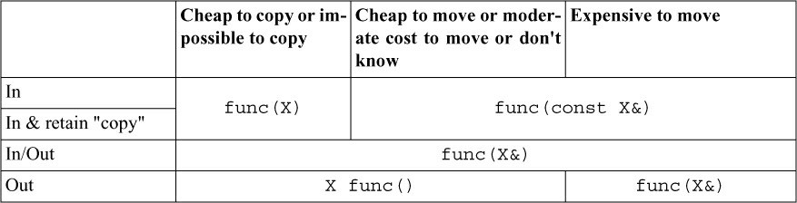

The table is very concise: The headings describe the characteristics of the data regarding the cost of copying and moving. The rows indicate the direction of parameter passing.  
Tablo oldukça basit: tablonun heading kısmı, copying yada moving işleminin maliyetine ilişkin tanım içerir. Satırlar da parametrelerin geçişinin yönünü gösterir.

* Kind of data  
  veri çeşitleri
  + Cheap to copy or impossible to copy: int or std::unique_ptr  
    Kopyalanamayan yada kopyalama maliyeti düşük olan: *int* yada *std::unique_ptr*
  + Cheap to move: std::vector<T> or std::string  
    *std::vector<T>* yada *std::string*  move yapmak maliyeti düşük
  + Moderate cost to move: std::array<std::vector> or BigPOD (POD stands for **P**lain **O**ld **D**ata - that is a class without constructors, destructors, and virtual member functions)  
    *std::array<std::vector>* gibi yada BigPOD işlem yükünü kontrol edin.( POD Plain Old Data, yani eski veri yapılarını temsil eder. Bu yapıların Constructor, Destructor yada üye fonksiyonları bulunmaz.)
  + Don’t know: Template  
    Template: Bilme
  + Expensive to move: BigPOD[] or std::array<BigPOD>  
    EbigPOD yada std::array<BigPOD> gibi verilerin taşıma maliyeti
* Direction of parameter passing  
  Parametre geçiş yönleri
  + In: Input parameter  
    In: giriş parametresi
  + In & retain “copy”: The caller retains its copy  
    Fonksiyonu çağıran işlem In bir kopyasını tutar
  + In/Out: Parameter which is modified  
    In/Out: Modifiye edilen parametre
  + Out: Output parameter  
    Out: Out parametresi

A cheap operation is an operation with a few int’s; moderate cost is about 1000 bytes without memory allocation.  
az bir int işlem maliyeti düşük; yaklaşık 1000 byte hafızada yer açmadan yönetilebilir.

These normal parameter passing rules should be your first choice. However there are also advanced parameter passing rules. Essentially, the case with “in & move from” semantic was added.  
bu normal parametreler geçistirilirken bu kuralları uygulamak ilk seçiminiz olsun. Ancak ileri seviye parametre geçişi vardır. Özellikle move semantic kısmı işin içine girince.

##### Table 4.2. Advanced parameter passing

After the “in & move from” call, the argument is in the so-called moved-from state. Moved-from means that it is in a valid but not nearer specified state. Essentially, you have to initialize the moved-from object before using it again.  
“in & move from” çağrımından sonra; arguman artık moved-from durumdadır. Moved-from durumundan kastedilen geçerli ancak özel bir durumu yoktur. Özellikle moved-from nesnesini kullanmadan önce initialize etmelisiniz.

The remaining rules to parameter passing provide the necessary background information for these tables.  
diğer kurallar, bu tablo için parametre geçişi için ekstra bilgilere ihtiyaç vardır.

### F.16: For “in” parameters, pass cheaply-copied types by value and others by reference to const Parametre in için kopyalama maliyeti düşük olanarı kopya olarak, diğerlerini const referans olarak gönderin.

The rule is straightforward to follow. Input values should be copied by default if possible. When they cannot be cheaply copied, take them by const reference. The C++ Core Guidelines give a rule of thumb to the question: Which objects are cheap to copy or expensive to copy?  
Bu kuralın takibi basit. Input değeri münkünse kopyalanmış veri olmalı. Eğer kopyalama maliyeti yüksek ise const referans kullanılmalı. C++ Core Guidelines bu soru için bir kaç kuralı var; hangi nesne kopyalama için ucuz hangisi için maliyetli;

* You should pass a parameter par by value if sizeof(par) < 3 * sizeof(void*).  
  Eğer kopya geçireceğiniz verinin boyutu sizeof(par) < 3 * sizeof(void*) kuralına uyuyorsa kopya gönderin.
* You should pass a parameter par by const reference if sizeof(par) > 3 * sizeof(void*).  
  Yeğer yukardaki kurala uymuyor ise const referans göndermelisiniz.

void f1(const std::string& s); // OK: pass by reference to const;

// always cheap

void f2(std::string s); // bad: potentially expensive void f3(int x); // OK: Unbeatable

void f4(const int& x); // bad: overhead on access in f4()

**F.19: For “forward” parameters, pass by TP&& and only std::forward the parameter  
“forward” parametresi için, TP&& ve std::forward parametre olarak geçin**

This rule stands for a special input value. Sometimes you want to forward the parameter par. This means, an lvalue is copied and an rvalue is moved. Therefore, the constness of a lvalue is ignored and the rvalue-ness of a rvalue is preserved.  
bu kural özel inputlar için geçerlidir. Bazen parametrenizi forward ederkeni lvalue değerleri kopya, rvalue değerleride referans olarak göndermek istersiniz. Böylece lvalue sabitliği ihmal edilir ve rvalue nin durumu korunur.

The typical use-case for forwarding parameters is a factory function which creates an arbitrary object by invoking its constructor. Neither do you know if the arguments are rvalues nor do you know how many arguments the constructor needs.  
forwarding parametresinin kullanım durumu, her nesnenin kedi contructor invoke ederek nesne oluşturan bir fabrika gibidir. Ne argumanınızın rvalue olduğunu bilirsiniz nede kaç tane argumanınızın contructor ihtiyacı olduğunu.

// forwarding.cpp

#include <string> #include <utility>

template <typename T, typename ... T1> // (1) T create(T1&& ... t1) {

return T(std::forward<T1>(t1)...);

}

struct MyType {

MyType(int, double, bool) {}

};

int main() {

// lvalue int five=5;

int myFive= create<int>(five);

// rvalues

int myFive2= create<int>(5);

// no arguments

int myZero= create<int>();

// three arguments; (lvalue, rvalue, rvalue) MyType myType = create<MyType>(myZero, 5.5, true);

}

The three dots (ellipsis) in the function create (1) denote a parameter pack. We call a template using a parameter pack an variadic template.  
3 noktalı fonksiyon olan create(1) paket parametreye sahiptir. Bu template parametreye **variadic template** denir.

##### Packing and unpacking of the parameter pack Paketlenmiş parametrei unpacking yada packing yapma

When the ellipsis is on the left of the type parameter T1, the parameter pack is packed; when on the right, it is unpacked. This unpacking in the return statement T(std::forward<T1>(t1)...) essentially means that the expression std::forward<T1>(t1) is repeated until all arguments of the parameter pack are consumed and a comma is put between each sub-expression. For the curious, C++ Insights shows this unpacking process.  
T1 in sol tarafındaki 3 nokta paketlenmiş T1 tipinde bir veri bloğudur. Sağ tarafki ise paket açılmış bir veridir. Paket açılımı işlemi std::forward<T1>(t1) işlemi ile paketteki son veriye kadar işlenir ve geri dönüş değerinde her birinin arasına virguk koyarak geri döndürür. Aşağıdaki paket açılımı işlemine bakalım.

The combination of forwarding together with variadic templates is the typical creation pattern in C++. Here is a possible implementation of std::make_unique<T>.  
variadic template ile forwarding parametresinin birlikte kullanılması C++’ta creation pattern tipidir. *Std::make_unique<T>* uygulamasına bir bakalım.

template<typename T, typename... Args> std::unique_ptr<T> make_unique(Args&&... args) {

return std::unique_ptr<T>(new T(std::forward<Args>(args)...));

}

std::make_unique<T> creates a std::unique_ptr for T

### F.17: For “in-out” parameters, pass by reference to non-const Aynı anda hem in hem out olan parametreler non-const olarak kullanın

The rule communicates its intention to the caller: this function modifies its argument.  
bu fonksiyon kendine verilen parametreyi modifiye ediyor. Bunun için non-const referans kullanılmalıdır.

std::vector<int> myVec{1, 2, 3, 4, 5};

void modifyVector(std::vector<int>& vec) { vec.push_back(6); vec.insert(vec.end(), {7, 8, 9, 10});

}

### F.20: For “out” output values, prefer return values to output parameters Out değeri için, Output parametresi değerinde bir parametre döndürmeyi tercih edin

The rule is straightforward. Just return the value, but don’t use a const value because it has no added value, and interferes with move semantic. Maybe you think, that copying a value is an expensive operation. Yes and no. Yes, you are right, but no, the compiler applies RVO (**R**eturn **V**alue **O**ptimization), or NRVO (**N**amed **R**eturn **V**alue **O**ptimization). RVO means, that the compiler is allowed to remove unnecessary copy operations. What was a possible optimization step, becomes in C++17 a guarantee.  
kural oldukça basit. Sadece değeri geri döndürün, fakat const olarak döndürmeyin çünkü bu ekli bir değer değil ve move semantiğe engel olur. Belki kopyalama işlemi maliyetli diye düşünebilirsiniz. Hem Evet hemde Hayır. Evet haklısın, ancak haksızsında. Çünkü compiler RVO( Return Value Optimization) uygular yada NRVO ( Named Return Value Optimization). RVO nun anlamı, compiler gereksiz kopyalama işlemleri yapmaz. Bu kuralı C++17 kesinlikle uygular.

MyType func() {

return MyType{}; // no copy with C++17

}

MyType myType = func(); // no copy with C++17

Two unnecessary copy operations can happen in these few lines. The first in the return call and the second in the function call. With C++17, no copy operation takes place. If the return value has a name, we call it NRVO. Maybe, you guessed it.  
İki farklı gereksiz kopyalama işlemi yukarıdaki kodda uygulanmıştır. Ilkinde return çağrısı ve ikinciside fonksiyon çağrısı. C++17 de bu satırlarda kopyalama işlemi yapılmaz. Eğer geri dönüş değeri var ise bu NRVO dur. Belkide tahmin etmişsindir.

MyType func() { MyType myValue;

return myValue; // one copy allowed

}

MyType myType = func(); // no copy with C++17

The subtle difference is that the compiler can still copy the value myValue in the return statement according to C++17. But no copy will take place in the function call.

Often, a function has to return more than one value. Here, the rule F.21 kicks in.  
Burada göze çarpmayan bir fark var. Geri dönüş değerinde kopyalama mevcut iken fonksiyon çağrısında C++17 sayesinde move işlemi uygulanmıştır. Fonksiyonlar bazen birden fazla değer döndürebilir. Bunun için F.21 Kuralına bakınız.

### F.21: To return multiple “out” values, prefer returning a struct or tuple. Birden fazla geri dönüş değeriniz var ise, struct yada tuple tipini kullanınız

When you insert a value into a std::set, overloads of the member function insert return a std::pair of an iterator to the inserted element and a bool set to true if the insertion was successfully. std::tie with C++11 or structured binding with C++17 are two elegant ways to bind both values to a variable.  
std::set bir overload üyesi member fonksiyonu ile bir değer girdiğiniz zaaman size std::pair olarak bir veri çifti döndürür. C++11 de std::tie ile ilk veri insert ettiğimiz veri, ikinci ise veri insert edilip edilmediğinin bilgisini içeren bir bool tipinde değişken döner. Aşağıdaki örneğe bakalım.

// returnPair.cpp; C++17

#include <iostream> #include <set> #include <tuple>

int main() {

std::cout << '\n'; std::set<int> mySet;

std::set<int>::iterator iter; bool inserted = false;

std::tie(iter, inserted) = mySet.insert(2011); // (1) if (inserted) std::cout << “2011 was inserted successfully\n”;

auto [iter2, inserted2] = mySet.insert(2017); // (2) if (inserted2) std::cout << “2017 was inserted successfully\n”;

std::cout << '\n';

}

Line (1) uses std::tie to unpack the return value of insert into iter and inserted. Line (2) uses structured binding to unpack the return value of insert into iter2 and inserted2. std::tie needs, in contrast to structured binding, a pre-declared variable.  
satır(1) de std::tie ile gelen packeti açarak iter ve inserted değişkenlerine atarız. Satır (2)’de bunu C++17 structred binding ile yapar. Std::tie, structured binding’in aksine bir ön tanıma ihtiyaç duyar.

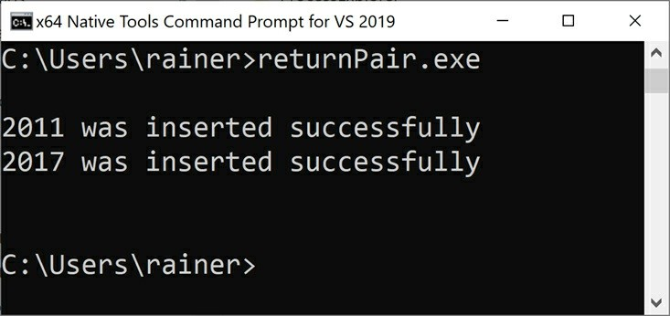

**Figure 4.3. Returning a std::pair**

### Parameter passing: ownership semantic Parametre geçişi: Sahiplik semantiği

The last section was about the flow of parameters: which parameters are input, input/output, or output values. But there is more to arguments than the direction of the flow. Passing parameters is about ownership semantic. This section presents five typical ways to pass parameters: by copy, by pointer, by reference, by std::unique_ptr, or by std::shared_ptr. Only the rules to smart pointers are inside this section. The rule to pass by copy is part of the previous section parameter passing: in and out, and the rules to pointers and references are part of the Interfaces section.

Buraya kadar ki bölüm parametre akışı ile ilgili olarak: hangi parametre in, in/out yada out değerleriydi. Fakat akış ile alakalı olarak daha fazla arguman var. bu bölümde 5 farklı parametre geçişinden bahsedecez; copy, pointer, referans, *std::unique_ptr* ve *std::shared_ptr.* Bu kısımda sadece smart pointerlardan bahsedecez. Pointer ve referans Interface kısmıyla alakalı copy de bir önceki kısımda idi.

The following table provides the first overview:  
Aşağıdaki Tablo ilk önizlenimimi bize verir.

##### Table 4.3. Ownership semantic of parameter passing

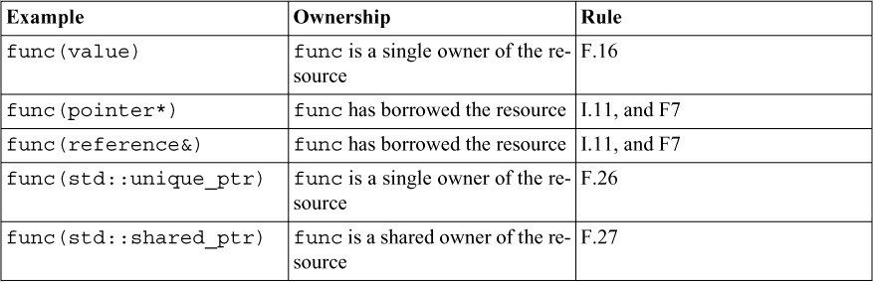

Here are more details:  
Daha fazla detay:

* func(value): The function func has its own copy of the value and is its owner. func

automatically releases the resource.  
*func(value):* value nin kopyasını alır ve onu kullandıktan sonra release eder.

* func(pointer*): func has borrowed the resource and is, therefore, not authorized to delete the resource. func has to check before each usage that pointer is not a null pointer.  
  *func(pointer*)* kaynağı ödünç alır ve onu silme yetkisi yoktur. *Func* pointerı kullanmadan önce nullptr olup olmadığını kontrol etmelidir.
* func(reference&): func has borrowed the resource. In contrast to the pointer, the reference always has a valid value.  
  *func* kaynağı ödünç alır. Pointerın aksine kaynak her zaman geçerli bir değerdir.
* func(std::unique_ptr): func is the new owner of the resource. The caller of the func has explicitly transferred the ownership of the resource to the callee. func automatically releases the resource.  
  *func* kaynağın yeni sahibidir. *func* çağırıcısı kaynağı doğrudan yeni sahibibe transfer eder. *Func* otomatik olarak kaynağı serbest bırakır.
* func(std::shared_ptr): func is an additional owner of the resource. func extends the lifetime of the resource. At the end of func, func ends its ownership of the resource. This end causes the release of the resource if func was the last owner.  
  *func* ek kaynak sahibi olur. *Func,* kaynağın ömürünü kendi ömrü kadar uzatır. *Func* sonunda kendi sahib olduğu kaynağı serbest bırakır. Kaynağı serbest bırakırken eğer kaynağın son sabihi ise kaynağı release eder.

##### Who is the owner? Sahiplik nedir?

It’s very important to indicate ownership clearly. Just imagine, that your program is written in legacy C++, and you have only a raw pointer to your disposal to express the four kinds of ownership by pointer, by reference, by std::unique_ptr, or by std::shared_ptr. The key question in legacy C++ is: Who is the owner?  
sahipliğin net olarak açıklanması için bu kısım çok önemlidir. Programınızın legacy C++ ile yazıldığını varsayın ve var olan raw pointerınızı destroy etmek için 4 çeşit yönteminiz var; pointer ile, referans ile, *std::unique_ptr* ile ve *std::shared_ptr* ile. Anahtar soru şu; sahib kim?

The following code snippet makes my point:

void func(double* ptr) {

...

}

double* ptr = new double[]; func(ptr);

The critical question is: Who is the owner of the resource? The callee of func, that uses the array, or the caller of the func, that created the array. If func is the owner, it has to release the resource. If not, func is not allowed to release the resource. This condition is not satisfactory. If

func does not release the resource, a memory leak may happen. If func does release the resource, undefined behavior may be the result.  
Kritik soru: yukardaki *func* daki verinin sahibi kim? *Func* çağırıcısı array kullanıyor, yada array yaratmış. Eğer fonksiyon sahibi ise kaynağı release eder, eğer değilse kaynağı release etmez. Kural tatmin edici değil. *Func* kaynağın sahibi değilse release etmez ve buda memory leak’e sebep olur. Eğer *func* kaynağı kendi release ederse bu undefined behaviour sebep olabilir.

In consequence ownership needs to be documented. Defining the contract using the type system in modern C++ is a big step in the right direction to eliminate this ambiguity on documentation.  
sonuç olarak mülkiyetin dökümente edilmeye ihtiyaç duyar. Modern C++’da değişken sistemi kullanarak contract tanımlamak, bu belirsiz dökümanı elimine ederken doğru yoldaki en büyük adımdır.

Using std::move on application level is not about moving. Using std::move on application level is about the transfer of ownership. E.g.: Applying std::move to a std::unique_ptr, transfers the ownership of the memory to another std::unique_ptr.  
*std::move* uygulama seviyesinde kullanmak taşıma anlamına gelmez. *Std::move* sahibin değişmesi anlamına gelir. *Std::unique_ptr* de *std::move* kullanmak hafızada başka bir *std::unique_ptr* aktarır.

auto uniquePtr1 = std::make_unique<int>(2011); // the original owner std::unique_ptr<int> uniquePtr2{ std::move(uniquePtr1) }; // the new owner

Here are five variants of ownership semantic in practice.  
Burada semantic ile ilgili 5 değişken var.

1 // ownershipSemantic.cpp 2

1. #include <iostream>
2. #include <memory>
3. #include <utility> 6
4. class MyInt {
5. public:
6. explicit MyInt(int val): myInt(val) {}
7. ~MyInt() noexcept {
8. std::cout << myInt << '\n';   
   12 }
9. private:
10. int myInt; 15 };

16

1. void funcCopy(MyInt myInt) {}
2. void funcPtr(MyInt* myInt) {}
3. void funcRef(MyInt& myInt) {}
4. void funcUniqPtr(std::unique_ptr<MyInt> myInt) {}
5. void funcSharedPtr(std::shared_ptr<MyInt> myInt) {} 22

23 int main() { 24

25 std::cout << '\n'; 26

27 std::cout << “=== Begin” << '\n'; 28

1. MyInt myInt{1998};
2. MyInt* myIntPtr = &myInt;
3. MyInt& myIntRef = myInt;
4. auto uniqPtr = std::make_unique<MyInt>(2011);
5. auto sharedPtr = std::make_shared<MyInt>(2014); 34
6. funcCopy(myInt);
7. funcPtr(myIntPtr);
8. funcRef(myIntRef);
9. funcUniqPtr(std::move(uniqPtr));
10. funcSharedPtr(sharedPtr); 40

41 std::cout << “==== End” << '\n'; 42  
43 std::cout << '\n'; 44

45 }

The type MyInt displays in its destructor (lines 10 - 12) the value of myInt (line 14). The five functions in the lines 17 - 21 implement each ownership semantic. The lines 29 - 33 have the corresponding values.  
MyInt tipinin destructor 10-12 arası gösterilmektedir. myInt değeri 14 de gösterilmektedir. 17-21 arası 5 fonksiyon kendi sahipliği için implementasyonu gösterilmektedir. 29-33 sonuçları göstermektedir.

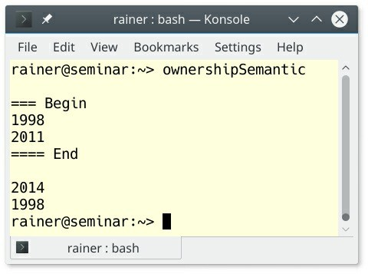

##### Figure 4.4. The five ownership semantics

The screenshot shows that two destructors are called before and two destructor’s are called at the end of the main function. The destructors of the copied myInt (line 35) and the moved uniquePtr (line 38) are called before the end of main. In both cases, funcCopy or funcUniqPtr becomes the owner of the resource. The lifetime of the functions ends before the lifetime of main. This end of the lifetime does not hold for the original myInt (line 29) and the sharedPtr (line 33). Their lifetime ends with main and, therefore, the destructor is called at the end of the main function.  
Ekran görüntüsünde önce iki destructor çağrıldı ve main fonksiyonunun sonunda 2 tane daha çağrıldı. 35 satırdaki kopya myInt değerinin destructor’u ve 38 inci satırdaki transfer edilmiş unique_ptr destructoru main fonksiyonunun sonunda çağrıldı.her durumda funcCopy ve funcUniqPtr kaynağın sahibidir. fonksiyonları lifetime’ı main fonksiyonunun lifetime’ından önce bitmektedir. 29 satırdaki myInt ile 33 satırdaki sharedPtr lifetime main fonksiyonunun lifetime ile bitmektedir, böylece destructor main fonksiyonunun sonu ile birlikte çağrılmaktadır.

### Value return semantics Değer döndürme semantiği

The seven rules in this section are in accordance with the previously mentioned rule F.20: For “out” output values, prefer return values to output parameters. The rules of this section are, in particular, about special use-cases and don’ts.  
daha önceki F.20 kuralınca, burada 7 kuraldan bahsettik. out değeri için out parametresine göre değer döndürmeyi tercih edin.

### When to return a pointer (T*) or a lvalue reference (T&) Pointer (T*) yada lvalue Referance (T&) döndürürken

As we know from the last section (parameter passing: ownership semantic), a pointer or a reference should never transfer ownership.  
şimdiye kadar incelediğimiz bölümde pointer yada referansların sahiplik transferi olmaması gerektiğini öğrendik.

#### F.42: Return a T* to indicate a position (only) Pointer T* sadeve posizyon için geri döndürün.

A pointer should only indicate a position. This is exactly what the function find does.  
find fonksiyonu çalıştığında pointerın sadece posizyon değeri göstermelidir

Node* find(Node* t, const string& s) { if (!t || t->name == s) return t;

if ((auto p = find(t->left, s))) return p; if ((auto p = find(t->right, s))) return p; return nullptr;

}

The pointer indicates that the Node is holding the position of s.  
burada s gösterdiği Node nesnesinin adresidir.

#### F.44: Return a T& when copy is undesirable and “returning no object” isn’t needed kopya istenmeyen ise T& geri döndürün

When return no object is no option, using a reference instead of a pointer comes into play.  
eğer geri bir nesne döndürmeyeceksek, pointerları yerine referanslar kullanın.

Sometimes, you want to chain operations without unnecessary copying and destruction of temporaries. Typical use-cases are input and output streams or assignment operators ( F.47: Return T& from assignment operators). What is the subtle difference between returning by T& or returning by T in the following code snippet?  
bazen, geçici dosyaları gereksiz yere kopyalamadan ve yok etmeden operasyonlarımı gerçekleştirmek isteriz. Bunu tipi olarak kullanımı assigment operatorudur. Aşağıdaki kod örneğine göre T& yada T arasındaki fark nedir?

A& operator = (const A& rhs) { ... }; A operator = (const A& rhs) { ... };

A = a1, a2, a3;

a1 = a2 = a3;

The copy assignment operator returning a copy (A) triggers the creation of two additional temporary objects of type A.  
Copy operatorü, A nesnesinden iki adet A tipinde geçici nesnenin oluşturulmasını tetikler.

#### A reference to a local referans locale almak

Returning a reference (pointer) to a local is undefined behavior.  
referansları locale geri döndürmek tanımsız bir davranışa sebep olur.

Undefined behavior essentially means: Don’t make any assumption about your program. Fix undefined behavior. The program lambdaFunctionCapture.cpp returns a reference to a local.  
tanımsız davranışın anlamı; programınız için bir varsayımda bulunmayın, tanımsız davranışları düzeltin. *lamdaFunctionCapture.cpp* local deki nesneye referans göstermektedir.

// lambdaFunctionCapture.cpp

#include <functional> #include <iostream> #include <string>

auto makeLambda() {

const std::string val = “on stack created”;

return [&val]{return val;}; // (2)

}

int main() {

auto bad = makeLambda(); // (1)

std::cout << bad(); // (3)

}

The main function calls the function makeLambda() (1). The function returns a lambda expression, which has a reference to the local variable val (2).  
main fonksiyonu makeLambda çağırmaktadır(1). Fonksiyon val değerini referans alan bir lamda ifadesi geri döndürmektedir.

The call bad() (3) causes the undefined behavior, because the lambda expression uses a reference to the local val. As local, its lifetime ends with the scope of makeLambda().  
*bad()* fonksiyonunu çağırmak tanımsız bir davranışa sebep olur. Çünkü lamda ifadesi local bir nesneyi referans göstermektedir. Val değeri lifetime’ı makeLambda scope sonunda lifetime bitecektir.

Executing the program gives unpredictable results. Sometimes, I get the entire string, sometimes a part of the string, or sometimes just the value 0. As an example, here are two runs of the program.  
bu programı çalıştırmak, beklenmeyen sonuçlar üretebilir. Bazen bir string alabilirsiniz, bazende bir string parçası yada bazende 0 değeri. Aşağıdaki 2 kere yürütülmüş program çıktısını görebiliesiniz.

In the first run, arbitrary characters are displayed until the string terminating symbol (\0) ends it.  
aşağıdaki ekran görüntüsü, \0 karakteri ile son bulmakta.

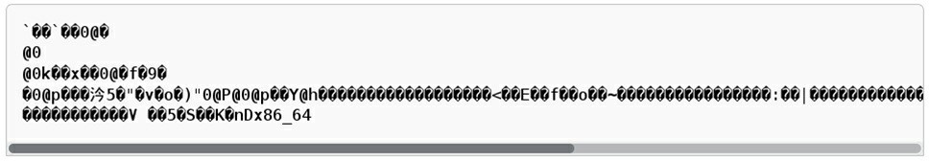

##### Figure 4.5. Displaying arbitrary characters

In the second run, the program causes a core dump.  
İkinci çağırım core dump sebep olmaktadır.

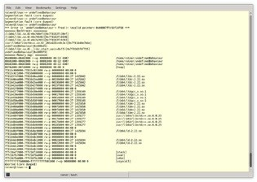

##### Figure 4.6. Causing a core dump

**F.45: Don’t return a T&& and F.48: Don’t return std::move(local)**

Both rules are very rigorous.  
Her iki kuralda çok titizdir.

**T&&**

You should not use a T&& as a return type. Here is a small example to demonstrate the issue.  
Geri döndürülen değeri T&& olarak yapmamalısınız. Küçük bir örnek ile gösterelim.

// returnRvalueReference.cpp

int&& returnRvalueReference() { return int{};

}

int main() {

auto myInt = returnRvalueReference();

}

When compiled, the GCC compiler complains immediately about a reference to a temporary. To be precise, the lifetime of the temporary ends with the end of the full expression auto myInt = return-RvalueReference();  
compiled Yukarıdaki kodu derlediğimiz de, GCC bize direk geçici bir nesnenin referansını alındığının uyarısını veriyor. Bu geçici nesnenin *returnRvalueReference()* lifetime süresi dolunca nesne kesinlikle destroy olur.

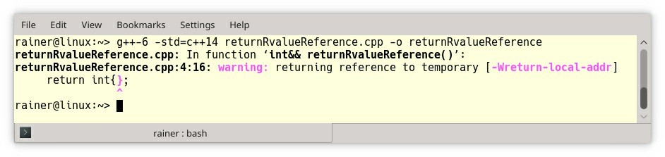

##### Figure 4.7. Returning a reference to a temporary

**std::move(local)**

Thanks to copy elision with RVO and NRVO using return std::move(local) is not an optimization but a pessimization. Pessimization means that your program may become slower.  
RVO ve NRVO sayesinde *return std::move(local)* optimize değildir fakat karamsardır. Karamsar olmasının sebebi de uygulamanızı daha yavaş hale getirir.

**F.46: int is the return type for main()**

According to the C++ standard, there are two variations of the main function:  
C++ standartına göre, main fonksiyonunun 2 varyasyonu vardır;

int main() { ... }

int main(int argc, char** argv) { ... }

The second version is equivalent to int main(int argc, char* argv[]) { ... }.  
ikinci varyasyon int main(int argc, char* argv[]) { ... }. Bu ifadeye eşitsin.

The main function does not need a return statement. If control reaches the end of the main function without encountering a return statement, the effect is that of executing return 0;. return 0 stands for the successful execution of the program.  
main fonksiyon geri dönüş değerine sahip olmak zorunda değildir. Eğer kontrol main fonksiyonunun sonuna herhangi bir durumla karşılaşmadan gelirse, return 0; olarak geri dönüş değer yapar. Return 0 programın başarılı bir şekilde yürütüldüğü anlamına gelir.

### Other functions

The rules in this section advice when to use lambdas and compare va_arg with fold expressions.  
bu kısımda ki kurallar, lambda ve va_arg fold ifadesinin karşılaştırması içeriyor.

### Lambdas

#### F.50: Use a lambda when a function won’t do (to capture local variables, or to write a local function) Bir fonksiyon birşey yapmıyorsa, onu lambda olarak kullanın

This rule states the use-case for lambdas. This raises immediately the question: When do you

have to use a lambda or a function? Here are two obvious reasons.  
Bu kural lambda ların nasıl kullanıldığıyla alakalıdır. Buda hemen şu soruyu aklımıza getirir; lambda fonksiyonları nerede kullanmalıyız? Gözlemlenen iki sebep var;

1. If your callable has to capture local variables or is declared in a local scope, you have to use a lambda function.  
   eğer fonksiyonunuz local declare edilmiş yada local değişkenleri kullanıyorsa, kesinlikle lambda kullanın
2. If your callable should support overloading, use a function.  
   eğer fonksiyonunuz overloading destekliyorsa, fonksiyon kullanın.

Now, I want to write about my crucial arguments for lambdas that is often ignored.  
şimdi, lambda için gözardı edilen önemli argumanları yazacağım.

#### Expressiveness Tanımsızlık

“Explicit is better than implicit”. This meta-rule from Python (PEP 20 -- The Zen of Python) also applies to C++. It means that your code should explicitly express its intent (see rule P.1. Express ideas directly in code). Of course, this holds, in particular, true for lambdas.  
“Explicit, implicitten daha iyidir.” Bu pythondan gelen bir kuraldır(PEP 20 – zen of python). Bunun anlamı ifadeniz, niyetini doğrudan belli eder(kural p.1 bakınız). Bu lambdalar için iyi bir kuraldır.

std::vector<std::string> myStrVec = {“523345”, “4336893456”, “7234”,

“564”, “199”, “433”, “2435345”};

std::sort(myStrVec.begin(), myStrVec.end(),

[](const std::string& f, const std::string& s) { return f.size() < s.size();

}

);

Compare this lambda with the function lessLength, which is subsequently used.  
lessLength fonksiyonu ile lambda fonksiyonunu karşılaştırın.

std::vector<std::string> myStrVec = {“523345”, “4336893456”, “7234”,

“564”, “199”, “433”, “2435345”};

bool lessLength(const std::string& f, const std::string& s) { return f.size() < s.size();

}

std::sort(myStrVec.begin(), myStrVec.end(), lessLength);

Both the lambda and the function provide the same order predicate for the sort algorithm. Imagine, your coworker would name the function foo. This means you have no idea what the function is supposed to do. As a consequence, you have to document the function.  
her iki fonksiyonda aynı işi yapmaktadır. Çalışanınız fonksiyonu foo olarak adlandırdığını düşünün. Bu fonksiyonun ne yapmanız gerektiği hakkında hiç bir bilgi olmadığı anlamına gelir. Sonuç olarak bu fonksiyonu dökümente etmeniz gerekmektedir.

// sorts the vector ascending, based on the length of its strings std::sort(myStrVec.begin(), myStrVec.end(), foo);

Further, you have to hope that your coworker did it right. If you don’t trust him, you have to analyze the implementation. Maybe that’s not possible because you have the declaration of the function. With a lambda, your coworker cannot fool you. The code is the truth. Let me put it more provocatively: **Your code should be so expressive that it does not require documentation.**Dahada ötesi, çalışanınızın bunu doğru yaptığını varsayarsınız. Eğer çalışanınıza güvenmiyorsanız fonksiyonu implementation’u kontrol etmeniz gerekmektedir. Belki bu mümkün olmayada bilir çünkü fonksiyonun declarasyonu var sadece. Lambda ile çalışanınız sizi aptal yerine koyamaz. Kod gerçektir. Bu local lambda fonksiyonun döküman da açıklamasına gerek kalmaz.

##### Expressiveness versus don’t repeat yourself (DRY) Tanımsızlık vs kendini tekrar etmeme

The design rule to write expressive code with lambdas often contradicts another import design rule: don’t repeat yourself (DRY). DRY means that you should not write the same code more than once. Making a reusable unit such as a function and give it a self-explanatory name is the appropriate cure against DRY. On the end, you have to decide in the concrete case if you rate expressiveness higher than DRY.  
lambda ile fonksiyonları yazarken, aynı lambda fonksiyonunu başka yerde yine tanımlamanız, DRY kuralı ile çelişir. DRY kod parçanızın projenizin herhangi bir yerinde aynısının olmamasıdır. Bu yüzden yeniden kullanılabilir bir birim oluşturmak ve ona açıklama vermek iyi yöntem olabilir. Sonuç olarak ifadenizin tanımını DRY daha iyi olduğunu derecelendirmeniz gerekmektedir.

#### F.52: Prefer capturing by reference in lambdas that will be used locally, including passed to algorithms, and F.53: Avoid capturing by reference in lambdas that will be used nonlocally, including returned, stored on the heap, or passed to another thread lambda da referansı kullanmayı tercih edin, ve F.53: heap de tutulani nonlocal olarak kullanılan, yada başka bir thread gönderilen için lambdada referans kullanın.

Both rules are strongly related, and they boil down to the following observation: a lambda should only operate on valid data. When the lambda captures the data by copy, the data is by definition valid. When the lambda captures data by reference, the lifetime of the data must outlive the lifetime of the lambda. The previous example with a reference to a local showed different results of a lambda referring to invalid data.  
bu kuralların hepsi birbirleri ile çok güçlü ilişkileri vardır, ve şu sıkıcı gözlemi düşürür; lamda sadece geçerli datalarda çalışır. Eğer lambda datayı kopya olarak kullanırsa, data tanımı geçerlidir. Eğer referans olarak capture alırsak, verinin lifetime’I lambda nın lifetime’ından daha uzun olmalıdır. Bir önceki örnekte, local değişkenin referansını alarak lambda nın geçersiz bir değeri refrerans aldığını görürüz.

Sometimes the issue is not so easy to catch.  
bazen bu durumları yakalamak kolay değildir.

int main() {

std::string str{“C++11”};

std::thread thr([&str]{ std::cout << str << '\n'; }); thr.detach();

}

Okay, I hear you say: “That is easy.” The lambda expression used in the created thread thr captures the variable str by reference. Afterwards, thr is detached from the lifetime of its creator, which is the main thread. Therefore, there is no guarantee that the created thread thr uses a valid string str, because the lifetime of str is bound to the lifetime of the main thread. Here is a straightforward way to fix the issue. Capture str by copy:  
Tamam, bu çok kolay dediğinizi duyuyor gibiyim. thr diye bir thread yaratılıyor ve lambda fonksiyonu bu thread de yaratılıyor. Daha sonra thr yaratıcısının lifetime’ın detach oluyor. Böylece, thr nin geçerli bir str kullanıcağının garantisi kalmıyor. Çünkü str main thread lifetime kadar geçerli olacak. Bu sorunun basit bir çözümü, bunu copy olarak almak.

int main() {

std::string str{“C++11”};

std::thread thr([str]{ std::cout << str << '\n'; }); thr.detach();

}

Problem solved? No! The crucial question is: Who is the owner of std::cout. std::cout’s lifetime is bound to the lifetime of the process. This means that the thread thr may be gone before std::cout prints C++11 on screen. The way to fix this problem is to join the thread thr. In this case, the creator waits until the created is done and, therefore, capturing by reference is also fine.  
Problem çözüldü mü; hayır! Soru basit: *std::cout* sahibi kim. *Std::cout* lifetime’ı process lifetime’ı kadardır. Bunun anlamı, *thr; std::cout* ekrana *c++11* yazdırmadan önce sonlanıyor. Çözüm: thr threadini detach olarak değil, join olarak başlatmak, yaratıcı bu threadin işlemi bitene kadar bekleyecektir(main thread) ve main thread thr threadinin işlemi bitene kadar bekleyeceğı için str değerinide referans olarak alabiliriz.

int main() {

std::string str{“C++11”};

std::thread thr([&str]{ std::cout << str << '\n'; }); thr.join();

}

### F.51: Where there is a choice, prefer default arguments over

**overloading**

If you need to invoke a function with a different number of arguments, prefer default arguments over overloading if possible. Therefore, you follow the DRY principle (don’t repeat yourself).

Bir fonksiyonu birden fazla invoke etmek yerine DRY kuralına göre yazarsak daha uygun olur. (DRY kendini tekrar etme)

void print(const string& s, format f = {});

The equivalent functionality with overloading requires two functions:  
Yukarıdaki fonksiyonun eşiti aşağıdaki fonksiyonlardır.

void print(const string& s); // use default format void print(const string& s, format f);

**F.55: Don’t use va_arg arguments**

The title of this rule is too short. Use variadic templates instead of va_arg arguments when your function should accept an arbitrary number of arguments.

Variadic functions are functions such as std::printf which can take an arbitrary number of arguments. The issue is that you have to assume that the correct types were passed. Of course, this assumption is very error-prone and relies on the discipline of the programmer.

To understand the implicit danger of variadic functions, here is a small example.

// vararg.cpp

#include <iostream> #include <cstdarg>

int sum(int num, ... ) { int sum = 0;

va_list argPointer; va_start(argPointer, num ); for( int i = 0; i < num; i++ )

sum += va_arg(argPointer, int ); va_end(argPointer);

return sum;

}

int main() {

std::cout << “sum(1, 5): “ << sum(1, 5) << '\n';

std::cout << “sum(3, 1, 2, 3): “ << sum(3, 1, 2, 3) << '\n';

std::cout << “sum(3, 1, 2, 3, 4): “

<< sum(3, 1, 2, 3, 4) << '\n'; // (1)

std::cout << “sum(3, 1, 2, 3.5): “

<< sum(3, 1, 2, 3.5) << '\n'; // (2)

}

sum is a variadic function. Its first argument is the number of arguments which should be summed up. The following background information about va_arg macros helps understanding the code.

* **va_list:** holds the necessary information for the following macros
* **va_start**: enables access to the variadic function arguments
* **va_arg:** accesses the next variadic function argument
* **va_end**: end the access of the variadic function arguments

For more information, read [cppreference.com](http://cppreference.com/) about variadic functions.

In (1) and (2), I had a bad day. First, the number of the arguments num is wrong; second, I provided a double instead of an int. The output shows both issues. The last element in line 1 is missing, and the double is interpreted as int (2).

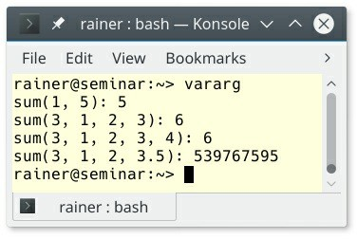

##### Figure 4.8. Summation with va_arg

These issues can be easily overcome with fold expressions in C++17. In contrast to va_arg’s, fold expressions automatically deduce the number and the type of their arguments.

// foldExpressions.cpp

#include <iostream>

template<class ... Args> auto sum(Args ... args) {

return (... + args);

}

int main() {

std::cout << “sum(5): “ << sum(5) << '\n';

std::cout << “sum(1, 2, 3): “ << sum(1, 2, 3) << '\n';

std::cout << “sum(1, 2, 3, 4): “ << sum(1, 2, 3, 4) << '\n';

std::cout << “sum(1, 2, 3.5): “ << sum(1, 2, 3.5) << '\n';

}

Okay, the function sum may look scary to you. It requires at least one argument, and uses C++11 variadic templates. These are templates that can accept an arbitrary number of arguments. The arbitrary number is held by a so-called parameter pack denoted by an ellipse (. . .). Additionally, with C++17, you can directly reduce a parameter pack with a binary operator. This addition,

based on variadic templates, is called fold expressions. In the case of the sum function, the binary

+ operator (...+ args) is applied. If you want to know more about fold expressions in C++17, here are more details: Fold Expressions.

The output of the program is as expected:

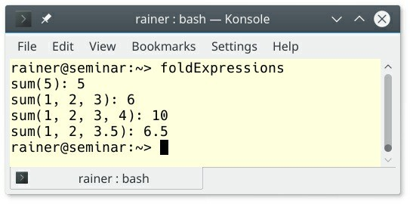

**Figure 4.9. Summation with fold expressions**

### Related rules

An additional rule to lambdas is in the section expressions and statements: ES.28: Use lambdas for complex initialization, especially of const variables.

I skipped the C++20 feature std::span in this chapter and provide basic information to

std::span in the chapter to (resource management).

### Distilled

##### Important

* A function should perform one operation, be short and simple, and have a carefully chosen name.
* Make functions that could run at compile-time constexpr.
* Make your functions pure if possible.
* Distinguish between in, in/out, and out parameter of a function. Use passing by value or by const reference for in, use passing by reference for in/out, and use passing by value for out parameter.
* Passing parameters to functions is a question of ownership semantic. Passing by value makes the function an independent owner of the resource. Passing by pointer or reference means, the function only borrows the resource. A std::unique_ptr transfers the ownership to the function. std::shared_ptr makes the function a shared owner.
* Use variadic templates instead of va_arg arguments when your function should accept an arbitrary number of arguments

## Chapter 5. Classes and Class Hierarchies

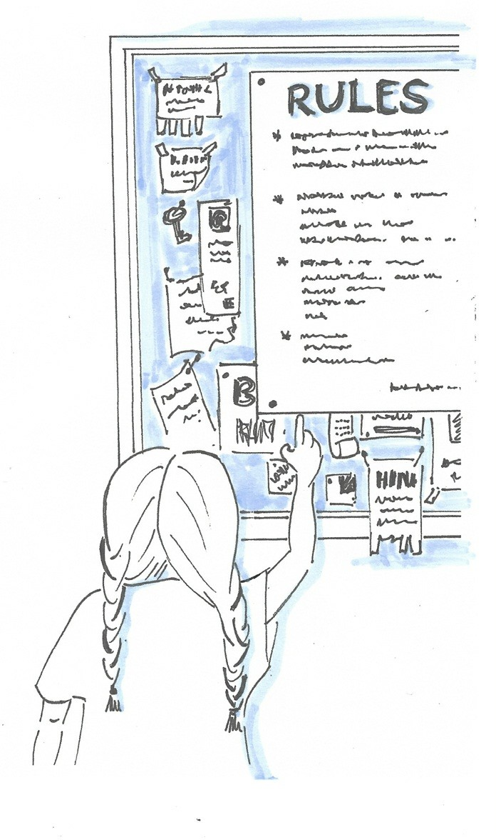

##### Figure 5.1. Cippi reasons about the rule of zero, five, or six

A class is a user-defined type for which the programmer can specify the representation, the operations, and the interface. Class hierarchies are used to organize related structures.

The C++ Core Guidelines have about a hundred rules for user-defined types.

The guidelines start with summary rules before they dive into the special rules for

* Concrete types
* Constructors, assignment, and destructors
* Class hierarchies
* Overloading and overloaded operators
* Unions

The eight summary rules provide the background for the special rules.

### Summary rules

The summary rules are quite short and don’t go into much detail. They provide broad but valuable insight into classes.

**Syntactic differences of class and struct**

This section often refers to the semantic difference of classes and structs. First of all: What are the syntactic differences? The differences are minimal but important: In a struct all members are public by default; in a class, all members are private by default. The same holds for inheritance. The base classes of a struct are public by default; the base classes of a class are private by default.

### C.1: Organize related data into structures (structs or classes) structure da ilişkili verileri organize etme (structlar yada classes)

How can draw’s interface be improved?  
aşağıdaki draw fonksiyon arayüzü nasıl geliştirilebilir?

void draw(int fromX, fromY, int toX, int toY);

It is not obvious what the ints stand for. Consequently, you may invoke the function with a wrong sequence of arguments. Compare the previous function draw with the new one:  
int burada niçin var gözlemlenemiyor. Sonuç olarak, bu fonksiyonu arguman sırasında yanlış arguman sırasına göre çağırabilirsiniz. Yeni draw fonksiyonunu eskisi ile karşılaştırınca

void draw(Point from, Point to);

By putting related elements together into a structure, the function signature becomes self- documenting and is, therefore, less error-prone such as the previous one.  
birbiri ile ilişkili yapı değerlerini koyarak, fonksiyonu daha okunur hale getirip, öncekine göre daha az hatalı hale getiririz.

### C.2: Use class if the class has an invariant; use struct if the data members can vary independently Eğer class bağımlı değişkenlere sahipse class kullanın, yoksa struct kullanın

A **class invariant**is an invariant used for constraining instances of a class. Member functions have to preserve this invariant. The invariant constraint the possible values for the instances of a class.  
class instance değişkenleri için bir kural içeriyorsa, yada sınırlayıcı varsa invariant class dır. Üye fonksiyonlar bu kuralları belirler. Bu invariant olası değerleri sınırlandırılır.

This is a common question in C++: When do I have to use a class or a struct? The C++ Core Guidelines give the following recommendation. Use a class if the class has an invariant. A class invariant can be that (y, m, d) together represent a valid calendar date.  
C++ da buna örnek olarak sorulacak soru; class yada struct hangisini ne zaman kullanmalıyım? C++ core guidelines şöyle bir kural belirler; date sınıfında ( y , m , d ) gibi değişken bir birleri ile bir kural çerçevesinde bağlıdır. Mesela 30/02/2022 gibi bir tarhi yoktur. Bunu sınırlandırmıştır.

struct Pair { // the members can vary independently string name;

int volume;

};

class Date { public:

// validate that {yy, mm, dd} is a valid date and initialize Date(int yy, Month mm, char dd);

// ... private:

int y; Month m;

char d; // day

};

The class invariant is initialized and checked in the constructor. The data type Pair has no invariant because all values for name and volume are valid. Pair is a simple data holder and needs no explicitly provided constructor.  
invariant değişkenler, constructor de yapılandırılmış ve kontrol edilmiştir. Fakat Pair struct’ı herhangi bir kuralı yada sınırlayıcılığı yoktur. Her durumda *name* ve *volume* geçerli bir datadır ve herhangi bir construction ihtiyaç duymaz.

### C.3: Represent the distinction between an interface and an implementation using a class class kullanarak interface ve implementation arasındaki ayrımlar göstermek

The public member functions of a class are the interface of a class and the private part is the implementation.  
Public üye fonksiyonlar class’ın interfacedir ve private partlar implementationdur.

class Date { public:

Date();

// validate that {yy, mm, dd} is a valid date and initialize Date(int yy, Month mm, char dd);

int day() const; Month month() const;

// ... private:

// ... some representation

};

From a maintainability perspective, the implementation of the class Date can be changed without affecting the user of the class.  
Date Sınıfının Sürdürülebilirlik açısından bakarsak, Kullanıcı hiç bir şeyden etkilenmeden implementation içerisinde değişiklikler yapabiliriz.

### C.4: Make a function a member only if it needs direct access to the representation of a class If a function needs no access to the internals of the class, it should not be a member. Hence you get loose coupling and a change of the internals of the class will not affect the helper functions. bir sınıfın öğelerine doğrudan erişim ihtiyacı duyarsanız üye fonksiyon yazın, yoksa yardımcı(helper) fonksiyon olarak yazınız. Böylece daha esnek bir yapı oluşturursunuz ve class içerisindeki değişiklikler yardımcı fonksiyonları etkilemez.

class Date {

// ... relatively small interface ...

};

// helper functions:

Date next_weekday(Date);

bool operator == (Date, Date);

The operators =, (), [], and -> have to be members.  
=, (), [], -> bu operatorler üye operatorler olmalıdır.

### C.5: Place helper functions in the same namespace as the class they support helper fonksiyonları aynı namespace altına koyun.

A helper function should be in the namespace of the class, because it is part of the interface to the class. In contrast to a member function, a helper function does not need direct access to the representation of the class.  
helper fonksiyonlar class bulunduğu namespace ile aynı namespace altında bulunmalıdır. Çünkü helper fonksiyonlar class öğlerine doğrudan erişimine ihtiyaç duymaz.

namespace Chrono { // here we keep time-related services class Date { /* ... */ };

// helper functions:

bool operator == (Date, Date); Date next_weekday(Date);

// ...

}

...

if (date1 == date2) { ... // (1)

Thanks to argument-dependent lookup (ADL) the comparison date1 == date2 will additionally look for the equality operator in the Chrono namespace. ADL is, in particular, important for overloaded operators such as the output operator: << .  
Sayesinde iki date *date1 == date2* karşılaştırması *Chrono* namespace içerisinde ADL(argument-dependent lookup) sayesinde bulunur. ADL, özellikle << gibi operatorlar için çok önemlidir.

### C.7: Don’t define a class or enum and declare a variable of its type in the same statement Bir sınıf veya numaranlandır belirledikten sonra onun adında bir değişken tanımlamayın.

Defining a class and declaring a variable of its type in the same statement confuses and should, therefore, be avoided.  
Aynı durum içerisinde class ve değişkenlerinin isimlerinin birbirleri işle aynı isimde olmaları kafa karıştırıcı olur, ve boşverilir.

// bad

struct Data { /*...*/ } data { /*...*/ };

// good

struct Data { /*...*/ }; Data data{ /*...*/ };

**C.8: Use class rather than struct if any member is non-public  
eğer non-public üyeniz var ise struct yerine class kullanın**

When your user-defined type has non-public members, you probably want to protect their invariants from the outside. It is the job of the constructor to establish the invariants. Accordingly, your user-defined type is more use a class.  
non-public bir üye tanımladıysanız, muhtemelen dışardan invariant’ını korumak içindir. Bu invariantlar constructor görevindedir ve buna göre de class kullanmalısınız.

### C.9: Minimize exposure of members Üyeleri sergilemeyi minimize edin

Data hiding and encapsulation is one of the corner stones of object oriented class design. You encapsulate the members in the class and allow only access via public member functions. You should think about two interfaces to your class. A public interface for the outside in general and a protected interface for derived classes. The remaining members should be private.  
Data hiding ve encapsolution, object oriented design da köşe taşlarından biridir. Sadece üye fonksiyonların classın üyelerine erişimi için encapsolution yapın. Class ta iki interface düşünmelisiniz. Genel olarak *Public* interface ve derived classlar için *protected* interface. Diğer üyelerin tamamı private olmalıdır.

### Concrete types Kalıp Tipler

This section has only two rules but introduces the terms of a concrete and a regular type.  
Bu kısımda sadece iki kuraldan ibarettir, fakat concrete ve regular tiplerede giriş yapacağız.

A **concrete type** is “the simplest kind of a class” according to the C++ Core Guidelines. It is often called a value type and is not part of a type hierarchy.  
concrete type lar C++ coreGuideLines göre bir sınıfın en basit türüdür. Sıklıkla çağırılan değişken tipleridir ve hiyerarşinin bir parçasıdır.

A **regular type** is a type that “behaves like an int” and has, therefore, to support copy and assignment, equality, and order. To be more formal, a regular type X behaves like an int and supports the following operations:  
regular tipler, int gibi davranan ve copy, assigment, equality ve order dır. Regular tipler daha çok int gibi davranır ve aşağıdaki operation lar tarafından desteklenir.

* Default constructor: X()
* Copy constructor: X(const X&)
* Copy assignment: operator = (const X&)
* Move constructor: X(X&&)
* Move assignment: operator = (X&&)
* Destructor: ~(X)
* Swap operator: swap(X&, X&)
* Equality operator: operator == (const X&, const X&)

### C.10: Prefer concrete types over class hierarchies Sınıf hiyerarşisi yerine somut tipler kullanın

If you do not have a use-case for a class hierarchy, use a concrete type. A concrete type is way easier to implement, smaller and faster. You do not have to worry about inheritance, virtuality, references or pointers including memory allocation and deallocation. There is no virtual dispatch and, therefore, no runtime overhead.  
  
class hiyerarşisi için bir kullanım durumunuz yoksa somut tipleri kullanın. Somut tipler; uygulaması en kolayı, daha küçük ve en hızlısıdır. İnheritance, virtuallity referans yada pointerları memory allocation yada deallocation için dert etmeyin. Çünkü virtual dispatch olmadığı için bir runtime overhead yoktur.

To make the long story short: apply KISS principle (keep it simple and stupid). Your type behaves like a value.  
uzun lafın kısası; KISS prensibini ( keep it simple and stupid ) kuralını uygulayın. Tanımladığınız tip bir değer gibi davranmalı

### C.11: Make concrete types regular Regular types (ints) are easier to understand. They are per se intuitive. This means that if you have a concrete type think about upgrading it to a regular type. somut tiplerinizi regular olarak tanımlayın. Regular tipler daha kolay anlaşılan tiplerdir. Bu, somut bir değişkeniniz var ise bunu regular bir değişkene yükselteceğiniz anlamına gelir.

The built-in types such as int or double are regular but so are the user-defined types such as

std::string or containers such as std::vector, or std::unordered_map. C++20 supports the concept of regular.  
built-in değişkenler, int veya double gibi regulardır fakat kullanıcı tanımlı değişkenlerde aynıdır. C++20 regular conceptini destekler.

### Constructors, assignments, and destructors

This section about constructors, assignments, and destructors has by far the most rules to classes and class hierarchies. They control the life-cycle of objects: creation, copy, move, and destruction. In short, we call them the Big Six. Here are the six special member functions:  
bu bölümde ki, constructor, assignments ve destructrorlar; açık ara en fazla class hiyerarşisi kuralını içerirler. Creation, copy, move be desturactionlar, nesnenin life-cycle nı kontrol ederler. Bunlara kısa Big Six denir. Bu altı özel üye fonksiyonlar:

* Default constructor: X()
* Copy constructor: X(const X&)
* Copy assignment: operator = (const X&)
* Move constructor: X(X&&)
* Move assignment: operator = (X&&)
* Destructor: ~(X)

The compiler can generate default implementations for the Big Six. The section starts with rules regarding default operations, continues with rules about constructors, copy and move operations, destructors, and ends with rules for the other default operations which do not fall into the previous four categories.  
Compiler, Big Six için varsayılan implementation lar oluşturabilir. Bu kısım, default contructor ile başlayıp, copy ve move operationları, destructorlar ve buraya kadarki son 4 kural da içermeyen kurallarla devam eder.

Based on the declaration of the default constructor you may have the impression that the default constructor takes no arguments. This is wrong. A default constructor can be invoked without argument but it may have default arguments for each parameter.  
Default contructor için herhangi bir arguman almadan çağrıldığı izlenimize sahip olabilirsiniz. Ancak bu doğru değildir. Default constructor argumanların varsayılan değerleri ile çağırılabilir.

### Default operations

By default, the compiler can generate the big six if needed. You can define the six special member functions, but can also ask explicitly the compiler to provide them with = default or delete them with = delete.  
Varsayılan olarak, bu Big Six leri ihtiyaç olduğunda oluşturabilir. 6 özel fonksiyonu tanımlayabilir yada compiler’a default olarak oluştur yada oluşturma diyebilirsiniz. Bunu *=default* yada *=delete* ile yapabilirsiniz.

#### C.20: If you can avoid defining any default operations, do default operationları gerekli değilse kullanmayın

This rule is also known as “**the rule of zero**”. That means, that you can avoid writing any custom constructor, copy/move constructors, assignment operators, or destructors by using types that support the appropriate copy/move semantics. This applies to the regular types such as the built- in types bool or double, but also the containers of the standard template library such as std::vector or std::string.  
bu kural sıfır kuralı olarak bilinir. Bunun anlamı;uygun tipleri kullandığınız da custom constructor, copy/move constructor, assigment operator yada destructor yazmayacağınız anlamına gelir. Bu normal tipler için uygulanır, mesela bool yada double gibi, bir container tiplerindede uygulanır; std::vector yada std::string gibi.

class Named_map { public:// ... no default operations declared ... private:

std::string name; std::map<int, int> rep;

};

Named_map nm; // default construct Named_map nm2 {nm}; // copy construct

The default construction and the copy construction work because they are already defined for std::string and std::map. When the compiler auto-generates for the example the copy constructor for a class, it invokes the copy constructor for all members and all bases of the class.  
default constructor yada copy constructor çalışır çünkü std::string ve std::map için bunlar zaten mevcut. Eğer compiler otomatik olarak class ın copy constructor’ını oluşturduğunda tüm üye fonksiyonlara ve base class lara invoke eder.

#### C.21: If you define or =delete any default operation, define or =delete them all Herhangi bir default operation tanımlarsanız yada =delete ederseniz, hepsini tanımlayın yada delete edin

The big six are closely related. Due to this relation, you have to define or =delete all six. Consequently, this rule is called “**the rule of six**”. Sometimes, you hear “**the rule of five**”, because the default constructor is special, and, therefore, sometimes excluded.  
Big Six, birbiri ile çok ilişkilidir. Bundan ötürü hepsini tanımlamanız yada =delete etmelisiniz. Sonuç olarak bu kurala altı kuralı denir. Bazen de 5 duyarbilirsiniz, çünkü default contstructor özeldir ve bazen bu kuralında dışında kalabilir.

##### Dependencies between the special member functions özel üye fonksiyonları birbirleri ile ilişkisi

Howard Hinnant developed in his talk at the ACCU 2014 conference an overview to the automatically generated special member functions.  
Howard Hinnant, ACCU 2014 konferansında, geliştirdiği bu otomatik oluşturulan özel üye fonksiyonlardan bahsetti.

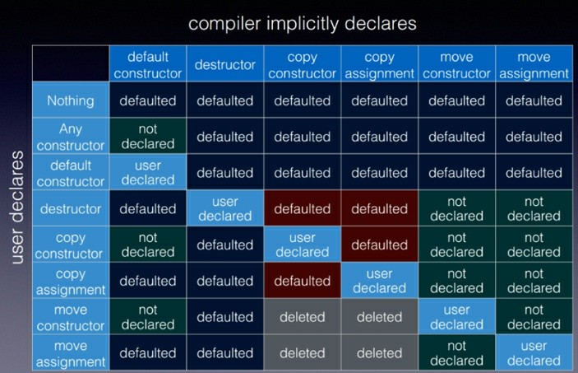

##### Figure 5.2. Automatically generated special member functions

Howard’s table demands a deep explanation.  
Howardın tablosu, derin açıklamaya bağlıdır.

First of all, user-declared means for one of these six special member functions that you define it explicitly or auto request it from the compiler with =default. Deletion of the special member function with =delete is also regarded as defined. Essentially, when you just use the name such the name of the default constructor, it counts as user declared.  
öncelikli olarak herhangi bir kullanı tanımlı üye fonksiyon olursa yada =default olarak compilerdan talep edilirse bu user-declared anlamına gelir. Aynı zaman da =delete olarak tanımlarsanız da bunu user-declared anlamına gelir. Temel olarak default constructor adını kullanırsanız, bu user-declared anlamına gelir.

When you define any constructor, you get no default constructor. A default constructor is a constructor which can be invoked without an argument.  
herhangi constructor tanımlarsanız, default constructor artık olmaz. Default constructor herhangi bir arguman çağrılmadan olan constructor.

When you define or delete a default constructor with =default or =delete, no other of the six special member functions is affected.  
eğer default constructor =delete yada =default olarak tanımlarsanız, bu 6 üye fonksiyonun diğerleri bu durumdan etkilenmen.

When you define or delete a destructor, a copy constructor, or a copy assignment operator with

=default or =delete, you get no compiler-generated move constructor and move assignment constructor. This means move operations such as move construction or move assignment falls back to copy operations such as copy construction or copy assignment. This fall back automatism is marked red in the table.  
destructor, copy constructor yada copy assigment =default yada =delete yada custom olarak tanımlarsanız, move constructor ve move assigment oluşturulmaz ve copy constructor ile copy assigment arka planına düşer. Tabloda kırmızı olarak işaretlendi.

When you define or delete with =default or =delete a move constructor or a move assignment operator, you get only the defined =default or =delete move constructor or move assignment operator. Consequently, the copy constructor and the copy assignment operator are set to

=delete. Invoking a copy operation such as copy construction or copy assignment causes, therefore, a compilation error.  
Sadece move constructor yada move assignment; custom, default yada delete olarak tanımlarsanız, copy assigment yada copy constructor delete olur ve sonuç olarak derleme hatası verir.

When you don’t follow this rule, you get very unintuitive objects. Here is an unintuitive example from the guidelines.  
Eğer bu kuralı uygulamazsanız, nesneniz belirsizlik içine girer. Ağağıdaki örneği kontrol edelim

// doubleFree.cpp #include <cstddef>

class BigArray { public:

BigArray(std::size_t len): len_(len), data_(new int[len]) {}

~BigArray(){

delete[] data_;

}

private: size_t len_; int* data_;

};

int main(){

BigArray bigArray1(1000); BigArray bigArray2(1000); bigArray2 = bigArray1; // (1)

} // (2)

Why does this program has undefined behavior? The default copy assignment operation bigArray2 = bigArray1 (1) of the example copies all members of bigArray2. Copying means, in particular, that pointer data is copied but not the data. Hence, the destructor for bigArray1 and bigArray2 is called (2) and we get undefined behavior because of double free.  
Bu program niçin belirsiz bir davranışa girer? Varsayınla copy assigment bütün üyelieri kopyalar. Yani özellikle data_ pointer nı kopyalar fakat içeriğini kopyalamaz. Bu yüzden kopyalanacak olan nesne destroy olduğunda pointerın gösterdiği data da silinir ve bunu da runtime anında belirsiz bir davranışa sokar.

The unintuitive behavior of the example is, that the compiler-generated copy assignment operator of BigArray makes a shallow copy of BigArray, but the explicit implemented destructor of BigArray assumes ownership of data.  
Örnekteki belirsiz davranış, compiler tarafından otomatik olarak oluşturulan sınırlı bir implementation olduğu için data içeriği kopyalanmaz ve sahiplik alınmaz.

AddressSanitizer makes the undefined behavior visible.  
AddressSanitizer bu belirsiz davranışı görünür hale getirir.

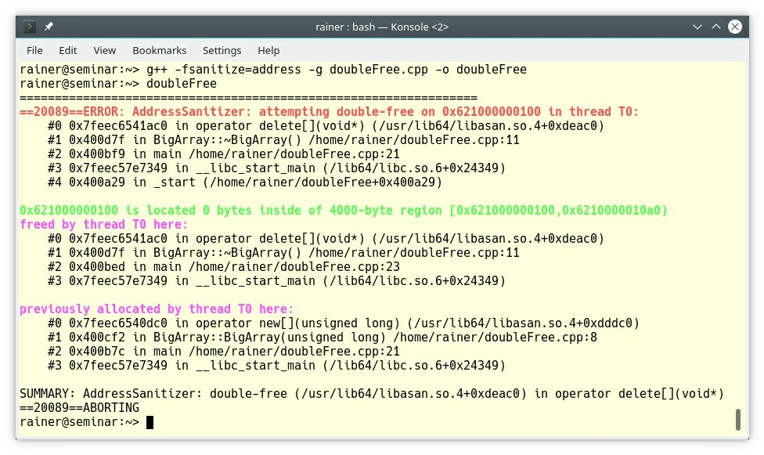

**Figure 5.3. Double free detected with AddressSanitizer**

#### C.22: Make default operations consistent Default operasyonları tutarlı yapın

This rule is related to the previous rule. If you implement the default operations with different semantics, the users of the class may become very confused. This strange behavior may also appear if you partially implement the member functions and partially request them via = default. You cannot assume that the compiler-generated special member functions have the same semantic such as yours.  
Bu kural bir önceki kuralla alakalı. Farklı semanticler için default operation implement edilirse, class kullanımı kafa karıştırıcı olmaya başlar. Bu, üye fonksiyonları ve compilerdan default olarak istenildiğinde de ortaya çıkar. Compiler oluşturacağı semantic fonksiyon ile sizin implement ettiğin fonksiyon aynı olmamalıdır.

For example, here is the class Strange. To observe the odd behavior, Strange includes a pointer to int.  
örneğin, Strange class ındaki tuhaf davranışa bakın, int tipinde ki pointer

1 // strange.cpp 2

3 #include <iostream> 4  
5 struct Strange {   
6

7 Strange(): p(new int(2011)) {} 8

9 // deep copy

10 Strange(const Strange& a) : p(new int(*a.p)) {} 11

1. // shallow copy
2. // equivalent to Strange& operator = (const Strange&) = default;
3. Strange& operator = (const Strange& a) {
4. p = a.p;
5. return *this;   
   17 }

18

19 int* p; 20

21 };

22

23 int main() { 24

25 std::cout << '\n'; 26

27 std::cout << “Deep copy” << '\n'; 28

1. Strange s1;
2. Strange s2(s1); 31

32 std::cout << “s1.p: “ << s1.p << “; *s1.p: “ << *s1.p << '\n';

33 std::cout << “s2.p: “ << s2.p << “; *s2.p: “ << *s2.p << '\n'; 34

35 std::cout << “*s2.p = 2017” << '\n'; 36 *s2.p = 2017;

37

38 std::cout << “s1.p: “ << s1.p << “; *s1.p: “ << *s1.p << '\n';

39 std::cout << “s2.p: “ << s2.p << “; *s2.p: “ << *s2.p << '\n'; 40

41 std::cout << '\n'; 42

43 std::cout << “Shallow copy” << '\n'; 44

45 Strange s3;

46 s3 = s1;

47

48 std::cout << “s1.p: “ << s1.p << “; *s1.p: “ << *s1.p << '\n';

49 std::cout << “s3.p: “ << s3.p << “; *s3.p: “ << *s3.p << '\n'; 50

51

52 std::cout << “*s3.p = 2017” << '\n'; 53 *s3.p = 2017;

54

55 std::cout << “s1.p: “ << s1.p << “; *s1.p: “ << *s1.p << '\n';

56 std::cout << “s3.p: “ << s3.p << “; *s3.p: “ << *s3.p << '\n'; 57

58 std::cout << '\n'; 59 std::cout <<“delete s1.p” << '\n';delete s1.p;   
62

63 std::cout << “s2.p: “ << s2.p << “; *s2.p: “ << *s2.p << '\n';

64 std::cout << “s3.p: “ << s3.p << “; *s3.p: “ << *s3.p << '\n'; 65

66 std::cout << '\n'; 67

68 }

The class Strange has a copy constructor (line 10) and a copy assignment operator (line 14). The copy constructor applies deep copy and the assignment operator applies shallow copy. By the way, the compiler-generated copy constructor or copy assignment operator also applies shallow copy. Most of the time, you want deep copy semantic (value semantic) for your types but you probably never want to have different semantic for these two related operations. The difference is, that deep copy semantic creates two new separate storage p(new int(*a.p)) while shallow copy semantic just copies the pointer p = a.p. Let’s play with the Strange types. Here is the output of the program.  
copy constructor line 10 da ve copy assigment line 14 de. Copy constructor deep copy yaparken, copy assigment shallow copy yapmaktadır. Bu arada compiler, copy constructor yada copy assigment shallow copy yapar. Çoğu zaman deep copy semantiğini uygulamak istersiniz fakat birbiri ile ilişkili bu iki fonksiyonu farklı semanticlerde yapmak istemezsiniz. Shallow copy sadece pointerın adresini kopyalarken, deep copy verinin tamamını kopyalar. Aşağıda program çıktısını görebilirsiniz.

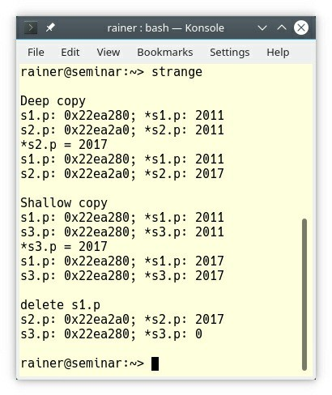

**Figure 5.4. Output of strange.cpp**

Line 30 uses the copy constructor to create s2. Displaying the addresses of the pointer and changing the value of the pointer s2.p (line 36) shows, s1 and s2 are two distinct objects. This is not the case for s1 and s3. The copy assignment operation in line 46 performs a shallow copy.

The result is that changing the pointer s3.p (line 53) also affects the pointer s1.p; because both pointers refer to the same value.  
30uncu satır, copy constructor ile s2 nesnesini oluşturur. 36 satırda, pointer gösterdiği değeri ve adresini gösteriyor. 46 satırdaki copy assignment operasyonu shallow copy yapıyor. 53 satırda s3.p değerinin değişmesi s1.p değerinin değişmesine sebep olur çünkü her ikiside aynı referans değerini gösteriyor.

The fun starts if I delete the pointer s1.p (line 61). Thanks to the deep copy, nothing bad happened to s2.p;  
 but the value of s3.p becomes an invalid pointer. To be more precise: dereferencing an invalid pointer such as in *s3.p (line 63) is undefined behavior.  
komedi, s1.p delete edersem başlıyor. Deep copy sayesinde s2.p herhangi bişey olmuyor, fakat s3.p gösterdiği adres geçersiz hale gelmektedir. Daha fazla tutarlılık için, *s3.p adresindeki pointer ın tanımsız davranışa sebep olacağı için dereferans olması gerekmektedir.

### Constructor

Thirteen rules deal with the construction of objects. Roughly speaking, they fall into five categories:

* Constructors in general
* Default constructor
* Constructor with a single argument
* Initialization of the members
* Special constructors such as an inheriting or a delegating constructor

At the end, I have a warning. Don’t call a virtual function from a constructor. I refer to this warning in a broader context, including destructors, in the section about other default operations.

#### Constructors in general

I skip the rule C.40: Define a constructor if a class has an invariant because I already wrote about in the rule C.2: Use class if the class has an invariant; use struct if the data members can vary independently. Therefore, two closely related guidelines are left: C.41: A constructor should create a fully initialized object and C.42: If a constructor cannot construct a valid object, throw an exception.

#### C.41: A constructor should create a fully initialized object

It is the job of the constructor to create a fully initialized object. A class having an init member function is asking for trouble.

class DiskFile { // BAD: default constructor not sufficient FILE* f; // call init() before any other function

// ... public:

DiskFile() = default;

void init(); // initialize f void read(); // read from f

// ...

};

int main() {

DiskFile file;

file.read(); // crash or bad read!

// ...

file.init(); // too late

// ...

}

The user might mistakenly invoke read before init or might just forget to invoke init. Making the member function init private and call it from all constructors is better, but not optimal. When you have common actions for all constructors of a class, use a delegating constructor.

#### C.42: If a constructor cannot construct a valid object, throw an exception

According to the previous rule: throw an exception if you cannot construct a valid object. There is not much to add. If you work with an invalid object you have always to check the state of the object before its usage. This is extremely tedious, inefficient, and, in particular, error-prone. Here is an example from the guidelines, violating this rule:

class DiskFile { // BAD: the constructor leaves a non-valid object behind FILE* f;

bool valid;

// ... public:

explicit DiskFile(const string& name)

:f{fopen(name.c_str(), “r”)}, valid{false} { if (f) valid = true;

// ...

}

bool is_valid() const { return valid; } void read(); // read from f

// ...

};

int main() {

DiskFile file {“Heraclides”}; file.read(); // crash or bad read!

// ...

if (file.is_valid()) { file.read();

// ...

}

else {

// ... handle error ...

}

// ...

}

#### Default constructor

The next two rules answer the question: When does and when doesn’t a class need a default constructor?

##### C.43: Ensure that a copyable (value type) class has a default constructor

Informally said, a class needs no default constructor when instances of the class have no meaningful default. For example, a human being has no meaningful default, but a type such bank account has it. The initial value of a bank account may be 0. Having a default constructor makes it easier to use your type. Many constructors of the STL containers rely on the fact that your type has a default constructor. For example for the value of an ordered associative container such as std::map. If all the members of the class have a default constructor, the compiler generates one

for your class if possible (read Dependencies between the special member functions for more details).

Now to the case where a default constructor should not be provided.

##### C.45: Don’t define a default constructor that only initializes data members; use member initializers instead

Often, code says more than a thousand words.

|  |  |  |
| --- | --- | --- |
| 1 | // classMemberInitializerWidget.cpp |  |
| 3 | #include <iostream> |
| 5 | class Widget { |
| 6 | public: |
| 7 | Widget(): width(640), height(480), |
| 8 | frame(false), visible(true) {} |
| 9 | explicit Widget(int w): width(w), height(getHeight(w)), |
| 10 | frame(false), visible(true) {} |
| 11 | Widget(int w, int h): width(w), height(h), |
| 12 | frame(false), visible(true) {} |
| 13 |  |
| 14 | void show() const { |
| 15 | std::cout << std::boolalpha << width << “x” << height |
| 16 | << “, frame: “ << frame |
| 17 | << “, visible: “ << visible << '\n'; |
| 18 | } |
| 19 | private: |
| 20 | int getHeight(int w) { return w*3/4; } |
| 21 | int width; |
| 22 | int height; |
| 23 | bool frame; |
| 24 | bool visible; |
| 25 | }; |
| 26 |  |
| 27 | class WidgetImpro { |
| 28 | public: |
| 29 | WidgetImpro() = default; |
| 30 | explicit WidgetImpro(int w): width(w), height(getHeight(w)) | {} |
| 31 | WidgetImpro(int w, int h): width(w), height(h) {} |  |
| 32 |  |  |
| 33 | void show() const { |  |
| 34 | std::cout << std::boolalpha << width << “x” << height |  |
| 35 | << “, frame: “ << frame |  |
| 36 | << “, visible: “ << visible << '\n'; |  |
| 37 | } |  |
| 38 |  |  |
| 39 | private: |  |
| 40 | int getHeight(int w) { return w * 3 / 4; } |  |
| 41 | int width{640}; |  |
| 42 | int height{480}; |  |
| 43 | bool frame{false}; |  |
| 44 | bool visible{true}; |  |
| 45 | }; |  |
| 46 |  |  |

2

4

47

48 int main() { 49

50 std::cout << '\n'; 51

1. Widget wVGA;
2. Widget wSVGA(800);

54 Widget wHD(1280, 720);

55

1. wVGA.show();
2. wSVGA.show();
3. wHD.show(); 59

60 std::cout << '\n'; 61

1. WidgetImpro wImproVGA;
2. WidgetImpro wImproSVGA(800);
3. WidgetImpro wImproHD(1280, 720); 65
4. wImproVGA.show();
5. wImproSVGA.show();
6. wImproHD.show(); 69

70 std::cout << '\n'; 71

72 }

The class Widget uses its three constructors (lines 7 - 12) exclusively to initialize its members. The refactored class WidgetImpro initialize its members directly in the class body (lines 41 - 44). By moving the initialization from the constructor to the class body, the three constructors (lines 29 - 31) become easier to comprehend and the class easier to maintain. For example, when you add a new member to the class, you have only to add the initialization in the class body, not to all constructors. Additionally, there is no need to think about and take care of putting initializers in constructor in correct order. Consequently, you cannot have a partially initialized object when you create a new object.

Of course, both objects behave identically.

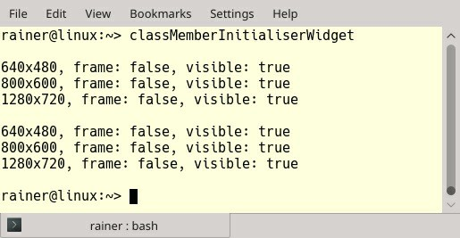

##### Figure 5.5. Directly initializing in the class

Here is the approach that I follow when I design a new class: **Define the default behavior in the class body. Use explicitly defined constructors only to vary the default behavior.**

Did you notice the keyword explicit in the previous constructor taking one argument?

#### C.46: By default, declare single-argument constructors explicit

To say it more explicitly: A single-argument constructor without explicit is a converting constructor. A converting constructor takes an argument and makes an object of the class out of it. This behavior is often the cause of big surprises.

The program convertingConstructor.cpp uses user-defined literals.

// convertingConstructor.cpp

#include <iomanip> #include <iostream> #include <ostream>

namespace Distance { class MyDistance {

public:

MyDistance(double d):m(d) {} // (5) friend MyDistance operator + (const MyDistance& a, // (2)

const MyDistance& b) { return MyDistance(a.m + b.m);

}

friend std::ostream& operator << (std::ostream &out, // (3)

const MyDistance& myDist) { out << myDist.m << “ m”;

return out;

}

private:

double m;

};

namespace Unit{

MyDistance operator "" _km(long double d) { // (1) return MyDistance(1000*d);

}

MyDistance operator "" _m(long double m) { return MyDistance(m);

}

MyDistance operator "" _dm(long double d) { return MyDistance(d/10);

}

MyDistance operator "" _cm(long double c) { return MyDistance(c/100);

}

}

}

using namespace Distance::Unit; int main() {

std:: cout << std::setprecision(7) << '\n';

std::cout << “1.0_km + 2.0_dm + 3.0_cm: “

<< 1.0_km + 2.0_dm + 3.0_cm << '\n'; std::cout << “4.2_km + 5.5_dm + 10.0_m + 0.3_cm: “

<< 4.2_km + 5.5 + 10.0_m + 0.3_cm << '\n'; // (4) std::cout << '\n';

}

A call such as 1.0_km goes to the literal operator "" _km(long double d) (1), which creates a MyDistance(1000.0) object that stands for 1000.0 meters. Additionally, MyDistance overloads the +-operator (2) and the output-operator (3). The main reason for user-defined literals is to define a type-safe arithmetic. Each number has its units attached.

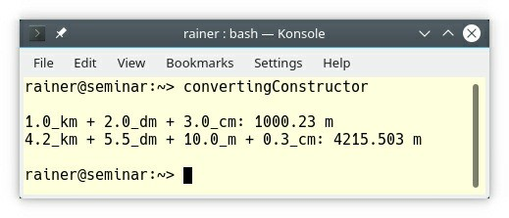

##### Figure 5.6. Converting constructor

Fine? No! I made an error and I wrote 5.5 (4) instead of 5.5_dm. The converting constructor made a MyDistance object out of it. What should be a decimeter ended being a meter. This implicit conversion from double would not have happened if the constructor (5) had been defined as explicit: explicit MyDistance(double d);

#### Initialization of the members

Three rules deal with the initialization of members. The first rule has the potential for a big surprise.

##### C.47: Define and initialize member variables in the order of member declaration

The class members are initialized in the order of their declaration. If you initialize them in the member initialization list in a different order you may get surprised.

// memberDeclarationOrder.cpp #include <iostream>

class Foo {

int m1; int m2;

public:

Foo(int x) :m2{x}, m1{++x} { // BAD: misleading initializer order std::cout << “m1: “ << m1 << '\n';

std::cout << “m2: “ << m2 <<

}

};

int main() {

std::cout << '\n'; Foo foo(1); std::cout<< '\n';

}

Many people assume that first m2 is initialized and then m1. As a consequence, m2 would have the value 1 and m1 the value 2.

The class member are destructed exactly in the reverse order to their initialization.

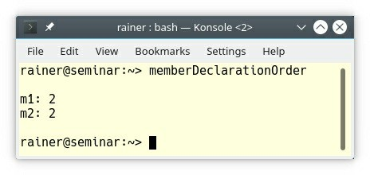

**Figure 5.7. Wrong initialization order of member variables**

#### C.48: Prefer in-class initializers to member initializers in constructors for constant initializers

This rule is kind of similar to the previous rule C.45: Don’t define a default constructor that only initializes data members; use member initializers instead. In-class initializer makes it a lot easier to define the constructors. Additionally, you cannot forget to initialize a member.

class X { // BAD int i;

string s; int j;

public:

X() :i{666}, s{“qqq”} {} // j is uninitialized

explicit X(int ii) :i{ii} {} // s is "" and j is uninitialized

// ...

};

class X2 {

int i{0}; std::string s{“qqq”}; int j{0}

public:

X2() = default; // all members are initialized to their defaults explicit X2(int ii) :i{ii} {} // s and j initialized to their defaults

// ...

};

While the in-class initialization establishes the default behavior of an object, the constructor allows the variation of the default behavior.

#### C.49: Prefer initialization to assignment in constructors

The most obvious pros of initialization to the assignment are twofold: first, you cannot forget to assign a value and use it uninitialized; second, initialization may be faster but never slower than an assignment. The following code snippet from the Guidelines shows why.

class Bad {

std::string s1; public:

Bad(const std::string& s2) { s1 = s2; } // BAD: default constructor

// followed by assignment

// ...

};

First, the default constructor of std::string is called and second, the assignment takes place in the constructor.

To the contrary, the constructor in the class Good initializes the std::string.

class Good {

std::string s1; public:

Good(const std::string& s2): s1{s2} {} // Good: initialization

// ...

};

#### Special constructors

Since C++11, a constructor can delegate its work to another constructor of the same class and constructor can be inherited from the parent class. Both techniques allow the programmer to write more concise and more expressive code.

#### C.51: Use delegating constructors to represent common actions for all constructors of a class

A constructor can delegate its work to another constructor of the same class. Delegating is the modern way in C++ to put common actions for all constructors into one constructor. Before C++11 a special initialization function, which was typically called init, had to be used.

class Degree { public:

explicit Degree(int deg) { // (1) degree = deg % 360;

if (degree < 0) degree += 360;

}

Degree(): Degree(0) {} // (2)

explicit Degree(double deg): // (3) Degree(static_cast<int>(std::ceil(deg))) {}

private:

int degree;

};

The constructors (2) and (3) of the class Degree delegate its initialization work to the constructor

1. which verifies its arguments. Invoking constructors recursively is undefined behavior.

A simplified implementation initializes Degree in the class and skips the default constructor.

class Degree { public:

explicit Degree(int deg) { // (1) degree= deg % 360;

if (degree < 0) degree += 360;

}

explicit Degree(double deg): // (3) Degree(static_cast<int>(std::ceil(deg))) {}

private:

int degree = 0;

};

#### C.52: Use inheriting constructors to import constructors into a derived class that does not need further explicit initialization

Reuse the constructors of the base class in the derived class if you can. This idea of reuse applies when your derived class has no members. If you don’t reuse constructors when you could, you violate the DRY (Don’t Repeat Yourself) principle. The inherited constructors keep all characteristics from their definition in the base class, such as access specifiers or attributes explicit or constexpr.

class Rec {

// ... data and lots of nice constructors ...

};

class Oper : public Rec { using Rec::Rec;

// ... no data members ...

// ... lots of nice utility functions ...

};

struct Rec2 : public Rec { int x;

using Rec::Rec;

};

Rec2 r {“foo”, 7};

int val = r.x; // uninitialized

There is a danger of using inherited constructors. If your derived class such as Rec2 has its own members such as int x, they are not initialized, unless they have in class initializers (see C.48:

Prefer in-class initializers to member initializers in constructors for constant initializers).

### Copy and move

Although the C++ Core Guidelines have eight rules regarding copy and move, they boil down to three classes of rules: copy- and move assignment operations, the semantics of copy and move, and the infamous slicing.

#### Assignment

##### Syntax

The two rules C.60: Make copy assignment non-virtual, take the parameter by const&, and return by non-const& and C.63: Make move assignment non-virtual, take the parameter by &&, and return by non-const& state explicitly the syntax of the copy and move assignment operator. std::vector follows the proposed syntax. Here is a simplified version:

// copy assignment

vector& operator = (const vector& other);

// move assignment

vector& operator = (vector&& other); // until C++17 vector& operator = (vector&& other) noexcept ; // since C++17

The small code snippet shows that the move assignment operator is noexcept. With C++17, the rule is quite obvious: C.66: Make move operations noexcept. Move operations include the move constructor and the move assignment operator. A as noexcept declared function is an optimization opportunity for the compiler. The following code snippet shows the declaration of the move operations for std::vector.

vector(vector&& other) noexcept ; // since C++17 vector& operator = (vector&& other) noexcept ; // since C++17

#### Self-assignment

Both rules address self-assignment: C.62: Make copy assignment safe for self-assignment and C.65: Make move assignment safe for self-assignment. Safe for self-assignment means that the operation x = x should not change the value of x.

Copy/move assignment of the containers of the STL, std::string, and built- types such as int is safe for self-assignment. The automatic generated copy/move assignment operator is safe for self-assignment. The same holds for an automatically generated copy/move assignment operator which uses types that are safe for self-assignment.

The following class Foo does the right job. No self-assignment could happen.

class Foo {

std::string s; int i;

public:

Foo& Foo::operator = (const Foo& a) { s = a.s;

i = a.i;

return *this;

}

Foo& Foo::operator = (Foo&& a) noexcept { s = std::move(a.s);

i = a.i; return *this;

}

// ....

};

Any redundant and expensive check for self-assignment is a pessimization in this case.

class Foo {

std::string s; int i;

public:

Foo& Foo::operator = (const Foo& a) {

if (this == &a) return *this; // redundant self-assignment check s = a.s;

i = a.i; return *this;

}

Foo& Foo::operator = (Foo&& a) noexcept {

if (this == &a) return *this; // redundant self-assignment check s = std::move(a.s);

i = a.i; return *this;

}

// ....

};

#### Semantic

The two guidelines for this section sound obvious: C.61: A copy operation should copy and C.64: A move operation should move and leave its source in a valid state. Whats does that mean?

* Copy operation
  + After copying (a = b), a and b must be the same: ( a == b).
  + Copying can be deep or shallow. Deep copying means that both objects a and b are afterward independent of each other (value semantic). Shallow copying means that both objects a and b share an object afterwards (reference semantic).
* Move operation
  + The C++ standard requires that the moved-from object must be afterwards in an unspecified but valid state. Often, this move-from state is in the default state of the source of the move operation.

#### C.67: A polymorphic class should suppress copying

This rule sounds innocuous but is often the reason for undefined behavior. First of all: What is a polymorphic class?

A **polymorphic class** is a class that defines or inherits at least one virtual function. Copying a polymorphic class may end in slicing. Slicing is one of the darkest parts of C++.

##### Slicing

Slicing means: you want to copy an object during assignment or initialization and you get only a part of the object. Let me give you a simple example:

// slice.cpp

struct Base { int base{1998};

};

struct Derived : Base { int derived{2011};

};

void needB(Base b) {

// ...

};

int main() {

|  |  |  |
| --- | --- | --- |
| Derived d; |  | |
| Base b = d; | // | (1) |
| Base b2(d); | // | (2) |
| needB(d); | // | (3) |

}

The markes (1), (2), and (3) have all the same effect: the Derived part of d is removed. I assume that was not your intention.

Now, it becomes really dangerous. Slicing kicks in when you copy a polymorphic class.

1 // sliceVirtuality.cpp 2

1. #include <iostream>
2. #include <string> 5
3. struct Base {
4. virtual std::string getName() const {
5. return “Base”; 9 }

10 };

11

1. struct Derived : Base {
2. std::string getName() const override {
3. return “Derived”; 15 }

16 };

17

18 int main() { 19

20 std::cout << '\n'; 21

1. Base b;
2. std::cout << “b.getName(): “ << b.getName() << '\n'; 24
3. Derived d;
4. std::cout << “d.getName(): “ << d.getName() << '\n'; 27
5. Base b1 = d; // slicing
6. std::cout << “b1.getName(): “ << b1.getName() << '\n'; 30
7. Base& b2 = d;
8. std::cout << “b2.getName(): “ << b2.getName() << '\n'; 33

34 Base* b3 = new Derived;

35 std::cout << “b3->getName(): “ << b3->getName() << '\n'; 36

37 std::cout << '\n'; 38

39 }

The program has a small hierarchy consisting of the Base and the Derived classes. Each object of this class hierarchy returns its name. The member function getName is virtual (line 7) and class Derived overrides it in line 13. Class Base is a polymorphic class. This means that I can use a derived object via a reference (line 31) or a pointer to a base object (line 34) to get polymorphic behavior. Under the hood, the object is of type Derived.

This behavior does not hold if I copy Derived d to Base b1 (line 28). In this case, slicing kicks in, and I have a Base object under the hood. In the case of copying, the declared or static type is used. If you use an indirection such as a reference or a pointer, the current or dynamic type is used.

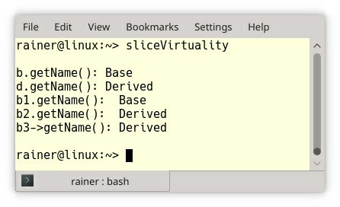

##### Figure 5.8. Slicing

If you want to make a deep copy, prefer a virtual clone function. Read the details about this technique in the rule C.130: For making deep copies of polymorphic classes prefer a virtual clone function instead of copy construction/assignment .

### Destructors

Does my class need a destructor? I often hear this question. Most of the time, the answer is no, and you are fine with the rule of zero. Sometimes the answer is yes, and we are back to the rule of five/six. To be more precise, the C++ Core Guidelines provide seven rules for destructors.

They fall into four categories: when are destructor needed, how should destructor handle pointers and references, how should base class destructor be defined, and should destructor fail.

#### Need for destructors

The destructor of an object is automatically invoked at the end of its lifetime. To be more precise, the destructor of the object is invoked when the object goes out of scope.

##### C.30: Define a destructor if a class needs an explicit action at object destruction

The question is if the compiler-generated destructor is sufficient in your case. If you must execute extra code at the end of the lifetime of your user-defined type, you have to write a destructor. For example, your user-defined type wants to deregister itself from a registration. If you define the destructor, the rule of five/six kicks in.

To put it the other way around, if no member of your class needs additional cleanup, there is no need to define a destructor such as in the following code snippet from the guidelines:

class Foo { // bad; use the default destructor public:

// ...

~Foo() { s = ""; i = 0; vi.clear(); } // clean up private:

std::string s; int i;

std::vector<int> vi;

};

##### C.31: All resources acquired by a class must be released by the class’s destructor

This rule sounds quite obvious and helps you to prevent resource leaks. Right? But you have to consider which of your class members have a full set of default operations. Now we are once more back to the rule of zero or the rule of five/six.

In the following example, while the std::ifstream class has a destructor, the class File might not have one, and, therefore, we get a memory leak if instances of MyClass goes out of scope.

class MyClass {

std::ifstream fstream; // may own a file File* file_; // may own a file

...

};

#### Pointers and references

If your class has raw pointers or references, you have to answer the crucial question: who is the owner?

##### C.32: If a class has a raw pointer (T*) or reference (T&), consider whether it might be

**owning**

If a class has a raw pointer or a reference, you have to be specific about ownership. This means in case of the pointer. If the ownership is obscure, you may delete a pointer to an object which you do not own or may not delete a pointer which you own. In the first case, you end up with undefined behavior because of double delete; in the second case, you end up with a memory leak. The corresponding reasoning holds about references.

The topic of this paragraph is already thoroughly answered in the chapter on the ownership semantics of function parameters. Read the details here: Parameter passing: ownership semantic.

##### C.33: If a class has an owning pointer member, define a destructor

The reason for this rule is straightforward: if a class owns an object, it is responsible for its destruction. The destruction is the job of the destructor.

Admittedly, there is more to write about a class owning a pointer member. You should first answer the following question: Is the class the exclusive owner of the pointer? The answer can be yes or no. Make the class the exclusive owner by putting the pointer into a std::unique_ptr. Make the class otherwise the shared owner by putting the pointer into a std::shared_ptr.

Rising the abstraction level from a pointer to a smart pointer makes ownership semantics transparent and way less error-prone.

What are the advantages of smart pointers to pointers? First and foremost, the lifetime of the smart pointer is automatically managed by the C++ runtime. Second, a std::shared_ptr supports the big six. This means, using a std::shared_ptr in a class does not impose any restriction on the class. To the contrary, a std::unique_ptr used in the class definition disables the copy semantics.

// classWithUniquePtr.cpp #include <memory>

struct MyClass {

std::unique_ptr<int> uniPtr = std::make_unique<int>(2011);

};

int main() {

MyClass myClass;

MyClass myClass2(myClass); MyClass myClass3; myClass3 = myClass;

}

Due to the std::unique_ptr, objects of type MyClass cannot be copied. Neither calling the copy constructor (MyClass myClass2(myClass)) nor calling the copy assignment operator (myClass3

= myClass) is valid.

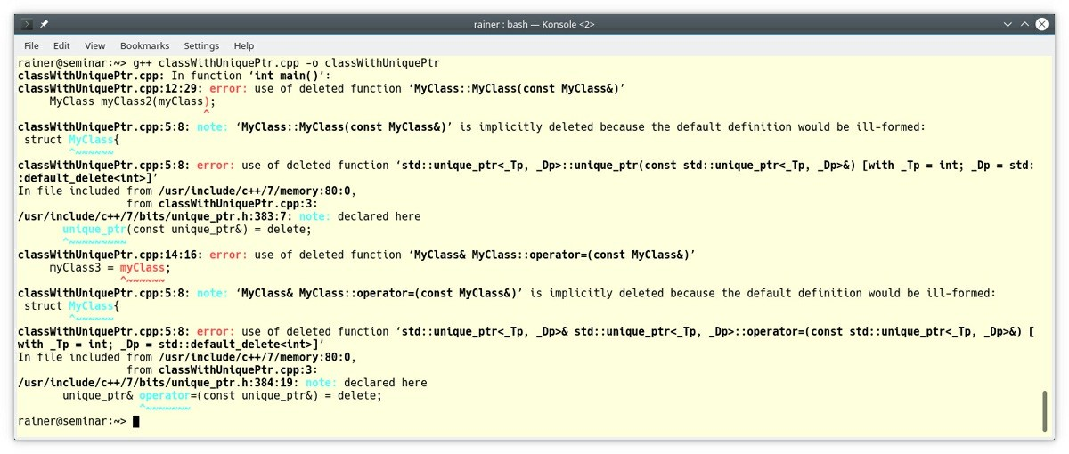

**Figure 5.9. A class with a std::unique_ptr**

#### C.35: A base class destructor should be either public and virtual, or protected and non-virtual

This rule is very interesting from the perspective of virtual functions. Let’s divide it into two parts.

##### Public and virtual destructor

If the base class has a public and virtual destructor, you can destroy instances of a derived class through a base class pointer. The same holds for references.

struct Base { // no virtual destructor virtual void f() {};

};

struct Derived : Base {

std::string s {“a resource needing cleanup”};

~Derived() { /* ... do some cleanup ... */ }

};

...

Base* b = new Derived(); delete b;

The compiler generates for Base a non-virtual destructor, but deleting an instance of Derived

through a Base pointer is undefined behavior if the destructor of Base is non-virtual.

##### Protected and non-virtual destructor

This is quite easy to get. If the destructor of the base class is protected, you cannot destroy derived objects using a base class pointer or reference; therefore, the destructor needs not to be virtual.

Here are a few concluding remarks about the access specifiers for destructors of a Base class.

* If the destructor of a class Base is private, you cannot derive from it.
* If the destructor of a class Base is protected, you can only derive Derived from Base and use

Derived.

struct Base {

protected:

~Base() = default;

};

struct Derived: Base {}; int main() {

Base b; // Error: Base::~Base is protected within this context Derived d;

}

The declaration Base b; causes an error because the destructor of Base is inaccessible;

#### Failing destructor

Two rules address the issue of failing destructors: C.36: A destructor may not fail and C.37: Make destructors noexcept.

##### Clarification on C.37: Make destructors noexcept

The wording of the rule is misleading. A user-defined or implicitly generated destructor of a type MyType is noexcept by default. If one of the members or bases of MyType has a destructor without a noexcept guarantee, the destructor of MyType has no noexcept guarantee, too.

##### Consequently, there is no need to specify the destructor as noexcept.

I think, I should add a few words about noexcept.

**noexcept**

If you declare a function func such as a destructor as noexcept an exception thrown in func calls std::terminate. std::terminate calls the currently installed std::terminate_handler, which is by default std::abort and your program aborts. By declaring a function void func() noexcept; as noexcept you state:

* My function does not throw any exception.
* If my function throws an exception, it is fine to let the program abort.

The reason that you should explicitly declare your destructor as noexcept is obvious. There is no general way to write error-free code if the destructor could fail. If all of the members of a class

have a noexcept destructor, the user-defined or compiler-generated destructor is implicitly

noexcept.

### Other default operations

The remaining rules related to constructors, assignments, and destructors have a broad focus. They cover, when you should use =default and =delete explicitly, and why you should not call virtual functions from constructors and destructors. The remaining rules make the story to regular types complete. The swap function (swap(X&, X&)) is first rule, followed by the equality operator (operator == (const X&)).

**Explicit use of =default and =delete**

This section provides guidance about when to use =default and =delete explicitly.

##### C.80: Use =default if you have to be explicit about using the default semantics

Do you remember the rule of five? It means that if you define one of the five special member functions, you have to define them all. The five special member functions are all the special member functions excluding the default constructor.

When I define the destructor such as in the following example, I have to define the copy and move constructor and the copy and move assignment operators. Requesting the remaining four by =default is the easiest way.

class Tracer { std::string message;

public:

explicit Tracer(const std::string& m) : message{m} { std::cerr << “entering “ << message << '\n';

}

~Tracer() { std::cerr << “exiting “ << message << '\n'; }

Tracer(const Tracer&) = default;

Tracer& operator = (const Tracer&) = default; Tracer(Tracer&&) = default;

Tracer& operator = (Tracer&&) = default;

};

This was easy! Right? Providing your own implementation is boring, and also very prone to mistakes. For example, the user-defined move constructor and move assignment operator in the following example are not declared noexcept.

class Tracer { std::string message;

public:

explicit Tracer(const std::string& m) : message{m} { std::cerr << “entering “ << message << '\n';

}

~Tracer() { std::cerr << “exiting “ << message << '\n'; }

Tracer(const Tracer& a) : message{a.message} {} Tracer& operator = (const Tracer& a) {

message = a.message; return *this;

}

Tracer(Tracer&& a) :message{a.message} {} Tracer& operator = (Tracer&& a) {

message = a.message; return *this;

}

};

##### C.81: Use =delete when you want to disable default behavior (without wanting an alternative)

Sometimes, you want to disable the default operations. Here comes =delete into play. C++ eats its own dog food. The copy constructor of almost all types from the threading API is set to delete. This holds true for data types such as mutexes, locks, or futures.

You can use delete to create strange types. Instances of Immortal cannot be destructed.

// immortal.cpp

class Immortal { public:

~Immortal() = delete; // do not allow destruction

};

int main() {

Immortal im; // (1) Immortal* pIm = new Immortal;

delete pIm; // (2)

}

An implicit call of the destructor (1) or an explicit call of the destructor (2) cause a compile-time error.

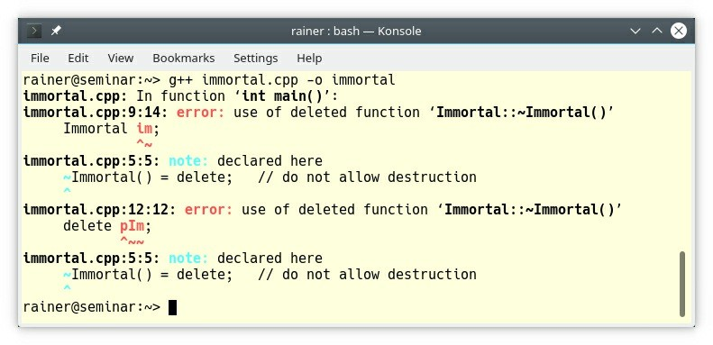

**Figure 5.10. delete the destructor**

#### C.82: Don’t call virtual functions in constructors and destructors

Calling a **pure** virtual function from a constructor or a destructor is undefined behavior. Calling a virtual function from a constructor or a destructor does not work the way you may expect. For protection reasons, the virtual call mechanism is disabled in the constructor or destructor, and you get a non-virtual call.

Hence, the Base version of the virtual function f will be called in the following example.

// virtualCall.cpp #include <iostream>

struct Base {

Base() {

f();

}

virtual void f() {

std::cout << “Base called” << '\n';

}

};

struct Derived: Base { void f() override {

std::cout << “Derived called” << '\n';

}

};

int main() {

std::cout << '\n'; Derived d; std::cout << '\n';

};

Here is the surprising behavior:

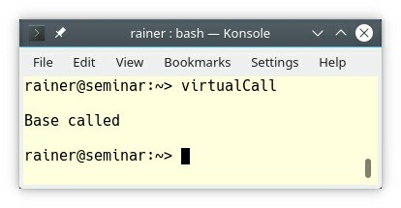

**Figure 5.11. Calling a virtual function in the constructor**

#### swap function

For a type to be a regular type, it has to support a swap function. A more informal term of regular type is a value-like type, and so is the name of the first rule: C.83: For value-like types, consider providing a noexcept swap function. Accordingly, to the first rule, a swap should not fail (C.84: A swap may not fail) and should, therefore, be declared as noexcept: C.85: Make swap noexcept.

The data type Foo from the C++ Core Guidelines has a swap function.

class Foo { public:

void swap(Foo& rhs) noexcept { m1.swap(rhs.m1);

std::swap(m2, rhs.m2);

}

private:

Bar m1; int m2;

};

For convenience reasons, you should consider supporting a non-member swap function based on the already implemented swap member function.

void swap(Foo& a, Foo& b) noexcept { a.swap(b);

}

If you do not provide a non-member swap function, then the standard library algorithms that require swapping (such as std::sort and std::rotate) will fall back to the std::swap template, which is defined in terms of move construction and move assignment.

template<typename T>

void std::swap(T& a, T& b) noexcept { T tmp(std::move(a));

a = std::move(b); b = std::move(tmp);

}

The C++ standard offers more than 40 overloads of std::swap. You can use the swap function as a building block for many idioms such as copy construction or move assignment. A swap function should not fail; therefore, you should declare it as noexcept.

##### The copy-and-swap idiom

If you use the copy-and-swap idiom to implement the copy assignment and the move assignment operator, you must define your own swap — either as a member function or as a friend. I added a swap function to the class Cont and use it in the copy assignment and move assignment operator.

class Cont { public:

// ...

Cont& operator = (const Cont& rhs); Cont& operator = (Cont&& rhs) noexcept;

friend void swap(Cont& lhs, Cont& rhs) noexcept { swap(lhs.size, rhs.size);

swap(lhs.pdata, rhs.pdata);

}

private:

int* pData; std::size_t size;

};

Cont& Cont::operator = (const Cont& rhs) { Cont tmp(rhs);

swap(*this, tmp); return *this;

}

Cont& Cont::operator = (Cont&& rhs) { Cont tmp(std::move(rhs)); swap(*this, tmp);

return *this;

}

Both assignment operators make a temporary copy tmp of the source object and then apply the

swap function to it.

When a swap function is based on copy semantics instead of move semantics, a swap function may fail because of memory exhaustion. The following implementation contradicts the already mentioned rule C.84: A swap may not fail. This is the C++98 implementation of std::swap.

template<typename T>

void std::swap(T& a, T& b) { T tmp = a;

a = b; b = tmp;

}

In this case, memory exhaustion causes a std::bad_alloc exception.

#### Equality operator

To be regular, a data-type also has to support the equality operator.

##### C.86: Make == symmetric with respect to operand types and noexcept

If you don’t want to surprise your user, you should make the equality operator symmetric.

The following code snippet shows an unintuitive equality operator which is defined inside the class.

class MyInt { // BAD: un-symmetric == int num;

public:

MyInt(int n): num(n) {};

bool operator == (const MyInt& rhs) const noexcept { return num == rhs.num;

}

};

int main() {

MyInt(5) == 5; // OK

5 == MyInt(5); // ERROR

}

The call MyInt(5) == 5 is valid because the constructor converts the int to an instance of MyInt. The last line (5 == MyInt(5)) gives an error. An object of type int cannot be compared with a MyInt object, and there is no conversion from MyInt to int possible.

The elegant way to solve this asymmetry is to declare a friend operator == inside the class

MyInt. Here is the improved version of MyInt.

class MyInt {

int num; public:

MyInt(int n): num(n) {};

friend bool operator == (const MyInt& lhs, const MyInt& rhs) noexcept { return lhs.num == rhs.num;

}

};

int main() {

MyInt(5) == 5; // OK 5 == MyInt(5); // OK

}

If you carefully read this book, you may recall that a constructor taking one argument should be explicit (C.46: By default, declare single-argument constructors explicit). Honestly, you are right.

class MyInt {

int num; public:

explicit MyInt(int n): num(n) {};

friend bool operator == (const MyInt& lhs, const MyInt& rhs) noexcept { return lhs.num == rhs.num;

}

};

int main() {

MyInt(5) == 5; // ERROR

5 == MyInt(5); // ERROR

}

Making the constructor explicit breaks the implicit conversion from int to MyInt. Providing two additional overloads solves the issue. One overload takes an int as the left and the other an int as the right argument.

// equalityOperator.cpp

class MyInt {

int num; public:

explicit MyInt(int n): num(n) {};

friend bool operator == (const MyInt& lhs, const MyInt& rhs) noexcept { return lhs.num == rhs.num;

}

friend bool operator == (int lhs, const MyInt& rhs) noexcept { return lhs == rhs.num;

}

friend bool operator == (const MyInt& lhs, int rhs) noexcept { return lhs.num == rhs;

}

};

int main() {

MyInt(5) == 5; // OK 5 == MyInt(5); // OK

}

The surprises continue with the equality operator.

#### C.87: Beware of == on base classes

Writing a foolproof equality operator for a hierarchy is hard. The guidelines gives a nice example of the complications involved. Here is the hierarchy.

// equalityOperatorHierarchy.cpp #include <string>

struct Base {

std::string name; int number;

virtual bool operator == (const Base& a) const { return name == a.name && number == a.number;

}

};

struct Derived: Base { char character;

virtual bool operator == (const Derived& a) const { return name == a.name &&

number == a.number && character == a.character;

}

};

int main() {

Base b;

Base& base = b; Derived d;

Derived& derived = d;

base == derived; // compares name and number, but (1)

// ignores derived’s character

derived == base; // error: no == defined (2) Derived derived2;

derived == derived2; // compares, name, number, and character Base& base2 = derived2;

base2 == derived; // compares name and number, but (3)

// ignores derived2’s and derived’s character

} // ignores derived2’s and derived’s character

Comparing instances of Base or instances of Derived work. But mixing instances of Base and

Derived does not work as expected. Using Base’s == operator ignores Derived’s character (3).

Using Derived’s operator does not work for instances of Base (4). The line causes a compilation error. The last line (3) is quite tricky. The equality operator of Base is used. Why? The == operator of Derived overwrote the == operator of Base. No! Both operators have different signatures. One operator takes an instance of Base; the other operator takes an instance of Derived. Derived’s version does not overwrite Base’s version.

These observations also hold for the other five comparison operators: !=, <, <=, >, and >=. This misbehaving is another facet of the slicing issue: C.67: A polymorphic class should suppress copying.

### Class hierarchies

The C++ Core Guidelines have about thirty rules in total addressing class hierarchies.

At first, what is a class hierarchy? The C++ Core Guidelines give a clear answer. Let me rephrase it. A class hierarchy represents a set of hierarchically organized concepts. Base classes typically act as interfaces. There are two uses for interfaces. One is often named interface inheritance and the other implementation inheritance.

**Interface inheritance** uses public inheritance. It separates users from implementations to allow derived classes to add or change functionality of the base class without affecting the users of base classes.

For example, if you derive public a class Handball from a Ball, you can use Handball instead of a Ball. A Handball is also a Ball. This principle is called the Liskov substitution principle.

**Implementation inheritance** often uses private inheritance. Typically, the derived class provides its functionality by adapting functionality from base classes.

A prominent example of implementation inheritance is the adapter pattern if you implement it with multiple inheritance. The idea of the adapter pattern is to adapt an existing interface to a new one. The adapter uses private inheritance from the implementation and public inheritance from the new interface. The new interface uses the existing implementation to provide its services to the user.

The first three rules to class hierarchies have a general focus. They provide a kind of summary for the more detailed rules to the designing of classes and the accessing of objects in class hierarchies.

### General rules

The first rules describe when to use class hierarchies, and introduce the idea of abstract classes.

#### C.120: Use class hierarchies to represent concepts with inherent hierarchical structure (only)

This rule makes a software system intuitive and easy to comprehend. If you model something in the code which has an inherently hierarchical structure, you should use a hierarchy. Often, the easiest way to reason about code is if you have a natural match between the code and the world.

For example, your job as a software architect is to model a complex system such as a

defibrillator. This system consists of many subsystems. For example, a subsystem is the user interfaces. The requirement for the defibrillator is that different input devices such as a keyboard, a touch screen, or a few buttons could be used as a user interface. This system consisting of various subsystems such as a user interface is inherently hierarchical and should, therefore, be modeled hierarchically. The great benefit is that the complex system is now easy to explain in a top-down fashion because there is a natural match between the real hardware and the software.

Of course, the classic example of using a hierarchy is in the design of graphical user interface (GUI). This is the example the C++ Core Guidelines is using.

class DrawableUIElement { public:

virtual void render() const = 0;

// ...

};

class AbstractButton : public DrawableUIElement { public:

virtual void onClick() = 0;

// ...

};

class PushButton : public AbstractButton { void render() const override;

void onClick() override;

// ...

};

class Checkbox : public AbstractButton {

// ...

};

If something is not inherently hierarchical, you should not model it in a hierarchical way. Have a look here.

template<typename T> class Container { public:

// list operations:

virtual T& get() = 0; virtual void put(T&) = 0;

virtual void insert(Position) = 0;

// ...

// vector operations:

virtual T& operator [] (int) = 0; virtual void sort() = 0;

// ...

// tree operations: virtual void balance() = 0;

// ...

};

Why is the example terrible? Read the comments! The class template Container consists of pure virtual functions for modelling a list, a vector, and a tree. That means if you use Container as an interface, you have to implement three disjunct concepts.

##### Interface segregation principle (ISP)

The class template Container breaks the interface segregation principle, coined by the software engineer and instructor Robert C. Martin popularly known as “Uncle Bob”. The interface- segregation principle states that no client such as a derived class should be forced to depend on member functions it does not use. In the concrete case of the class template Container, each class implementing the interface has to implement all abstract methods.

The ISP splits interfaces that are too large and consist of too many member functions into smaller and more specific ones.

#### C.121: If a base class is used as an interface, make it an abstract class

An abstract class is a class that has at least one pure virtual function. A pure virtual function (virtual void function() = 0 ) is a function that must be implemented by a derived class if that class should not be abstract. An abstract class cannot be instantiated.

I want to add for completeness reasons: an abstract class can provide an implementation for a pure virtual function. A derived class can, therefore, use this implementation.

Interfaces should usually consist of public pure virtual functions, don’t have data members, and have a default/empty virtual destructor (virtual ~My_interface() = default).

#### C.122: Use abstract classes as interfaces when complete separation of interface and implementation is needed

Abstract classes are about the separation of interface and implementation. If the client such as in this case an application depends only on the interface Device, it can use different implementations during runtime. Additionally, a modification in the implementation does not necessarily affect the interface and, therefore, not the application.

struct Device {

virtual void write(std::span<const char> outbuf) = 0; virtual void read(std::span<char> inbuf) = 0;

};

class Mouse : public Device {

// ... data ...

void write(std::span<const char> outbuf) override; void read(std::span<char> inbuf) override;

};

class TouchScreen : public Device {

// ... different data ...

void write(std::span<const char> outbuf) override; void read(std::span<char> inbuf) override;

};

### Designing classes

The twelve rules for designing classes target the following topics: constructors for abstract classes, virtuality, access specifiers for data members, multiple inheritance, and typical traps.

#### C.126: An abstract class typically doesn’t need a constructor

Let me combine the already presented rules C.2: Use class if the class has an invariant; use struct if the data members can vary independently, and C.41: A constructor should create a fully initialized object to get the actual rule. An invariant is a condition on a class data member that has to be established by the constructor. On the contrary, an abstract base class does not have any data and needs, therefore, no declared constructor.

#### Virtuality

There a few rules to virtual functions you should keep in mind when designing class hierarchies.

**C.128: Virtual functions should specify exactly one of virtual, override, or final**

Since C++11 we have three keywords to control overriding.

* **virtual**: declares a virtual function that can be overridden in derived classes
* **override**: verifies that the function is virtual and overrides a virtual function of a base class
* **final**: verifies that the function is virtual and cannot be overridden by a member function of a derived class

According to the guidelines, the rules for the usage of the three keywords are straightforward: “Use virtual only when declaring a new virtual function. Use override only when declaring an overrider. Use final only when declaring a final overrider.”.

struct Base{

virtual void testGood() {} virtual void testBad() {}

};

struct Derived: Base{

void testGood() final {}

virtual void testBad() final override {}

};

int main() {

Derived d;

}

The member function testBad() in the class Derived provides much redundant information.

* You should only use final or override if the function is virtual. Skip virtual: void test- Bad() final override {}
* Using the keyword final without the virtual keyword is only valid if the function is already virtual; therefore, the function must override a virtual function of a base class. Skip override: void testBad() final {}

#### C.130: For making deep copies of polymorphic classes prefer a virtual clone

**function instead of copy construction/assignment**

This rule is a continuation of rule C.67: A polymorphic class should suppress copying The mentioned rules C.67 explicitly shows that copying a polymorphic class may lead to the slicing problem. To overcome this issue, override a virtual clone function that copies the actual type and returns an owning pointer (std::unique_ptr) to the new object. In the derived class,return the derived type by using the so-called covariant return type.

* **Covariant return type:** allows for an overriding member function to return a derived type of the return type of the overridden member function.

Let me illustrate this recommendation with an example.

// cloneFunction.cpp

#include <iostream> #include <memory> #include <string>

struct Base { // GOOD: base class suppresses copying Base() = default;

virtual ~Base() = default; Base(const Base&) = delete;

Base& operator = (const Base&) = delete;

virtual std::unique_ptr<Base> clone() { return std::make_unique<Base>(); } virtual std::string getName() const { return “Base”; }

};

struct Derived : public Base { Derived() = default;

std::unique_ptr<Base> clone() override { return std::make_unique<Derived>(); } std::string getName() const override { return “Derived”; }

};

int main() {

std::cout << '\n';

auto base1 = std::make_unique<Base>(); auto base2 = base1->clone();

std::cout << “base1->getName(): “ << base1->getName() << '\n'; std::cout << “base2->getName(): “ << base2->getName() << '\n';

auto derived1 = std::make_unique<Derived>(); auto derived2 = derived1->clone();

std::cout << “derived1->getName(): “ << derived1->getName() << '\n'; std::cout << “derived2->getName(): “ << derived2->getName() << '\n';

std::cout << '\n';

}

The clone member function returns the newly created object in a std::unique_ptr. The ownership of the newly created objects goes, therefore, to the caller. Now, the virtual dispatch happens as expected.

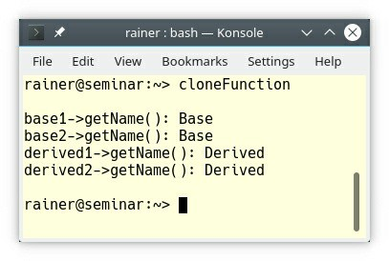

##### Figure 5.12. A virtual clone member function

It’s obligatory for the covariant return type, that the Derived::clone member functions return type is std::unique_ptr<Base>, and not std::unique_ptr<Derived>. When I change the return type of Derived::clone to std::unique_ptr<Derived>, the compilation fails:

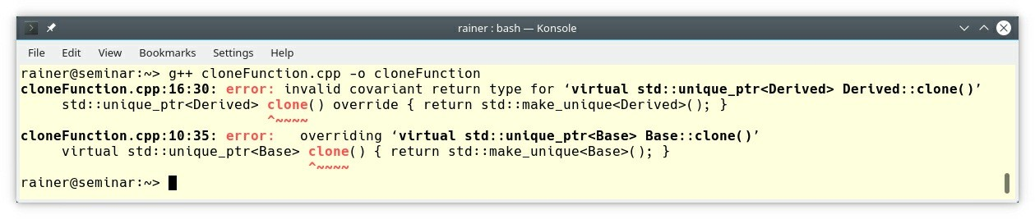

**Figure 5.13. A virtual clone member function without covariant return type**

#### C.132: Don’t make a function virtual without reason

A virtual function is a feature that does not come for free. A virtual function

* increases the run-time and the object code-size.
* is open for errors because it can be overridden in derived classes.

#### Access specifiers for data members

Typically, the access specifier for all data members of a class is the same: either all data members are public or private.

* public if there is no invariant on the data members. Use a struct.
* private if there is an invariant on the data members. Use a class.

##### C.131: Avoid trivial getters and setters

Getters or setters are trivial if they do not provide additional semantic value to the data members. Here are two examples of trivial getters and setters from the C++ Core Guidelines:

class Point { // Bad: verbose public:

Point(int xx, int yy) : x{xx}, y{yy} { } int get_x() const { return x; }

void set_x(int xx) { x = xx; } int get_y() const { return y; } void set_y(int yy) { y = yy; }

// no behavioral member functions private:

int x; int y;

};

x and y can have arbitrary values. This means an instance of Point maintains no invariant on x and y. x and y are just values. Using a struct as a collection of values is more appropriate and x and y should, consequently, become public.

struct Point { int x{0};

int y{0};

};

**C.133: Avoid protected data**

protected data make your program complex and error-prone. If you put protected data into a base class, you cannot reason about derived classes in isolation and, therefore, you break encapsulation. You always have to reason about the entire class hierarchy.

This means you have to answer at least these three questions.

1. Do I have to implement a constructor to initialize the protected data?
2. What is the actual value of the protected data if I use them?
3. Who is affected if I modify the protected data?

Answering these questions becomes more and more difficult as your class hierarchy becomes more and more complex.

To put it the other way, protected data is a kind of global data in the scope of the class hierarchy. And you know, non-const global data is bad.

#### C.134: Ensure all non-const data members have the same access level

The previous rule C.133 stated that you should avoid protected data. Consequently, all of your non-const data members should either be public or private. An object can have data members that do not represent the invariants of the object. Non-const data members that do not represent the invariants of an object should be public. In contrast, non-const private data members are

used for the object invariants. As a reminder: a data member having an invariant cannot have all the values of the underlying type.

Based on the observation and the additional observation that you should not mix data members representing/not representing invariants in one class, all your non-const data members should either be public or private. Imagine if you have a class with public and private data- members which are non-const. Now, your data type is confusing. Does your data type maintain an invariant, or is it merely a collection of unrelated values?

#### Multiple inheritance

There are two typical use-cases for multiple inheritance: separating interface inheritance from implementation inheritance and implementing multiple distinct interfaces.

##### C.129: When designing a class hierarchy, distinguish between implementation inheritance and interface inheritance

Interface inheritance is about the separation of interface and implementation, so that a derived class can be changed without affecting the user of the base class; implementation inheritance is the use of inheritance to support new functionality by extending existing functionality.

Pure interface inheritance is if your base class only has pure virtual functions. In contrast, if your base class has data members or implemented functions, this is implementation inheritance.

Consequently, you break the previous rule C.121: if a base class is used as an interface, make it an abstract class. The C++ Core Guidelines give an example mixing both concepts.

class Shape { // BAD, mixed interface and implementation public:

Shape(Point ce = {0, 0}, Color co = none): cent{ce}, col {co} {

/* ... */

}

Point center() const { return cent; } Color color() const { return col; }

virtual void rotate(int) = 0;

virtual void move(Point p) { cent = p; redraw(); }

virtual void redraw() const;

// ... public:

Point cent; Color col;

};

class Circle : public Shape { public:

Circle(Point c, int r) :Shape{c}, rad{r} { /* ... */ }

// ... private:

int rad;

};

class Triangle : public Shape { public:

Triangle(Point p1, Point p2, Point p3); // calculate center

// ...

};

Mixing the concepts of interface inheritance and implementation inheritance is bad. Why?

* As the Shape class evolves, it may become more and more difficult and error-prone to maintain the various constructors.
* The member functions of the Shape class may never be used.
* If you add data to the Shape class, a recompilation becomes probable.

How can we get the best of those two worlds: stable interfaces with interface hierarchies and code reuse with implementation inheritance. One possible answer, which I implement in this chapter, is dual inheritance. Another answer is the PImpl idiom. PImpl stands for **P**ointer to **Impl**ementation. It moves implementation details in a separate class, that can be accessed through a pointer.

Let’s continue with dual inheritance. Dual inheritance implements a quite sophisticated recipe.

##### Define the base Shape of the class hierarchy as pure interface

class Shape { public:

virtual Point center() const = 0; virtual Color color() const = 0;

virtual void rotate(int) = 0; virtual void move(Point p) = 0;

virtual void redraw() const = 0;

// ...

};

1. **Derive a pure interface Circle from the Shape**

class Circle : public virtual Shape { public:

virtual int radius() = 0;

// ...

};

1. **Provide the implementation class Impl::Shape**

class Impl::Shape : public virtual Shape { public:

// constructors, destructor

// ...

Point center() const override { /* ... */ } Color color() const override { /* ... */ }

void rotate(int) override { /* ... */ } void move(Point p) override { /* ... */ }

void redraw() const override { /* ... */ }

// ...

};

##### Implement the class Impl::Circle by inheriting from the interface and the implementation

class Impl::Circle : public Circle, public Impl::Shape { public:

// constructors, destructor

int radius() override { /* ... */ }

// ...

};

##### If you want to extend the class hierarchy, you have to derive from the interface and from the implementation

class Smiley : public Circle { public:

// ...

};

// implementation

class Impl::Smiley : public virtual Smiley, public Impl::Circle { public:

// constructors, destructor

// ...

}

This is the big picture to the two hierarchies.

* Interface: Smiley -> Circle -> Shape
* Implementation: Impl::Smiley -> Impl::Circle -> Impl::Shape

By reading the last lines, maybe you had a déjà vu. You are right. This technique of multiple inheritance is similar to the adapter pattern, implemented with multiple inheritance. The adapter pattern is from the well-known Gang of Four (GoF) design pattern book, authored by Erich Gamma, Richard Helm, Ralph Johnson, and John Vlissides.

#### C.135: Use multiple inheritance to represent multiple distinct interfaces

It is a good idea that your interfaces support only one aspect of your design. What does that mean? If you provide a pure interface consisting only of pure virtual functions a concrete class has to implement all functions. If the interface is too broad, the class has to implement functions it doesn’t need or make no sense.

An example of two distinct interfaces is istream and ostream from C++’s input and output streams library.

class iostream : public istream, public ostream { // very simplified

// ...

};

#### Typical traps

There are two typical traps when it comes to the design of a class hierarchy.

##### C.138: Create an overload set for a derived class and its bases with using

This rule holds for virtual and non-virtual functions. If you don’t use the using declaration, member functions in the derived class hide the entire overload set. This process is also often called shadowing. Shadowing is a behavior which contradicts the intuition of many C++ developers, because an overload may be chosen which doesn’t seem like the best match.

// overloadSet.cpp #include <iostream>

class Base { public:

void func(int i) { std::cout << “Base::func(int) \n”; }

void func(double d) { std::cout << “Base::func(double) \n”; }

};

class Derived: public Base { // Bad: shadowing func of Base public:

void func(int i) { std::cout << “Derived::func(int) \n”; }

};

int main() {

std::cout << '\n';

Derived der; der.func(2011); der.func(2020.5);

std::cout << '\n';

}

The line der.func(2020.5) with a double argument is called but the int overload of class Derived is used. Consequently, a narrowing conversion from double to int happens. That is most of the time not the behavior that you want.

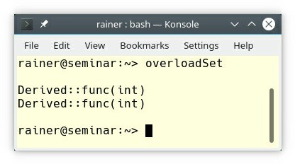

##### Figure 5.14. Shadowing of member functions

To use the double overload of class Base, you have to introduce it in the scope of Derived.

class Derived: public Base { // good: Base::func is introduced public:

void func(int i) { std::cout << “f(int) \n”; } using Base::func; // exposes func(double)

};

##### C.140: Do not provide different default arguments for a virtual function and an overrider

If you provide different default arguments for a virtual function and an overrider, your class may cause lots of confusion.

// overrider.cpp #include <iostream>

class Base { public:

virtual int multiply(int value, int factor = 2) = 0;

};

class Derived : public Base { // Bad: different defaults for virtual functions public:

int multiply(int value, int factor = 10) override { return factor * value;

}

};

int main() {

std::cout << '\n'; Derived d;

Base& b = d;

std::cout << “b.multiply(10): “ << b.multiply(10) << '\n'; std::cout << “d.multiply(10): “ << d.multiply(10) << '\n';

std::cout << '\n';

}

Here is the surprising output of the program:

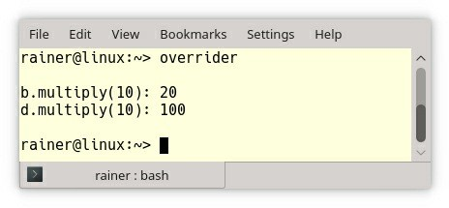

##### Figure 5.15. Different default arguments for virtual functions

What’s happening? Both objects b and d call the same function. The function is virtual and, therefore, late binding happens. Late binding applies to member functions, but not to data members of a class including default arguments. They are statically bound, and early binding happens for that part.

### Accessing objects

Although this section has nine rules, only about four of them are covered, for two reasons. First, the rule C.145: Access polymorphic objects through pointers and references adds nothing new to the rule C.67: A polymorphic class should suppress copying. Second, the C++ Core Guidelines dedicate an entire section to smart pointers. The section about resource management. provides complete details.

The remaining rules are about the dynamic_cast and the erroneous assignment of a pointer to an array of derived class objects.

**dynamic_cast**

Before I write about the dynamic_cast let me emphasize, casts including dynamic_cast are used way too often. The job of the dynamic_cast is to “Safely converts pointers and references to classes up, down, and sideways along the inheritance hierarchy.” ([cppreference.com](http://cppreference.com/))

Let’s first start with the use-case of a dynamic_cast.

#### C.146: Use dynamic_cast where class hierarchy navigation is unavoidable

It’s the job of a dynamic_cast to navigate in a class hierarchy.

struct Base { // an interface virtual void f();

virtual void g();

};

struct Derived : Base { // a wider interface void f() override;

virtual void h();

};

void user(Base* pb) {

if (Derived* pd = dynamic_cast<Derived*>(pb)) {

// ... use Derived’s interface ...

}

else {

// ... make do with Base’s interface ...

}

}

To detect the right type for pb during run-time a dynamic_cast is necessary:

dynamic_cast<Derived*>(pb). If the cast fails, you get a null pointer.

A downcast can also be performed with static_cast, which avoids the cost of the run-time check. static_cast is only safe if the object is definitely Derived.

These are two options you have for dynamic_cast:

##### C.147: Use dynamic_cast to a reference type when failure to find the required class is considered an error, and C.148: Use dynamic_cast to a pointer type when failure to find the required class is considered a valid alternative

To make it short: You can apply a dynamic_cast to a pointer or to a reference. If the dynamic_cast fails, you get back a null pointer in the case of a pointer, and a std::bad_cast exception in the case of a reference. Consequently, use a dynamic_cast to a pointer if a failure is a valid option; if a failure is not a valid option, use a reference.

The program badCast.cpp shows both cases.

// badCast.cpp

struct Base {

virtual void f() {}

};

struct Derived : Base {}; int main() {

Base a;

Derived* b1 = dynamic_cast<Derived*>(&a); // nullptr Derived& b2 = dynamic_cast<Derived&>(a); // std::bad_cast

}

The g++ compiler complains about both dynamic_cast’s at compile-time. At run-time, the program throws the expected exception std::bad_castfor the reference.

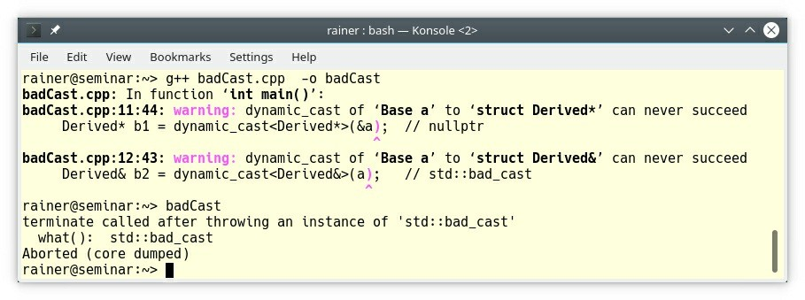

**Figure 5.16. dynamic_cast causes a std::bad_cast exception**

#### C.152: Never assign a pointer to an array of derived class objects to a pointer to its base

This may not happen very often but when it happens the consequences are terribly bad. The result may be an invalid object access or memory corruption. The code snippet shows the invalid object access.

struct Base { int x; };

struct Derived : Base { int y; };

Derived a[] = {{1, 2}, {3, 4}, {5, 6}};

Base* p = a; // Bad: a decays to &a[0] which is converted to a Base* p[1].x = 7; // overwrite Derived[0].y

The last assignment should update the Base member x of the second array element, but due to pointer arithmetic it points to the second int after p[0].x. This happens to be memory of a[0].y! The reason is that Base* was assigned a pointer to an array of derived objects Derived. During this assignment (Base* p = a;), the array a decays to &a[0], which is converted to a Base*.

* **Decay** is the name of an implicit conversion, that applies lvalue-to-rvalue, array-to-pointer, and function-to-pointer conversions removing const and volatile qualifiers. This means that you can call a function accepting Derived* with an array of Derived’s. Necessary information such as the length of the array of Derived’s is lost.

In the following code snippet, the function func takes its array as a pointer to the first element.

void func(Derived* d);

Derived d[] = {{1, 2}, {3, 4}, {5, 6}};

func(d);

The array-to-pointer decay is perfectly fine in this func case, but causes problems in the previous p[1].x case.

### Overloading and overloaded operators

You can overload functions, member functions, template functions, and operators. You cannot overload function objects and, therefore, you cannot overload lambdas.

The seven rules to overloading and overloaded operators follow one key idea: build intuitive software systems for your users. Let me rephrase this key idea with a well-known golden rule in software development: Follow the principle of least astonishment (also known as principle of least surprise). Principle of least astonishment essential means that the components of a system should behave in a way that most users will expect it to behave. This principle is very important for overloading and overloaded operators because with great power comes great responsibility.

Although the seven rules address the intuitive behavior of overloading and overloaded operators, they take different perspectives. They address their conventional usage, the implicit conversion of operators, the equivalence of overloaded operations, and that you should overload operators in the namespace of their operands.

### Conventional usage

Conventional usage means that the user should not be surprised by unexpected behavior or mysterious side effects of the operators.

#### C.167: Use an operator for an operation with its conventional meaning

Conventional meaning includes that you use the appropriate operator. For example, here are a few operators that we are used to:

• **==**, **!=**, **<**, **<=**, **>**, and **>=**: comparison operations

• **+**, **-**, **\***, **/**, and **%**: arithmetic operations

* ->, unary **\***, and **[]**: access of objects

• **=**: assignment of objects

* **<<**, **>>**: input and output operations

#### C.161: Use nonmember functions for symmetric operators

Conventional meaning includes that your data type should behave like a number if it models a number. This rule is a kind of a generalization of the rule C.86: Make == symmetric with respect to operand types and noexcept.

In general, the implementation of a symmetric operator such as + is inside the class is not possible.

Assume that you want to implement a type MyInt. MyInt should support the addition of MyInt’s and built-in int’s. Let’s give it a try.

// MyInt.cpp struct MyInt {

MyInt(int v):val(v) {};

MyInt operator + (const MyInt& oth) const { return MyInt(val + oth.val);

}

int val;

};

int main() {

MyInt myFive = MyInt(2) + MyInt(3); MyInt myFive2 = MyInt(3) + MyInt(2);

MyInt myTen = myFive + 5; // OK

MyInt myTen2 = 5 + myFive; // ERROR

}

Due to the implicit conversion constructor (MyInt(int v):val(v)), the expression myFive + 5 is valid. Constructors taking one argument are conversion constructors because it takes in the concrete case an int and returns a MyInt. In contrast, the last expression 5 + myFive is not valid, because the + operator for int and MyInt is not overloaded.

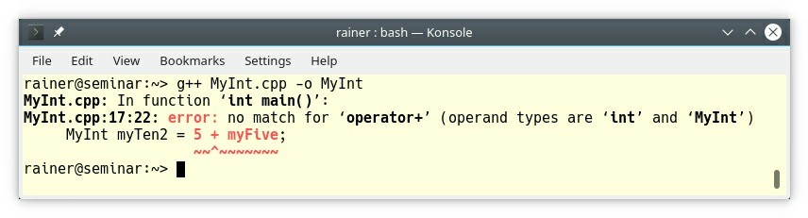

##### Figure 5.17. Missing overload for int and MyInt

The small program has many issues:

1. The + operator is not symmetric.
2. The val variable is public.
3. The conversion constructor is implicit.

It’s quite easy to overcome the first both issues with a non-member operator + that is in the class declared as a friend.

// MyInt2.cpp

class MyInt2 { public:

MyInt2(int v):val(v) {};

friend MyInt2 operator + (const MyInt2& fir, const MyInt2& sec) { return MyInt2(fir.val + sec.val);

}

private:

int val;

};

int main() {

MyInt2 myFive = MyInt2(2) + MyInt2(3); MyInt2 myFive2 = MyInt2(3) + MyInt2(2); MyInt2 myTen = myFive + 5; // OK MyInt2 myTen2 = 5 + myFive; // OK

}

Now, implicit conversion from int to MyInt2 kicks in and the variable val is private. Thanks to the implicit conversion, the 5 in the last line becomes a MyInt2(5).

According to rule C.46: By default, declare single-argument constructors explicit, you should not use an implicit conversion constructor.

MyInt3 has an explicit conversion constructor.

// MyInt3.cpp

class MyInt3 { public:

explicit MyInt3(int v):val(v) {};

friend MyInt3 operator + (const MyInt3& fir, const MyInt3& sec) { return MyInt3(fir.val + sec.val);

}

private:

int val;

};

int main() {

MyInt3 myFive = MyInt3(2) + MyInt3(3); MyInt3 myFive2 = MyInt3(3) + MyInt3(2);

MyInt3 myTen = myFive + 5; // ERROR MyInt3 myTen2 = 5 + myFive; // ERROR

}

Making the conversion constructor explicit, breaks the compilation.

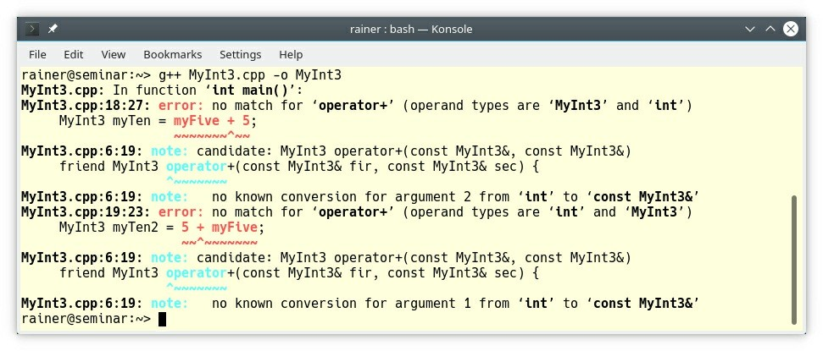

**Figure 5.18. Using an explicit constructor**

The general way to solve the challenge is to implement two additional + operator for MyInt4. One takes an int as left and one takes an int as the right argument.

// MyInt4.cpp

class MyInt4 { public:

explicit MyInt4(int v):val(v) {};

friend MyInt4 operator + (const MyInt4& fir, const MyInt4& sec) { return MyInt4(fir.val + sec.val);

}

friend MyInt4 operator + (const MyInt4& fir, int sec) { return MyInt4(fir.val + sec);

}

friend MyInt4 operator + (int fir, const MyInt4& sec) { return MyInt4(fir + sec.val);

}

private:

int val;

};

int main() {

MyInt4 myFive = MyInt4(2) + MyInt4(3); MyInt4 myFive2 = MyInt4(3) + MyInt4(2);

MyInt4 myTen = myFive + 5; // OK MyInt4 myTen2 = 5 + myFive; // OK

}

Make a constructor taking one argument explicit. The same reason holds for the conversion

operator.

### C.164: Avoid implicit conversion operators

If you want to have fun, overload the operator bool and make it not explicit. Making it not explicit means that integer promotion from bool to int can happen silently.

Let me design a data type MyHouse that can be bought. I implement the operator bool to easily check if a family has already bought the house.

1 // implicitConversion.cpp 2

1. #include <iostream>
2. #include <string> 5
3. struct MyHouse {
4. MyHouse() = default;
5. explicit MyHouse(const std::string& fam): family(fam) {} 9
6. operator bool(){ return not family.empty(); }
7. // explicit operator bool(){ return not family.empty(); } 12

13 std::string family = ""; 14 };

15

16 int main() { 17

18 std::cout << std::boolalpha << '\n'; 19

1. MyHouse firstHouse;
2. if (not firstHouse) {
3. std::cout << “firstHouse is not sold.” << '\n'; 23 }

24

1. MyHouse secondHouse(“grimm”);
2. if (secondHouse) {
3. std::cout << “Grimm bought secondHouse.” << '\n'; 28 }

29

30 std::cout << '\n'; 31

1. int myNewHouse = firstHouse + secondHouse;
2. int myNewHouse2 = (20 * firstHouse - 10 * secondHouse)
3. / secondHouse;

35

1. std::cout << “myNewHouse: “ << myNewHouse << '\n';
2. std::cout << “myNewHouse2: “ << myNewHouse2 << '\n'; 38

39 std::cout << '\n'; 40

41 }

Now, I can easily check with the operator bool (line 10) if a family (line 21) or no family (line 26) lives in the house. Fine. Due to the implicit operator bool, I can use objects of MyHouse in arithmetic expressions (lines 32 and 33). Supporting arithmetic was not my intention.

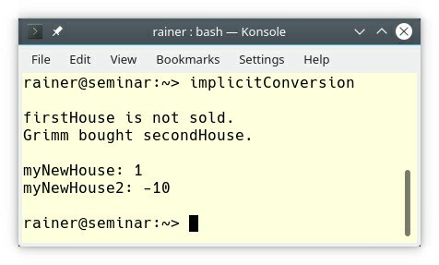

**Figure 5.19. Implicit operator bool**

This is weird!

Since C++11 you can make a conversion operator explicit; therefore, no implicit conversion to int kicks in. If I use the explicit operator bool (line 11), the arithmetic of houses is not possible anymore, but houses can be used in logical expressions.

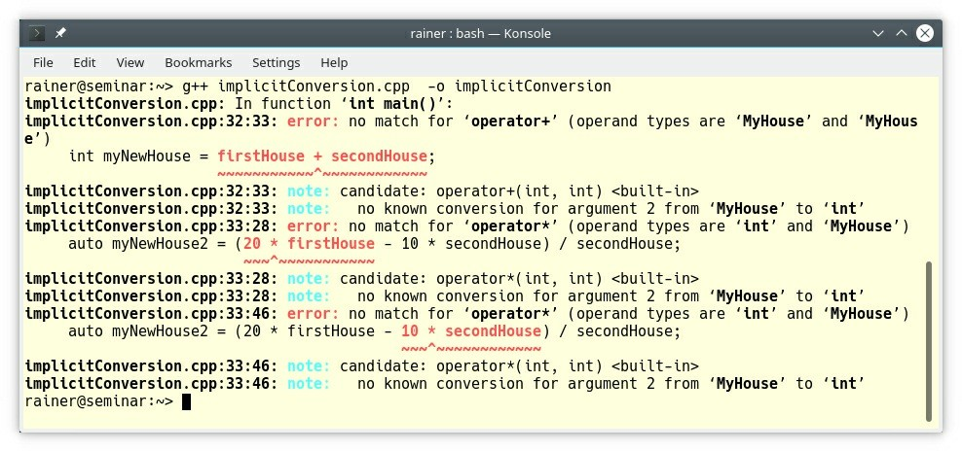

**Figure 5.20. Explicit operator bool**

### C.162: Overload operations that are roughly equivalent and C.163: Overload only for operations that are roughly equivalent

Both rules are closely related. Equivalent operations should have the same name. Or the other way around. Non-equivalent operations should not have the same name.

Here is the example from the C++ Core Guidelines.

void print(int a);

void print(const string&);

...

print(5);

Invoking print(5) feels like generic programming. You don’t have to care which version of

print is used. This observation will not hold if the functions have different names.

void print_int(int a);

void print_string(const string&);

...

print_int(5)

If non-equivalent operations have the same name, the names are too general or just wrong. This is confusing and error-prone.

std::string translate(const std::string& text); // translate into English Code translate(const Code& code); // compile the code

### C.168: Define overloaded operators in the namespace of their operands

Have you ever wondered, why the following program works and displays Test?

#include <iostream>

int main() {

std::cout << “Test\n”;

}

First of all. When you execute the program, it essential becomes the following program:

#include <iostream> int main() {

operator << (std::cout, “Test\n”);

}

std::cout << “Test\n” boils down to operator << (std::cout, “Test\n”);. There is no operator << in the global namespace, but argument-dependent lookup (ADL) examines the std namespace. The operator << finds std::operator << (std::ostream&, const char*) because std::cout is in the std:: namespace.

* **Argument-dependent lookup** (ADL or also called Koenig lookup) means that for unqualified function calls, the functions in the namespace of the function arguments are considered by the C++ compile time.

Let me rephrase the definition of ADL using operands and operators. The C++ runtime also considers for operators the namespace of the operands. Consequently, you should define overloaded operators in the namespace of their operands.

### Unions

A union is a special class type where all members start at the same address. A union can hold only one type at a time; therefore, you can save memory. A tagged union (aka discriminated union) is a union that keeps track of its types. std::variant is a tagged union.

The C++ Core Guidelines states that the job of unions is to save memory. You should not use naked unions but tagged unions such as std::variant.

### C.180: Use unions to save memory

Because a union can hold only one type at one point in time, you can save memory, because the elements of an union share the same memory. The union will be as big as the biggest type.

union Value { int i; double d;

};

Value v = { 123 }; // initializes the first member with an int

std::cout << v.i << '\n'; // write 123

v.d = 987.654; // now v holds a double std::cout << v.d << '\n'; // write 987.654

Value is a “naked” union. You should not use it according to the next rule.

### C.181: Avoid “naked” unions

“Naked” unions are very error-prone because you have to keep track of the underlying type.

// nakedUnion.cpp #include <iostream>

union Value { int i; double d;

};

int main() {

std::cout << '\n'; Value v;

v.d = 987.654;

std::cout << “v.d: “ << v.d << '\n';

std::cout << “v.i: “ << v.i << '\n'; // (1) std::cout << '\n';

v.i = 123;

std::cout << “v.i: “ << v.i << '\n';

std::cout << “v.d: “ << v.d << '\n'; // (2)

std::cout << '\n';

}

The union holds a double in the first section, and an int value in the second section. If you read a double as an int (1), or an int as a double (2), you get undefined behavior.

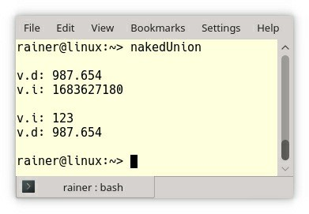

##### Figure 5.21. Undefined behavior with a “naked” union

To overcome this source of errors, you should use a tagged union.

### C.182: Use anonymous unions to implement tagged unions

Implementing a tagged union is quite sophisticated. In case you are curious, have a look at the rule C.182: Use anonymous unions to implement tagged unions.

To simplify the code sample below, I used the tagged union std::variant, which is part of C++17.

1 // variant.cpp; C++17 2

1. #include <variant>
2. #include <string> 5

6 int main() { 7

1. std::variant<int, float> v;
2. std::variant<int, float> w; 10

11 int i = std::get<int>(v); // i is 0 12

1. v = 12; // v contains int
2. int j = std::get<int>(v); 15
3. w = std::get<int>(v);
4. w = std::get<0>(v); // same effect as the previous line
5. w = v; // same effect as the previous line 19

20

21 // std::get<double>(v); // error: no double in [int, float]

|  |  |  |  |  |
| --- | --- | --- | --- | --- |
| 22 | // std::get<3>(v); | |  | // error: valid index values are 0 and 1 |
| 23 |  | |  |  |
| 24 | try{ | |  |  |
| 25 | std::get<float>(w); | |  | // w contains int, not float: will throw |
| 26 | } | |  |  |
| 27 | catch (std::bad_variant_access&) | | {} |  |
| 28 |  | |  |  |
| 29 | v = 5.5f; | // switch to float | | |
| 30 | v = 5; | // and back | | |
| 31 |  |  | | |
| 32 | std::variant<std::string> | v2(“abc”); // converting constructors ok when | | |

unambiguous

33 v2 = “def”; // converting assignment ok when unambiguous

34

35 }

Line 8 and 9 defines the two variants v and w. Both variants can have an int and a float value. Their initial value is 0 (line 11). 0 is the default value for the first underlying type int. v gets in the line 13 the value 13. Thanks to std::get<int>(v), you can get the value to the underlying type. Line 16 and the following two lines show three possibilities to assign the variant v the variant w. You have to keep a few rules in mind. You can ask for the value of a variant by type or by index. The type must be unique, and the index valid (lines 21 and 22). If not, you get a std::bad_variant_access exception. Lines 29 and 30 switch the variant v to float and back to int. If the constructor call or assignment call is unambiguous, a conversion takes place. This conversion is the reason you can construct a std::variant<std::string> with a C-string or assign a new C-string to the variant (lines 27 and 28).

### Related rules

I have skipped two sections from the classes and class hierarchies part of the C++ Core Guidelines. The first one is the section to containers and other resource handles; the second one is the section related to function objects and lambdas.

I also skipped the six guidelines discussing containers and other resource handles because they lack content.

The four guidelines to function objects and lambdas are already part of the section functions and expressions and statements.

The rules related to smart pointers are presented with a bigger context in the section about resource management.

### Distilled

##### Important

* Prefer concrete types over class-hierarchies. Make your concrete type regular. Regular types support the big six (default constructor, destructor, copy and move constructor, copy and move assignment operator), the swap function and the equality operator.
* If possible, let the compiler generate the big six. If not, request all the special member functions via default. If this is not possible, implement all of them explicitly and give them a consistent design. A copy constructor or copy assignment operator should copy. A move constructor or move assignment operator should move.
* A constructor should return a fully initialized object. Use the constructor to establish the invariant. Don’t use a constructor to set the members to its defaults. Prefer in-class initialization to reduce repetition.
* Implement a destructor if you need cleanup action at object destruction. A base-class destructor should be public and virtual or protected and non-virtual.
* Use class hierarchies to model only inherent hierarchical structures. Make the base class abstract if used as an interface to separate the interface from the implementation. An abstract class should have only a defaulted default constructor.
* Distinguish between interface inheritance and implementation inheritance. The objective of interface inheritance is to separate the user from the implementation; implementation inheritance is about reusing an existing implementation. Don’t mix both concepts in a class.
* A class with virtual functions should have a public and virtual or protected destructor. Use exactly one of virtual, override, or final for a virtual function.
* Data members of a class should either all be public or private. Make them private and use a

class if the class establishes an invariant. If not, make them public and use a struct.

* Make single-argument constructors and conversion operators explicit.
* Use unions to save memory but don’t use naked unions, prefer tagged unions such as

std::variant from C++17.

## Chapter 6. Enumerations

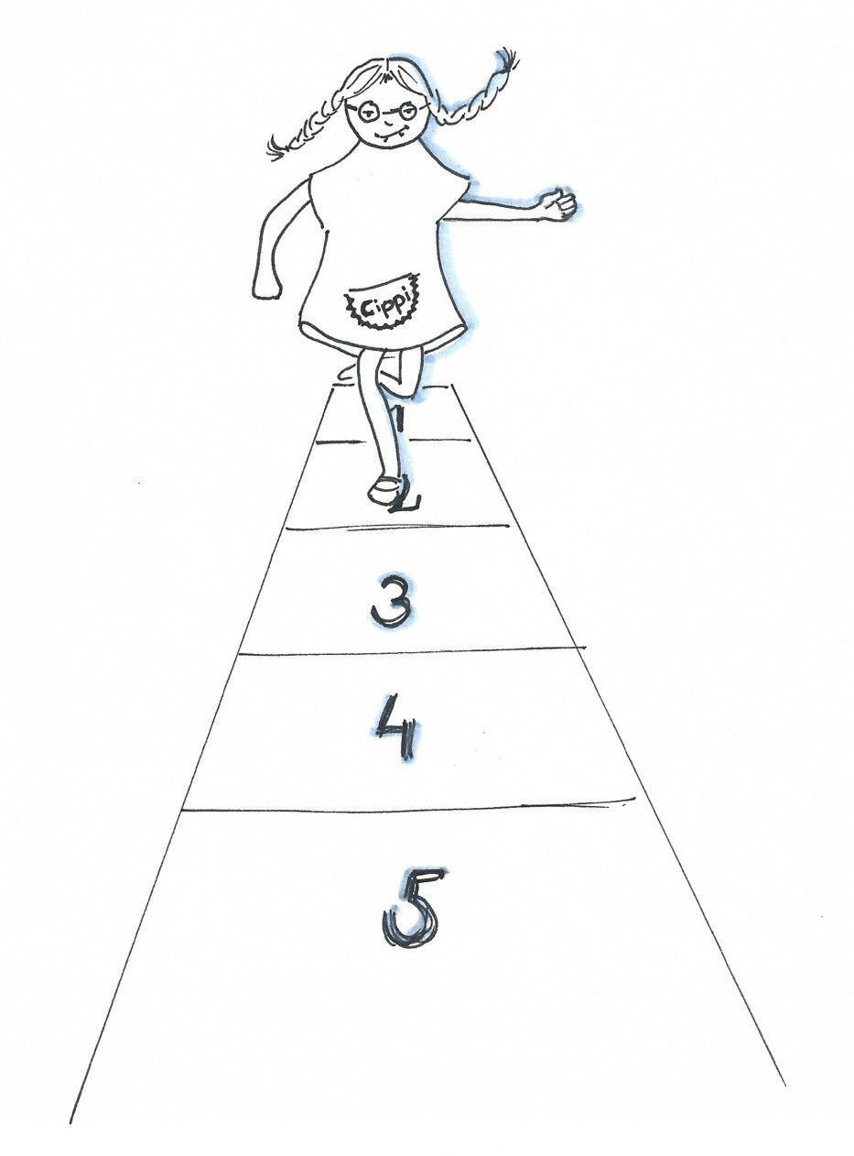

##### Figure 6.1. Cippi counts from 1 to 5

Enumerations are used to define sets of integer values and also a type for such sets of values. Although this section has eight rules about enums, there is a crucial-rule. Prefer scoped enumerations to classic enumerations. Scoped enumerations are also called strongly-typed enums or enum class.

Classical enumerations (before C++11) have many drawbacks. Let me explicitly compare plain (unscoped) enumerations and scoped enumerations, because the difference is not explicitly mentioned in the C++ Core Guidelines.

Here is a classical enumeration:

enum Color { red, blue, green

};

What are the drawbacks of classical enumerations? The enumerators

* have no scope.
* implicitly convert int.
* pollute the global namespace.
* have an unknown type. The type has to be big enough to hold the enumerators.

By using the keyword class or struct, the enumeration becomes a scoped enumeration (class enum):

enum class ColorScoped { red,

blue, green

};

Now, you have to use the scope operator (::) to access the enumerators: ColorScoped::red. ColorScoped::red does not implicitly convert to int and, therefore, does not pollute the global name-space. This is the reason they are often called strongly-typed.

Additionally, the underlying type is by default int, but you can chose a different integral type.

Now that the background information has been provided, let’s dive directly into the most important rules.

### Enum.1: Prefer enumerations over macros

Macros don’t respect scope and have no type. This means you can override a previously set macro which specifies a color.

// webcolors.h #define RED 0xFF0000

// productinfo.h #define RED 0

int webcolor = RED; // should be 0xFF0000

With ColorScoped this would not have happend because you have to use the scope operator:

ColorScoped webcolor = ColorScoped::red;.

### Enum.2: Use enumerations to represent sets of related named constants

This rule is obvious because enumerators create a set of integers which is a named type.

enum class Day { Mon,

Tue, Wed, Thu, Fri, Sat, Sun

};

**Enum.3: Prefer enum classes over “plain” enums**

The enumerators of a scoped enumerator (enum class) do not automatically convert to int. You have to access them with the scope operator.

// scopedEnum.cpp

#include <iostream> enum class ColorScoped {

red, blue, green

};

void useMe(ColorScoped color) { switch(color) {

case ColorScoped::red:

std::cout << “ColorScoped::red” << ’\n'; break;

case ColorScoped::blue:

std::cout << “ColorScoped::blue” << '\n'; break;

case ColorScoped::green:

std::cout << “ColorScoped::green” << '\n'; break;

}

}

int main() {

std::cout << static_cast<int>(ColorScoped::red) << '\n'; // 0 std::cout << static_cast<int>(ColorScoped::green) << '\n'; // 2

ColorScoped color{ColorScoped::red};

useMe(color); // ColorScoped::red

}

**Enum.5: Don’t use ALL_CAPS for enumerators**

If you use ALL_CAPS for enumerators, you may get a conflict with macros because they are typically written in ALL_CAPS.

enum class ColorScoped{ RED };

#define RED 0xFF0000

Of course, this rules does not only apply to enumerators but constants in general.

### Enum.6: Avoid unnamed enumerations

Not every compile-time constant should be an enum. C++ also let you define compile-time constants as constexpr variables. Use enums only for sets of ***related*** constants (Enum.2).

// bad

enum { red = 0xFF0000, scale = 4, is_signed = 1 };

// good

constexpr int red = 0xFF0000; constexpr short scale = 4; constexpr bool is_signed = true;

### Enum.7: Specify the underlying type of an enumeration only when necessary

Since C++11, you can specify the underlying type of the enumeration and save memory. By default the type of a scoped enum is int and, therefore, you can forward declare an enum.

// typeEnum.cpp #include <iostream>

enum class Color1 { red,

blue, green

};

enum struct Color2: char { red,

blue,

green

};

int main() {

std::cout << sizeof(Color1) << '\n'; // 4 std::cout << sizeof(Color2) << '\n'; // 1

}

### Enum.8: Specify enumerator values only when necessary

By specifying the enumerator values you may set a value twice. The following enumeration Col2

has this issue.

enum class Col1 { red, yellow, blue };

enum class Col2 { red = 1, yellow = 2, blue = 2 }; // typo enum class Month { jan = 1, feb, mar,

apr, may, jun, jul, aug, sep,

oct, nov, dec }; // 1 is conventional

Sccoped enumerations check the value of there underlying enumerators at compile-time.

// enumChecksRange.cpp enum struct Color: char {

red = 127, blue, green

};

int main() {

Color color{Color::green};

}

The compilation of the program fails because the enumerators are too big to fit into the underlying type.

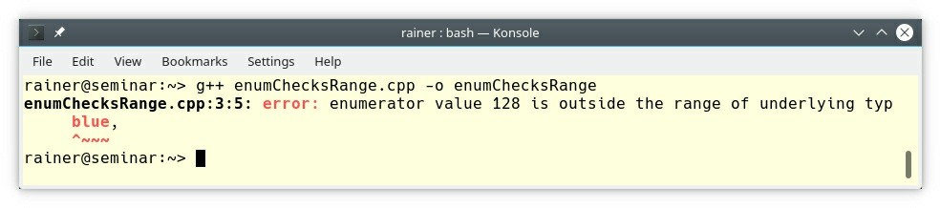

##### Figure 6.2. The enumerators are too big for the underlying type

With classical enumerators, the size of the underlying type would just be big enough.

### Related Rules

The chapter Expressions and Statements deepens the discussion to constexpr values.

### Distilled

##### Important

* Use scoped enumerations instead of classical enumerations. As the name suggests, scoped enumerations have a scope, do not implicitly convert to int, do not pollute the global namespace, and have by default int as their underlying.
* Specify the underlying type of the scoped enumerations and the values of the enumerators only when necessary.

## Chapter 7. Resource Management



##### Figure 7.1. Cippi maintains the garden

First, what is a resource? A resource is something that you have to manage. That means you have to acquire and release it because resources are limited, or you have to protect it. You can only have a limited amount of memory, sockets, processes or threads; only one process can write a shared file or one thread can write a shared variable at one point in time. If you don’t follow the protocol, many issues are possible.

If you think about resource management, it all boils down to one critical point: ownership. What I like, in particular, about modern C++, is, that we can directly express our intention about ownership in code.

* **Local objects**: The C++ runtime as the owner automatically manages the lifetime of these resources. The same holds for global objects or members of a class. The guidelines call them scoped objects.
* **References**: I’m not the owner. I only borrowed the resource that cannot be empty.
* **Raw pointers**: I’m not the owner. I only borrowed the resource that can be empty. I must not delete the resource.
* **std::unique_ptr**: I’m the exclusive owner of the resource. I may explicitly release the resource.
* **std::shared_ptr**: I share the resource with other shared_ptr and release the resource if I’m the last owner. I may explicitly release my share of the ownership.
* **std::weak_ptr**: I’m not the owner of the resource, but I may temporary become a shared owner of the resource by using the member function std::weak_ptr.lock().

### General rules

Although this section has six rules, only two of them, RAII and scoped objects, are original. Two of them are already part of other sections:

* R.2: In interfaces, use raw pointers to denote individual objects (only) (see arrays as arguments)
* R.6: Avoid non-const global variables (see non-const global variables)

The remaining four about the semantics of pointers and references extend existing rules.

The first general rule is idiomatic for C++: RAII. RAII stands for **R**esource **A**cquisition **I**s **I**nitialization. The C++ standard library systemactically relies on RAII.

### R.1: Manage resources automatically using resource handles and RAII (Resource Acquisition Is Initialization)

The idea of RAII is simple. You create a kind of a proxy object for your resource. The

constructor of the proxy acquires the resource and the destructor of the proxy releases the resource. The central idea of RAII is that the C++ runtime is the owner of this proxy as a **local object** and therefore, of the resource. When the proxy object as a local object goes out of the scope, the destructor of the proxy is automatically called. Consequently, we get deterministic destruction behavior in C++.

RAII is heavily used in the C++ ecosystem. Examples for RAII are the containers of the standard template library, smart pointers, and locks. Containers take care of their elements, smart pointers take care of their memory, and locks take care of their mutexes.

The following class ResourceGuard models RAII.

1 // raii.cpp 2

1. #include <iostream>
2. #include <new>
3. #include <string> 6
4. class ResourceGuard {
5. public:
6. explicit ResourceGuard(const std::string& res):resource(res){
7. std::cout << “Acquire the “ << resource << “.” << ’\n'; 11 }
8. ~ResourceGuard(){
9. std::cout << “Release the “<< resource << “.” << '\n'; 14 }
10. private:
11. std::string resource; 17 };

18

19 int main() { 20

21 std::cout << '\n'; 22

23 ResourceGuard resGuard1{“memoryBlock1”}; 24

25 std::cout << “\nBefore local scope” << '\n'; 26 {

27 ResourceGuard resGuard2{“memoryBlock2”}; 28 }

29 std::cout << “After local scope” << '\n'; 30

31 std::cout << '\n'; 32

33

1. std::cout << “\nBefore try-catch block” << '\n';
2. try {
3. ResourceGuard resGuard3{“memoryBlock3”};
4. throw std::bad_alloc(); 38 }
5. catch (const std::bad_alloc& e) {
6. std::cout << e.what(); 41 }

42 std::cout << “\nAfter try-catch block” << '\n'; 43

44 std::cout << '\n';

45

46 }

ResourceGuard is the guard that manages its resource. In this case, the resource is a simple string. ResourceGuard creates the resource in its constructor (line 9 - 11) and releases the resource in its destructor (line 12 - 14). It does its job very reliable. The creation and the releasing of the resource is only indicated in the constructor and in the destructor.

The C++ runtime calls the destructor of resGuard1 (line 23) exactly at the end of the main function (line 46). The lifetime of resGuard2 (line 27) already ends in line 28. Therefore, the C++ runtime calls the destructor once more. Even the throwing of the exception std::bad_alloc does not affect the reliability of resGuard3 (line 36). Its destructor is called at the end of the try block (line 35 - 38).

The screenshot displays the lifetime of the objects.

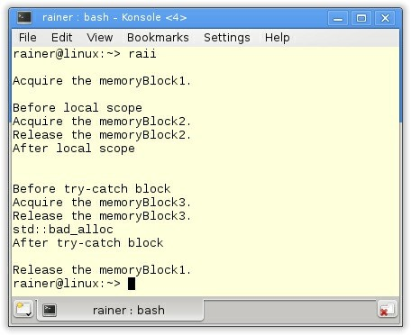

**Figure 7.2. Resource Acquisition Is Initialization**

### R.3: A raw pointer (a T*) is non-owning and R.4: A raw reference (a T&) is non-owning

Both rules generalize the ownership aspect of the rule passing pointers or references to functions and the rule when to return a pointer (T*) or a lvalue reference (T&) from a function. The critical question for pointers and references is: Who is the owner of the resource? If you are not the owner, but you just borrowed it, you must not delete the resource.

### R.5: Prefer scoped objects, don’t heap-allocate unnecessarily

The rule to scoped objects is probably the most important rule for resource management in order to make it simple. If possible, use a scoped object.

A scoped object is an object with its scope. That may be a local object, a global object, or a member of a class. The C++ runtime takes care of the scoped objects. There is no memory allocation and deallocation involved, and you cannot get a std::bad_alloc exception.

Why is the following example bad?

void f(int n) {

auto* p = new Gadget{n};

// ... delete p;

}

There is no need to create Gadget on the heap. It costs time, and it is error-prone. You may forget to deallocate the memory, or an exception may happen before the delete call. In the end, you have a memory leak. Just a local object and you are safe by design.

void f(int n) { Gadget g{n};

// ...

}

##### The power of curly braces

It is handy to use extra curly braces to define an artificial scope. Thanks to the artificial scope, you can control the lifetime of a local object explicitly.

int main() {

{

std::vector<int> myVec(SIZE); measurePerformance(myVec, “std::vector<int>(SIZE)”);

}

{

std::deque<int> myDec(SIZE); measurePerformance(myDec, “std::deque<int>(SIZE)”);

}

{

std::list<int> myList(SIZE); measurePerformance(myList, “std::list<int>(SIZE)”);

}

{

std::forward_list<int> myForwardList(SIZE); measurePerformance(myForwardList,

“std::forward_list<int>(SIZE)”);

}

{

std::string myString(SIZE,' '); measurePerformance(myString, “std::string(SIZE,' ')”);

}

}

The code snippet shows part of a performance test (measurePerformance) which includes substantial allocations. The temporarily created containers in each artificial scope are quite big.

Without deleting them at the end of each artificial scope, your computer may run out of memory, and you get a std::bad_alloc exception.

### Allocation and deallocation

Maybe, you are a little bit bewildered? The C++ Core Guidelines has only four rules for allocation and deallocation. Three of the four rules are about smart pointers. In the end, the essence of this section is that you should use smart pointers which are the topic of the following section.

Before I dive into the four rules, let me give you a little background which is necessary for understanding the rules. Creating an object in C++ with new consists of two steps.

1. Allocate the memory for the object.
2. Constructs the object into the allocated memory.

operator new or operator new [] makes the first step; the constructor is the second step.

The same strategy applies to the destruction but the other way around. First, the destructor is called (if any) and then the memory is deallocated with operator delete or operator delete [].

**R.10: Avoid malloc() and free()**

What is the difference between new and malloc, or delete and free? The C-functions malloc and free do only half of the job. malloc allocates the memory, and free deallocates the memory. Neither does malloc invoke the constructor nor does free invoke the destructor.

This means, if you use an object which was just *created* via malloc, your program has undefined behavior.

// mallocVersusNew.cpp

#include <iostream> #include <string>

struct Record {

explicit Record(const std::string& na): name(na) {} std::string name;

};

int main() {

Record* p1 = static_cast<Record*>(malloc(sizeof(Record))); // (1) std::cout << p1->name << '\n';

auto p2 = new Record(“Record”); // (2) std::cout << p2->name << '\n';

}

I only allocate memory for the Record object (1). The result is that the output p1->name call in the following line is undefined behavior. Undefined behavior just means that you cannot make

any assumption about the behavior of the program. On repeated runs, I got no output, the

*expected* output, which is an empty string, and a core dump.

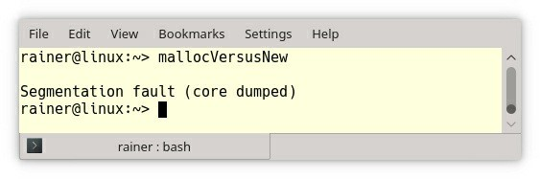

##### Figure 7.3. Undefined behavior causes a core dump

In contrast, the call (2) invokes the constructor.

**R.11: Avoid calling new and delete explicitly**

You should keep this rule in mind. The emphasis in this rule lies in the word **explicitly** because using smart pointers or containers of the Standard Template Library gives you objects which **implicitly** use new and delete.

For example, here a few variations to create std::unique_ptr, and std::shared_ptr.

std::unique_ptr<int> uniq1(new int(2011)); // (1) std::unique_ptr<int> uniq2 = std::make_unique<int>(2014);

std::shared_ptr<int> shar1(new int(2011)); // (1) std::shared_ptr<int> share2 = std::make_shared<int>(2014);

If you don’t know which version you should prefer, the rules R.22: Use make_shared() to make

shared_ptrs, and R.23: Use make_unique() to make unique_ptrs give you the definite answer.

You cannot entirely avoid the calls in (1). When you want to create a std:::unique_ptr or a std::shared_ptr, which shouldn’t use the destructor of the underlying type, the following syntax is obligatory:

std::shared_ptr<int> shar1(new int(2011), MyIntDeleter());

### R.12: Immediately give the result of an explicit resource allocation to a manager object

The C++ community loves acronyms. For memory allocation there is a special name for this rule: NNN. NNN stands for **N**o **N**aked **N**ew and means, the result of a memory allocation should be given to a manager object. This manager object could be a std::unique_ptr or a std::shared_ptr. Of course, this rule has a broader context. For example, containers of the standard template library know how to take care for their elements, or locks know how to care of their mutexes.

When you don’t follow these rules, lurks the danger of undefined behavior.

// standaloneAllocation.cpp // Bad: because of double free

#include <iostream> #include <memory>

struct MyInt{

explicit MyInt(int myInt):i(myInt) {}

~MyInt() {

std::cout << “Goodbye from “ << i << ’\n’;

}

int i;

};

int main() {

std::cout << '\n';

MyInt* myInt = new MyInt(2011);

std::unique_ptr<MyInt> uniq1 = std::unique_ptr<MyInt>(myInt); std::unique_ptr<MyInt> uniq2 = std::unique_ptr<MyInt>(myInt);

std::cout << '\n';

}

The class MyInt displays in its destructor the value of the member attribute i_. The issue starts with the standalone allocation (MyInt* myInt = new MyInt(2011)). Either uniq1, or uniq2 are owners of myInt, but not both. Due to the two owners, two deallocations of the memory happen, which is undefined behavior.

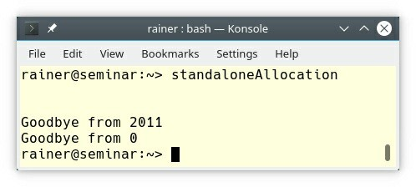

**Figure 7.4. Two owners with std::unique_ptr**

Two deallocations of myInt happen at the end of the main function. The first deallocation via the handle is fine, **but the second causes undefined behavior**. The value of the member attribute i_ is 0 in the second case.

When using std::make_unique, you avoid the risk of double-free problems:

int main() {

std::cout << '\n';

std::unique_ptr<MyInt> uniq = std::make_unique<int>(2011); std::cout << '\n';

}

### R.13: Perform at most one explicit resource allocation in a single expression statement

This rule is a little bit tricky.

void func(std::shared_ptr<Widget> sp1, std::shared_ptr<Widget> sp2) {

...

}

func(std::shared_ptr<Widget>(new Widget(1)), std::shared_ptr<Widget>(new Widget(2)));

This function call is not exception-safe and may, therefore, result in a memory leak. Why? The reason is that four operations must be performed to initialize both shared pointers.

1. Allocate memory for Widget(1)
2. Construct Widget(1)
3. Allocate memory for Widget(2)
4. Construct Widget(2)

Up to C++14, the compiler is free to first allocate the memory for Widget(1) and Widget(2), and then construct both. From the optimization perspective, this makes much sense, because one memory allocation of two Widgets’s is very likely faster than two allocations of one Widget.

This means the following instructions could happen:

1. Allocate memory for Widget(1)
2. Allocate memory for Widget(2)
3. Construct Widget(1)
4. Construct Widget(2)

If one of the constructors throws an exception, the memory of the other object is not automatically freed and we get a memory leak.

It’s easy to overcome this issue by using the factory function std::make_shared for creating a

std::shared_ptr.

func(std::make_shared<Widget>(1), std::make_shared<Widget>(2));

std::make_shared guarantees that the function call has no effect if an exception is thrown. The analogous function std::make_unique for creating a std::unique_ptr gives the same guarantee.

##### Guaranteed evaluation order with C++17

Thanks to the guaranteed evaluation order in C++17, the already discussed code snippet in this

rule cannot cause a memory leak.

void func(std::shared_ptr<Widget> sp1, std::shared_ptr<Widget> sp2) {

...

}

func(std::shared_ptr<Widget>(new Widget(1)), std::shared_ptr<Widget>(new Widget(2)));

The C++17 standard guarantees, in contrast to the C++14 standard, each sub expression in the function call func is evaluated before the other. It is still unspecified, in which sequence.

### Smart pointers

From the library perspective, the smart pointers were the most important addition to the C++11 standard. The C++ Core Guidelines have more than ten rules related about std::unique_ptr, std::shared_ptr, and std::weak_ptr. The rules for smart pointers boil down to two categories: the basic usage of smart pointer as owners and smart pointer as function parameters.

### Basic usage

I assume in this section a basic familiarity with smart pointers. If you want to know all the details, read the documentation to std::unique_ptr, std::shared_ptr, and std::weak_ptr.

**R.20: Use unique_ptr or shared_ptr to represent ownership**

For completeness reason, I also include std::weak_ptr in this rule. Modern C++ has three smart pointers for expressing three different kinds of ownership.

* **std::unique_ptr**: exclusive owner
* **std::shared_ptr**: shared owner
* **std::weak_ptr**: non-owning reference to an object that is managed by a std::shared_ptr

A **std::unique_ptr** is the exclusive owner of its resource. A std::unique_ptr cannot be copied, only moved.

auto uniquePtr1 = std::make_unique<int>(1998); auto uniquePtr2(std::move(uniquePtr1));

In contrast, a **std::shared_ptr** shares ownership. If you copy or copy assign a shared pointer, the reference counter is increased; if you delete or reset a shared pointer, the reference counter is decreased. If the reference counter becomes zero, the underlying resource will be deleted.

auto sharedPtr1 = std::make_shared<int>(1998) // reference count 1 auto sharedPtr2(sharedPtr1); // reference count 2

A **std::weak_ptr** is not a smart pointer. It has a reference to an object that is managed by a std::shared_ptr. Its interface is quite limited and doesn’t allow the transparent access on the underlying resource. By using the member function lock on a std::weak_ptr, you can create a std::shared_ptr from a std::weak_ptr.

auto sharedPtr1 = std::make_shared<int>(1998) // reference count 1 std::weak_ptr<int> weakPtr1(sharedPtr1); // reference count 1 auto sharedPtr2 = weakPtr1.lock(); // reference count 2

**R.21: Prefer unique_ptr over shared_ptr unless you need to share ownership**

The std::unique_ptr should always be your first choice if you need a smart pointer. A

std::unique_ptr is per design as fast and as memory efficient as a raw pointer.

This observation does not hold for a std::shared_ptr. A std::shared_ptr needs to manage its reference counter and allocate extra memory for maintaining the control block. The control block is necessary to manage the lifetime of the controlled object. The std::shared_ptr shines when you need shared ownership. In this case, allocating the shared resource only once may spare memory and time.

Don’t use a std::shared_ptr for convenience reasons because you want to copy them. A

std::unique_ptr cannot be copied, but it can be moved.

1 // moveUniquePtr.cpp 2

1. #include <algorithm>
2. #include <iostream>
3. #include <memory>
4. #include <utility>
5. #include <vector> 8

9 void takeUniquePtr(std::unique_ptr<int> uniqPtr) {

10 std::cout << “*uniqPtr: “ << *uniqPtr << ’\n'; 11 }

12

13 int main() { 14

15 std::cout << '\n'; 16

17 auto uniqPtr1 = std::make_unique<int>(2011); 18

19 takeUniquePtr(std::move(uniqPtr1)); 20

1. auto uniqPtr2 = std::make_unique<int>(2014);
2. auto uniqPtr3 = std::make_unique<int>(2017); 23
3. std::vector<std::unique_ptr<int>> vecUniqPtr {};
4. vecUniqPtr.push_back(std::move(uniqPtr2));
5. vecUniqPtr.push_back(std::move(uniqPtr3));
6. vecUniqPtr.push_back(std::make_unique<int>(2020)); 28

29 std::cout << '\n'; 30

1. std::for_each(vecUniqPtr.begin(), vecUniqPtr.end(),
2. [](std::unique_ptr<int>& uniqPtr) {
3. std::cout << *uniqPtr << '\n'; 34 });

35

36 std::cout << '\n'; 37

38 }

The function takeUniquePtr (line 9) takes a std::unique_ptr by value. The key observation is that you have to move the std::unique_ptr inside. The same argument holds for the std::vector<std::unique_ptr<int>> (line 24). std::vector as all containers of the standard template uses copy semantics. The container wants to own its elements but to copy a std::unique_ptr is not possible. std::move solves this issue (lines 25 and 26). Directly constructing the std::unique_ptr is also possible (line 27). You can apply an algorithm such as std::for_each on the std::vector<std::unique_ptr<int>> (line 31) if no copy semantics is used internally.

Finally, the output of the program.

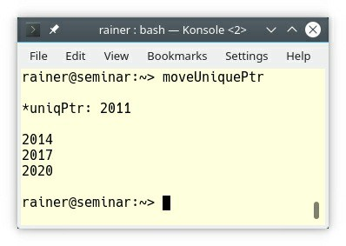

**Figure 7.5. Moving a std::unique_ptr**

**R.22: Use make_shared() to make shared_ptrs and R.23: Use make_unique() to make unique_ptrs**

There are two reasons to prefer std::make_unique to std::unique_ptr, and to prefer

std::make_shared to std::shared_ptr.

The first reason is exception safety. Read the details in the previous rule R.13: Perform at most one explicit resource allocation in a single expression statement.

The second reason only holds for std::shared_ptr.

auto sharPtr1 = std::shared_ptr<int>(new int(1998));

auto sharPtr2 = std::make_shared<int>(1998);

When you call std::shared_ptr<int>(new int(1998)), two memory allocations are involved. One allocation for new int(1998), and the second for the control block of the std::shared_ptr. Memory allocation is expensive. Therefore, you should avoid it. std::make_shared<int>(1998) makes out of two memory allocations one and is, therefore, faster. Additionally, the allocated object (new int(1998)) and the control block are next to each other and can, therefore, faster be accessed.

**R.24: Use std::weak_ptr to break cycles of shared_ptrs**

You get cyclic references of std::shared_ptr if the std::shared_ptr reference each other. For

example, a doubly-linked list creates cycles. If you implement the links with std::shared_ptr, your reference counter never becomes zero, and you end with a memory leak. Here is a short example.

There are two cycles in the following graphic. First, between the mother and her daughter; second, between the mother and her son. The subtle difference is, however, that the mother references her daughter with a std::weak_ptr. So there’s a std::shared_ptr cycle between mother and son keeping both object alive, while there is no std::shared_ptr cycle between mother and daughter, which allows the daughter to be deleted.

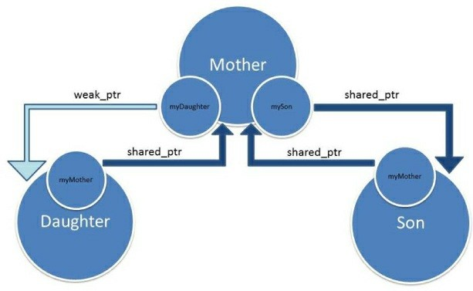

##### Figure 7.6. Cycles of smart pointers

If you don’t like images, here is the corresponding source code.

1 // cycle.cpp 2

1. #include <iostream>
2. #include <memory> 5
3. struct Son;
4. struct Daughter; 8

9 struct Mother {

1. ~Mother() {
2. std::cout << “Mother gone” << ’\n’; 12 }
3. void setSon(const std::shared_ptr<Son> s) {
4. mySon = s; 15 }
5. void setDaughter(const std::shared_ptr<Daughter> d) {
6. myDaughter = d; 18 }
7. std::shared_ptr<Son> mySon;
8. std::weak_ptr<Daughter> myDaughter;

21 };

22

1. struct Son {
2. explicit Son(std::shared_ptr<Mother> m): myMother(m) {}

25 ~Son() {

26 std::cout << “Son gone” << ’\n’; 27 }

28 std::shared_ptr<Mother> myMother; 29 };

30

1. struct Daughter {
2. explicit Daughter(std::shared_ptr<Mother> m): myMother(m) {}
3. ~Daughter() {
4. std::cout << “Daughter gone” << ’\n’; 35 }

36 std::shared_ptr<Mother> myMother; 37 };

38

39 int main() { 40

1. std::shared_ptr<Mother> m = std::make_shared<Mother>();
2. std::shared_ptr<Son> s = std::make_shared<Son>(m);
3. std::shared_ptr<Daughter> d = std::make_shared<Daughter>(m);
4. m->setSon(s);
5. m->setDaughter(d); 46

47 }

At the end of the main function, the lifetime of the mother, the son, and the daughter ends. Or to say it the other way around. Mother, son, and daughter go out of scope and therefore the destructor of the class Mother (line 10 - 12), Son (line 25 - 27), and Daughter (line 33 - 35) should automatically be invoked.

Should, because only the destructor of the daughter is called.

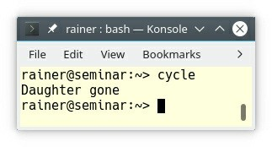

##### Figure 7.7. Cycles of smart pointers

Due to the cycle of std::shared_ptr’s between the mother and the son, the reference counter is always greater than zero and the destructor is not automatically invoked. That observation is not true for the mother and the daughter. If daughter goes out of scope, she is automatically deleted.

### Function parameters

The remaining rules in this section answer the question: How should a function take smart

pointers as parameters? Should the parameter be a std::unique_ptr, or a std::shared_ptr; should the argument be taken by const or by reference. You should perceive these rules to smart pointers as function parameters as a refinement of the more general previous rules to the parameter passing of function parameters: parameter passing: in and out and parameter passing: ownership semantics.

Before I dive into the rules, here is an overview first.

##### Table 7.1. Smart pointers as function parameters

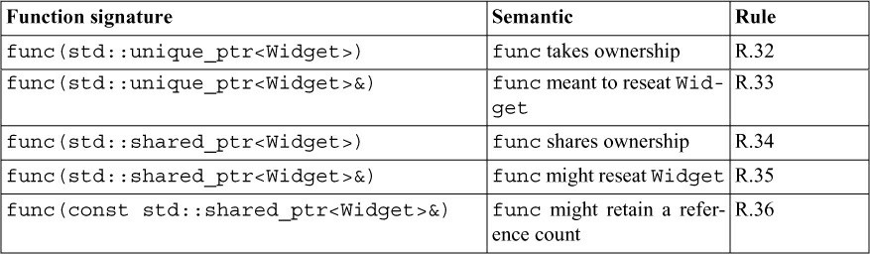

The table has five rules. Two rules for using smart pointers as parameters are still missing. First, we have to answer the question: when to use smart pointers as function parameters? Second, there are dangers involved, if a function takes its parameters by reference.

Let’s answer the first question: When to use smart pointers as function parameters?

#### R.30: Take smart pointers as parameters only to explicitly express lifetime semantics

If you pass a smart pointer as a parameter to a function, and in this function you use only the underlying resource of the smart pointer, you do something wrong. In this case, you should use a raw pointer or a reference as a function parameter, because you don’t need the lifetime semantics of a smart pointer.

Let me give you an example showing the quite sophisticated lifetime management of a smart pointer.

1 // lifetimeSemantic.cpp 2

1. #include <iostream>
2. #include <memory> 5

6 using std::cout; 7

1. void asSmartPointerGood(std::shared_ptr<int>& shr) {
2. cout << “asSmartPointerGood \n”;
3. cout << “ shr.use_count(): “ << shr.use_count() << ’\n’;
4. shr.reset(new int(2011));
5. cout << “ shr.use_count(): “ << shr.use_count() << ’\n’;
6. cout << “asSmartPointerGood \n”; 14 }

15

1. void asSmartPointerBad(std::shared_ptr<int>& shr) {
2. cout << “asSmartPointerBad(sharedPtr2) \n”; 18 *shr += 19;

19 }

20

21 int main() { 22

23 cout << ’\n’; 24

1. auto sharedPtr1 = std::make_shared<int>(1998);
2. auto sharedPtr2 = sharedPtr1;
3. cout << “sharedPtr1.use_count(): “ << sharedPtr1.use_count() << ’\n’; 28

29 cout << ’\n’; 30

31 asSmartPointerGood(sharedPtr1); 32

33 cout << ’\n’; 34

1. cout << “*sharedPtr1: “ << *sharedPtr1 << ’\n’;
2. cout << “sharedPtr1.use_count(): “ << sharedPtr1.use_count() << ’\n’; 37

38 cout << ’\n’; 39

1. cout << “*sharedPtr2: “ << *sharedPtr2 << ’\n’;
2. cout << “sharedPtr2.use_count(): “ << sharedPtr2.use_count() << ’\n’; 42

43 cout << ’\n’; 44

1. asSmartPointerBad(sharedPtr2);
2. cout << “*sharedPtr2: “ << *sharedPtr2 << ’\n’; 47

48 cout << ’\n’; 49

50 }

Let me start with the good case for a std::shared_ptr. The reference counter at line 27 is 2 because I used the shared pointer sharedPtr1 to initialize sharedPtr2. Let’s have a closer look at the invocation of the function asSmartPointerGood (line 8). In line 10, the reference count of shr is 2, and then, it becomes 1 in the line 12. What happened in line 11? I reset shr to the new resource: new int(2011). Consequently, both the shared pointer sharedPtr1 and sharedPtr2 are immediately owners of different resources. You can observe the behavior in the screenshot.

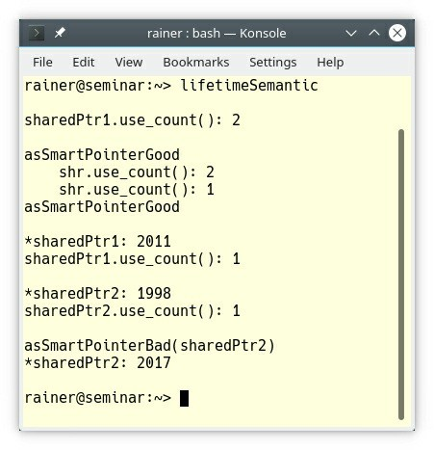

##### Figure 7.8. Lifetime semantics of smart pointers

When you invoke reset on a shared pointer sharedPtr, a sophisticated workflow happens under the hood:

* If you invoke reset without an argument on sharedPtr, the reference counter is decreased by one. Afterwards, sharedPtr is no owner anymore.
* If you invoke reset with an argument and the reference counter is at least 2, you get two independent shared pointer owning different resources.
* If you invoke reset with or without an argument and the reference counter becomes zero, the resource is released.

The semantic of the argument of asSmartPointerBad(std::shared_ptr<int>& shr) suggests, that you might reseat the smart pointer in the method, but the method does not have any intent to do so.

So the user of your method is pushed into the wrong direction.

This magic is an overkill if you are only interested in the underlying resource of the shared pointer; therefore, a raw pointer or a reference is the right kind of parameter for the function asSmartPointerBad (line 16).

**std::unique_ptr**

There are two rules regarding std::unique_ptr parameters:

* R.32: Take a unique_ptr<widget> parameter to express that a function assumes ownership of

a Widget

* R.33: Take a unique_ptr<widget>& parameter to express that a function reseats the Widget

Here are the two corresponding function signatures:

void sink(std::unique_ptr<Widget>) void reseat(std::unique_ptr<Widget>&)

**std::unique_ptr<Widget>**

When a function takes ownership of a Widget, you should take the std::unique_ptr<Widget>

by value. The consequence is that the caller has to move the std::unique_ptr<Widget>.

// uniqPtrMove.cpp

#include <memory> #include <utility>

struct Widget {

explicit Widget(int) {}

};

void sink(std::unique_ptr<Widget> uniqPtr) {

// do something with uniqPtr, then dispose of it

}

int main() {

auto uniqPtr = std::make_unique<Widget>(1998); sink(std::move(uniqPtr)); // OK

sink(uniqPtr); // ERROR

}

The call sink(std::move(uniqPtr)) is fine but the call sink(uniqPtr) breaks because you cannot copy a std::unique_ptr. When your function only wants to use a Widget, it should take its parameter, accordingly to the previous rule R.30: Take smart pointers as parameters only to explicitly express lifetime semantics, by pointer or by reference.

**std::unique_ptr<Widget>&**

Sometimes a function want’s to reseat a Widget. In this case, you should pass the

std::unique_ptr<Widget> by a non-const reference.

// uniqPtrReference.cpp

#include <memory> #include <utility>

struct Widget{ Widget(int) {}

};

void reseat(std::unique_ptr<Widget>& uniqPtr) { uniqPtr.reset(new Widget(2003));

// do something with uniqPtr

}

int main() {

auto uniqPtr = std::make_unique<Widget>(1998);

reseat(std::move(uniqPtr)); // ERROR reseat(uniqPtr); // OK

}

Now, the call reseat(std::move(uniqPtr)) fails, because you cannot bind an rvalue to a non- const lvalue reference. This error does not hold for the call in the following line: reseat(uniqPtr). A lvalue can be bound to an lvalue reference. By the way, the uniqPtr.reset(new Widget(2003)) generates a new Widget(2003), and destructs the old Widget(1998).

Two of the three rules to std::shared_ptr are repetitions; therefore, I will not bother you with details.

**std::shared_ptr**

There are three rules about parameters of type std::shared_ptr:

* R.34: Take a shared_ptr<widget> parameter to express that a function is part owner R.35: Take a shared_ptr<widget>& parameter to express that a function might reseat the shared pointer
* R.36: Take a const shared_ptr<widget>& parameter to express that it might retain a reference count to the object

Here are the relevant function signatures for std::shared_ptr:

void share(std::shared_ptr<Widget>); void reseat(std::shared_ptr<Widget>&);

void mayShare(const std::shared_ptr<Widget>&);

Let’s look at each function signature in isolation. What does this mean from the function perspective?

* **void share(std::shared_ptr<Widget> )**: I’m during the lifetime of the function a shared owner of the Widget. At the beginning of the function, I increase the reference counter; at the end of the function, I decrease the reference counter; therefore, the Widget stays alive, as long as I use it.
* **void reseat(std::shared_ptr<Widget>&)**: I’m not a shared owner of the Widget, because I do not change the reference counter. I have no guarantee that the Widget stays alive during the execution of the function, but I can reseat the resource.
* **void mayShare(const std::shared_ptr<Widget>&)**: I only borrow the resource. Neither can I extend the lifetime of the resource, nor can I reseat the resource. Honestly, it would be best if you use a pointer (Widget*) or a reference (Widget&) as a parameter instead, because there is no added value in using a const std::shared_ptr<Widget>& as a parameter.

#### R.37: Do not pass a pointer or reference obtained from an aliased smart pointer

First of all, the title of this rule may be misleading. An aliased smart pointer (reference to a smart pointer) is a smart pointer, for which you are not the owner. Violating this rule often ends in a dangling pointer.

The code snippet exemplifies the problem.

void oldFunc(Widget* wid){

// do something with wid

}

void shared(std::shared_ptr<Widget>& shaPtr){ oldFunc(*shaPtr);

// do something with shaPtr

}

auto globShared = std::make_shared<Widget>(2011);

...

shared(globShared);

globShared is a globally shared pointer. The function shared takes its argument by reference. Therefore, the reference counter of shaPtr as the aliased smart pointer is not increased and the function share does not extend the lifetime of Widget(2011). The issue begins with the call oldFunc(*shaPtr). oldFunc accepts a pointer to the Widget; therefore, oldFunc has no guarantee that the Widget stays alive during its execution. oldFunc only borrows the Widget.

The cure is simple. You have to ensure that the reference count of globShared is increased before the call to the function oldFunc.

* Pass the std::shared_ptr by value to the function shared:

void shared(std::shared_ptr<Widget> shaPtr) { oldFunc(*shaPtr);

// do something with shaPtr

}

* Make a copy of the shaPtr in the function shared:

void shared(std::shared_ptr<Widget>& shaPtr) {

auto keepAlive = shaPtr; oldFunc(*shaPtr);

// do something with keepAlive or shaPtr

}

Let me formulate the cure as a straightforward rule: “**You should access a shared resource only if you actually hold a share in its ownership**.”

The same reasoning also applies to std::unique_ptr, but there is no simple cure because you can not copy a std::unique_ptr.

### Related Rules

The general rules for resources management have a strong overlap with the existing rules regarding Functions and Interfaces.

The guidelines addressing smart pointers as function parameters are a refinement of the previous rules regarding the parameter passing of function parameters: parameter passing: in and out and parameter passing: ownership semantics.

### Distilled

##### Important

* Manage resources automatically. Create a kind of a proxy object for your resource. The constructor of the proxy acquires the resource and the destructor of the proxy releases the resource. The C++ runtime takes care of the proxy.
* Use scoped objects, if possible. A scoped object is an object with its scope. That may be a local object, a global object, or a member of a class. The C++ runtime takes care of the scoped objects.
* Don’t use malloc and free, and avoid new and delete. Give the result of a resource allocation immediately to a resource manager such as std::unique_ptr, or std::shared_ptr.
* Use the smart pointer std::unique_ptr to represent exclusive ownership, and the smart pointer std::shared_ptr to represent shared ownership. Use std::make_unique to create a std::unique_ptr, and std::make_shared to create a std::shared_ptr.
* Take smart pointers as function parameters if you want to express lifetime semantics. If not, use a plain pointer or a reference.
* Take smart pointer as function parameters by value to express ownership semantics; take smart pointers by reference to express that the function might reseat the smart pointer.

## Chapter 8. Expressions and Statements

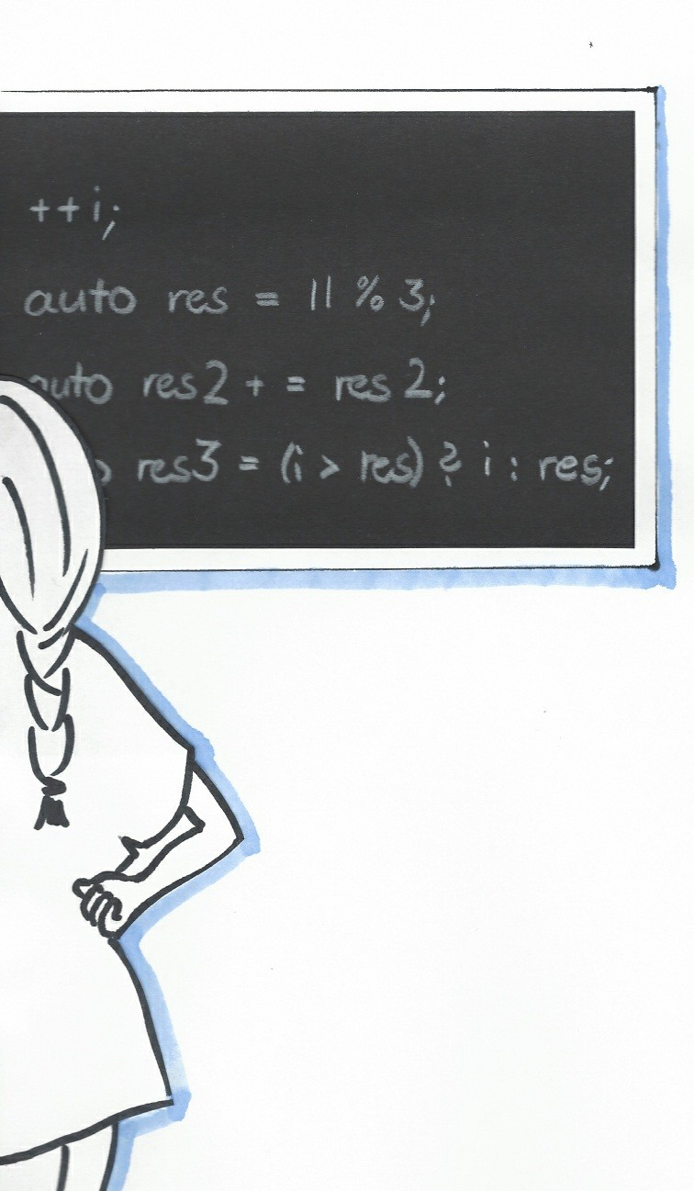

##### Figure 8.1. Cippi is back at school

According to the C++ Core Guidelines, “expressions and statements are the lowest and most direct way of expressing actions and computation”. This section has about 65 rules, that list best practices with expressions and statements in general, declarations, expressions, statements, and arithmetic.

First of all, I want to give you an informal definition of what expressions and statements are:

* An **expression** evaluates to a value.
* A **statement** does something and is often composed of expressions or statements.

5 * 5; // expression

std::cout << 25; // print statement auto a = 10; // assignment statement

auto b = 5 * 5; // expression statement

Declarations in a block scope are statements. A block scope is something within curly braces.

### General

The C++ Core Guidelines have two general rules with a particular focus on expressions and statements.

### ES.1: Prefer the standard library to other libraries and to “handcrafted code”

There is no reason to write a raw loop, to sum up a vector of doubles:

int max = v.size(); double sum = 0.0;

for (int i = 0; i < max; ++i) sum += v[i];

Instead, use the std::accumulate algorithm from the STL. This clearly communicates your intent, and makes the code more readable.

auto sum = std::accumulate(std::begin(v), std::end(v), 0.0);

Maybe, your next task is to build the product of the doubles. Just invoke std::accumulate with the suitable lambda.

auto pro = std::accumulate(std::begin(v), std::end(v), 1.0, [](double fir, double sec){ return fir * sec; });

The solution is good, but not perfect. The C++ standard already defines many function objects such as multiplication.

auto pro = std::accumulate(std::begin(v), std::end(v), 1.0,

std::multiplies<>());

This rule reminds me of a sentence from Sean Parent at the “C++ Seasoning.” conference in

2013: “If you want to improve the code quality in your organization, replace all your coding guidelines with one goal: Prefer an algorithm to a raw loop.” Or to say it more directly: **If you write a raw loop, you probably don’t know the algorithms of the STL good enough.** The STL has more than 100 algorithms.

### ES.2: Prefer suitable abstractions to direct use of language features

This is the next déjà vu. In one C++ seminar, I had a long discussion followed by an even more extended analysis of a few quite sophisticated and handmade functions for reading and writing std::strstreams. My students had to maintain a function and, after one week, they had no idea what was going on. The main reason why they got confused was that the functionality was not based on the right abstraction.

For example, consider this handmade function for reading a std::istream.

char** read1(istream& is, int maxelem, int maxstring, int* nread) { auto res = new char*[maxelem];

int elemcount = 0;

while (is && elemcount < maxelem) { auto s = new char[maxstring]; is.read(s, maxstring); res[elemcount++] = s;

}

nread = &elemcount; return res;

}

In contrast, how easy is it to comprehend the following function?

std::vector<std::string> read2(std::istream& is) { std::vector<std::string> res;

for (string s; is >> s;) res.push_back(s); return res;

}

The right abstraction often means that you don’t have to think about ownership such as in the function read2. This concern does hold for the function read1. The caller of read1 is the owner of the result and has, therefore, to delete it.

### Declarations

First of all, here is how a declaration is defined in the C++ Core Guidelines:

* A **declaration** is a statement. A declaration introduces a name into a scope and may cause the construction of a named object.

The rules for declarations are about names, the variables and their initialization, and macros.

### Names

On the one hand, the following rules are obvious, and I only describe them shortly. On the other hand, I know many code bases which permanently break these rules. For example, I discussed with a former Fortran programmer, who stated: Each name should have exactly three characters.

Let me first name the most important rule: **Good names are probably the most important rule for good software.**

#### ES.5: Keep scopes small

If a scope is small, you can put it on a screen and get an idea of what is going on. If a scope becomes too big, you should structure your code into functions or classes. Identify logical entities and use self-explanatory names in your refactoring process. Afterward, it becomes easier to think about your code.

#### ES.6: Declare names in for-statement initializers and conditions to limit scope

Since the first C++ standard, we can declare a variable in a for statement.

##### The Design and Evolution of C++ by Bjarne Stroustrup

Bjarne Stroustrup pointed out during the reviewing of this book that the definition of names in for-statements was even possible before the first C++ standard. In case you are curious about the history of C++, I strongly suggest you to read Bjarne’s book “The Design and Evolution of C++”.

Since C++17, we can declare variables also in an if or a switch statement.

std::map<int,std::string> myMap;

if (auto result = myMap.insert(value); result.second) { useResult(*result.first);

// ...

}

else {

// ...

} // result is automatically destroyed

The variable result is only valid inside the if and else branch of the if statement. result does not pollute the outer scope and is automatically destroyed. Before C++17, you have to declare result in the outer scope.

std::map<int,std::string> myMap; auto result = myMap.insert(value) if (result.second){

useResult(*result.first);

// ...

}

else {

// ...

}

#### ES.7: Keep common and local names short, and keep uncommon and nonlocal names longer

This rule sounds strange, but we are already used to it. Giving a variable the name i or j, or giving a variable the name T makes its intention immediately clear: i and j are indices, and T is a type for a template parameter.

template<typename T>

void print(std::ostream& os, const std::vector<T>& v) { for (int i = 0; i < v.size(); ++i) os << v[i] << '\n';

}

i is an okay name for a loop control variable, a poor name for a function parameter, and a terrible name for a global variable.

There is a meta-rule underlying this rule. A name should be self-explanatory. In a short context, you understand with a glance what the variable means. This will not automatically hold for longer contexts; therefore, use longer names.

#### ES.8: Avoid similar-looking names

Can you read this example without any hesitation?

if (readable(i1 + l1 + ol + o1 + o0 + ol + o1 + I0 + l0)) surprise();

For example, I often have problems with the number 0 and the big capital letter O. Depending on the font used it looks quite similar. A few years ago, it took me quite a time to log into a server. My automatically generated password had a letter O.

**ES.9: Avoid ALL_CAPS names**

If you use ALL_CAPS, macro substitution may kick in because ALL_CAPS are commonly used for macros. The following code snippet may be a little surprising.

// somewhere in some header:

#define NE !=

// somewhere else in some other header: enum Coord { N, NE, NW, S, SE, SW, E, W };

// somewhere third in some poor programmer’s .cpp: switch (direction) {

case N:

// ... case NE:

// ...

// ...

}

#### ES.10: Declare one name (only) per declaration

Let me give you two examples. Did you spot two issues?

char* p, p2; char a = 'a'; p = &a;

p2 = a;

int a = 7, b = 9, c, d = 10, e = 3;

p2 is just a char and c is not initialized. With C++17, we got one exception to this rule: structured binding.

Now, I can write the if statement with initializer in rule “ES.6: Declare names in for-statement initializers and conditions to limit scope” using a cleaner and more readable syntax.

std::map<int, std::string> myMap;

if (auto [iter, succeeded] = myMap.insert(value); succeeded) { useResult(iter);

// ...

}

else {

// ...

} // iter and succeeded are automatically destroyed

#### ES.11: Use auto to avoid redundant repetition of type names

If you use auto, changing your code may become a piece of cake.

The following code snippet only uses auto. You do have not to think about the types and, therefore, you cannot make an error. This means the type of res will be int at the end. Thanks to the typeid operator, you get a string representation of the type.

auto a = 5; auto b = 10;

auto sum = a * b * 3; auto res = sum + 10;

std::cout << typeid(res).name() << '\n'; // i

If you decide to change the literal b from int to double (1), or use instead of the int literal 3 a float literal 3.1f (2), res always has the correct type. The compiler automatically deduces the correct type.

auto a = 5;

auto b = 10.5; // (1)

auto sum = a * b * 3; auto res = sum * 10;

std::cout << typeid(res).name() << '\n'; // d

auto a = 5; auto b = 10;

auto sum = a * b * 3.2f; // (2) auto res = sum * 10;

std::cout << typeid(res).name() << '\n'; // f

The GCC and the Clang compiler generated the type hints i, d and f in the tree code snippets. The MSVC compiler would write more verbose type hints such as int, double, and float.

#### ES.12: Do not reuse names in nested scopes

For readability and maintenance reasons, you should not reuse names in nested scopes.

// shadow.cpp #include <iostream>

int shadow(bool cond) { int d = 0;

if (cond) {

d = 1;

}

else {

int d = 2; // declare a local scoped d;

// hiding d of the parent scope

d = 3;

} // the local scoped d is removed return d;

}

int main() {

|  |  |  |
| --- | --- | --- |
| std::cout | << | '\n'; |
| std::cout | << | "shadow(true): " << shadow(true) << '\n'; |
| std::cout | << | "shadow(false): " << shadow(false) << '\n'; |
| std::cout | << | '\n'; |

}

What is the output of the program? Confused by the d’s? Here is the result.

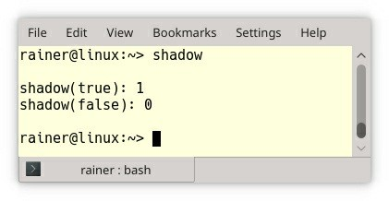

##### Figure 8.2. Reusing names in nested scopes

This was easy! Right? But the same behavior is quite surprising in a class hierarchy.

// shadowClass.cpp

#include <iostream> #include <string>

struct Base {

void shadow(std::string) { // (1) std::cout << "Base::shadow" << '\n';

}

};

struct Derived: Base {

void shadow(int) { // (2)

std::cout << "Derived::shadow" << '\n';

}

};

int main() {

std::cout << '\n'; Derived derived;

derived.shadow(std::string{}); // (3) derived.shadow(int{});

std::cout << '\n';

}

Both structs Base and Derived have a member function shadow. The one in the Base accepts a std::string (1) and the other one an int (2). When you invoke the object derived with a default-constructed std::string (3), you may assume that the base version is called. Wrong! The member function shadow is implemented in the class Derived. The member function of the base class is not considered during name resolution. Here is the compilation error of GCC.

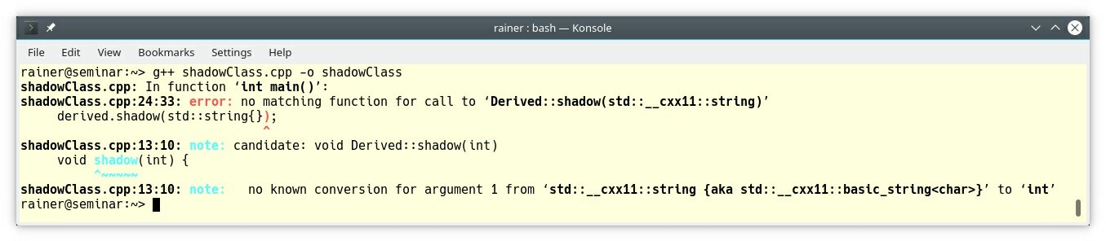

##### Figure 8.3. Hiding member functions of a base

Thanks to the using declaration, the base variant of shadow is visible in Derived.

struct Derived: Base { using Base::shadow; void shadow(int) {

std::cout << "Derived::shadow" << '\n';

}

};

After adding the using Base::shadow into Derived, the program behaves as expected. The guideline “C.138: Create an overload set for a derived class and its bases with using” showed the issue of shadowing in a class hierarchy.

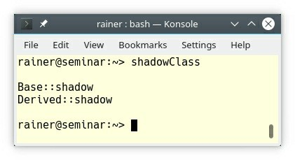

**Figure 8.4. Change visibility with a using declaration**

### Variables and their initialization

As in the section for names before, the rules in this section regarding variables and their initialization are often quite obvious, but sometimes provide very precious insights.

Consequently, I cover the intuitive rules quickly, and write about the very precious insights in more depth.

#### ES.20: Always initialize an object

This is one of these elementary techniques which many professional C++ programmers get wrong. The simple question is: Which variable is initialized?

struct T1 {};

class T2{ public:

T2() {}

};

int n; // OK

int main() {

int n2; // BAD std::string s; // OK T1 t1; // OK

T2 t2; // OK

}

n has a global scope and has a fundamental type. Consequently, it is initialized to 0. The initialization does not happen for n2, because it has a local scope and is, therefore, not initialized. But if you use a user-defined type such as std::string, T1, or T2, it initialized even in a local scope.

There is a simple fix, to prevent this issue: use auto. Now, you cannot forget to initialize a variable.

struct T1 {};

class T2{ public:

T2() {}

};

auto n = 0;

int main() { auto n2 = 0; auto s = ""s; auto t1 = T1(); auto t2 = T2();

}

#### ES.21: Don’t introduce a variable (or constant) before you need to use it

In the C-standard C89, you must declare all of your variables at the beginning of a scope. We program in C++, not in C89.

#### ES.22: Don’t declare a variable until you have a value to initialize it with

If you don’t follow this rule, you may have a so-called use-before-set error. Have a look at the example from the guidelines.

int var;

if (cond) set(&var); // some non-trivial condition else if (cond2 || !cond3) {

var = set2(3.14);

}

// use var

If cond3 holds but not cond, or cond2, then var is not initialized when it is used.

#### ES.23: Prefer the {}-initializer syntax

There are many reasons to use {}-initialization:

{}-initialization is

* always applicable,
* overcomes the most vexing parse,
* and prevents narrowing conversion.

While the first two arguments make C++ more intuitive, the last argument often prevents undefined behavior.

##### Always applicable

{}-initialization is always applicable. Here are a few examples:

// uniformInitialization.cpp #include <map>

#include <vector> #include <string>

// Initialization of a C-Array class Array {

public:

Array(): myData{1,2,3,4,5} {} private:

const int myData[5];

};

class MyClass { public:

int x; double y;

};

class MyClass2 { public:

MyClass2(int fir, double sec): x{fir}, y{sec} {}; private:

int x; double y;

};

int main() {

// Direct initialization of standard containers int intArray[]= {1, 2, 3, 4, 5};

std::vector<int> intArray1{1, 2, 3, 4, 5}; std::map<std::string, int> myMap{ {"Scott", 1976},

{"Dijkstra", 1972} };

Array arr;

// Default initialization of arbitrary objects int i{}; // i becomes 0

std::string s{}; // s becomes "" std::vector<float> v{}; // v becomes an empty vector double d{}; // d becomes 0.0

// Direct initialization of an object with public members MyClass myClass{2011, 3.14};

MyClass myClass1 = {2011, 3.14};

// Initialization of an object using the constructor MyClass2 myClass2{2011, 3.14};

MyClass2 myClass3 = {2011, 3.14};

}

You should never say always. There is a weird behavior, which is fixed in C++17.

##### Type deduction with auto

Always applicable? Yes, but you have to keep a special rule in mind. If you use automatic type

deduction with auto in combination with an {}-initialization, you get a

std::initializer_list.

auto initA{1}; // std::initializer_list<int> auto initB = {2}; // std::initializer_list<int> auto initC{1, 2}; // std::initializer_list<int> auto initD = {1, 2}; // std::initializer_list<int>

This counter-intuitive behavior changes with C++17.

auto initA{1}; // int

auto initB = {2}; // std::initializer_list<int> auto initC{1, 2}; // error, no single element auto initD = {1, 2}; // std::initializer_list<int>

##### Most vexing parse

The most vexing parse is well-known, and almost any professional C++ developer has already fallen into this trap. The following short program demonstrates the trap.

// mostVexingParse.cpp

#include <iostream> struct MyInt {

MyInt(int arg = 0): i(arg) {} int i;

};

int main() {

MyInt myInt(2011); MyInt myInt2();

std::cout << myInt.i; std::cout << myInt2.i;

}

This simple looking program does not compile!

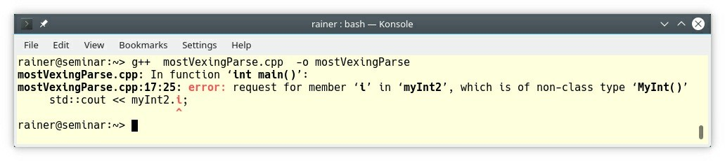

##### Figure 8.5. The most vexing parse

The error message is not very meaningful. The compiler can interpret the expression MyInt myInt2() as a call of a constructor or as a declaration of a function. When there is an ambiguity, it selects a function declaration. Consequently, the call myInt2.i is not valid.

Replacing round braces in the call MyInt myInt2() with curly braces MyInt myInt2{}, solves the ambiguity.

// mostVexingParseSolved.cpp #include <iostream>

struct MyInt {

MyInt(int arg = 0): i(arg) {} int i;

};

int main() {

MyInt myInt(2011); MyInt myInt2{};

std::cout << myInt.i; std::cout << myInt2.i;

}

##### Narrowing conversion

Narrowing conversion is an implicit conversion of arithmetic values, including a loss of accuracy. That sounds extremely dangerous and is a common cause of undefined behavior.

The following code snippet exemplifies narrowing conversion for the two fundamental types

char and int. It doesn’t matter whether I use direct initialization or copy initialization.

// narrowingConversion.cpp #include <iostream>

int main() {

char c1(999); char c2 = 999;

std::cout << "c1: " << c1 << '\n'; std::cout << "c2: " << c2 << '\n';

int i1(3.14); int i2 = 3.14;

std::cout << "i1: " << i1 << '\n'; std::cout << "i2: " << i2 << '\n';

}

The output of the program shows both issues. First, the int literal 999 doesn’t fit into the type

char; second, the double literal doesn’t fit into the int type.

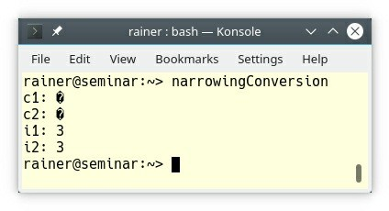

##### Figure 8.6. Narrowing conversion

Narrowing conversion is not possible with {}-initialization.

// narrowingConversionSolved.cpp #include <iostream>

int main() {

char c1{999}; char c2 = {999};

std::cout << "c1: " << c1 << '\n'; std::cout << "c2: " << c2 << '\n';

int i1{3.14};

int i2 = {3.14};

std::cout << "i1: " << i1 << '\n'; std::cout << "i2: " << i2 << '\n';

}

The program is ill-formed, because {}-initialization detects narrowing conversion. The compiler has at least to diagnose a warning. Most of the compilers treat narrowing conversion as an error. To be on the safe side, compile your program always with the narrowing flag set. The following screenshot shows the failing compilation with GCC.

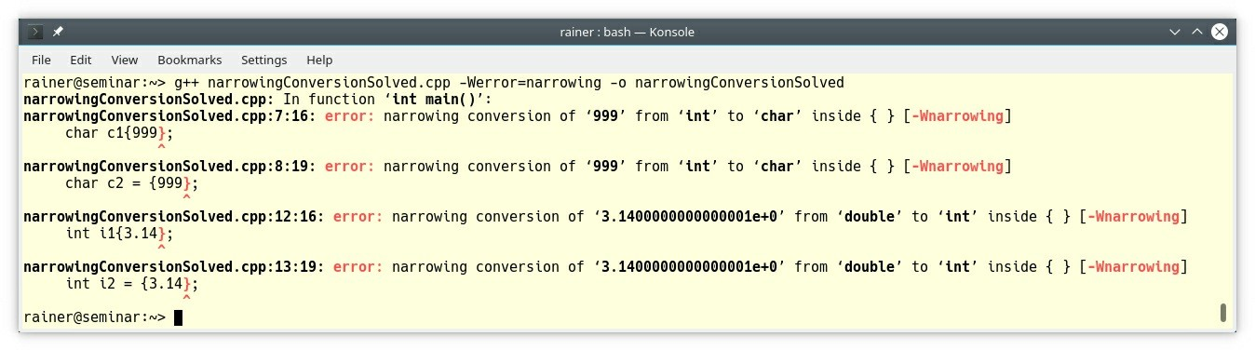

**Figure 8.7. Narrowing conversion detected**

#### ES.26: Don’t use a variable for two unrelated purposes

Do you like the following code?

void use() {

int i;

for (i = 0; i < 20; ++i) { /* ... */ }

for (i = 0; i < 200; ++i) { /* ... */ } // bad: i recycled

}

I hope not. Put the declaration of i into the for loop and you are fine. i is now bound to the lifetime of the for loop.

void use() {

for (int i = 0; i < 20; ++i) { /* ... */ } for (int i = 0; i < 200; ++i) { /* ... */ }

}

With C++17, you can declare variables directly in an if statement or a switch statement.

#### ES.28: Use lambdas for complex initialization, especially of const variables

I often hear the question: Why should I invoke a lambda function in place? This rule answers this question. You can put complex initialization steps in a lambda. The in place invocation of a lambda is, in particular, valuable, if your variable should become const.

If you don’t want to modify your variable after initialization, you should make it const. But sometimes, the initialization of the variable consists of more than one step. Consequently, you cannot make the variable const.

The widget x in the following example should be const after its initialization. It cannot be const, because it is modified a few times during its initialization.

widget x; // should be const, but:

for (auto i = 2; i <= N; ++i) {

x += some_obj.do_something_with(i);

}

// from here, x should be const,

// but we can’t say so in code in this style

Now, a lambda expression comes to our rescue. Use a technique called “**I**mmediately **I**nvoked **L**ambda **E**xpression”. (IILE)

Put the initialization stuff into a lambda expression, capture the environment by reference, and initialize your const variable with the in-place invoked lambda function.

const widget x = [&]{ widget val;

for (auto i = 2; i <= N; ++i) {

val += some_obj.do_something_with(i);

}

return val;

}();

Admittedly, it looks a little bit strange to invoke a lambda function just in place, but from the conceptional view, I like it. You put the whole initialization stuff just in the body of a lambda. The final pair of parentheses invokes the lambda.

### Macros

If there is one unanimous consensus in the C++ standardization committee, then this is one: **Macros must go**. Macros are just text substitution without any C++ semantics. They transform the written code so, that the compiler sees a different one. This transformation is highly error- prone and obscures the cause of the error.

But sometimes, you have to deal with legacy code, which relies on macros. For completeness, the C++ Core Guidelines have four rules for macros.

* ES.30: Don’t use macros for program text manipulation
* ES.31: Don’t use macros for constants or “functions”
* ES.32: Use ALL_CAPS for all macro names
* ES.33: If you must use macros, give them unique names

Let me start with the don’t s. The following example shows the usage of the function-like macro

max. I copied max from the param.h header file, which is part of the GNU C library.

// macro.cpp #include <stdio.h>

#define max(a, b) ((a) > (b)) ? (a) : (b) int main() {

int a = 1, b = 2;

printf("\nmax(a, b): %d\n", max(a, b)); printf("a = %d, b = %d\n", a, b);

printf("\nmax(++a, ++b): %d\n", max(++a, ++b)); // (1) printf("a = %d, b = %d\n\n", a, b); // (2)

}

The output in (2) may surprise you.

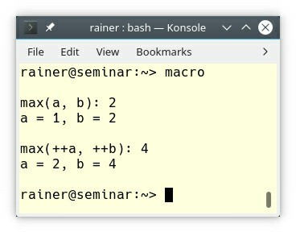

##### Figure 8.8. Usage of the function-like macro max

The variable b is two times evaluated and, therefore, incremented twice. Use instead of the function-like macro max a constexpr function or a max function template.

template<typename T> T max (T i, T j) {

return ((i > j) ? i : j);

}

constexpr int max (int i, int j){ return ((i > j) ? i : j);

}

The same argumentation applies to macros as constants.

#define PI 3.14 // bad

constexpr double pi = 3.14 // good

If, for whatever reason, you have to use or to maintain macros, write them ALL_CAPS and give them unique names. The following code snippet breaks both rules. forever is written in lowercase letters and the macro CHAR may conflict with someone else using the name CHAR

#define forever for (;;) #define CHAR

### Expressions

There are about twenty rules related to expressions. They are quite diverse, and overlap with existing rules. Here I focused on the rules applying to complicated expressions, pointers, the order of evaluation, and conversions.

### Complicated expressions

First and foremost, you should avoid complicated expressions.

#### ES.40: Avoid complicated expressions

What does complicated mean? Here is the example from the C++ Core Guidelines, including the explanation:

// bad: assignment hidden in subexpression while ((c = getc()) != -1)

// bad: two non-local variables assigned in a sub-expressions while ((cin >> c1, cin >> c2), c1 == c2)

// better, but possibly still too complicated for (char c1, c2; cin >> c1 >> c2 && c1 == c2;)

// OK: if i and j are not aliased (names for the same data) int x = ++i + ++j;

// OK: if i != j and i != k v[i] = v[j] + v[k];

// bad: multiple assignments "hidden" in subexpressions x = a + (b = f()) + (c = g()) * 7;

// bad: relies on commonly misunderstood precedence rules x = a & b + c * d && e ^ f == 7;

// bad: undefined behavior x = x++ + x++ + ++x;

#### ES.41: If in doubt about operator precedence, parenthesize

On one hand, the guidelines say: If you are in doubt about operator precedence, use parentheses. On the other hand, they state: You should know enough not to need parentheses here. Finding the right balance is, therefore, the challenge and depends on the expertise of the users.

const unsigned int flag = 2; unsigned int a = flag;

if (a & flag != 0) // bad: means a&(flag != 0) if (a < 0 || a <= max) { // good: quite obvious

// ...

}

For an expert, the expression may be obvious but for a beginner, it may be a challenge. I have only two tips in mind:

1. If in doubt about precedence, use parentheses. The precedence table gives you all details.
2. Program for the beginners! Keep the precedence table under your pillow.

#### ES.42: Keep use of pointers simple and straightforward

Let me quote the C++ Core Guidelines: “Complicated pointer manipulation is a major source of errors.”. Why should we care? Of course, our legacy code is full of pointer manipulations such as in the following code snippet.

void f(int* p, int count) { if (count < 2) return;

int* q = p + 1; int n = *p++;

if (count < 6) return; p[4] = 1;

p[count - 1] = 2;

use(&p[0], 3);

}

int myArray[100];

f(myArray, 100);

The main issue with these lines of code is that the caller must provide the correct length of the C- array. If not, undefined behavior kicks in.

Think about the last two lines of the code snippet for a few seconds. We start with an C-array and remove its type information by passing it to the function f. This process is called an array to pointer decay and is the reason for many errors. Maybe we counted the number of elements wrong or the size of the C-arrays changed. The result is the same in both cases: undefined behavior.

What should we do? We should use the appropriate data type. C++20 offers std:::span.

void f(std::span<int> a) { if (a.size() < 2) return;

int n = a[0]; // OK std::span<int> q = a.subspan(1); if (a.size() < 6) return;

a[4] = 1;

a[count - 1] = 2;

use(a.data(), a.size());

}

std::span knows its size. I hear your complaint. C++20 is not an option for you. To our rescue, C++ has templates; therefore, it’s easy to overcome this restriction and write bounds-safe code.

1 // at.cpp 2

1. #include <algorithm>
2. #include <array>
3. #include <deque>
4. #include <string>
5. #include <vector> 8
6. template <typename T>
7. void use(T*, int) {} 11
8. template <typename T>
9. void f(T& a) { 14

15 if (a.size() < 2) return; 16

17 int n = a.at(0); 18

1. std::array<typename T::value_type , 99> q;
2. std::copy(a.begin() + 1, a.end(), q.begin()); 21

22 if (a.size() < 6) return; 23

24 a.at(4) = 1;

25

26 a.at(a.size() - 1) = 2;

27

28 use(a.data(), a.size()); 29 }

30

31 int main() { 32

1. std::array<int, 100> arr{};
2. f(arr); 35
3. std::array<double, 20> arr2{};
4. f(arr2); 38

39 std::vector<double> vec{1, 2, 3, 4, 5, 6, 7, 8, 9};

40 f(vec); 41

1. std::string myString= "123456789";
2. f(myString); 44

45 // std::deque<int> deq{1, 2, 3, 4, 5, 6, 7, 8, 9, 10};

46 // f(deq);

47

48 }

Now, the function f works for std::array’s of different sizes and types (lines 34 and 37), but also for a std::vector (line 40) or a std::string (line 43). These containers have in common, that their data is stored in a contiguous memory block. This is not the case for std::deque; therefore, the call a.data() in comment (line 46) fails. The key observation in the example is,

that the at call on a container checks its boundaries and throws eventually a std::out_of_range

exception.

The expression T::value_type helps to get the type of the elements of the container. T is a so- called dependent type because T is a type parameter of the function template f. This is the reason, I have to give the compiler a hint that T::value_type is actually a type: typename T::value_type.

#### ES.45: Avoid “magic constants”; use symbolic constants

A symbolic constant is more explicit than a magic constant. The example of the C++ Core Guidelines starts with the magic constants 1 and 12, and ends with the symbolic constant first_month, and last_month.

// don’t: magic constants 1 and 12

for (int m = 1; m <= 12; ++m) std::cout << month[m] << '\n';

// months are indexed 1..12 (symbolic constant) constexpr int first_month = 1;

constexpr int last_month = 12;

for (int m = first_month; m <= last_month; ++m) { std::cout << month[m] << '\n';

}

#### ES.55: Avoid the need for range checking

If you don’t have to check the length of a range, you will not get an off-by-one error. Let’s sum up the elements of a std::vector.

// sumUp.cpp

#include <iostream> #include <numeric> #include <vector>

int main() {

std::vector<int> vec{1, 2, 3, 4, 5, 6, 7, 8, 9, 10};

// bad

int sum1 = 0;

auto sizeVec = vec.size();

for (int i = 0; i < sizeVec; ++i) sum1 += vec[i]; std::cout << sum1 << '\n'; // 55

// better int sum2 = 0;

for (auto v: vec) sum2 += v; std::cout << sum2 << '\n'; // 55

// the best

auto sum3 = std::accumulate(vec.begin(), vec.end(), 0); std::cout << sum3 << '\n'; // 55

}

Iterating explicitly through a container is very error-prone. In contrast, iterating implicitly with a range-based for loop is safe. Additionally, the algorithm std::accumulate of the STL documents its intention.

### Pointers

The rules for pointers start with null pointers and continue with the deletion and dereferencing of pointers.

**ES.47: Use nullptr rather than 0 or NULL**

Why should you not use 0 or NULL to denote a null pointer?

* **0**: The literal 0 can be the null pointer (void*)0 or the number 0. This is dependent on the context. Consequently, what started as null pointer could end up as number.
* **NULL**: NULL is a macro and, therefore, you don’t know what’s inside. A possible implementation according to [cppreference.com](http://cppreference.com/) could be:

#define NULL 0

//since C++11 #define NULL nullptr

**Replace the null pointer 0 and NULL with the nullptr**

I normally don’t suggest to refactor existing code. Both null pointer 0 and NULL are an exception of this rule. Replace all occurrences of null pointer 0 and NULL with the null pointer nullptr.

int* a = 0; // bad int* b = NULL; // bad

int* a = nullptr; // good int* b = nullptr; // good

If your program compiles after the refactoring, fine. If you get a compiler error, you already know that you used a null pointer against its nature and you detected undefined behavior.

The null pointer nullptr avoids the ambiguity of the number 0 and the macro NULL. nullptr is and remains of type std::nullptr_t. You can assign a nullptr to an arbitrary pointer. The pointer becomes a null pointer and points, therefore, to no data. You cannot dereference a nullptr. The pointer of this type can on one hand be compared with all pointers and can on the other hand be converted to all pointers. You cannot compare and convert a nullptr to an integral type. There is one exception to this rule. nullptr can be explicitly or contextually converted to bool. Hence, you can use a nullptr in a logical expression.

##### Generic code

Using the three kinds of null pointers in generic code shows immediately the flaws of the number

0 and the macro NULL. Thanks to template argument deduction the literals 0 and NULL deduce to

integral types. The information, that both literals should be null pointer constants is lost.

// nullPointer.cpp

#include <cstddef> #include <iostream>

template<class P >

void functionTemplate(P p) { int* a = p;

}

int main() {

int* a = 0; int* b = NULL;

int* c = nullptr;

functionTemplate(0); // (1)

functionTemplate(NULL); // (2) functionTemplate(nullptr);

}

You can use 0 and NULL to initialize the int pointer in (1) and (2) But if you use the values 0 and

NULL as arguments to the function template, the compiler will loudly complain.

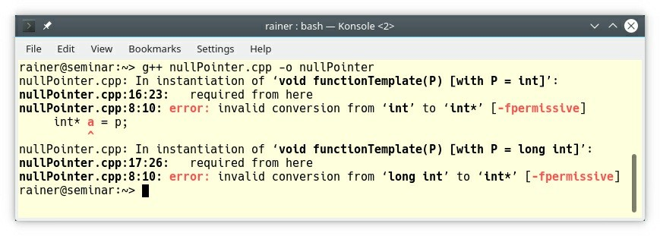

**Figure 8.9. The null pointers 0, NULL, and nullptr**

The compiler deduces 0 in the function template to type int; it deduces NULL to the type long int. This observation does not hold for nullptr. nullptr preservers its type std::nullptr_t through template argument deduction.

**ES.61: Delete arrays using delete[] and non-arrays using delete**

Explicit memory management and not using a container of the STL or a smart pointer such as

std::unique_ptr<X[]> is very error-prone:

void f(int n) {

auto p = new X[n]; // n default constructed Xs

// ...

delete p; // error: just delete the object p,

// rather than delete the array p[]

}

Deleting a C-Array with an *non-array* delete is undefined behavior.

If you have to manage raw memory, read the rules in the allocation and deallocation section.

#### ES.65: Don’t dereference an invalid pointer

If you dereference an invalid pointer, your program has undefined behavior. The only way to avoid this behavior is to check your pointer before its usage.

void func(int* p) { if (!p) {

// do something special

}

int x = *p;

}

How can you overcome this issue? Don’t use a naked pointer. Use a smart pointer such as

std::unique_ptr or std::shared_ptr if you need pointer-like semantics.

### Order of evaluation

If you don’t apply the right order of evaluation in an expression, your program may end in undefined behavior.

#### ES.43: Avoid expressions with undefined order of evaluation

In C++14, the following expression has undefined behavior.

v[i] = ++i; // the result is undefined

This undefined behavior has been addressed in C++17. With C++17, the order of evaluation of the last code snippet is right to left; therefore, the expression has well-defined behavior.

Here are the additional guarantees we have with C++17:

* Postfix expressions are evaluated from left to right. This includes functions calls and member selection expressions.
* Assignment expressions are evaluated from right to left. This includes compound assignments such as +=.
* Operands to shift operators are evaluated from left to right. Here are a few examples:

a.b a->b

a->*b

a(b1, b2, b3) b @= a

a[b]

a << b a >> b

How should you read these examples? First, a is evaluated and then b.

The function call a(b1, b2, b3) is tricky. With C++17, we have the guarantee that each function argument is entirely evaluated before each other function argument, but the order of the evaluation of the arguments is still unspecified.

Let me elaborate a little bit more on the last sentence.

#### ES.44: Don’t depend on order of evaluation of function arguments

In the last years, I saw many errors because developers assumed that the order of the evaluation of function arguments is left to right. Wrong! There is no such guarantee!

// unspecified.cpp #include <iostream>

void func(int fir, int sec) {

std::cout << "(" << fir << "," << sec << ")" << '\n';

}

int main(){

int i = 0; func(i++, i++);

}

The order of the evaluation of the function arguments is unspecified. Unspecified behavior means that the behavior of the program may vary between implementations and the conforming implementation is not required to document the effects of each behavior.

Consequently, the output from GCC and Clang differs even if both compilers conform to the C++ standard:

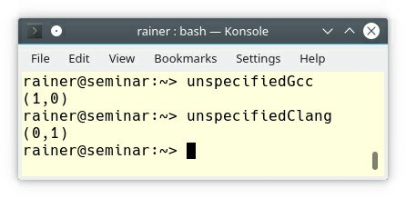

##### Figure 8.10. Unspecified behavior

**Guaranteed order of evaluation in expressions with C++17**

With C++17, the order of evaluation of the following expressions is specified:

f1()->m(f2()); // evaluation left to right std::cout << f1() << f2(); // evaluation left to right

f1() = f(2); // evaluation right to left

Here is the reason, why:

* f1()->m(f2()): Postfix expressions are evaluated from left to right. This includes functions calls and member selection expressions.
* std::cout << f1() << f2(): Operands to shift operators are evaluated from left to right.
* f1() = f(2): Assignment expressions are evaluated from right to left.

### Conversions

Casting types is a common cause of undefined behavior. If necessary, use explicit casts.

#### ES.48: Avoid casts

Let’s see what happens if I screw up the type system and cast a double to a long int and to a

long long int.

// casts.cpp #include <iostream> int main() {

double d = 2;

auto p = (long*)&d; auto q = (long long*)&d;

std::cout << d << ' ' << *p << ' ' << *q << '\n';

}

The result with the Visual Studio compiler is not promising.

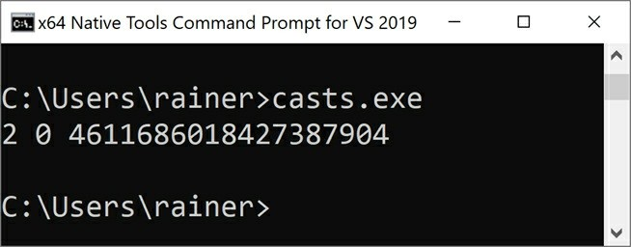

##### Figure 8.11. Wrong casts with the Visual Studio compiler

Nor is the result with the GCC and Clang compiler promising.

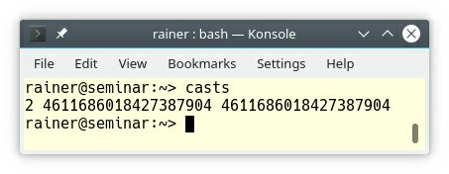

##### Figure 8.12. Wrong casts with the GCC or Clang compiler

What is terrible about the C-cast? You don’t see which cast is actually performed. If you perform a C-cast, a combination of casts is applied if necessary.

Roughly speaking, a C-cast starts with a static_cast, continues with a const_cast, and finally performs a reinterpret_cast.

#### ES.49: If you must use a cast, use a named cast

The principle from The Zen of Python “explicit is better than implicit” also applies to casts in C++: use a named cast if necessary.

With C++11, we have the six following casts:

* **static_cast**: conversion between similar types such as pointer types or numeric types
* **const_cast**: adds or removes const or volatile
* **reinterpret_cast**: converts between pointers or between integral types and pointers
* **dynamic_cast**: converts between polymorphic pointers or references in the same class hierarchy
* **std::move**: converts to an rvalue reference
* **std::forward**: converts an lvalue to an lvalue reference and an rvalue to an rvalue reference

I assume you are surprised that I presented std::move and std::forward as casts. Let’s have a closer look at the internals of std::move:

static_cast<std::remove_reference<decltype(arg)>::type&&>(arg)

What’s happening here? First, the type of the argument arg is deduced by decltype(arg). Afterward, all references are removed, and two new references are added. The function std::remove_reference is from the type-traits library. In the end, we always get an rvalue reference.

#### ES.50: Don’t cast away const

Casting away const is undefined behavior if the underlying object such as constInt is const

and you try to modify the underlying object.

const int constInt = 10;

const int* pToConstInt = &constInt;

int* pToInt = const_cast<int*>(pToConstInt);

*pToInt = 12; // undefined behavior

You can find the rationale to this rule in the C standard, which is also relevant for the C++ standard: “The implementation may place a const object that is not volatile in a read-only region of storage.” ([ISO/IEC 9899:2011] (subclause 6.7.3, paragraph 4).

### Statements

Statements fall mainly into two categories: iteration statements and selection statements. The rules for both kinds of statements are quite clear. Consequently, I quote the rule of the C++ Core Guidelines and add a few pieces of information when necessary.

### Iteration statements

C++ implements three iterations statements: while, do while, and for. With C++11, syntactic sugar is added to the for loop: range-based for loop:

std::vector<int> vec = {0, 1, 2, 3, 4, 5};

// for loop

for(std::size_t i = 0; i < vec.size(); ++i) { std::cout << vec[i] << ' ';

}

// range-based for loop

for (auto ele : vec) std::cout << ele << ' ';

* A range-based for loop is easier to read, and, you can not make an index error or change the index while looping. (ES.71: Prefer a range-for-statement to a for-statement when there is a choice and ES.86: Avoid modifying loop control variables inside the body of raw for loops)
* When you have an obvious loop variable, you should use a for loop instead of a while statement (ES.72: Prefer a for-statement to a while-statement when there is an obvious loop variable); if not, you should use a while statement (ES.73: Prefer a while-statement to a for- statement when there is no obvious loop variable).

for (auto i = 0; i < vec.size(); ++i) {

// do work

}

int events = 0;

while (wait_for_event()) {

++events;

// do work

}

* You should declare a loop variable in a for loop (ES.74: Prefer to declare a loop variable in the initializer part of a for-statement). To remind you, since C++17, declaring a variable such a result can also be done in the initialization part of an if or a switch statement.

std::map<int,std::string> myMap;

if (auto result = myMap.insert(value); result.second){ useResult(result.first);

// ...

}

else{

// ...

} // result is automatically destroyed

* Avoid do while statements (ES.75: Avoid do-statements), goto statements (ES.76: Avoid goto), and minimize the use of break and continue in iteration statements (ES.77: Minimize the use of break and continue in loops) because they are difficult to read. If something is difficult to read, it’s error-prone and make refactoring of your code challenging. A break statement ends the iteration statement and a continue statement ends the current iteration step.

##### Prefer an algorithm to a raw loop

There is one meta-rule missing in this section: “*prefer an algorithm to a raw loop provided there is a suitable named algorithm for the purpose*” (Bjarne Stroustrup during his proof reading). The more than 100 algorithms of the Standard Template Library provide implicit operations on containers. This operation can often be adapted by a lambda expression or performed in a parallel or parallel and vectorized version.

std::vector<int> vec = {-10, 5, 0, 3, -20, 31};

// permitting parallel execution std::sort(std::execution::par, vec.begin(), vec.end());

// permitting parallel and vectorized execution std::sort(std::execution::par_unseq, vec.begin(), vec.end())

### Selection statements

if and switch are the selection statements of C++ which we inherited from C.

* You should prefer a switch statement to an if statement when there is a choice (ES.70: Prefer a switch statement to an if-statement when there is a choice) because a switch statement may be more readable and can be better optimized than an if statement.

The next two rules related to switch statements need more attention then the ones before.

#### ES.78: Don’t rely on implicit fallthrough in switch statements

I saw switch statements in legacy code, which had more than a hundred case labels. If you use nonempty cases without a break, the maintenance of these switch statements becomes a nightmare. Here is an example from the C++ Core Guidelines:

switch (eventType) { case Information:

update_status_bar(); break;

case Warning:

write_event_log();

// Bad - implicit fallthrough case Error:

display_error_window(); break;

}

Maybe, you overlooked it. The Warning case has no break statement; therefore, the Error case is automatically executed.

Since C++17, we have a cure with the attribute [[fallthrough]]. Now, you can explicitly express your intention. [[fallthrough]] has to be in its own statement line and immediately before a case label. [[fallthrough]] indicates to the compiler that a fall through is intentional. Consequently, the compiler may not diagnose a warning.

void f(int n) {

void g(), h(), i(); switch (n) {

case 1:

case 2:

g();

[[fallthrough]]; // (1)

case 3:

h(); // (2)

case 4:

i();

[[fallthrough]]; // (3)

}

}

The [[fallthrough]] attribute in (1) suppresses a compiler warning. That does not hold for (2). The compiler may warn. (3) is ill-formed because no case label is following.

#### ES.79: Use default to handle common cases (only)

The program switch.cpp should exemplify this rule.

// switch.cpp

#include <iostream> enum class Message{

information, warning, error, fatal

};

void writeMessage() { std::cerr << "message" << '\n'; } void writeWarning() { std::cerr << "warning" << '\n'; }

void writeUnexpected() { std::cerr << "unexpected" << '\n'; }

void withDefault(Message message) { switch(message) {

case Message::information: writeMessage(); break;

case Message:: warning:

writeWarning(); break;

default:

writeUnexpected(); break;

}

}

void withoutDefaultGood(Message message) { switch(message) {

case Message::information: writeMessage(); break;

case Message:: warning: writeWarning(); break;

default:

// nothing can be done break;

}

}

void withoutDefaultBad(Message message) { switch(message) {

case Message::information: writeMessage(); break;

case Message::warning: writeWarning(); break;

}

}

int main() {

withDefault(Message::fatal); withoutDefaultGood(Message::information); withoutDefaultBad(Message::warning);

}

The implementation of the functions withDefault and withoutDefaultGood are expressive enough. The maintainer of the function withoutDefaultGood knows because of the comment that there is no default case for this switch statement. Compare the function withoutDefaultGood and withoutDefaultBad from a maintenance point of view. Do you know, if the implementer of the function withoutDefaultBad forgot the default case or if the enumerator’s Message::error and Message::fatal were later added? To make sure, you have to study the source code or ask the original author of the code, if possible.

### Arithmetic

The seven arithmetic rules provide a significant surprise potential. They focus on two topics: arithmetic with signed and unsigned integers, and typical arithmetic errors such as overflow/underflow and division by zero.

### Arithmetic with signed/unsigned integers

Breaking these arithmetic rules ends often in unexpected results.

#### ES.100: Don’t mix signed and unsigned arithmetic

If you mix signed and unsigned arithmetic, you may not get the expected result.

// mixSignedUnsigned.cpp #include <iostream>

int main() {

int x = -3; unsigned int y = 7;

std::cout << x - y << '\n'; // 4294967286 std::cout << x + y << '\n'; // 4 std::cout << x * y << '\n'; // 4294967275 std::cout << x / y << '\n'; // 613566756

}

GCC, clang, and the Microsoft Compiler produce the same result.

#### ES.101: Use unsigned types for bit manipulation

Bit manipulations with bitwise operators (~, >>, >>=, <<, <<=, &, &=, ^, ^=, |, and |=) have implementation-defined behavior when performed on signed operands. Implementation-defined behavior means that the behavior varies between implementations, and the implementation must document the effects of each behavior. Consequently, don’t perform bit manipulations on signed types, but use unsigned types instead:

unsigned char x = 0b00110010;

unsigned char y = ~x; // y == 0b11001101

#### ES.102: Use signed types for arithmetic

First, you should not do arithmetic with unsigned types, because subtraction of two values gives often a negative value. Second, you should not mix signed and unsigned arithmetic according to the previous rule: ES.100: Don’t mix signed and unsigned arithmetic. Let’s see what happens when I break the rule.

GCC, clang, and the Microsoft Compiler produce the same result.

// signedTypes.cpp #include <iostream>

template<typename T, typename T2> T subtract(T x, T2 y) {

return x - y;

}

|  |  |  |  |  |
| --- | --- | --- | --- | --- |
| int | main() {  int s = 5; unsigned int | us = 5; |  | |
|  | std::cout << | subtract(s, 7) << '\n'; | // | -2 |
|  | std::cout << | subtract(us, 7u) << '\n'; | // | 4294967294 |
|  | std::cout << | subtract(s, 7u) << '\n'; | // | -2 |
|  | std::cout << | subtract(us, 7) << '\n'; | // | 4294967294 |
|  | std::cout << | subtract(s, us + 2) << '\n'; | // | -2 |
|  | std::cout << | subtract(us, s + 2) << '\n'; | // | 4294967294 |
| } |  |  |  |  |

#### ES.106: Don’t try to avoid negative values by using unsigned

There is an interesting relation. When you assign a -1 to an unsigned int, you get the largest

unsigned int.

The behavior of arithmetic expression may differ between signed and unsigned types. Let’s start with a simple program.

// modulo.cpp

#include <cstddef> #include <iostream>

int main(){

std::cout << '\n';

unsigned int max{100000}; unsigned short x{0}; std::size_t count{0};

while (x < max && count < 20) { std::cout << x << " ";

x += 10000; // (1)

++count;

}

std::cout << "\n\n";

}

The crucial point of the program is that the successive addition to x in (1) does not trigger an overflow but a modulo operation if the value range of x ends. The reason is that x is of type unsigned short.

Making x signed changes the behavior of the program drastically.

// overflow.cpp

#include <cstddef> #include <iostream>

int main() {

std::cout << '\n';

int max{100000}; short x{0}; std::size_t count{0};

while (x < max && count < 20) { std::cout << x << " ";

x += 10000;

++count;

}

std::cout << "\n\n";

}

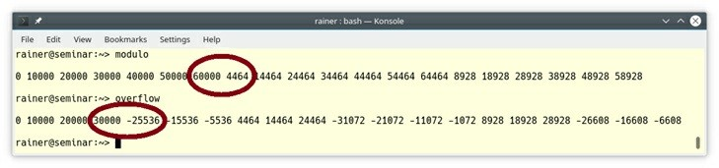The addition now triggers an overflow. In the screenshot, I marked the key points with red circles.

##### Figure 8.13. Modulo versus overflow with unsigned’s and signed’s Detecting overflow

You may have a burning question: How can you detect an overflow? Quite easy! Replace the erroneous assignment x += 1000 with an expression using curly braces: x = {x + 1000}.

The difference is that the compiler checks for narrowing conversions and, therefore, detects the overflow. Here is the output from GCC.

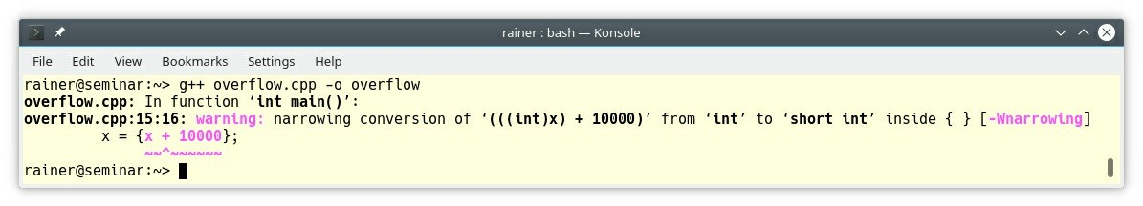

**Figure 8.14. Detecting narrowing conversion**

### Typical arithmetic errors

The following three rules always result in undefined behavior.

#### ES.103: Don’t overflow, and ES.104: Don’t underflow

Let me combine both rules. The effect of an overflow or an underflow is the same: memory corruption and, therefore, undefined behavior. Let’s make a simple test with an int array. How long will the following program run, when I compile it with GCC?

// overUnderflow.cpp

#include <cstddef> #include <iostream>

int main() {

int a[0]; int n = 0;

while (true){

if (!(n % 100)){

std::cout << "a[" << n << "] = " << a[n]

<< ", a[" << -n << "] = " << a[-n] << '\n';

}

a[n] = n; a[-n] = -n;

++n;

}

}

Disturbingly long. The program writes each 100th array entry to std::cout.

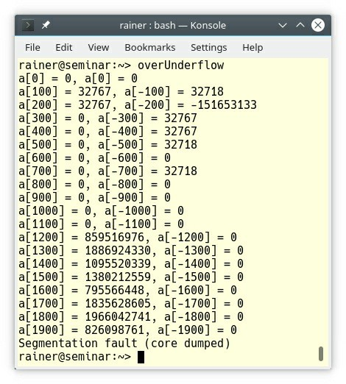

**Figure 8.15. Underflow and overflow of a C-array**

#### ES.105: Don’t divide by zero

Dividing by zero crashes with high probability the execution of your program.

auto res = 5 / 0; // crash

Diving by zero may be fine in a logical expression.

auto res = false and (5 / 0); // fine

The result of the expression (5 / 0) is not necessary for the overall result and is thus not evaluated. This technique is called short circuit evaluation and is a special case of lazy evaluation.

### Related Rules

I write about the rule ES.25: Declare an object const or constexpr unless you want to modify its value later on in the section Constants and Immutability.

The section metaprogramming provides an introduction to template metaprogramming and

constexpr functions as a replacement for a function-like macro.

The rules related to expressions have a broad focus. Consequently, some of the rules have a strong overlap with already presented rules. Find more details in the referenced rules:

* ES.56: Write std::move() only when you need to explicitly move an object to another scope (see Parameter passing: ownership semantics)
* ES.60: Avoid new and delete outside resource management functions (see R.12: Immediately give the result of an explicit resource allocation to a manager object)
* ES.63: Don’t slice (see C.67: A polymorphic class should suppress copying)
* ES.64: Use the T{e} notation for construction (see ES.23: Prefer the {}-initializer syntax)

### Distilled

##### Important

* If you write a loop, you probably don’t know the algorithms of the Standard Template Library (STL) good enough. The STL has more than 100 algorithms.
* Good names are probably the most important rule for good software. Good names mean, that your names should be self-explanatory, should be as local as possible, should not be similar to existing names, should not be written in ALL_CAPS, and should not be reused in nested scopes.
* Always initialize a variable. Prefer {}-initialization to prevent narrowing conversion. For complex initialization of const variables, use in-place invoked lambda-expressions.
* Don’t use macros for constants or functions. If you have to use them or to maintains existing ones, use unique ALL_CAPS names.
* You should prefer a range-base for loop to a for loop if possible. range-based for loops are easier to read and cannot cause an index error.
* You should prefer a switch statement to an if statement. switch statements are easier to read and have more optimization potential.
* Unless there is a specific reason, use signed integers and don’t mix signed and unsigned arithmetic.
* Be aware that overflow or underflow is undefined behavior and ends typically in a crash at run-time of your program.

## Chapter 9. Performance



##### Figure 9.1. Cippi’s performance test

Performance or low-latency is the sweet-spot for C++, right? Therefore, I’m quite surprised that only a quarter of the 20 rules to performance have substantial content. Hence, I have to improvise a little to make a story out of the existing guidelines. The performance rules of the C++ Core Guidelines start with rules for wrong optimizations, continue with rules about wrong assumptions, and end with rules to enable optimization.

### Wrong optimizations

* Per.1: Don’t optimize without reason
* Per.2: Don’t optimize prematurely
* Per.3: Don’t optimize something that’s not performance critical A famous quote can nicely summarize the three first rules.

The real problem is that programmers have spent far too much time worrying about efficiency in the wrong places and at the wrong times; premature optimization is the root of all evil (or at least most of it) in programming

—Donald Knuth, Computer Programming as an Art (1974)

To make it short, keep the phrase “premature optimization is the root of all evil” in mind. Before you make any performance assumption apply the most critical rule to performance analysis: **Measure the performance of your program**.

Without performance numbers, you don’t know:

* Which part of your program is the bottleneck?
* How fast is good enough for your user?
* How fast could the program potentially be?

Make the performance test with real-world data and test under version control. Re-run those performance tests each time you change something in your infrastructure such as the hardware or the compiler.

Applying substantial optimization based on wrong assumptions is a typical anti-pattern.

### Wrong assumptions

* Per.4: Don’t assume that complicated code is necessarily faster than simple code
* Per.5: Don’t assume that low-level code is necessarily faster than high-level code
* Per.6: Don’t make claims about performance without measurements

Before I continue, I have to make a disclaimer: I do not recommend using the infamous singleton pattern. The singleton has many drawbacks. You can read more about them in section dedicated to singletons. I use the singleton pattern in this section because the following example is based

on a real-world example.

Let me show you that complicated and low-level code does not always pay off. To prove my point I have to measure the performance of various singleton implementation.

The key idea of the performance test is to invoke the singleton pattern 40,000,000 times from four threads, measure the execution time of each thread and sum the numbers up. Four threads seem to be the right choice due to my four core machine. The singleton pattern is initialized lazily; therefore, the first call has to initialize it.

Don’t take the performance numbers too seriously. They should only give a ballpark feeling.

My first implementation is based on the so-called Meyers singleton. It is thread-safe because of the C+ +11 standard guarantees that a static variable with block scope is initialized in a thread- safe way.

1 // singletonMeyers.cpp 2

1. #include <chrono>
2. #include <iostream>
3. #include <future> 6

7 constexpr auto tenMill = 10'000'000; 8

1. class MySingleton {
2. public:
3. static MySingleton& getInstance() {
4. static MySingleton instance;
5. volatile int dummy{};
6. return instance; 15 }
7. private:
8. MySingleton()= default;
9. ~MySingleton()= default;
10. MySingleton(const MySingleton&)= delete;
11. MySingleton& operator = (const MySingleton&)= delete; 21 };

22

23 std::chrono::duration<double> getTime() { 24

1. auto begin= std::chrono::system_clock::now();
2. for (size_t i = 0; i < tenMill; ++i) {
3. MySingleton::getInstance(); 28 }

29 return std::chrono::system_clock::now() - begin; 30

31 };

32

33 int main() { 34

1. auto fut1 = std::async(std::launch::async,getTime);
2. auto fut2 = std::async(std::launch::async,getTime);
3. auto fut3 = std::async(std::launch::async,getTime);
4. auto fut4 = std::async(std::launch::async,getTime); 39
5. auto total = fut1.get() + fut2.get() +
6. fut3.get() + fut4.get(); 42

43 std::cout << total.count() << '\n'; 44

45 }

Line 12 uses the guarantee of the C++11-runtime that the singleton is initialized in a thread-safe way. Each of the four threads in the main function invokes ten million times the singleton in line

27. In total, this makes forty million calls. The volatile variable dummy at line 13 is necessary. Without the variable dummy, the optimizer would make a perfect job and remove the loop in lines 26 - 28. Of course, the performance numbers would be impressive.

Let’s try to do better. This time I use atomics to make the singleton pattern thread-safe. My implementation is based on the infamous double-checked locking pattern. For the sake of simplicity, I will only show the implementation of the class MySingleton.

class MySingleton { public:

static MySingleton* getInstance() {

MySingleton* sin= instance.load(std::memory_order_acquire); if ( !sin ) {

std::lock_guard<std::mutex> myLock(myMutex); sin = instance.load(std::memory_order_relaxed);

if( !sin ){

sin = new MySingleton(); instance.store(sin,std::memory_order_release);

}

}

volatile int dummy{}; return sin;

}

private:

MySingleton()= default;

~MySingleton()= default; MySingleton(const MySingleton&)= delete;

MySingleton& operator = (const MySingleton&)= delete;

static std::atomic<MySingleton*> instance; static std::mutex myMutex;

};

std::atomic<MySingleton*> MySingleton::instance; std::mutex MySingleton::myMutex;

To understand the implementation, you have to study the memory orderings, think about the acquire-release semantics and think about the synchronization and ordering constraint. This is not an easy job and it may take days.

But you know, highly sophisticated code pays off.

Darn. I forgot to apply the critical rule of performance optimization: Per.6: Don’t make claims about performance without measurements. Here are the performance numbers for the Meyers singleton on Linux. I compiled the program, as always, with maximum optimization.

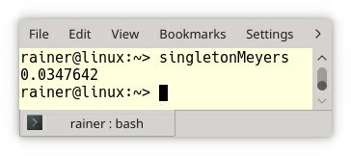

##### Figure 9.2. Performance of the Meyers singleton

Now I’m curious. What are the numbers for my highly sophisticated code?

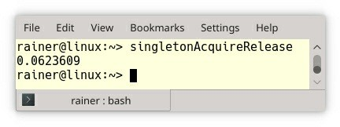

##### Figure 9.3. Performance of the singleton based on acquire-release semantic

80% percent slower! 80% percent slower, and we cannot even prove that the implementation is correct.

Are we done? No! I don’t have a baseline. The baseline should be your starting, not your ending point for a performance test. How fast can forty million invocations of a singleton be? Invoking forty million times the singleton from a single-threaded implementation with no synchronization overhead provides me a good baseline.

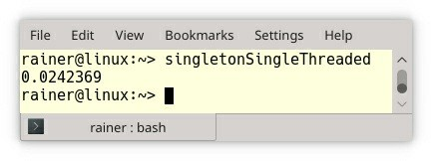

##### Figure 9.4. Performance of the singleton in the single-threaded case

The single-threaded execution takes about 0.024 seconds, and the mulithreaded execution based on the Meyers singleton about 0.035 seconds. This means that the synchronization overhead makes the Meyers singleton 45 % slower.

This small synchronization overhead is quite remarkable. If you want to know the entire story behind the thread-safe initialization of the singleton pattern, read the post: Thread-Safe Initialization of a Singleton. This story includes additional implementations based on the function std::call_once and the std::once_flag, the lock std::lock_guard, and atomics using sequential consistency. The performance numbers provided are for Linux (GCC) and the

Microsoft platform (cl.exe).

### Enable optimization

The last section is about wrong assumptions. Now, I want to take an optimistic approach.

##### Get the ultimate truth with the Compiler Explorer

If you want to know, which code is better optimized, you have to study the generated assembler instructions. Compiler Explorer generates the assembler instructions for various compilers including GCC, clang, and the Microsoft Compiler the assembler instructions. Various versions of the various compilers are available. Additionally, you can specify the compiler flags such as - O3 or /Ox for maximum optimization.

### Per.7: Design to enable optimization

This rule applies, in particular, to move semantics. Because you should write your algorithms using move semantics and not copy semantics. Using move semantics automatically provides a few benefits.

1. Instead of an expensive copy operation, your algorithm uses a cheap move operations.
2. Your algorithm is a lot more stable because it requires no memory allocation and, therefore,

std::bad_alloc exceptions are not possible.

1. You can use your algorithm with move-only types such as std::unique_ptr.

You may see a loophole in my argumentation. What happens when I use a copy-only type in an algorithm requiring move semantics?

// swap.cpp

#include <algorithm> #include <iostream> #include <utility>

template <typename T>

void swap(T& a, T& b) noexcept { // (2) T tmp(std::move(a));

a = std::move(b); b = std::move(tmp);

}

class BigArray { public:

explicit BigArray(std::size_t sz): size(sz), data(new int[size]) {}

BigArray(const BigArray& other): size(other.size),

data(new int[other.size]) { std::cout << "Copy constructor" << '\n'; std::copy(other.data, other.data + size, data);

}

BigArray& operator = (const BigArray& other) { std::cout << "Copy assignment" << '\n'; if (this != &other){

delete [] data; data = nullptr; size = other.size;

data = new int[size];

std::copy(other.data, other.data + size, data);

}

return *this;

}

~BigArray() {

delete[] data;

}

private:

std::size_t size; int* data;

};

int main(){

std::cout << '\n';

BigArray bigArr1(2011); BigArray bigArr2(2017); swap(bigArr1, bigArr2); // (1)

std::cout << '\n';

}

BigArray does not support move semantics, only copy semantics. What happens if I swap the

BigArray’s in (1)? My swap algorithm uses move semantics (2) internally. Let’s try it out.

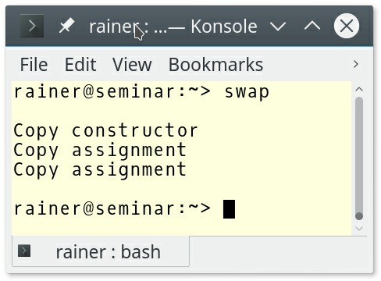

##### Figure 9.5. Move semantics on a copy-only type

Applying move operations on a copy-only type triggers copy operations. Copy semantics is a kind of fall-back to move semantics. You can see it the other way around. Move is an optimized copy. How is this possible? I asked for a move operation in my swap algorithm. The reason is that std::move returns an rvalue. A const lvalue reference can bind to an rvalue, and the copy constructor or the copy assignment operator takes a const lvalue reference. If BigArray would have a move constructor or a move assignment operator taking rvalue references, both would have higher priority than the copy constructor or the move assignment operator. Implementing your algorithms with move semantics means that move semantics automatically kicks in if your data types support it. If not, copy semantics is used as a fallback. In the worst case, you get the classical behavior.

When you study the copy assignment operator, it has a number of flaws. Here are they:

1. The expression (if(this != &other)) checks for self-assignment. Most of the times self- assignment does not happen, but the check is always performed.
2. If the allocation (data = new int[size]) fails, this is already modified. The size is wrong, and data is already deleted. This behavior means the copy constructor only guarantees that there is no leak after an exception.
3. The expression (std::copy(other.data, other.data + size, data)) is used in the copy constructor, and in the copy assignment operator.

Implementing a swap function for BigArray and implementing the copy assignment operator with the help of the swap function would solve all flaws. Here is the copy assignment operator, which takes its argument by value. Consequently, a test for self-assignment is not necessary.

BigArray& operator = (BigArray other) { swap(*this, other);

return *this;

}

BigArray still has few flaws. Using a std::vector instead of a C-array solves them. The definition of BigArray boils down to a few lines:

class BigArray { public:

BigArray(std::size_t sz): vec(std::vector<int>(sz)) {} private:

std::vector<int> vec;

};

The compiler can auto-generate the big six if all members of the class support the big six. The big six include the default constructor, destructor, copy and move assignment operator, and copy and move constructor. std::vector supports the big six and, therefore, BigArray does support he big six with one exception. Due to the user-defined constructor, BigArray does not have a default constructor.

### Per.10: Rely on the static type system

There are many ways that you can help the compiler to generate more optimized code.

* **Write local code:**Using an in-place invoked lambda instead of a function to adjust the

behavior of std::sort is in-general the faster variant. The compiler has all the information available to generate the most optimized code. On the contrary, a function could be defined in another translation unit, which is a hard boundary for the optimizer.

bool lessLength(const std::string& f, const std::string& s){ return f.size() < s.size();

}

int main() {

std::vector<std::string> vec = {"12345", "123456", "1234",

"1", "12", "123", "12345"};

// a function as predicate std::sort(vec.begin(), vec.end(), lessLength);

// a lambda as predicate std::sort(vec.begin(), vec.end(),

[](const std::string& f, const std::string& s) { return f.size() < s.size();

});

}

* **Write simple code:**: The optimizer looks for known patterns which could be optimized. If your code is very hand-crafted and complicated, you make the job of the optimizer harder to find known patterns. In the end, you often get less optimized code
* **Give the compiler additional hints:** When your function cannot throw, or you don’t care, declare it as noexcept. It is equally valuable to the optimizer to declare a virtual function as final, if it should not be overridden.

### Per.11: Move computation from run time to compile-time

The following example shows the gcd algorithm which calculates the greatest common division at runtime. gcd is implemented using the euclidean algorithm.

int gcd(int a, int b) { while (b != 0) {

auto t = b; b = a % b; a = t;

}

return a;

}

By declaring gcd as constexpr gcd becomes a function that can be executed at compile-time. There are a few restrictions on constexpr functions. gcd must not use static or thread_local variables, exception handling, goto statements, and all variables have to be initialized and have a literal type. A literal type is essential a built-in type, or a reference, or an array of literal types, or a class with a constexpr constructor.

Let’s try it out.

// gcd.cpp

#include <iostream>

constexpr int gcd(int a, int b) { while (b != 0){

auto t = b; b = a % b; a = t;

}

return a;

}

int main() {

std::cout << '\n';

constexpr auto res1 = gcd(121, 11); // (1) std::cout << "gcd(121, 11) = " << res1 << '\n';

auto val = 121; // (3)

auto res2 = gcd(val, 11); // (2) std::cout << "gcd(val, 11) = " << res2 << '\n';

std::cout << '\n';

}

Declaring gcd as a constexpr function does not mean that it has to run at compile-time. It means that gcd has the potential to run at compile-time. A constexpr function has to be executed at compile-time if used in a constant expression. resl in (1) is a constant expression because I ask for the result with a constexpr variable res1. res2 in (2) is not a constant expression because val in (3) is not a constant expression. When I change res2 to constexpr auto res2, I get an error: val is not a constant expression. The following image shows the output of the program.

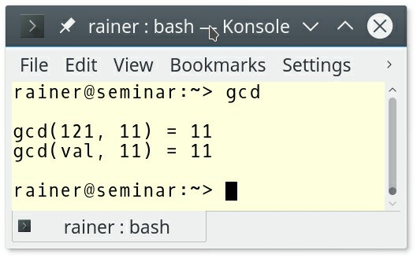

##### Figure 9.6. Invoking gcd at compile-time and run-time

Once more, here is the key observation. **You can use a constexpr function at run-time and compile-time. To use it at compile-time its arguments have to be constant expressions.**

Thanks to the Compiler Explorer, I can show the relevant assembler instructions for this program. The invocation of the function gcd(121, 11) in line 18 boils down to its result as a constant.

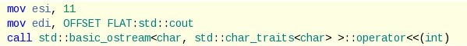

**Figure 9.7. The relevant assembler instructions to the algorithm gcd**

### Per.19: Access memory predictably

What does predictably mean? For example, you read an int from memory more than the size of this one int is read from memory. An entire cache line is read from memory and stored in a CPU’s cache.

On modern architectures, a cache line typically has 64 bytes. If you now request an additional variable from memory and this variable is already cached, the read directly uses this cache, and the operation is much faster.

A data structure such as std::vector, which stores its data in a contiguous memory block, is a cache line friendly data structure because each element in the cache line is typically used. This cache line friendliness also holds for a std::array, and std::string.

std::deque is in its structure similar to std::vector, but the elements of std::deque are not stored in a contiguous memory block. The elements of a std::deque are typically stored in a sequence of fixed-size arrays. The fixed-sized arrays are filled before new arrays are added to the std::deque.

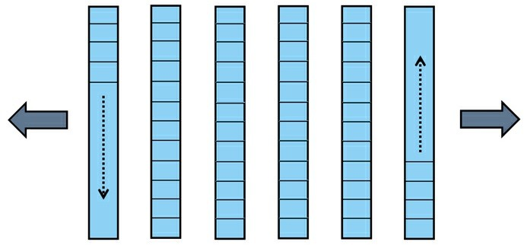

**Figure 9.8. std::deque**

In contrast, std::list and std::forward_list are doubly or singly linked containers. A

std::list increases in both directions, but a std::forward_list in one direction.



**Figure 9.9. std::list**



**Figure 9.10. std::forward_list**

This was the theory of cache lines. Now, I’m curious. Does it make a performance difference to read and accumulate all elements of a std::vector, a std::deque, a std::list, and a std::forward_list. The small program gives an answer.

1 // memoryAccess.cpp 2

|  |  |  |  |
| --- | --- | --- | --- |
| 3 | #include | <forward_list> | |
| 4 | #include | <chrono> | |
| 5 | #include | <deque> | |
| 6 | #include | <iomanip> | |
| 7 | #include | <iostream> | |
| 8 | #include | <list> | |
| 9 | #include | <string> | |
| 10 | #include | <vector> | |
| 11 | #include | <numeric> | |
| 12 | #include | <random> | |
| 13 |  |  | |
| 14 | const int SIZE = 100'000'000; | |  |
| 15 |  | |  |
| 16 | template <typename T> | |  |
| 17 | void sumUp(T& t, const std::string& cont) { | |  |
| 18 |  | |  |
| 19 | std::cout << std::fixed << std::setprecision(10); | |  |
| 20 |  | |  |
| 21 | auto begin = std::chrono::steady_clock::now(); | |  |
| 22 | std::size_t res = std::accumulate(t.begin(), t.end(), | | 0LL); |
| 23 | std::chrono::duration<double> last = | |  |
| 24 | std::chrono::steady_clock::now() - begin; | |  |
| 25 | std::cout << cont << '\n'; | |  |
| 26 | std::cout << "time: " << last.count() << '\n'; | |  |
| 27 | std::cout << "res: " << res << '\n'; | |  |
| 28 | std::cout << '\n'; | |  |
| 29 |  | |  |
| 30 | std::cout << '\n'; | |  |
| 31 |  | |  |
| 32 | } | |  |
| 33 |  | |  |
| 34 | int main() { | |  |
| 35 |  | |  |
| 36 | std::cout << '\n'; | |  |
| 37 |  | |  |

|  |  |  |
| --- | --- | --- |
| 38 |  | std::random_device seed; |
| 39 |  | std::mt19937 engine(seed()); |
| 40 |  | std::uniform_int_distribution<int> dist(0, 100); |
| 41 |  |  |
| 42 |  | std::vector<int> randNum; |
| 43 |  | randNum.reserve(SIZE); |
| 44 |  | for (int i = 0; i < SIZE; ++i){ |
| 45 |  | randNum.push_back(dist(engine)); |
| 46 |  | } |
| 47 |  |  |
| 48 |  | { |
| 49 |  | std::vector<int> vec(randNum.begin(), randNum.end()); |
| 50 |  | sumUp(vec,"std::vector<int>"); |
| 51 |  | } |
| 52 |  |  |
| 53 |  |  |
| 54 |  | { |
| 55 |  | std::deque<int>deq(randNum.begin(), randNum.end()); |
| 56 |  | sumUp(deq,"std::deque<int>"); |
| 57 |  | } |
| 58 |  |  |
| 59 |  | { |
| 60 |  | std::list<int>lst(randNum.begin(), randNum.end()); |
| 61 |  | sumUp(lst,"std::list<int>"); |
| 62 |  | } |
| 63 |  |  |
| 64 |  | { |
| 65 |  | std::forward_list<int>forwardLst(randNum.begin(), |
| 66 |  | randNum.end()); |
| 67 |  | sumUp(forwardLst,"std::forward_list<int>"); |
| 68 |  | } |
| 69 |  |  |
| 70 | } |  |

The program memoryAccess.cpp creates first 100 million random numbers between 0 and 100 (line 38). Then it accumulates the elements using a std::vector (line 50), a std::deque (line 56), a std::list (line 61), and a std::forward_list (line 67). The actual work is done in the function sumUp (lines 16 - 32). My educated guess is that GCC, clang, and the Microsoft Visual Studio compiler use a quite similar implementation of std::accumulate.

template<class InputIt, class T>

T accumulate(InputIt first, InputIt last, T init) { for (; first != last; ++first) {

init = init + *first;

}

return init;

}

Consequently, the access time of the elements is the dominant factor for the overall performance.

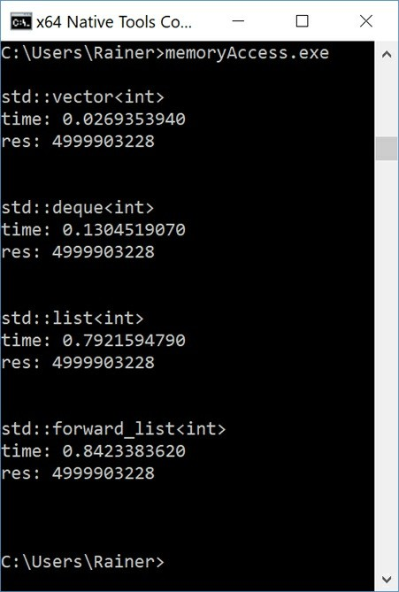

##### Figure 9.11. Memory access for sequence containers on Windows

Here are a few observations:

* std::vector is 30 times faster than std::list or std::forward_list.
* std::vector is 5 times faster than std::deque.
* std::deque is 6 times faster than std::list and std::forward_list.
* std::list and std::forward_list are in the same ballpark.

Although I got similar relative numbers on Linux with the GCC compiler, don’t take the performance numbers too seriously. The performance numbers give a solid indication that the access time to the elements heavily depends on the cache line friendliness of the container.

### Related Rules

The section metaprogramming provides an introduction to template metaprogramming, the type- traits library and constexpr functions as a means to move computation from run-time to compile-time.

### Distilled

##### Important

* Before you make any supposed optimization based on wrong assumptions, measure the performance of your program.
* Help the compiler to optimize your program. Implement your functions with move semantics and make them constexpr if possible.
* Modern computer architectures are optimized for the contiguous reading of memory. Consequently, std::vector, std::array, or std::string should be your first choice.

## Chapter 10. Concurrency



##### Figure 10.1. Cippi's challenges with threads

The C++ Core Guidelines list about 30 rules for concurrency that focus on three main goals:

* To help in writing code that is amenable to being used in a multithreaded environment
* To show clean, safe ways to use the threading primitives offered by the standard library
* To offer guidance on what to do when concurrency and parallelism aren’t giving the performance gains needed

The rules consist of general guidelines, targeted to a non expert audience applied to: concurrency, parallelism, message passing, and lock-free programming.

##### Concurrency versus parallelism

* **Concurrency**: The execution of several tasks overlaps. Concurrency is a superset of parallelism.
* **Parallelism**: several tasks are run at the same time. Parallelism is a subset of concurrency.

### General guidelines

Although the rules of this section have a general focus, all of them are very important.

### CP.1: Assume that your code will run as part of a multi-threaded program

Maybe, you are surprised to read this rule. Why should I optimize for the special case? To make it clear, this rule is mainly about code used in libraries. And the experience shows that library code is often reused. This reuse means that the code is likely to be end up being exercised in a multi-threaded program.

The code snippet shows an example from the guidelines.

1 double cached_computation(double x) {

|  |  |  |  |
| --- | --- | --- | --- |
| 2 | static | | double cached_x = 0.0; |
| 3 | static | | double cached_result = COMPUTATION_OF_ZERO; |
| 4 | double | | result; |
| 5 |  | |  |
| 6 |  | if (cached_x == x) return cached_result; | |
| 7 |  | result = computation(x); | |
| 8 |  | cached_x = x; | |
| 9 |  | cached_result = result; | |
| 10 |  | return result; | |
| 11 | } |  | |

The function cached_computation is fine if it runs in a single-threaded environment. This observation does not hold for a multithreading environment because of the static variables

cached_x (lines 2, 6, and 9) and cached_result (lines 3, 6, and 9 ) can be modified simultaneously by various threads.

Unsynchronized reading and writing of a shared non-atomic variable is a data race. Consequently, your program has undefined behavior.

What are your options to get rid of the data race?

1. Use one lock to protect the entire critical region.
2. Protect the call to the function cached_computation by a lock.
3. Make both static variables thread_local. thread_local guarantees that each thread gets its variable cached_x and cached_result. Such a static variable is bound to the lifetime of the main-thread, a thread_local variable is bound to the lifetime of its thread.

std::mutex m;

double cached_computation(double x) { // (1) static double cached_x = 0.0;

static double cached_result = COMPUTATION_OF_ZERO; double result;

{

std::lock_guard<std::mutex> lck(m); if (cached_x == x) return cached_result; result = computation(x);

cached_x = x; cached_result = result;

}

return result;

}

std::mutex cachedComputationMutex; // (2)

{

std::lock_guard<std::mutex> lck(cachedComputationMutex); auto cached = cached_computation(3.33);

}

double cached_computation(double x) { // (3) thread_local double cached_x = 0.0;

thread_local double cached_result = COMPUTATION_OF_ZERO; double result;

if (cached_x == x) return cached_result; result = computation(x);

cached_x = x; cached_result = result; return result;

}

First, the C++11 standard guarantees that the C++ run-time initializes static variables in a thread-safe way; therefore, you do not need to protect their initialization.

1. This version uses a coarse-grained locking approach. Usually, you should not use coarse- grained locking such in this version, but maybe, in this use-case, it is acceptable.
2. This version is the most coarse-grained solution because the entire function is locked. Of course, the downside is that the user of the function is responsible for the synchronization. In general, that is a bad idea.
3. Just make the static variables thread_local, and you are done.

### CP.2: Avoid data races

First of all, what is a data race?

* A **data race** is a situation, in which at least two threads access a non-atomic shared variable without synchronization, and at least one thread tries to modify the variable.

The rest is simple. If you have a data race in your program, your program has undefined behavior.

If you read the definition of data race carefully, you notice that shared mutable state is necessary for having a data race. Here is a picture to display this critical observation. You should avoid the bottom right quadrant, in particular, in a concurrent environment.



##### Figure 10.2. Four categories of variables

Let me show you a simple data race.

// dataRace.cpp

#include <future> int getUniqueId() {

static int id = 1; return id++;

}

int main() {

auto fut1 = std::async([]{ return getUniqueId(); }); auto fut2 = std::async([]{ return getUniqueId(); });

auto id = fut1.get(); auto id2= fut2.get();

}

What can go wrong? For example id++ is a read-modify-write operation. Even if each of the three operations read, modify, and write would be atomic, the read-modify-write operation is not atomic. The effect of this data race would be with high probability, that id's would not be

unique.

### CP.3: Minimize explicit sharing of writable data

Based on the previous rule related to data races, your shared data should be constant.

Now, the only challenge left to solve is how to initialize the constant shared data in a thread-safe way. C ++11 support a few ways to achieve this.

1. Initialize your data before you start a thread. This is not due to C++11 but often quite easy to apply.

const std::unordered_map<std::string, int> val = {

{"Grimm",1966},

{"Smith",1968},

{"Blac",1930} };

std::thread t1([&tele] { });

std::thread t2([&tele] { });

1. Use constant expressions because they are initialized at compile-time.

constexpr auto doub = 5.1;

1. Use the function std::call_once in combination with the std::once_flag. You can put the important initialization stuff into the function onlyOnceFunc. The C++ runtime guarantees that this function runs exactly once successfully.

std::once_flag onceFlag;

void do_once() { std::call_once(onceFlag, []{

std::cout << "Important initialization" << '\n';

};

}

...

std::thread t1(do_once); std::thread t2(do_once); std::thread t3(do_once); std::thread t4(do_once);

1. Use static variables with block scope because the C++11 runtime guarantees that they are initialized in a thread-safe way.

void func() {

....

static int val = 2011;

....

}

...

std::thread t1{ func() };

std::thread t2{ func() };

### CP.4: Think in terms of tasks, rather than threads

What is a task? A test is a general term for a unit of execution. Since C++11, we use task as a special term, which stands for two components: a promise and a future. A promise produces a value that the future can asynchronously pick up. Promise and future can run in different threads and are connect by a secure data channel.

Promise exists in three variations in C++: std::async, std::packaged_task, and std::promise. To get more details on tasks, consult the following blog posts I've written on ModernesCpp.com:tasks.

A std::packaged_task, and a std::promise have in common that they are quite low-level; therefore, I present std::async.

Here are a thread and a future/promise pair which calculate the sum of 3 + 4.

// thread int res;

std::thread t([&]{ res = 3 + 4; }); t.join();

std::cout << res << '\n';

// task

auto fut = std::async([]{ return 3 + 4; }); std::cout << fut.get() << '\n';

What is the fundamental difference between a thread and a future/promise pair? **A thread is about how something should be calculated; a task is about what should be calculated.**

Let me be more specific.

* The thread t uses the shared variable res to provide its results. In contrast, the promise std::async uses a secure data channel established by the promise to communicate its result to the future fut. This sharing means for the thread t that you have to protect res.
* In case of a thread, you explicitly create a thread. This creation of a thread does not hold automatically for the promise std::async. You specify, what should be calculated and not, how it should be calculated. The C++ runtime decides to create a thread, if necessary.

### CP.8: Don’t try to use volatile for synchronization

If you want to have an atomic in Java or C# you declare it as volatile. You may think that you could do the same in C++? That is wrong. volatile has no multithreading semantics in C++.

Atomics are called std::atomic in C++11.

Now, you may be curious: What is the meaning of volatile in C++?

volatile is meant to be used for special objects, on which optimized read or write operations are not allowed. volatile is typically used in embedded programming domain to denote objects that can change independently of the regular program flow. These are, for example, objects that represent an external device (memory-mapped I/O). Because these objects can change independently of the regular program flow, their value is directly written to main memory.

Consequently, there is no optimized storing of values in hardware caches.

### CP.9: Whenever feasible use tools to validate your concurrent code

This rule is probably one of the most important ones, and I, therefore, fully agree.

My students write lots of bugs; in fact, even many of my own programs contain bugs!. How can I be sure? Because of the dynamic code analysis tool ThreadSanitizer and the static code analysis tool CppMem. The use-cases for ThreadSanitizer and CppMem are different.

ThreadSanitizer gives you the big picture and detects if the execution of your program has a data race. CppMem gives you a detailed insight into small pieces of your code, most of the time, including atomics. You get the answer to the question: Which interleavings are possible according to the memory model?

Let's start with ThreadSanitizer.

#### ThreadSanitizer

Here is the official introduction to ThreadSanitizer: "ThreadSanitizer (aka TSan) is a data race detector for C/C++. Data races are one of the most common and hardest bugs in concurrent systems. A data race occurs when two threads access the same non-atomic variable concurrently, and at least one of the accesses is a write. C++11 standard officially bans data races as undefined behavior."

ThreadSanitizer is part of clang 3.2 and GCC 4.8. To use it you have to compile and link using the -fsanitize=thread option, use at least optimization level -O2 and the flag -g for producing debugging information: -fsanitize=thread -O2 -g.

The run-time overhead is significant: the memory usage may increase by 5 - 10 times and the execution time by 2 - 20 times. Of course, you know the outstanding law of software development: **First, make your program correct; then, make it fast.**

Now, let's see ThreadSanitizer in action. Here is a typical exercise I have often given in my multithreading classes to condition variables:

Write a small ping pong game.

* Two threads should alternatively set a bool value to true or false. One thread sets the value to true and notifies the other thread. The other thread sets the value to false and notifies the original thread. That play should end after a fixed amount of iterations.

And this is the typical implementation my students come up with.

1 // conditionVariablePingPong.cpp 2

1. #include <condition_variable>
2. #include <iostream>
3. #include <thread> 6

7 bool dataReady= false; 8

1. std::mutex mut;
2. std::condition_variable condVar1;
3. std::condition_variable condVar2; 12
4. int counter = 0;
5. int COUNTLIMIT = 50; 15

|  |  |  |
| --- | --- | --- |
| 16 | void setTrue() { |  |
| 17 |  |
| 18 | while(counter <= COUNTLIMIT) { |
| 19 | std::unique_lock<std::mutex> lck(mut); |
| 20 | condVar1.wait(lck, []{return dataReady == | false;}); |
| 21 | dataReady = true; |  |
| 22 | ++counter; |  |
| 23 | std::cout << dataReady << '\n'; |  |
| 24 | condVar2.notify_one(); |  |
| 25 | } |  |
| 26 | } |  |
| 27 |  |  |
| 28 | void setFalse() { |  |
| 29 |  |  |
| 30 | while(counter < COUNTLIMIT) { |  |
| 31 | std::unique_lock<std::mutex> lck(mut); |  |
| 32 | condVar2.wait(lck, []{return dataReady == | true;}); |
| 33 | dataReady = false; |  |
| 34 | std::cout << dataReady << '\n'; |  |
| 35 | condVar1.notify_one(); |  |
| 36 | } |  |
| 37 | } |  |
| 38 |  |  |
| 39 | int main() { |  |
| 40 |  |  |
| 41 | std::cout << std::boolalpha << '\n'; |  |
| 42 |  |  |
| 43 | std::cout << "Begin: " << dataReady << '\n'; |  |
| 44 |  |  |
| 45 | std::thread t1(setTrue); |  |
| 46 | std::thread t2(setFalse); |  |
| 47 |  |  |
| 48 | t1.join(); |  |
| 49 | t2.join(); |  |
| 50 |  |  |
| 51 | dataReady = false; |  |
| 52 | std::cout << "End: " << dataReady << '\n'; |  |
| 53 |  |  |
| 54 | std::cout << '\n'; |  |
| 55 |  |  |
| 56 | } |  |

Function setTrue (line 16) sets the boolean value dataReady (line 21) to true and function set- False (line 28) sets it to false. The play starts with setTrue. The condition variable in the function waits for the notification and therefore checks first the boolean dataReady (line 20).

Afterwards, the function increments the counter (line 22) and notifies the other thread with the help of the condition variable condVar2 (line 24). The function setFalse follows the same workflow. If the counter becomes equal to COUNTLIMIT (line 18), the game ends. Fine? NO!

There is a data race on the counter. It is read (line 30) and written (line 22) without synchronization. ThreadSanitizer shows the data race.

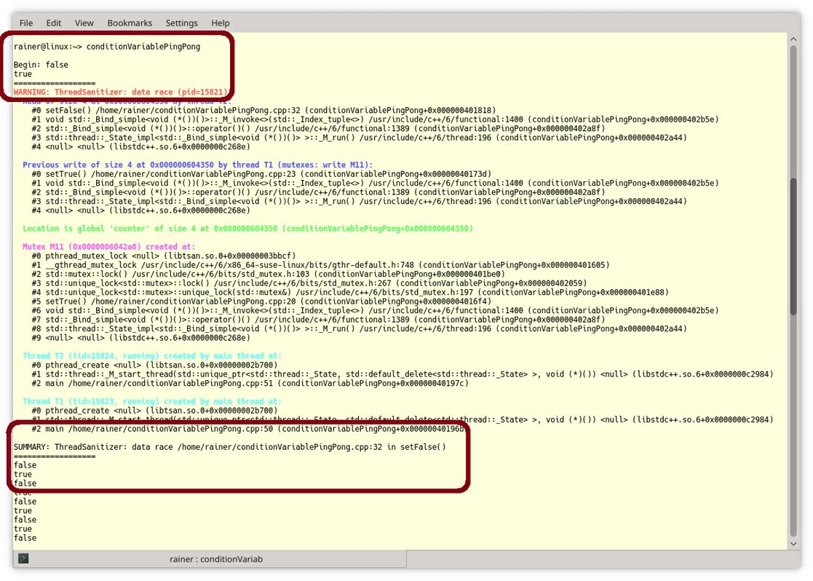

##### Figure 10.3. Data race detection with ThreadSanitizer

ThreadSanitizer detects data races during run-time, CppMem lets you analyze small code snippets.

#### CppMem

Here is a short overview of CppMem.

The online tool which you can also install on your PC provides very valuable services.

1. CppMem validates small code snippets, typically including atomics.
2. The very accurate analysis of CppMem gives you a deep insight into the C++ memory model.

For more in-depth insight, read my blog posts about CppMem. For now, I refer to the first point and provide you a 10000-foot view of CppMem.

My overview uses the default configuration of the tool. This overview should give you the basis for further experiments.

For simplicity reasons, I refer to the red numbers in the following screenshot.

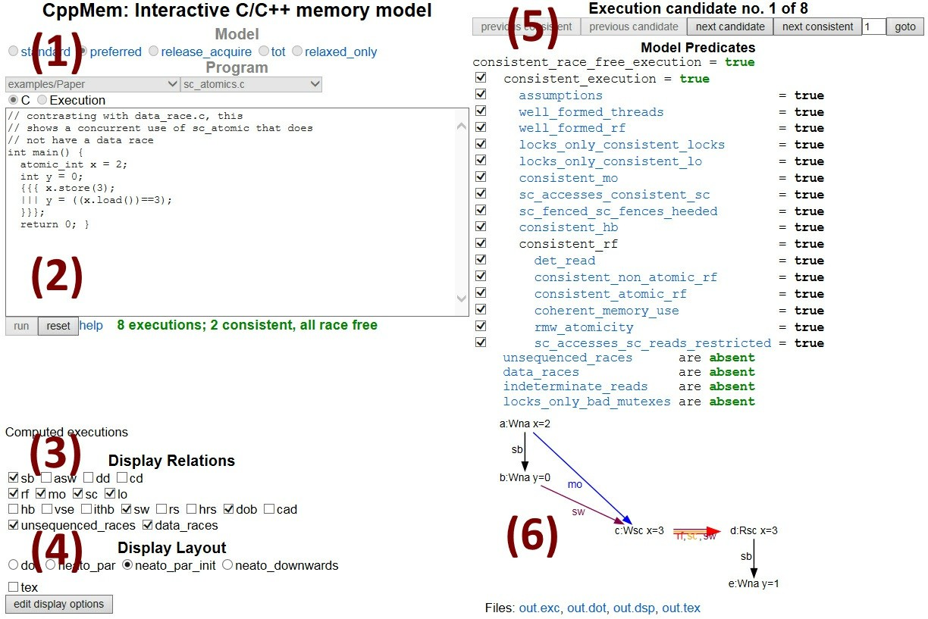

##### Figure 10.4. Overview of CppMem

1. **Model**
   * Specifies the C++ memory model. *preferred* is the C++ memory model.

##### Program

* + It is the executable program in C or C++ like syntax.
  + CppMem offers you a bunch of typical interleavings of atomics. To get the details to these programs, read the very well written article Mathematizing C++ Concurrency. Of course, you can also use your code.
  + CppMem is about multithreading, so there are a few simplifications.
  + You can easily define two threads by the symbols {{{ ... ||| ... }}}. The three dots (...) stand for the work package of the thread.

##### Display Relations

* + Describes the relations between the read, write and read-write modifications on atomic operations, fences, and locks.
  + If the relation is enabled it is displayed in the annotated graph (see point 6).
    - **sb:** sequenced-before
    - **rf:** read from
    - **mo:** modification order
    - **sc:** sequential consistency
    - **lo:** lock order
    - **sw:** synchronizes-with
    - **dob:** dependency-ordered-before

##### data_races

1. **Display Layout**
   * You can choose with this switch, which Doxygraph graph is used.

##### Choose the Executions

* + Switch between the various consistent executions.

##### Annotated Graph

* + Displays the annotated graph. Now, let's try it out.

The program dataRaceOnX.cpp has a data race on the int variable x. y is an atomic and, therefore, fine from the concurrency perspective.

// dataRaceOnX.cpp

#include <atomic> #include <iostream> #include <thread>

int x = 0; std::atomic<int> y{0};

void writing() { x = 2000;

y.store(11);

}

void reading(){

std::cout << y.load() << " "; std::cout << x << '\n';

}

int main() {

std::thread thread1(writing); std::thread thread2(reading);

thread1.join(); thread2.join();

}

In order to use CppMem, you **must** rewrite your C++ program into the dialect of C expected by CppMem's parser. Cutting and pasting standard C++ code fails with a cryptic "Frontc.ParseError". Here is the equivalent program written in the more concise CppMem syntax.

// dataRaceOnXCppMem.txt

int main(){ int x = 0;

atomic_int y = 0;

{{{

{

}

|||

{

}

}}}

}

x = 2000;

y.store(11);

y.load(); x;

CppMem shows it immediately. The first consistent execution has a data race on x.

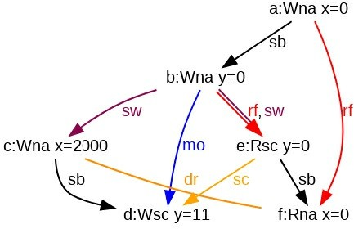

##### Figure 10.5. A data race in CppMem

You can observe the data race in the graph. It is the yellow edge (dr) between the write operation (x=2000) and the read operation (x=0).

To get more details on CppMem, read the following blog posts I've written on ModernesCpp.com: CppMem.

### Concurrency

Concurrency is a very challenging topic. This challenge is, due, in particular, to the low-level abstraction we have now to our disposal. Knowing and applying the rules of this section is, therefore, crucial to get a well-defined multithreading program.

Let me classify about fifteen rules into rules related to locks, threads, condition variables, but also data sharing between threads, resource considerations, and a sometimes overlooked danger.

### Locks

NNN stands for **N**o **N**aked **N**ew and means, that memory allocation should not be done as a standalone operation, but inside a manager object (R.12: Immediately give the result of an explicit resource allocation to a manager object) . The same observation holds for mutexes. Mutexes should immediately be given to a manager object, which is, in this case, a lock. In modern C++, we have a std::lock_guard, std::unique_lock, std::shared_lock (C++14), or std::scoped_lock (C++17). Consequently, keep the acronym NNM, that stands for **N**o **N**aked **M**utex in mind. Locks implement the RAII idiom. The crucial idea of the RAII idiom is to bind the lifetime of a resource to the lifetime of a local variable. C++ automatically manages the lifetime of locals.

**CP.20: Use RAII, never plain lock()/unlock()**

The small code snippet should make the value of a lock immediately clear.

std::mutex mtx;

void do_stuff() { mtx.lock();

// ... do stuff … (1)

mtx.unlock();

}

It doesn't matter if an exception occurs in (1) or you just forgot to unlock the mtx; in both cases, you will get a deadlock if another thread wants to acquire (lock) the std::mutex mtx. Locks come to the rescue.

std::mutex mtx;

void do_stuff() { std::lock_guard<std::mutex> lck {mtx};

// ... do stuff ...

}

Put the mutex into a lock and the mutex is automatically locked in the constructor of the

std::lock_guard and unlocked, when lck goes out of scope.

**CP.21: Use std::lock() or std::scoped_lock to acquire multiple mutexes**

If a thread needs more than one mutex at a time, you have to be extremely careful that you lock the mutexes always in the same sequence. If not, a bad interleaving of threads may cause a deadlock. The following program causes a deadlock.

// lockGuardDeadlock.cpp

#include <iostream> #include <chrono> #include <mutex> #include <thread>

struct CriticalData { std::mutex mut;

};

void deadLock(CriticalData& a, CriticalData& b) {

std::lock_guard<std::mutex> guard1(a.mut); // (1) std::cout << "Thread: " << std::this_thread::get_id() << '\n';

std::this_thread::sleep_for(std::chrono::milliseconds(1));

std::lock_guard<std::mutex> guard2(b.mut); // (1) std::cout << "Thread: " << std::this_thread::get_id() << '\n';

// do something with a and b (critical region) (2)

}

int main() {

std::cout << '\n'; CriticalData c1;

CriticalData c2;

std::thread t1([&]{deadLock(c1, c2);});

std::thread t2([&]{deadLock(c2, c1);});

t1.join();

t2.join();

std::cout << '\n';

}

Thread t1 and t2 need two resources CriticalData to perform their jobs in (2). CriticalData has its mutex mut to synchronize the access. Unfortunately, both invoke the function deadlock with the arguments c1 and c2 in a different sequence (1). Now we have a race condition that could end up in a deadlock. Thread t1 can lock the first mutex a.mut but not the second one b.mut because, in the meantime thread, t2 locked the second one.

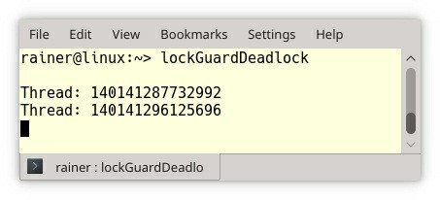

##### Figure 10.6. A deadlock due to multiple locked mutexes

The easiest way to solve the deadlock is to lock both mutexes atomically.

With C++11, you can use a std::unique_lock together with std::lock. Thanks to the tag std::defer_lock, the std::unique_lock takes the mutex without locking it. The locking finally takes place in the std::lock call. std::lock can take an arbitrary number of arguments.

void deadLock(CriticalData& a, CriticalData& b) { std::unique_lock<mutex> guard1(a.mut, std::defer_lock); std::unique_lock<mutex> guard2(b.mut, std::defer_lock); std::lock(guard1, guard2);

// do something with a and b (critical region)

}

With C++17, a std::scoped_lock can lock an arbitrary number of mutex in an atomic operation.

void deadLock(CriticalData& a, CriticalData& b) { std::scoped_lock scoLock(a.mut, b.mut);

// do something with a and b (critical region)

}

#### CP.22: Never call unknown code while holding a lock (e.g., a call-back)

Why is this code snippet very bad and should not pass a code review?

std::mutex m;

{

std::lock_guard<std::mutex> lockGuard(m); sharedVariable = unknownFunction();

}

I can only speculate about the unknownFunction. If unknownFunction

* tries to lock the mutex m, you get undefined behavior. Most of the time, the result of this undefined behavior is a deadlock.
* starts a new thread that tries to lock the mutex m, you get a deadlock.
* locks another mutex m2. In this case, you may get a deadlock because you lock the two mutexes m and m2 at the same time. Another thread may lock the same mutexes in a different sequence.
* does not directly or indirectly try to lock the mutex m; all seems to be fine. “Seems” because a coworker can modify the function, and you get a changed version of the function unknownFunction. Now, all bets are off.
* work as expected, but you may have a performance issue because the unknownFunction takes quite a while. What was meant to be a multithreaded program similarly to a single-threaded program.

To overcome the issues, use a local variable and invoke the unknown function outside of the critical region.

std::mutex m;

auto tempVar = unknownFunction();

{

std::lock_guard<std::mutex> lockGuard(m); sharedVariable = tempVar;

}

This additional indirection solves all issues. tempVar is a local variable and can, therefore, not be a victim of a data race. No victim means that you can invoke unknownFunction without a synchronization mechanism. Additionally, the time for holding the lock is reduced to its bare minimum: assigning the value of tempVar to sharedVariable.

### Threads

Threads are the basic building block for concurrent and parallel programming. With each new C++ standard, threads become more and more an implementation detail for concurrency. For example, with C++17 we got the parallel STL which allows us to specify the execution policy, with C++20 coroutines, and with C++23 we can hope for transactional memory.

#### CP.23: Think of a joining thread as a scoped container, and CP.24: Think of a

**thread as a global container**

The slight variation of the code snippet from the C++ core guidelines should make both rules clear:

void f(int* p) {

// ...

*p = 99;

// ...

}

int glob = 33;

void some_fct(int* p) { // (1) int x = 77;

std::thread t0(f, &x); // OK

std::thread t1(f, p); // OK

std::thread t2(f, &glob); // OK auto q = make_unique<int>(99); std::thread t3(f, q.get()); // OK

// ...

t0.join();

t1.join();

t2.join();

t3.join();

// ...

}

void some_fct2(int* p) { // (2) int x = 77;

std::thread t0(f, &x); // bad

std::thread t1(f, p); // bad

std::thread t2(f, &glob); // OK auto q = make_unique<int>(99); std::thread t3(f, q.get()); // bad

// ...

t0.detach();

t1.detach();

t2.detach();

t3.detach();

// ...

}

The only difference between the functions some_fct (1) and some_fct2 (2) is that the first variation joins its created threads, but the second variation detaches all created threads.

First of all, you have to join or detach the children threads. If not, you get a std::terminate in the destructor of the child thread (see rule CP.25: Prefer gsl::joining_thread over std::thread).

The difference between joining or detaching a created thread is the following one: When the creator calls thr.join() call on the created thread thr, it waits until the created thread is done. thr.join() is a synchronization point. To put it the other way around. The child thread thr can use all variables (state) of the enclosing scope, in which it was created. Consequently all calls of the function f are well defined.

On the contrary, a thr.detach() call does not wait and is, therefore, not a synchronization point. This means that the created thread can outlive its creator. Consequently, using variables of the enclosing scope may not valid anymore. Precisely this is the issue in the function some_fct2.

The variable x, the pointer p, or the resource of the std::unique_ptr q may not valid anymore.

A thread can be seen as a global container using variables from outside. Additionally, in case of a joining thread, the lifetime of the container is scoped.

**CP.25: Prefer std::jthread over std::thread**

The original title of this rule is: "CP.25: Prefer gsl::joining_thread over std::thread. I replaced gsl::joining_thread from the Guideline Support Library with std::jthread from C

++20.

In the following program, I forgot to join the thread t.

// threadWithoutJoin.cpp

#include <iostream> #include <thread>

int main() {

std::thread t([]{

std::cout << std::this_thread::get_id() << '\n';

});

}

The execution of the program ends abruptly.

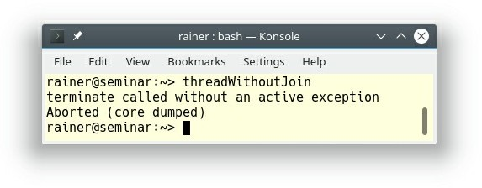

##### Figure 10.7. Forget to join a thread

The lifetime of the created thread t ends with its callable. The creator has two choices. First: it waits, until its child is done (t.join()). Second: it detaches itself from its child: t.detach(). A thread t with a callable unit - you can create threads without callable units - is called joinable if neither a t.join() or t.detach() call happened. The destructor of a joinable thread throws a std::terminate exception which ends in std::abort. In our case, the program terminated before the child thread had time to display its id.

In addition to a std::thread, a std::jthread automatically joins on destruction. Replacing the

std::thread with a std::jthread therefore, solves the issue.

// threadWithJoin.cpp; C++20

#include <iostream> #include <thread>

int main() {

std::jthread t([]{

std::cout << std::this_thread::get_id() << '\n';

});

}

**CP.26: Don’t detach() a thread**

This rule sounds strange. The C++11 standard supports detaching a thread but we should not do it! The reason is that detaching a thread can be quite challenging. For example, have a look at this small program that has undefined behavior. Even objects with static duration can be critical.

// threadDetach.cpp

#include <iostream> #include <string> #include <thread>

void func() {

std::string s{"C++11"};

std::thread t([&s]{ std::cout << s << '\n';}); t.detach();

}

int main() {

func();

}

The lambda takes s by reference. This is undefined behavior, because the child thread t uses the variables s which goes out of scope. STOP! This is the obvious problem but the hidden issue that many programmers overlook is std::cout. std::cout has static duration. Static duration means, the lifetime of std::cout ends with the end of the process, and we have, additionally, a race condition: thread t may use std::cout at this time.

* **Race condition:** A race condition is a situation, in which the result of an operation depends on the interleaving of certain individual operations.

### Condition variables CP.42: Don’t wait without a condition)

Condition variables support a quite simple concept. One thread prepares something and sends a notification to another thread that is waiting for it.

Here is the rationale for the rule: "A wait without a condition can miss a wakeup or wake up simply to find that there is no work to do." What does that mean? Condition variables are subject to two very serious issues: lost wakeups and spurious wakeups. The key concern about condition variables is that they have no memory.

Before I present you this issue, let me first present the correct way to use condition variables.

// conditionVariable.cpp

#include <condition_variable> #include <iostream>

#include <mutex> #include <thread>

std::mutex mut; std::condition_variable condVar;

bool dataReady{false}; void waitingForWork() {

std::cout << "Waiting " << '\n';

std::unique_lock<std::mutex> lck(mut); condVar.wait(lck, []{ return dataReady; }); // (4) std::cout << "Running " << '\n';

}

void setDataReady() {

{

std::lock_guard<std::mutex> lck(mut); dataReady = true;

}

std::cout << "Data prepared" << '\n'; condVar.notify_one(); // (3)

}

int main() {

std::cout << '\n';

std::thread t1(waitingForWork); // (1)

std::thread t2(setDataReady); // (2)

t1.join();

t2.join();

std::cout << '\n';

}

How does the synchronization work? The program has two children threads: t1 and t2. They get their work package waitingForWork and setDataReady (1) and (2). setDataReady notifies - using the condition variable condVar - that it is done with the preparation of the work: condVar.notify_one()(3). While holding the lock, thread t1 waits for its notification: condVar.wait(lck, [] { return dataReady; })(4). The sender and receiver need a lock. In the case of the sender a std::lock_guard is sufficient because it calls lock and unlock only once. In the case of the receiver, a std::unique_lock is necessary because it usually frequently locks and unlocks its mutex.

Here is the output of the program.

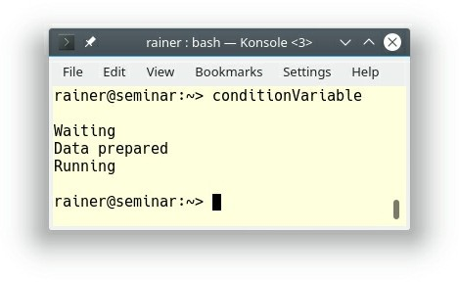

##### Figure 10.8. A condition variable in action

Maybe you are wondering: Why do we need a predicate for the wait call since you can invoke wait without a predicate? This workflow seems quite too complicated for such a simple synchronization of threads.

Now we are back to the missing memory of condition variables, and the two phenomena called lost wakeup and spurious wakeup.

* **Lost wakeup**: The phenomenon of the lost wakeup is that the sender sends its notification before the receiver begins waiting. The consequence is that the notification is lost.
* **Spurious wakeup**: The receiver may wake up even if no notification has been sent. At least POSIX Threads and the Windows API can be victims of these phenomena.

To avoid these two issues, you have to use an additional predicate as memory; or as the rule states it an additional condition. If you use a condition variable without a predicate, it's possible, that you get a lost wakeup and, therefore a deadlock because the waiting thread is waiting for something that never happens.

The following program uses a condition variable without an additional predicate. Let's see what happens:

// conditionVariableWithoutPredicate.cpp

#include <condition_variable> #include <iostream>

#include <mutex> #include <thread>

std::mutex mut; std::condition_variable condVar;

void waitingForWork() {

std::cout << "Waiting " << '\n'; std::unique_lock<std::mutex> lck(mut); condVar.wait(lck);

std::cout << "Running " << '\n';

}

void setDataReady() {

std::cout << "Data prepared" << '\n'; condVar.notify_one();

}

int main() {

std::cout << '\n';

std::thread t1(waitingForWork); std::thread t2(setDataReady);

t1.join();

t2.join();

std::cout << '\n';

}

Whenever the notification thread t2 runs before the waiting thread t1, the notification is lost. The second execution shows this phenomenon that results in a deadlock.

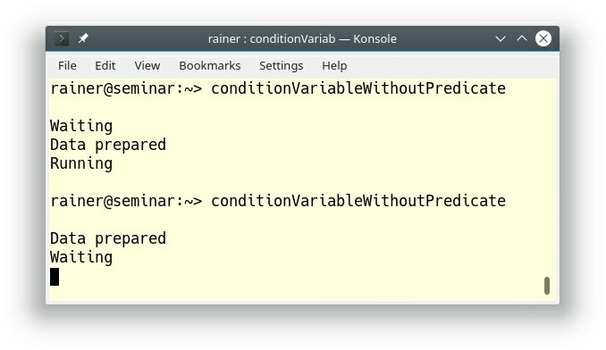

**Figure 10.9. A condition variable without a predicate**

### Data sharing

The less you share data, and the more you work with local variables, the better. Sometimes though, you have no other option but to share data. For example, the child thread wants to communicate its work to its parent thread.

#### CP.31: Pass small amounts of data between threads by value, rather than by reference or pointer

Passing data to a thread by value immediately gives you two benefits:

1. There is no sharing, and, therefore, no data race is possible. The requirements for a data race are mutable, shared state.
2. You don't have to be concerned about the lifetime of the data. The data stays alive for the lifetime of the created thread.

Of course, the crucial question is: What does a small amount of data mean? The C++ Core Guidelines is not clear about this point. In the rule "F.16 For “in” parameters, pass cheaply- copied types by value and others by reference to" , the C++ core guidelines state that 4 * sizeof(int) is a rule of thumb for functions. Meaning, smaller than 4 * sizeof(int) should be passed by value; bigger than 4 * sizeof(int) by reference or pointer.

In the end, you have to measure the performance of your program if necessary.

**CP.32: To share ownership between unrelated threads use shared_ptr**

Imagine, that you have an object which you want to share between unrelated threads. Unrelated means that there is no data race on that object. The key question is, who is the owner of the object and, therefore, responsible for releasing the memory? Now you can choose between a memory leak if you don't deallocate the memory or undefined behavior if you invoke delete more than once. Most of the time the undefined behavior causes a run-time crash.

// threadSharesOwnership.cpp

#include <iostream> #include <thread>

using namespace std::literals::chrono_literals; struct MyInt {

int val{2017};

~MyInt() { // (4)

std::cout << "Goodbye" << '\n';

}

};

void showNumber(const MyInt* myInt) { std::cout << myInt->val << '\n';

}

void threadCreator() {

MyInt* tmpInt= new MyInt; // (1)

std::thread t1(showNumber, tmpInt); // (2) std::thread t2(showNumber, tmpInt); // (3)

t1.detach();

t2.detach();

}

int main() {

std::cout << '\n';

threadCreator(); std::this_thread::sleep_for(1s);

std::cout << '\n';

}

The example is intentionally simple. I let the main thread sleep for one second to be sure that it outlives the lifetime of the children threads t1 and t2. This is, of course, not an appropriate synchronization, but it helps to make my point. The vital issue of the program is: Who is responsible for the deletion of tmpInt (1)? Thread t1 (2), thread t2 (3), or the function (main thread) itself. Because I cannot forecast how long each thread runs I decided to go with a memory leak. Consequently, the destructor of MyInt (4) is never called:

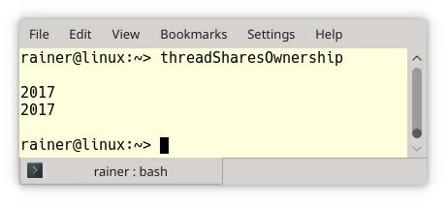

##### Figure 10.10. Shared ownership using a pointer

The lifetime issues are easy to handle if I use a std::shared_ptr.

// threadSharesOwnershipSharedPtr.cpp

#include <iostream> #include <memory> #include <thread>

using namespace std::literals::chrono_literals; struct MyInt {

int val{2017};

~MyInt() {

std::cout << "Goodbye" << '\n';

}

};

void showNumber(std::shared_ptr<MyInt> myInt) { std::cout << myInt->val << '\n';

}

void threadCreator() {

auto sharedPtr = std::make_shared<MyInt>(); // (1)

std::thread t1(showNumber, sharedPtr); std::thread t2(showNumber, sharedPtr);

t1.detach();

t2.detach();

}

int main() {

std::cout << '\n';

threadCreator(); std::this_thread::sleep_for(1s);

std::cout << '\n';

}

Two small changes to the source code are necessary. First, the pointer in (1) becomes a std::shared_ptr and second, the function showNumber takes a smart pointer instead of a raw pointer. I assume for simplicity reasons that the threads t1 and t2 are done within a second.

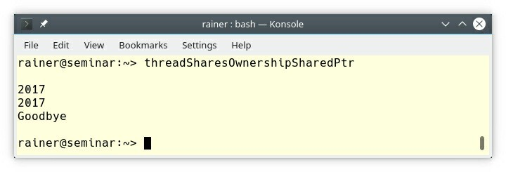

**Figure 10.11. Shared ownership using a smart pointer**

### Resources

One of the main reasons for using concurrency is performance. You have to keep in mind that using threads requires resources: time and memory. The resource usage begins with creation, continues with context switching from user space to kernel space and ends with the destruction of a thread. Additionally, a thread has its own state that has to be allocated and maintained.

#### CP.40: Minimize context switching, and CP.41: Minimize thread creation and destruction

How expensive is a thread? The answer to this question is the reason for this rule. Let me first talk about the usual size of a thread and then about the costs of its creation.

##### Size

A std::thread is a thin wrapper around the native thread and I'm, therefore, interested in the size of a Windows thread and a POSIX thread.

* **Windows systems**: the blog post Thread Stack Size gave me the answer: 1MB.
* **Linux systems**: the pthread_create man-page provides me with the answer: 2MB. This number applies to the i386 and x86_64 architectures. If you want to know the sizes for other architectures that support POSIX, here are they:

##### Table 10.1. Typical thread size

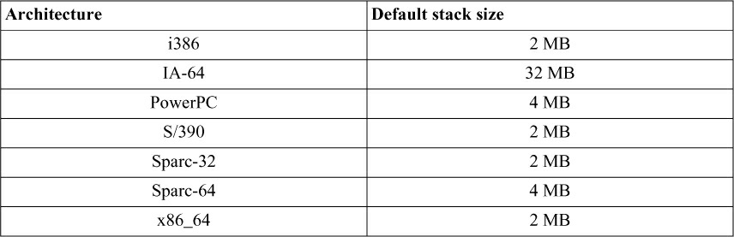

**Creation**

I didn't find numbers on how much time it takes to create a thread. To get a gut feeling, I made a simple performance test on Linux and Windows. Don't use the numbers to compare Linux and Windows. This is not the point of this experiment.

I used GCC 6.2.1 on a desktop and Microsoft Visual Studio 2017 on a laptop for my performance tests. I compiled the programs with maximum optimization on both platforms.

Here is the small test program.

// threadCreationPerformance.cpp

#include <chrono> #include <iostream> #include <thread>

constexpr long long numThreads= 1'000'000; int main() {

auto start = std::chrono::system_clock::now();

for (long long i = 0; i < numThreads; ++i) { // (1) std::thread([]{}).detach();

}

std::chrono::duration<double> dur = std::chrono::system_clock::now() - start;

std::cout << "time: " << dur.count()

<< " seconds" << '\n';

}

The program creates 1 million threads that execute an empty lambda function (1). These are the results for Linux and Windows:

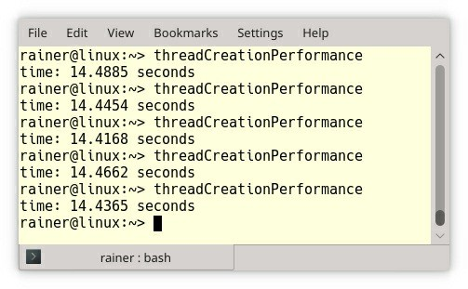

##### Figure 10.12. Thread creation on Linux

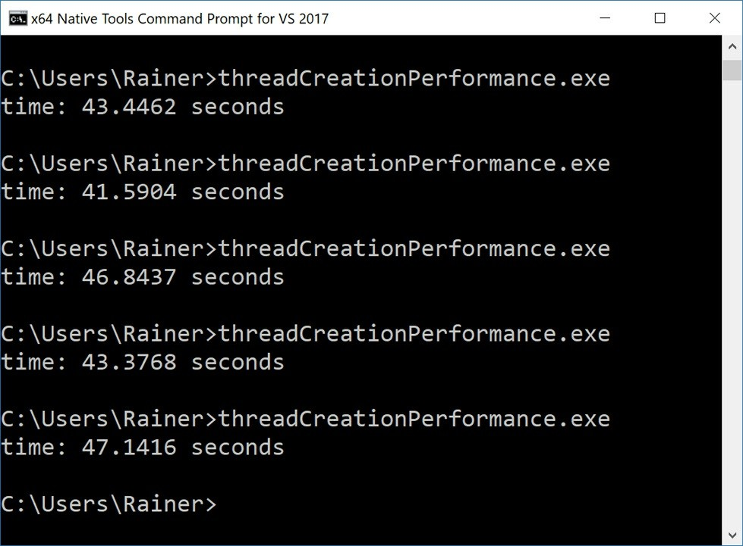

**Figure 10.13. Thread creation on Windows**

This means that the creation of a single thread took about 14.5 sec / 1000000 = **14.5 microseconds on Linux**, and about 44 sec / 1000000 = **44 microseconds on Windows.**

To put it another way, in one second, you can create about **69 thousand threads on Linux and 23 thousand threads on Windows.**

#### CP.43: Minimize time spent in a critical section

The less time you lock a mutex, the more time other threads can run. Let's take the example of the notification of a condition variable.

void setDataReady() { std::lock_guard<std::mutex> lck(mut);

dataReady = true; // (1)

std::cout << "Data prepared" << '\n';

condVar.notify_one();

}

The Mutex mut is locked at the begin of the function and unlocked at the end of the function. This locking is not necessary. Only the expression dataReady = true (1) has to be protected.

First, std::cout is thread-safe. The C++11 standard guarantees that each character is written in an atomic step and the right sequence. Second, the notification condVar.notify_one() is thread- safe.

Here is the improved version of the function setDataReady:

void setDataReady() {

{

std::lock_guard<std::mutex> lck(mut); dataReady = true;

}

std::cout << "Data prepared" << '\n'; condVar.notify_one();

}

### Overlooked Danger (CP.44: Remember to name your

**lock_guards and unique_locks)**

When you don't name the std::lock_guard, or the std::unique_lock, you just create a temporary which is created and immediately destroyed. The std::lock_guard or std::unique_lock automatically locks its mutex and its constructor and unlocks it in its destructor. This pattern is called RAII.

My small example shows the conceptual behavior of a std::lock_guard. Its big brother

std::unique_lock supports more operations.

// myGuard.cpp

#include <mutex> #include <iostream>

template <typename T> class MyGuard { public:

explicit MyGuard(T& m): myMutex(m) { std::cout << "lock" << '\n'; myMutex.lock();

}

~MyGuard() {

myMutex.unlock();

std::cout << "unlock" << '\n';

}

private:

T& myMutex;

};

int main() {

std::cout << '\n';

std::mutex m;

MyGuard<std::mutex> {m}; // (1) oops! std::cout << "CRITICAL SECTION" << '\n'; // (2)

std::cout << '\n';

} // (3)

MyGuard calls lock and unlock in its constructor and its destructor. Because of the temporary, the call to the constructor and destructor happens in (1) and not, as usual, in line (3). As a consequence, the critical section in line (2) is executed unprotected.

This execution of the program shows that the output of "unlock" happens before the output of

"CRITICAL SECTION".

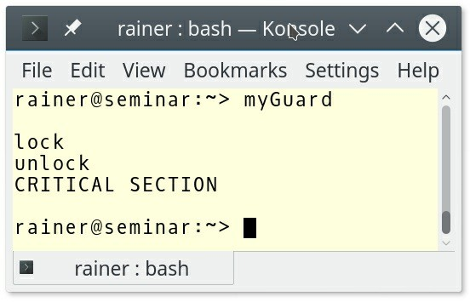

**Figure 10.14. Using a temporary Lock std::lock_guard**

By giving the unnamed MyGuard MyGuard<std::mutex> {m}; (1) a name MyGuard<std::mutex> myGuard{m};, the critical section becomes protected.

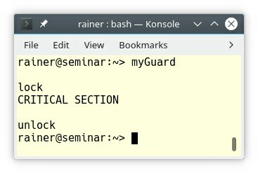

**Figure 10.15. Using a named temporary std::lock_guard**

### Parallelism

Beside the title, there is no content regarding parallelism in the C++ Core Guidelines. To fill the gap, I provide a short introduction to the parallel STL and a rule. First of all, here is my rule.

##### Prefer the parallel algorithms of the STL to handcrafted solutions with threads

The idea is quite simple. The Standard Template has more than 100 algorithms for searching, counting, and manipulating of ranges and their elements. With C++17, 69 of them are overloaded and a few new are added. The overloaded and new algorithms can be invoked with a so-called execution policy. By using the execution policy, you can specify whether the algorithm should run sequential, parallel, or parallel and vectorized.

* **std::execution::seq**: runs the algorithm sequentially
* **std::execution::par**: runs the algorithm in parallel on multiple threads
* **std::execution::par_unseq**: runs the algorithm in parallel on multiple threads and allows the interleaving of individual loops

Vectorization (std::execution::par_unseq) stands for the SIMD (**S**ingle **I**nstruction, **M**ultiple **D**ata) extensions of the instruction set of a modern processor. SIMD enables your processor to execute one operation in parallel on multiple data.

With the execution policy tag, you can choose which variant of an algorithm should be performed. The tag is not binding but is a strong hint to the C++ run-time.

std::vector<int> v = {5, -3, 10, -5, -10, 22, 0};

// standard sequential sort std::sort(v.begin(), v.end());

// sequential execution std::sort(std::execution::seq, v.begin(), v.end());

// permitting parallel execution std::sort(std::execution::par, v.begin(), v.end());

// permitting parallel and vectorized execution std::sort(std::execution::par_unseq, v.begin(), v.end())

69 of the algorithms of the STL support a parallel or a parallel and vectorized execution.

##### Table 10.2. Algorithms of the STL for which parallel versions are available (the std namespace is omitted)

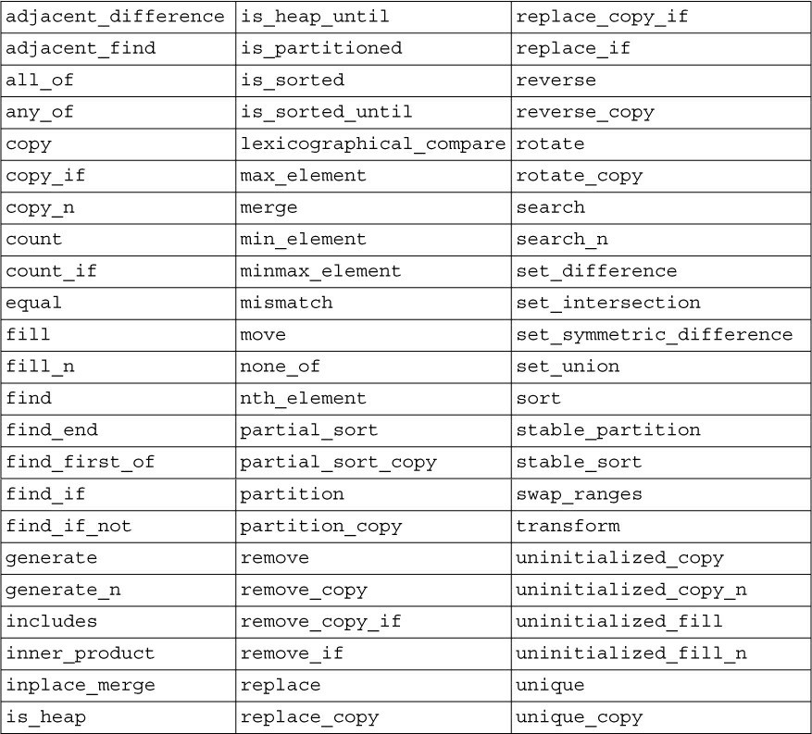

Additionally, eight new algorithms are added with C++17.

std::for_each std::for_each_n std::exclusive_scan std::inclusive_scan std::transform_exclusive_scan std::transform_inclusive_scan std::reduce std::transform_reduce

The following example shows the usage of the std::transform_exclusive_scan algorithm.

// transformExclusiveScan.cpp; C++17 with MSVC

#include <execution> #include <numeric> #include <iostream> #include <vector>

int main() {

std::cout << '\n';

std::vector<int> resVec{1, 2, 3, 4, 5, 6, 7, 8, 9}; std::vector<int> resVec1(resVec.size()); std::transform_exclusive_scan(std::execution::par,

resVec.begin(), resVec.end(), resVec1.begin(), 0,

[](int fir, int sec){ return fir + sec; }, [](int arg){ return arg * arg; });

std::cout << "transform_exclusive_scan: "; for (auto v: resVec1) std::cout << v << " ";

std::cout << '\n';

}

The std::transform_exclusive_scan algorithm is quite challenging to read. Let me try to explain it. In the first step, std::transform_exclusive_scan applies the lambda expression [] (int arg){ return arg * arg; } to each element of the range resVec.begin() to resVec.end(). In the second step, the algorithm applies the binary operation [](int fir, int sec){ return fir + sec; } to the intermediate vector. This means the algorithm sums up all elements using 0 as the initial value. The result is placed in resVec1.

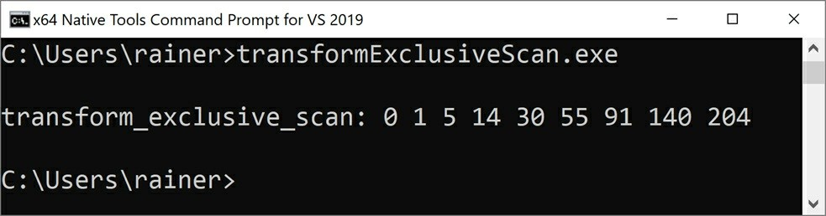

**Figure 10.16. Usage of std::transform_exclusive_scan**

### Message passing

The section on message passing has two rules.

* CP.60: Use a future to return a value from a concurrent task
* CP.61: Use an async() to spawn a concurrent task

Both rules lack content. Therefore, I have to improvise.

A task is the C++-ish way to pass messages between threads. The message can be a value, an exception, or a notification. A task consists of the two components promise and future. Promise exists in three variations in C++: std::async, std::packaged_task, and std::promise. The promise creates the message which the future picks up asynchronously.

I already gave a short example to std::async in the rule "CP.4: Think in terms of tasks, rather than threads" to send a value from the promise to the future. In this section, I use a std::promise as the sender.

### Sending a value, or an exception

In contrast to a thread, the promise and the associated future share a secure channel. In the following example, one promise sends a value, and one promise sends an exception.

// promiseFutureException.cpp

#include <exception> #include <future> #include <iostream> #include <thread> #include <utility>

struct Div {

void operator()(std::promise<int> intPromise, int a, int b) const {

try { // (4)

if (b == 0) {

std::string err = "Illegal division by zero: " +

std::to_string(a) + "/" + std::to_string(b); throw std::runtime_error(err);

}

intPromise.set_value(a / b); // (2)

}

catch ( ... ) {

intPromise.set_exception(std::current_exception()); // (1)

}

}

};

void executeDivision(int nom, int denom) { std::promise<int> divPromise;

std::future<int> divResult= divPromise.get_future();

Div div;

std::thread divThread(div, std::move(divPromise), nom, denom);

// get the result or the exception // (5) try {

std::cout << nom << "/" << denom << " = "

<< divResult.get() << '\n'; // (3)

}

catch (std::runtime_error& e){ std::cout << e.what() << '\n';

}

divThread.join();

}

int main() { std::cout << '\n';

executeDivision(20, 0);

executeDivision(20, 10); std::cout << '\n';

}

If the callable used by std::promise throws an error, the exception is stored in the shared state. When the future divResult then calls divResult.get() (3), the exception is rethrown, and the associated future has to handle it. The std::promise prom set the exception via prom.set_value(std::current_exception()) (1), and the value via divPromise.set_value

1. as the shared state. As the promise in (4), the future has to deal with the exception in its try- catch block (5). Dividing a number by 0 is undefined behavior. The function executeDivision displays the result of the calculation or the exception.

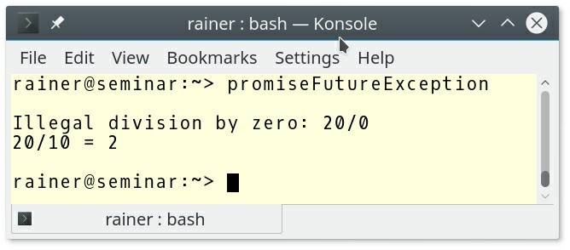

**Figure 10.17. A value and an exception as message**

### Sending a notification

If you use promises and futures (in short tasks) to synchronize threads, they have a lot in common with condition variables. Most of the time, promises and futures are the safer choice than condition variables.

Before I present you an example, here is the big picture.

##### Table 10.3. Condition variables versus tasks

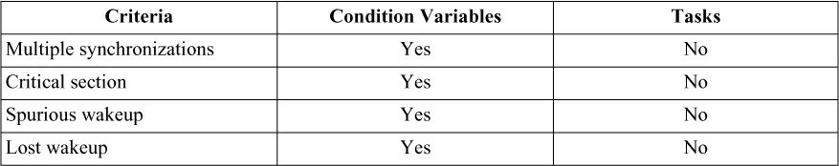

The advantage of a condition variable with respect to a promise and future is that you can use condition variables to synchronize threads multiple times. In contrast to that, a promise can send its notification only once. If you use a condition variable for only one synchronization, the condition variable is a lot more challenging to use correctly. A promise and future pair needs no locks, there is no critical sections, no additional conditional, and is not prone to spurious or lost wakeups.

// promiseFutureSynchronize.cpp

#include <future> #include <iostream> #include <utility>

void waitingForWork(std::future<void> fut) { std::cout << "Waiting " << '\n';

fut.wait(); // (5)

std::cout << "Running " << '\n';

}

void setDataReady(std::promise<void> prom) { std::cout << "Data prepared" << '\n';

prom.set_value(); // (6)

}

int main() {

std::cout << '\n';

std::promise<void> sendReady; // (1)

|  |  |  |
| --- | --- | --- |
| auto fut = sendReady.get_future(); | // | (2) |
| std::thread t1(waitingForWork, std::move(fut)); | // | (3) |
| std::thread t2(setDataReady, std::move(sendReady)); | // | (4) |
| t1.join();  t2.join(); |  |  |
| std::cout << '\n'; |  |  |

}

Thanks to sendReady (1) you get a future fut (2). Both communication endpoints are moved into threads t1 and t2 (3) and (4). The future waits using the call fut.wait() (5) gets the notification of the associated promise: prom.set_value() (6).

The structure and the output of the program matches the corresponding program in the rule for condition variables: C.42: Don't wait without a condition.

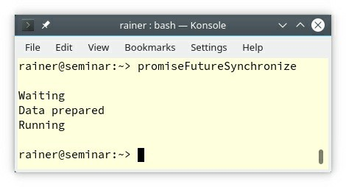

**Figure 10.18. Notifications with a task**

### Lock-free programming

The rules on concurrency and parallelism target non-experts. Lock-free programming is an experts-only topic. Consequently, there are only a few and short rules to lock-free programming.

### CP.100: Don’t use lock-free programming unless you absolutely have to

This rule is the most critical meta-rule to lock-free programming. If you don't believe me, here are a few citations from talks given by worldwide recognized experts in this particular domain.

* **Herb Sutter**: "*Lock-free programming is like playing with knives.*" (CppCon 2014)
* **Anthony Williams**: "*Lock-free programming is about how to shoot yourself in the foot.*" (NDC 2016)
* **Tony Van Eerd**: "*Lock-free coding is the last thing you want to do*."
* **Fedor Pikus**: "*Writing lock-free programs is hard. Writing correct lock-free programs is even harder.*" (NDC 2018)

### CP.101: Distrust your hardware/compiler combination

What does that mean: distrust your hardware/compiler combination? Let me put in another way: When you break the sequential consistency, you also break your intuition with high probability. Let me start with a simple program.

// sequentialConsistency.cpp

#include <atomic> #include <iostream>

#include <thread>

std::atomic<int> x{0}; std::atomic<int> y{0};

void writing(){

x.store(2000); // (1)

y.store(11); // (2)

}

void reading(){

std::cout << y.load() << " "; // (3)

std::cout << x.load() << '\n'; // (4)

}

int main(){

std::thread thread1(writing); std::thread thread2(reading); thread1.join(); thread2.join();

}

I have a question for the short example. Which values for y and x are possible in (3) and (4)? Because y and x are atomic, no data race is possible. I further don't specify the memory ordering; therefore sequential consistency applies. Sequential consistency means:

* Each thread performs its operation in the specified sequence: (1) happens before (2) and (3) happens before (4).
* There is a global order of all operations on all threads. To put the other way around. Each thread sees all operations in the same sequence.

If you combine these two properties of the sequential consistency, there is only one combination of x and y not possible: y == 11 and x == 0. Now, let me break the sequential consistency and maybe your intuition.

The relaxed semantic is the weakest of all memory orderings. Relaxed semantic essentially boils down to one guarantee: Operations on atomics only guarantee atomicity

// relaxedSemantic.cpp

#include <atomic> #include <iostream> #include <thread>

std::atomic<int> x{0}; std::atomic<int> y{0};

void writing(){

x.store(2000, std::memory_order_relaxed); y.store(11, std::memory_order_relaxed);

}

void reading(){

std::cout << y.load(std::memory_order_relaxed) << " "; std::cout << x.load(std::memory_order_relaxed) << '\n';

}

int main(){

std::thread thread1(writing); std::thread thread2(reading); thread1.join(); thread2.join();

}

Two highly unintuitive phenomena can happen. First, thread2 can see the operations of thread1 in a different sequence. Second, thread1 can reorder its instruction because it is not performed on the same atomic. What does this mean for the possible values of x and y? y == 11 and x == 0 is now a possible result. I want to be more specific. Which result is possible depends on your hardware.

For example, operation reordering is quite conservative on x86 or AMD64; stores can be reordered after loads but on Alpha, IA64, or RISC (ARM) architectures, all four possible reorderings of store and load operations are allowed.

##### Table 10.4. Operation reordering on various platforms

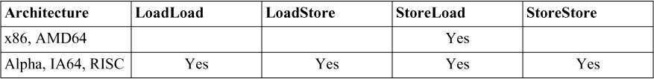

LoadLoad in the table means for one control flow that a load operation on an atomic is followed by a load operation on another atomic. The same argumentation applies to LoadStore, StoreLoad, and StoreStore.

### CP.102: Carefully study the literature

Here are a few links to outstanding literature. Study them first.

* Anthony Williams: C++ concurrency in action. Manning Publications. (February 2019, ISBN 9781617294693)
* Bartosz Milewski: Bartosz Milewski's Programming Cafe
* Herb Sutter: Effective Concurrency
* Jeff Preshing: Preshing on Programming

### Related Rules

* The two rules CP.110: Do not write your own double-checked locking for initialization and CP.111: Use a conventional pattern if you really need double-checked locking are already covered by the rule about wrong assumptions.
* The rule CP.200: Use volatile only to talk to non-C++ memory was already addressed in the

rule CP.8: Don’t try to use volatile for synchronization.

### Distilled

##### Important

* Distinguish concurrency from parallelism. Concurrency is the overlap of several tasks, but parallelism is when several tasks run at the same time.
* Avoid data races by minimizing the sharing of data and make your shared data immutable.
* Use tools such as ThreadSanitizer or CppMem to validate your concurrent code.
* Don't lock or unlock a mutex directly. Put your mutexes into a lock such as std::lock_guard, or std::unique_lock.
* Don't call unknown code while holding a lock. Try to acquire not more than one lock at any point in time.
* When you need more than one lock at a given time, acquire them atomically by using

std::lock or std::scoped_lock.

* Use std::jthread instead of std::thread for automatic rejoining at destruction.
* Don't use a condition variable without an additional predicate to avoid spurious wakeup and lost wakeup.
* If you want to perform a job in parallel, prefer the parallel algorithms of the STL over hand- crafted solutions with threads.
* Use tasks to pass messages or exceptions between threads. Use tasks and not condition variables to synchronize threads.
* Only use lock-free programming techniques if you have to. Study the literature before carefully.

## Chapter 11. Error Handling



##### Figure 11.1. Cippi handles errors

First of all, according to the C++ Core Guidelines, the following aspects are involved in error handling:

* Detect an error
* Transmit information about an error to some handler code
* Preserve the valid state of a program
* Avoid resource leaks

You should use exceptions for error handling. David Abrahams, one of the founders of the Boost C+ + Library and former member of the ISO C++ standardization committee, formalized in the

document “Exception-Safety in Generic Components” what exception-safety means. Abrahams Guarantees describe a contract that is fundamental if you think about exception-safety. Here are the four levels of the contract:

1. **No-throw guarantee**, also known as **failure transparency**: Operations are guaranteed to succeed and satisfy all requirements, even in exceptional situations. If an exception occurs, it is handled internally and cannot be observed by clients.
2. **Strong exception safety**, also known as **commit or rollback semantics**: Operations can fail, but failed operations are guaranteed to have no side effects, so all data retains their original values.
3. **Basic exception safety**, also known as a **no-leak guarantee**: Partial execution of failed operations can cause side effects, but all invariants are preserved, and there are no resource leaks (including memory leaks). Any stored data contains valid values, even if they differ from what they were before the exception.
4. **No exception safety**: No guarantees are made.

The rules from the guidelines should help you to avoid the following kinds of errors. I added typically examples in the parenthesis:

* Type violations (casts)
* Resource leaks (memory leaks)
* Bounds errors (accessing a container outside the boundaries)
* Lifetime errors (accessing an object after deletion)
* Logical errors (logical expressions)
* Interface errors (passing wrong values in interfaces)

There are more than 20 rules divided into three categories. The first two categories are about the design of the error handling strategy and its concrete implementation. The third category discusses situations where you can’t throw an exception.

This section on error handling has a massive overlap with the sections for functions and classes and class hierarchies. I intentionally skipped all rules which I already presented in those sections. The related rules section provides you the details to the skipped rules.

### Design

Each software unit has two communication channels to its client. One for the regular case and one for the irregular case. The software units should be designed around invariants.

### Communication

* E.1: Develop an error handling strategy early in a design
* E.17: Don’t try to catch every exception in every function
* E.18: Minimize the use of explicit try/catch

First of all, what is a software unit? A software unit may be a function, an object, a sub-system, or the entire system. The software units communicate with their clients. Designing the communication should, therefore, be early in the design of your system. At the boundary level, you have two ways to communicate: regularly and irregularly. The regular communication is the functional aspect of the interface. Or to say it differently: What the software unit should do. The irregular communication stands for the non-functional aspects. The non-functional aspects specifies how a system should operate. A big part of the non-functional aspects is error handling or what can go wrong. Often the non-functional aspects are just called quality attributes.

From the control-flow perspective, explicit try/catch has a lot in common with the goto statement. This means that if an exception is thrown, the control flow directly jumps to the exception handler, which might be in a different software unit. In the end you may get spaghetti code; meaning code with control flow that is difficult to predict and maintain.

Now, the question is: How should you structure your exception handling? I think you should ask yourself the question: Is it possible to handle the exception locally? If yes, do it. If not, let the exception propagate until you have sufficient context to handle it. Handling an exception can also mean to catch it, and then rethrow a different exception more convenient to the client. This translation of an exception may serve the purpose that the client of the software unit has only to deal with a limited number of different exceptions.

Often boundaries are the appropriate place to handle exceptions because you want to protect the client from arbitrary exceptions. Consequently, boundaries are also the appropriate place to test regular and irregular communication.

### Invariants

* E.2: Throw an exception to signal that a function can’t perform its assigned task
* E.4: Design your error handling strategy around invariants
* E.5: Let a constructor establish an invariant, and throw if it cannot

According to the C++ Core Guidelines, “*An invariant is a logical condition for the members of an object that a constructor must establish for the public member functions to assume. After the invariant is established (typically by a constructor) every member function can be called for the object.*” This definition is too narrow for me. An invariant can also be established by a function using concepts or contracts.

There are more rules about invariants and how to establish an invariant that complement the discussion at the beginning of this chapter:

* C.2: Use class if the class has an invariant; use struct if the data members can vary independently
* C.41: A constructor should create a fully initialized object
* C.45: Don’t define a default constructor that only initializes data members; use member

initializers instead

This paragraph essentially says that you should define your error handling strategy around invariants. If an invariant can’t be established, throw an exception.

### Implementation

When implementing the error handling you have to keep a few do’s and don’ts in mind.

### Dos

Besides the dos referred to in the section related rules to error handling, there are three additional rules.

#### E.3: Use exceptions for error handling only

Exceptions are a kind of goto statements. Maybe your code guidelines forbid you to use goto statements. Therefore, you came up with a clever idea: use exceptions for the control flow. In the following example, the exception is used in the success case.

// don’t: exception not used for error handling

int getIndex(std::vector<const std::string>& vec, const std::string& x) { try {

for (auto i = 0; i < vec.size(); ++i) { if (vec[i] == x) throw i; // found x

}

} catch (int i) { return i;

}

return -1; // not found

}

In my opinion, this is the worst misuse of exceptions. In this case, the regular control flow is not separated from the exceptional control flow. In the success case, the code uses a throw statement; in the failure case, the code uses a return statement. That is confusing, isn’t it?

#### E.14: Use purpose-designed user-defined types as exceptions (not built-in types)

You should not use built-in types, nor even the standard exception types. Here are two code snippets from the C++ Core Guidelines exemplifying the don’ts.

void my_code() // Don’t

{

// ...

throw 7; // 7 means "moon in the 4th quarter"

// ...

}

void your_code() // Don’t

{

try {

// ... my_code();

// ...

}

catch(int i) { // i == 7 means "input buffer too small"

// ...

}

}

In this case, the exception is an int without any semantic. What 7 means is described in the comment, but it would be better to use a self-describing type. The comment can be wrong. To be sure, you have to consult the documentation to get an idea. You cannot attach any meaningful information to an exception of kind int. If you have a 7, I assume, you use at least the numbers 1 to 6 for your exception handling. 1 probably meaning an unspecific error and so on. This strategy is way too sophisticated, error-prone, and quite hard to read and to maintain.

Let’s use a standard exception instead of an int.

void my_code() // Don’t

{

// ...

throw std::runtime_error{"moon in the 4th quarter"};

// ...

}

void your_code() // Don’t

{

try {

// ... my_code();

// ...

}

catch(const std::runtime_error&) { // std::runtime_error means

// "input buffer too small"

// ...

}

}

Using a standard exception instead of a built-in type is better because you can attach additional information to an exception or build hierarchies of exceptions. This standard exception is better but not good. Why? The exception is too generic. It’s just a std::runtime_error. Imagine that the function my_code is part of an input sub-system. If the client of the function catches the exception by std::runtime_error, it has no idea if it was a generic error such as “input buffer too small” or a sub-system specific error such as “input device is not connected”.

To overcome these issues derive your specific exception from std::runtime_error. Here is a short example to give you the idea:

class InputSubsystemException: public std::runtime_error { const char* what() const noexcept override {

return “Provide more details to the exception”;

}

};

Now, the client of the input sub-system can specifically catch the exception via catch(const InputSubsystemException& ex). Additionally, you can refine the exception hierarchy by further deriving from the class InputSubsystemException.

#### E.15: Catch exceptions from a hierarchy by reference

If you catch an exception from a hierarchy by-value, you may become a victim of slicing. Imagine that you derive a new exception class USBInputException from

InputSubsystemException (previous rule E.14: Use purpose-designed user-defined types as exceptions (not built-in types). You then catch the exception by-value of type InputSubsystemException. Now, an exception of type USBInputException is thrown.

void subsystem() {

// ...

throw USBInputException();

// ...

}

void clientCode() { try {

subsystem();

}

catch(InputSubsystemException e) { // slicing may happen

// ...

}

}

By catching the USBInputException by-value to InputSubsystemException, slicing kicks in and e has the base type InputSubsystemException. Read the details of slicing in the guideline C.67: A polymorphic class should suppress copying.

To say it explicitly:

1. Catch your exception by const reference and only by reference if you want to modify the exception.
2. If you rethrow an exception e in the exception handler, just use throw and not throw e. In the second case, e would be copied.

There is a straightforward cure to catch an exception by-value: apply the rule C.121: If a base class is used as an interface, make it an abstract class. Making the InputSubsystemException an abstract base class makes it impossible to catch InputSubsystemException by-value.

### Don’ts

Additionally to the does, the C++ Core Guidelines has a three don’ts.

#### E.13: Never throw while being the direct owner of an object

This is the example of direct ownership from the C++ Core Guidelines:

void leak(int x) { // Bad: may leak auto* p = new int{7};

auto* pa = new int[100]

if (x < 0) throw Get_me_out_of_here{}; // leaks *p, and *pa

// ...

delete p; // we may never get here delete [] pa;

}

If the throw is fired the memory is lost and you have a memory leak. The simple solution is to get rid of the ownership and make the C++ runtime the direct owner of the object. This means you simply apply RAII: R.1: Manage resources automatically using resource handles and RAII (Resource Acquisition Is Initialization).

Just create a local object or at least a guard as a local object. The C++ runtime takes care of local objects and, therefore, frees the memory in necessary. Here are three variations of automatic memory management:

void leak(int x) { // Good: does not leak auto p1 = int{7};

auto p = std::make_unique<int>(7); auto pa = std::vector<int>(100);

if (x < 0) throw Get_me_out_of_here{};

// ...

}

p1 is a local, but p and pa are kind of guards for the underlying objects. The std::vector uses the heap to manage its data. Additionally, with all three variations, you eliminate the delete call.

#### E.30: Don’t use exception specifications

First, here is an example of an exception specification:

int use(int arg) throw(X, Y) {

// ...

auto x = f(arg);

// ...

}

This means that the function use may throw an exception of type X, or Y. If a different exception is thrown, std::terminate is called.

Dynamic exception specifications with argument throw(X, Y) and without argument throw() are deprecated since C++11. Dynamic exception specification with arguments is removed with C++17, dynamic exception specification without arguments is removed with C++20. Until C++20 throw() is equivalent to noexcept.

Read more details to noexcept in the rule E.12: Use noexcept when exiting a function because of a throw is impossible or unacceptable.

#### E.31: Properly order your catch-clauses

An exception is caught according to the first match strategy. This means that the first exception handler that fits for an exception is used. This is the reason why you should structure your exception handler from specific to general. If not, your specific exception handler may never be invoked. In the following example, the DivisionByZeroException is derived from std::exception.

try{

// throw an exception (1)

}

catch(const DivisionByZeroException& ex) { .... } // (2) catch(const std::exception& ex) { .... } // (3)

catch(...) { .... } // (4)

In this case, the DivisionByZeroException (2) is used first for handling the exception thrown in (1). If the specific handler does not fit, all exceptions derived from std::exception are caught in the following line (3). The last exception handler in line (4) has an ellipsis (...) and can, therefore, catch all other exceptions.

### If you can’t throw

* E.25: If you can’t throw exceptions, simulate RAII for resource management
* E.26: If you can’t throw exceptions, consider failing fast
* E.27: If you can’t throw exceptions, use error codes systematically

Let me start with the first rule: E.25: If you can’t throw exceptions, simulate RAII for resource management. The idea of RAII is simple. If you have to take care of a resource, put the resource into a class. Use the constructor of the class for the initialization and the destructor for the destruction of the resource. When you create a local instance of the class on the stack, the C++- runtime takes automatically care of the resource and you are done. For more information on RAII, read the first rule for resource management: R.1: Manage resources automatically using resource handles and RAII (Resource Acquisition Is Initialization).

What does it mean to simulate RAII for resource management? Imagine, you have a function

func which exits with an exception if Gadget can’t be created.

void func(std::string& arg) { Gadget g {arg};

// ...

}

If you can’t throw an exception, you should simulate RAII by adding a valid member function to Gadget.

error_indicator func(std::string& arg) { Gadget g {arg};

if (!g.valid()) return gadget_construction_error;

// ...

return 0; // zero indicates “good”

}

In this case, the caller has to test the return value of func.

The rule “E.26: If you can’t throw exceptions, consider failing fast” is straightforward. If there is no way to recover from an error such as memory exhaustion, fail fast. If you can’t throw an exception call std::abort, which causes abnormal program termination.

void f(int n) {

// ...

p = static_cast<X*>(malloc(n, X));

if (!p) std::abort(); // abort if memory is exhausted

// ...

}

std::abort causes an abnormal program termination if you don’t install a signal handler that

catches the signal SIGABRT.

When you don’t install a signal handler, the function f behaves such as the following one:

void f(int n) {

// ...

p = new X[n]; // throw if memory is exhausted

// ...

}

Now, I write about the abominable keyword goto in the last rule: E.27: If you can’t throw exceptions, use error codes systematically.

In case of an error, you have a few issues to solve according to the C++ Core Guidelines:

1. How do you transmit an error indicator out of a function?
2. How do you release all resources from a function before doing an error exit?
3. What do you use as an error indicator?

In general, your function should have two return values. The value and the error indicator; therefore, std::pair is a good fit. Releasing the resources may easily become a maintenance nightmare, even if you encapsulate the cleanup code in a function.

std::pair<int, error_indicator> user() {

Gadget g1 = make_gadget(17); Gadget g2 = make_gadget(17);

if (!g1.valid()) { return {0, g1_error};

}

if (!g2.valid()) { cleanup(g1);

return {0, g2_error};

}

// ...

if (all_foobar(g1, g2)) { cleanup(g1); cleanup(g2);

return {0, foobar_error};

// ...

cleanup(g1); cleanup(g2); return {res, 0};

}

Okay, seems to be correct! Or?

Do you know, what **DRY** stands for? **D**on’t **R**epeat **Y**ourself. Although the cleanup code is encapsulated into functions, the code has a smell of code repetition because the cleanup functions are invoked in various places. How can we get rid of this repetition? Just put the cleanup code at the end of the function and jump to it.

std::pair<int, error_indicator> user() { error_indicator err = 0;

Gadget g1 = make_gadget(17); Gadget g2 = make_gadget(17);

if (!g1.valid()) {

err = g1_error; // (1) goto exit;

}

if (!g2.valid()) {

err = g2_error; // (1) goto exit;

}

if (all_foobar(g1, g2)) {

err = foobar_error; // (1) goto exit;

}

// ...

exit:

if (g1.valid()) cleanup(g1);

if (g2.valid()) cleanup(g2); return {res, err};

}

Admittedly, with the help of goto the overall structure of the function is quite clear. In case of an error, just the error indicator (1) is set. Exceptional circumstances require exceptional actions.

### Related Rules

RAII was already the topic of the first rule to resource management: R.1: Manage resources automatically using resource handles and RAII (Resource Acquisition Is Initialization).

Consequently, I skip the rule E.6: Use RAII to prevent leaks.

The rules E.7: State your preconditions and E.8: State your postconditions are about contracts, which are not part of C++20. I give a concise introduction to them in the appendix: contracts.

The rule E.12: Use noexcept when exiting a function because of a throw is impossible or unacceptable is already handled in the rule F.6: If your function may not throw, declare it noexcept to functions.

Global state is hard to manage and introduces hidden dependencies: I.2: Avoid non-const global variables. Consequently, rule E.28 applies: Avoid error handling based on global state (e.g. errno),

The rule E.16: Destructors, deallocation, and swap must never fail is already handled in the rules about classes failing destructors and about the swap function.

### Distilled

##### Important

* Software units communicate their results via a regular and an irregular channel to their clients. Error handling is a main part of the irregular channel and should be developed early in the design.
* Design your error handling around invariants. The job of a constructor is it to establish the invariant. If the invariant cannot be established, throw an exception.
* Use user-defined types for exceptions. Catch them by reference, ordered from specific to general.
* Use exceptions only for error handling.
* Never directly own an object. Always use RAII types to manage any resources that will need freeing. RAII helps with resource management, even if you don’t use exceptions.

## Chapter 12. Constants and Immutability



##### Figure 12.1. Cippi admires her diamond

I have a bit of an issue: On the one hand, pretty much everything in the five rules about constants and immutability has been covered in previous rules. On the other hand, writing your software using as much constant and immutable data as possible solves many challenges by design.

Therefore, this section recapitulates the rules on constness, and refers to previous rules when they provide additional value. In the end, const, constexpr, and immutability are such essential ideas that they should have an explicit place in this book about the C++ Core Guidelines.

**const correctness**

When someone speaks or writes about constness and immutability, you often hear the term const correctness. According to the C++ FAQ, it means: “It [const correctness] means using the keyword const to prevent const objects from getting mutated.”

### Con.1: By default, make objects immutable

This rule is straightforward. You can make a value of a built-in data type or an instance of a user- defined data type const. The effect is the same. If you want to change it, you get a compiler error.

struct Immutable { int val{12};

};

int main() {

const int val{12};

val = 13; // assignment of read-only variable 'val'

const Immutable immu;

immu.val = 13; // assignment of member 'Immutable::val' in read-only object

}

Casting away const may cause undefined behavior if the underlying object is const: ES.50: Don’t cast away const.

### Con.2: By default, make member functions const

Declaring member functions const has two obvious benefits. An immutable object can only invoke const member functions and const member functions cannot modify the underlying object. Here is a short example which includes the error messages from GCC:

struct Immutable { int val{12};

void canNotModify() const {

val = 13; // assignment of member 'Immutable::val'

// in read-only object

}

void modifyVal() { val = 13;

}

};

int main() {

const Immutable immu;

immu.modifyVal(); // passing 'const Immutable' as 'this'

// argument discards qualifiers

}

This was not the full truth. Sometimes, you have to distinguish between the logical and the physical constness of an object. Sounds strange, right?

* **Physical constness**: Your object is declared const and cannot, therefore, be changed. It’s

representation in memory is fixed.

* **Logical constness**: Your object is declared const but could be changed. It’s logical value is fixed, but it’s representation in memory my change at runtime.

Physical constness is quite easy to comprehend, but logical constness is more subtle. Let me modify the previous example a bit. Assume, I want to change the attribute val in a const member function.

// mutable.cpp #include <iostream>

struct Immutable {

mutable int val{12}; // (1) void canNotModify() const {

val = 13;

}

};

int main() {

std::cout << '\n'; const Immutable immu;

std::cout << "val: " << immu.val << '\n'; immu.canNotModify(); // (2) std::cout << "val: " << immu.val << '\n';

std::cout << '\n';

}

The specifier mutable (1) made the magic possible. The const object can, therefore, invoke the

const member function (2) which modifies val.

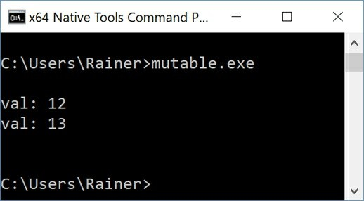

**Figure 12.2. A mutable variable**

Typically, a mutex used in a class member variable is mutable. Imagine, your class has a read

operation, which should be const. Because you use the data of the class concurrently you have to protect the read member function with a mutex. So the class gets a mutex, and you lock the mutex in the read operation. Now, you have an issue. Your read member function cannot be const because of the locking of the mutex. The solution is to declare the mutex as mutable.

Here is a sketch of the presented use-case. Without mutable, this code would not work.

struct Immutable { mutable std::mutex m; int read() const {

std::lock_guard<std::mutex> lck(m);

// critical section

...

}

};

### Con.3: By default, pass pointers and references to consts

If you pass pointers or references to const to a function, the intention of the function is obvious. The pointed to or referenced object cannot be modified. This observation matches the previous rule to parameter passing: in and out.

void getCString(const char* cStr);

void getCppString(const std::string& cppStr);

Are both declarations equivalent? No! In the case of the function getCString, the pointer could be a null pointer. This means you have to check it before its usage: if (cStr) .... .

But there is even more. The pointer and the pointee can be const.

* **const char* cStr**: cStr points to a char that is const; the pointee cannot be modified but the pointer can.
* **char* const cStr**: cStr is a const pointer; the pointer cannot be modified but the pointee can.
* **const char* const cStr**: cStr is a const pointer to a char that is const; neither the pointer nor the pointee can be modified.

Too complicated? Read the expressions from right-to-left or use a reference to const.

### Con.4: Use const to define objects with values that do not change after construction

If you want to share a variable immutable between threads and this variable is declared as const, you are done. You can use const variables without synchronization, and you get the most performance out of your machine. The reason is quite simple. To get a data race, you need to have a mutable, shared state. I already wrote about data races in the section addressing concurrency and parallelism: CP.2: Avoid data races .

There is an additional problem to solve when using immutable and shared data in a concurrent environment. You have to initialize the shared variable in a thread-safe way. I have at least four

ideas in my mind.

1. Initialize the shared variable before you start a thread.
2. Use the function std::call_once in combination with the flag std::once_flag.
3. Use a static variable with block scope.
4. Use a constexpr variable.

In the rule CP.3: Minimize explicit sharing of writable data, I already addressed these challenges.

### Con.5: Use constexpr for values that can be computed at compile-time

constexpr values give you better performance, are evaluated at compile-time, and are never subject to data races. You must initialize a constexpr value constexprValue at compile-time:

constexpr double constexprValue = constexprFunction(2);

A constexpr function constexprFunction can be executed at compile-time. There is no state at compile-time. A constexpr function, when executed at compile-time, is pure. Pure functions have many advantages:

1. The function call can be replaced by the result.
2. The function can be performed on a different thread.
3. A function call can be reordered.
4. They can easily be refactored or be tested in isolation.

Read more details about the benefits of constexpr functions in previous rules for functions:

* F.4: If a function may have to be evaluated at compile-time, declare it constexpr
* F.8: Prefer pure functions

### Distilled

##### Important

* By default, make objects immutable. Immutable objects cannot be a subject to data races. Ensure that these objects are initialized in a thread-safe way.
* By default, make member functions const. Distinguish if your object should be physical or logical const.
* Don’t cast away the constness from an original const object. This conversion is undefined behavior if you try to modify the object.
* If possible, make your functions constexpr. constexpr functions can run at compile-time, are pure when they run at compile-time, and provide additional optimization opportunities.

## Chapter 13. Templates and Generic Programming



##### Figure 13.1. Should Cippi use the left or right door?

There are more than 50 rules regarding templates and generic programming that are unique for many reasons.

* Often, they have a very low-level focus. Since they address the experts, they are irrelevant for the novice, or need additional information. This observation holds true, in particular, for the section on metaprogramming, which gives additional information on metaprogramming to get the most out of the rules of the C++ Core Guidelines.
* Often the rules lack content, or sometimes contradict each other. For example, the rule T.5: Combine generic and OO techniques to amplify their strengths, not their costs presents type- erasure as a solution, but the rule T.49: Where possible, avoid type-erasure states the contrary.
* More than ten rules are about concepts in C++20. I provide a short introduction to concepts in the appendix of this book. In the examples in the C++ Core Guidelines, concepts are often commented out. I follow this convention. If you want to try them out, comment them in. [cppreference.com](http://cppreference.com/) provides details to the current compiler support of concepts.

First of all, I use the term templates and generic programming, although templates are just one way to write generic code. I assume you know what templates in C++ are, but do you know what generic programming means? Here is my favorite definition from Wikipedia.

* **Generic programming** is a style of computer programming in which algorithms are written in terms of types *to-be-specified-later* that are then *instantiated* when needed for specific types provided as parameters.

The rules about templates focus on their use, about their interfaces, and their definition. Additional rules address hierarchies with templates, variadic templates, metaprogramming, and other rules to templates.

### Use

Concepts are predicates on templates that are evaluated at compile time. They should model semantic categories such as Arithmetic, Callable, Iterator, or Range but not syntactic restrictions such as HasPlus, or IsInvocable. Maybe you are puzzled by the difference between semantic categories and syntactic restrictions. The first rule helps to distinguish those terms.

### T.1: Use templates to raise the level of abstraction of code

Here is the example from the guidelines, but I renamed the second concept Addable.

template<typename T>

// requires Addable<T>

T sum1(const std::vector<T>& v, T s) { for (auto x : v) s += x;

return s;

}

template<typename T>

// requires Addable<T>

T sum2(const std::vector<T>& v, T s) { for (auto x : v) s = s + x; return s;

}

What is wrong with those concepts? Both concepts are too specific. Both concepts are based on specific operations such as the increment and the + operation. Let’s go one step further from the syntactic constraints to the semantic category Arithmetic.

template<typename T>

// requires Arithmetic<T>

T sum(const std::vector<T>& v, T s) { for (auto x : v) s += x;

return s;

}

Now, the algorithm has the adequate requirements. The algorithm is better but not good. It only works on a std::vector. It’s generic on the element-type of the container but not on the container. Let me generalize the sum algorithm further.

template<typename Cont, typename T>

// requires Container<Cont>

// && Arithmetic<T>

T sum(const Cont& v, T s) { for (auto x : v) s += x; return s;

}

Now, that’s better. Maybe you prefer a more concise definition of sum. Instead of the keyword

typename, I use the concepts directly.

template<Container Cont, Arithmetic T> T sum(const Cont& cont, T s) {

for (auto x : cont) s += x; return s;

}

### T.2: Use templates to express algorithms that apply to many argument types

When you study the first overload of std::find at [cppreference.com](http://cppreference.com/), it looks like this:

template< class InputIt, class T >

InputIt find( InputIt first, InputIt last, const T& value );

The types of the Iterators are encoded in their names: InputIt stands for input iterator and essentially means that it is an iterator that can read from the pointed-to element at least once and allows to iterate in one direction. An input iterator It supports the following operations:

++It, It++

*It

It == It2, It != It2

There are two issues with this declaration:

1. The requirements for the iterators are encoded in the name. This encoding reminds me of the infamous Hungarian notation.
2. There is no requirement specifying that the pointed-to element can be compared with the value.

Let me use the iterator concept directly:

template<Input_iterator Iter, typename Val>

// Equality_comparable<Value_type<Iter>, Val> Iter find(Iter b, Iter e, const Val& v) {

// ...

}

### T.3: Use templates to express containers and ranges

Container needs to be generic. Thanks to templates, you can rely on the static type system (Per.10). For example, here is a Vector.

template<typename T>

// requires Regular<T> class Vector {

// ...

T* elem; // points to sz Ts int sz;

};

Vector<double> v(10); v[7] = 9.9;

One question remains. When is a type T regular? I answer this question in section T.46: Require template arguments to be at least Regular or SemiRegular.

### Interfaces

An interface is a contract between a user and an implementer. It should, therefore, be written with great care.

### T.40: Use function objects to pass operations to algorithms

Often, you can adapt the behavior of the around 100 algorithms of the STL by providing a callable. Callables are typically functions, function objects, or lambdas.

There are various ways to sort a vector of strings.

// functionObjects.cpp

#include <algorithm> #include <functional> #include <iostream> #include <iterator> #include <string> #include <vector>

bool byLessLength(const std::string& f, const std::string& s) { // (4) return f.size() < s.size();

}

class ByGreaterLength { public:

bool operator()(const std::string& f, const std::string& s) const { // (5) return f.size() > s.size();

}

};

int main() {

std::vector<std::string> myStrVec = {"523345", "4336893456", "7234",

"564", "199", "433", "2435345"};

std::cout << '\n';

std::cout << "Ascending by length with a function \n"; std::sort(myStrVec.begin(), myStrVec.end(), byLessLength); // (1) for (const auto& str: myStrVec) std::cout << str << " ";

std::cout << "\n\n";

std::cout << "Descending by length with a function object \n"; std::sort(myStrVec.begin(), myStrVec.end(), ByGreaterLength()); // (2) for (const auto& str: myStrVec) std::cout << str << " ";

std::cout << "\n\n";

std::cout << "Ascending by length with a lambda \n"; std::sort(myStrVec.begin(), myStrVec.end(),

[](const std::string& f, const std::string& s){ // (3) return f.size() < s.size();

});

for (const auto& str: myStrVec) std::cout << str << " ";

std::cout << "\n\n";

}

The program sorts a vector of strings based on the length of the strings. The marker (1), (2), and

1. use a function (4), a function object (5), and a lambda expression (3). A function object is a class (5), for which the call operator (operator()) is overloaded.

For completeness, here is the output of the program.

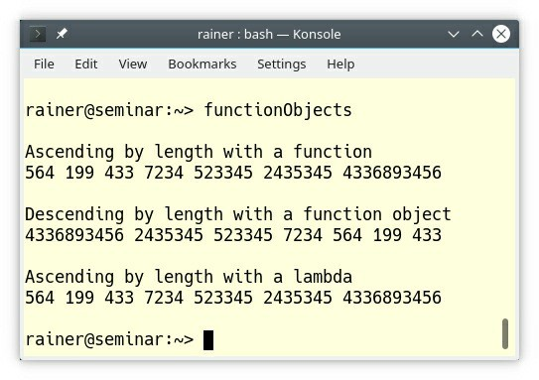

##### Figure 13.2. A function, a function object, and a lambda as sorting criteria

The rule states: you should use function objects to pass operations to algorithms.

#### Advantages of function objects

My argumentation for function objects boils down to three points: performance, expressiveness, and state. It makes my argumentation easier if we consider that lambda functions are function objects under the hood.

##### Performance

The more the optimizer can reason locally, the better the code becomes. A lambda (3) is compiler-generated just in place. Compare this to a function that is defined in a different translation unit. In this case, the optimizer can not perform all optimization steps.

##### Expressiveness

**Your code should be such expressive that it needs no documentation,** and lambdas give you this expressiveness. I can make my argumentation short because I already wrote about the expressiveness of lambdas in the chapter on functions.

##### State

In contrast to a function, a function object can have state. The code example makes my point.

// sumUpFunctionObject.cpp

#include <algorithm> #include <iostream> #include <vector>

class SumMe {

int sum{0}; public:

SumMe() = default;

void operator()(int x) { sum += x;

}

int getSum() const { return sum;

}

};

int main() {

std::vector<int> intVec{1, 2, 3, 4, 5, 6, 7, 8, 9, 10};

// (1)

SumMe sumMe = std::for_each(intVec.begin(), intVec.end(), SumMe()); std::cout << '\n'; // (2)

std::cout << "Sum of intVec= " << sumMe.getSum() << '\n'; std::cout << '\n';

}

The std::for_each call in (1) is crucial. std::for_each is a unique algorithm of the Standard Template Library because it can return its callable. I invoke std::for_each with the function object SumMe and can, therefore, store the result of the function call directly in the function object. I ask in (2) for the sum of all calls.

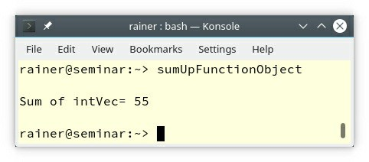

##### Figure 13.3. A function object with state

Just to be complete, lambdas can also have state. You can use a lambda to accumulate values.

// sumUpLambda.cpp

#include <algorithm> #include <iostream> #include <vector>

int main(){

std::cout << '\n';

std::vector<int> intVec{1, 2, 3, 4, 5, 6, 7, 8, 9, 10};

std::for_each(

intVec.begin(), intVec.end(), [sum = 0](int i) mutable {

sum += i;

std::cout << sum << " ";

}

);

std::cout << "\n\n";

}

This lambda looks scary. First of all, the variable sum represents the state of the lambda. With C++14, the so-called initialization capture of lambdas is supported. sum = 0 declares and initializes a variable of type int which is only valid in the scope of the lambda. Lambdas are per default const. By declaring it as mutable, I can add the numbers to sum.

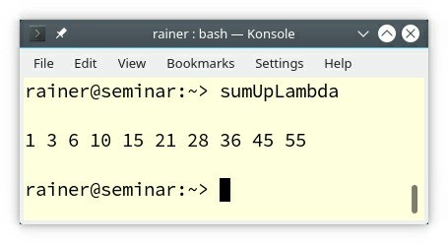

##### Figure 13.4. A lambda with state

A lambda expression is syntactic sugar for a function object which is instantiated in place. Thanks to C+ + Insights, you can observe the transformation performed by the compiler.

### T.42: Use template aliases to simplify notation and hide implementation details

Since C++11, we have template aliases. A template alias is a name that refers to a family of types. Using them makes your code more readable and helps you to get rid of type traits. The section metaprogramming provides more information to type traits.

Let’s see what the C++ Core Guidelines mean by readability. The first example uses type traits:

template<typename T> void user(T& c) {

// ...

typename container_traits<T>::value_type x; // bad, verbose

// ...

}

Here is the equivalent case with template aliases:

template<typename T>

using value_type = typename container_traits<T>::value_type;

void user2(T& c) {

// ... value_type<T> x;

// ...

}

Readability is also the reason for the next rule.

**T.43: Prefer using over typedef for defining aliases**

There are two arguments from the readability perspective to prefer using over typedef. First, using comes first when used. Second, using feels quite similar to auto. Additionally, using can easily be used for template aliases.

typedef int (*PFI)(int); // OK, but convoluted using PFI2 = int (*)(int); // OK, preferred

template<typename T>

typedef int (*PFT)(T); // error (1)

template<typename T>

using PFT2 = int (*)(T); // OK

The first two lines define a pointer to a function (PFI and PFI2) which takes an int and returns an int. In the first case, typedef is used and, in the second case using. The last two lines define a function template (PFT2), which takes a type parameter T and returns an int. Line (1) is not valid.

### T.44: Use function templates to deduce class template argument types (where feasible)

The primary reason that we have factory functions such as std::make_tuple or std::make_unique is that a function template can deduce its template arguments from its function arguments. During this process, the compiler applies a few simple conversions such as removing the outermost const/volatile qualifier and decaying C-arrays and functions to a pointer to the first element of the C-arrray or a pointer to the function.

This automatic template argument deduction makes our life as a programmer much more comfortable.

Instead of typing

std::tuple<int, double, std::string> myTuple = {2011, 20.11, "C++11"};

, you can use the factory function std::make_tuple.

auto myTuple = std::make_tuple(2011, 20.11, "C++11");

Since C++17, the compiler can in many situations deduce its template arguments not only from the function arguments but also from the constructor arguments. Here is the way to define myTuple in C++17:

std::tuple myTuple = {2017, 20.17, "C++17"};

An obvious effect of this C++17 feature is that most of the factory functions such as

std::make_tuple become obsolete.

The following program templateArgumentDeduction.cpp shows class and function argument deduction in action.

// templateArgumentDeduction.cpp; C++17 #include <iostream>

template <typename T> void showMe(const T& t) {

std::cout << t << '\n';

}

template <typename T> struct ShowMe{

ShowMe(const T& t) { std::cout << t << '\n';

}

};

int main() { std::cout << '\n';

showMe(5.5); // not showMe<double>(5.5); showMe(5); // not showMe<int>(5);

ShowMe a(5.5); // not ShowMe<double>(5.5); ShowMe b(5); // not ShowMe<int>(5);

std::cout << '\n';

}

The comments display the explicit specification of the template arguments. With template argument deduction, the user invokes a function or a class. The fact that the function is a function template or that the class is a class template is an implementation detail.

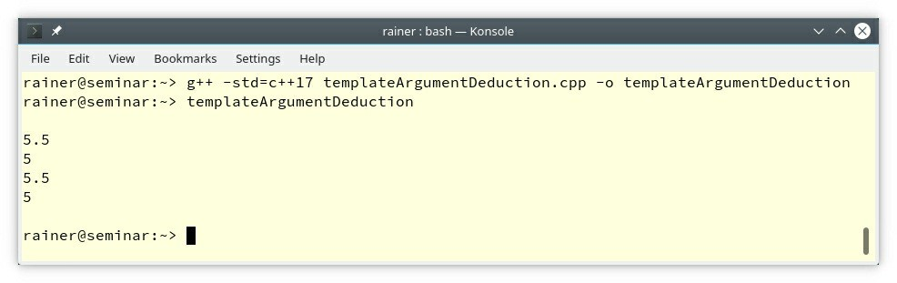

##### Figure 13.5. Template argument deduction

**T.46: Require template arguments to be at least Regular or SemiRegular**

The concepts Regular and SemiRegular are quite important in C++. Regular types work well in the C++ ecosystem. A Regular type “behaves like an int.” It can be copied and, the result of the copy operation is independent of the original one and has the same value.

Let’s be more formal. All Regular types are also SemiRegular. Consequently, I start with defining a SemiRegular type.

* **SemiRegular**: A SemiRegular type has to support the rule of six and has to be swappable.
  + Default constructor: X()
  + Copy constructor: X(const X&)
  + Copy assignment: X& operator = (const X&)
  + Move constructor: X(X&&)
  + Move assignment: X& operator = (X&&)
  + Destructor: ~X()
  + Swappable: swap(X&, X&)
* **Regular**: A SemiRegular type that supports equality comparable is Regular.
  + Equality operator: operator == (const X&, const X&)
  + Inequality operator: operator != (const X&, const X&)

##### The STL containers and algorithms, in particular, assume Regular data types.

What is commonly used but not a Regular type? Right: a reference. A reference is not even

SemiRegular because it cannot be default constructed.

// semiRegular.cpp; C++17

#include <iostream> #include <type_traits>

int main() {

std::cout << std::boolalpha << '\n';

std::cout << "std::is_default_constructible<int&>::value: "

<< std::is_default_constructible<int&>::value << '\n'; std::cout << "std::is_copy_constructible<int&>::value: "

<< std::is_copy_constructible<int&>::value << '\n'; std::cout << "std::is_copy_assignable<int&>::value: "

<< std::is_copy_assignable<int&>::value << '\n'; std::cout << "std::is_move_constructible<int&>::value: "

<< std::is_move_constructible<int&>::value << '\n'; std::cout << "std::is_move_assignable<int&>::value: "

<< std::is_move_assignable<int&>::value << '\n'; std::cout << "std::is_destructible<int&>::value: "

<< std::is_destructible<int&>::value << '\n'; std::cout << '\n';

std::cout << "std::is_swappable<int&>::value: "

<< std::is_swappable<int&>::value << '\n'; std::cout << '\n';

}

The type-traits library gives the authoritative answer.

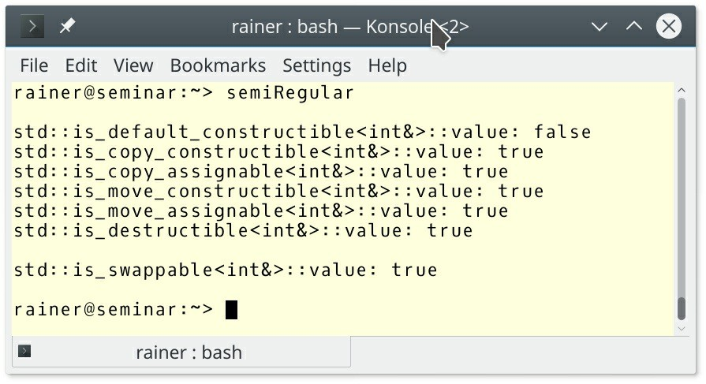

**Figure 13.6. A reference is not SemiRegular**

### T.47: Avoid highly visible unconstrained templates with common names

To get the point of this rule, I have to make a short detour. This detour is about argument- dependent lookup (ADL), also known as koenig lookup named after Andrew Koenig. First of all, what is argument-dependent lookup?

##### Argument-dependent lookup (ADL)

* **Argument-dependent lookup** is a set of rules for the lookup of unqualified function names. Unqualified function names are additionally looked up in the namespace of their arguments.

Unqualified function names mean functions without the scope operator (::). Is argument- dependent lookup bad? Of course not, ADL makes our life as a programmer easier. Here is an example.

#include <iostream>

int main() {

std::cout << "Argument-dependent lookup";

}

Fine. Let me remove the syntactic sugar of operator overloading and use the function call directly.

#include <iostream>

int main() {

operator << (std::cout, "Argument-dependent lookup");

}

This equivalent program shows what is happening under the hood. The function operator << is called with the two arguments std::cout and the C-string “Argument-dependent lookup.”

Fine? No? The question arises: Where is the definition of the function operator <<. Of course, there is no definition in the global namespace. operator << is an unqualified function name; therefore, argument-dependent lookup kicks in. The function name is additionally looked up in the namespace of their arguments. In this particular case the namespace std is due to the first argument std::cout considered and the lookup finds the appropriate candidate: std::operator

<< (std::ostream&, const char*). Often ADL provides you precisely with the function you are looking for but sometimes ... .

Now, we have the necessary background information to write about this rule.

In the expression std::cout << “Argument-dependent lookup", the overloaded output operator << is the highly visible common name because it is defined in the namespace std. The following program, based on the program of the C++ Core Guidelines, shows the crucial point of this rule.

// argumentDependentLookup.cpp

#include <iostream> #include <vector>

namespace Bad {

struct Number { int m;

};

template<typename T1, typename T2> // generic equality (5) bool operator == (T1, T2) {

return false;

}

}

namespace Util {

bool operator == (int, Bad::Number) { // equality to int (4) return true;

}

void compareSize() {

Bad::Number badNumber{5}; // (1) std::vector<int> vec{1, 2, 3, 4, 5};

std::cout << std::boolalpha << '\n';

std::cout << "5 == badNumber: " <<

(5 == badNumber) << '\n'; // (2) std::cout << "vec.size() == badNumber: " <<

(vec.size() == badNumber) << '\n'; // (3)

std::cout << '\n';

}

}

int main() { Util::compareSize();

}

I expect that in both cases (2) and (3), that the overloaded Util::operator == (4) is called because it takes an argument of type Bad::Number (1); therefore, I should get two times true.

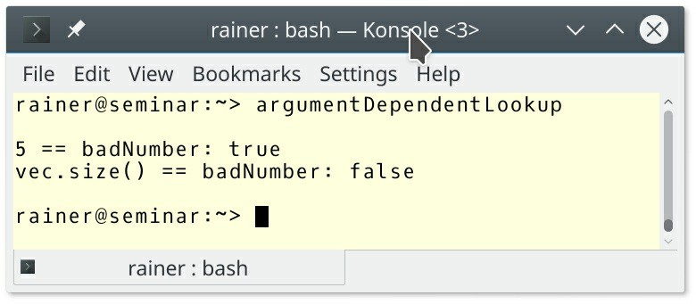

##### Figure 13.7. Surprise with argument-dependent lookup

What happened here? The call in (3) is resolved by the generic equality operator in (5)? The reason for the surprise is that vec.size() returns a value of type std::size_type, which is an unsigned integer type. This means that the equality operator requires in (4) a conversion to int. This conversion is not necessary for the generic equality (5) because this is an ideal fit. Thanks to argument-dependent lookup, the generic equality operator belongs to the set of possible overloads.

The rules states “Avoid highly visible unconstrained templates with common names". Let me see what would happen if I follow the rule and remove the generic equality operator. Here is the fixed code.

// argumentDependentLookupResolved.cpp

#include <iostream> #include <vector>

namespace Bad {

struct Number { int m;

};

}

namespace Util {

bool operator == (int, Bad::Number) { // compare to int (4) return true;

}

void compareSize() {

Bad::Number badNumber{5}; // (1) std::vector<int> vec{1, 2, 3, 4, 5};

std::cout << std::boolalpha << '\n';

std::cout << "5 == badNumber: " <<

(5 == badNumber) << '\n'; // (2) std::cout << "vec.size() == badNumber: " <<

(vec.size() == badNumber) << '\n'; // (3)

std::cout << '\n';

}

}

int main() { Util::compareSize();

}

Now, the result matches my expectations.

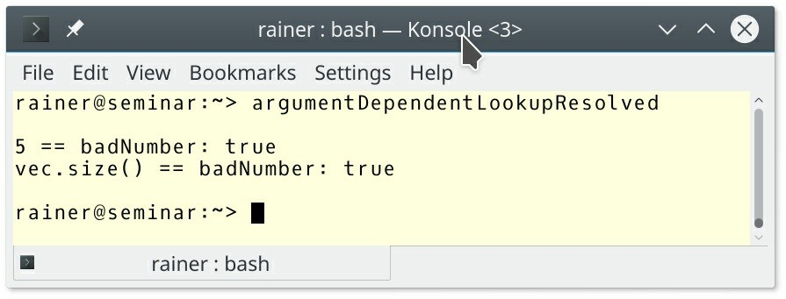

**Figure 13.8. Surprises with argument-dependent lookup solved**

### T.48: If your compiler does not support concepts, fake them with

#### enable_if

When I present std::enable_if in my seminars, a few participants are scared. Here is the simplified version of a generic greatest common divisor algorithm.

// enable_if.cpp

#include <iostream> #include <type_traits>

template<typename T, // (1)

typename std::enable_if<std::is_integral<T>::value, T>::type = 0> T gcd(T a, T b) {

if( b == 0 ){ return a; }

else{

return gcd(b, a % b); // (2)

}

}

int main() { std::cout << '\n';

std::cout << "gcd(100, 10)= " << gcd(100, 10) << '\n'; std::cout << "gcd(3.5, 4)= " << gcd(3.5, 4.0) << '\n';

std::cout << '\n';

}

The algorithm is too generic. It should only work for integral types. Now, std::enable_if from the type-traits library (1) comes to my rescue.

The expression std::is_integral (1) is critical for the understanding of the program. This line determines whether the type parameter T is integral. If T is not integral and therefore the return value false, there is no template instantiation for this specific type.

Only if std::is_integral returns true std::enable_if has a public member typedef type. But this is not an error.

The C++ standard says: When substituting the deduced type for the template parameter fails, the specialization is discarded from the overload set instead of causing a compile error. There is a shorter acronym for this rule SFINAE (**S**ubstitution **F**ailure **I**s **N**ot **A**n **E**rror).

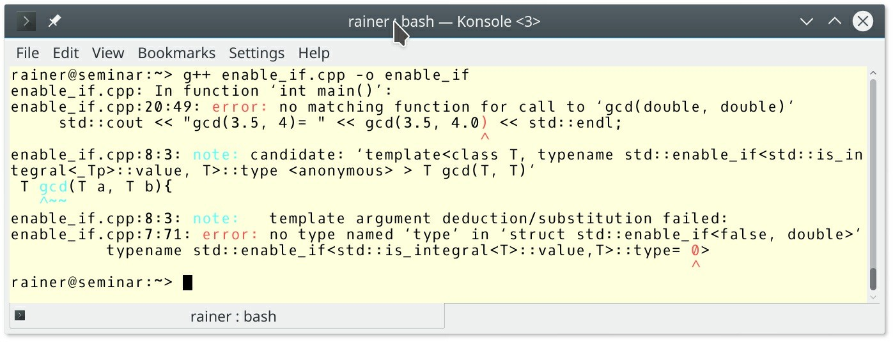

##### Figure 13.9. std::enable_if

The output of the compilation (enable_if.cpp: 20:49) shows it. There is no template specialization for the type double available.

### Definition

When defining templates, you should minimize dependencies, avoid over-parametrizing, and factor out code from the template that does not depend on its type parameters.

### T.60: Minimize a template’s context dependencies

To be honest, it took me a moment to get this rule. Let’s look at the function templates sort and

algo. Here is a simplified example from the C++ Core Guidelines.

template<typename C> void sort(C& c) {

std::sort(begin(c), end(c)); // necessary and useful dependency

}

template<typename Iter>

Iter algo(Iter first, Iter last) { for (; first != last; ++first) {

auto x = sqrt(*first); // potentially surprising dependency:

// which sqrt()?

helper(first, x); // potentially surprising dependency:

// helper is chosen based on first

// and x

}

It would be optimal but not always manageable if a template operates only on its arguments. This argument holds for the function template sort but not for algo. The function template algo has dependencies on sqrt and the function helper. Moreover, the implementation of algo introduces more dependencies than the interface shows. For example, the calls sqrt and helper are not qualified and, therefore, argument-dependent lookup kicks in. Using std::sqrt instead of sqrt reduces the dependencies.

### T.61: Do not over-parameterize members

If a member of a template does not depend on a template parameter, remove it from the template. A member may be a type or a member function. By following this rule, you may decrease the code size because the non-generic code is factored out.

The example from the guidelines is straightforward.

template<typename T, typename A = std::allocator{}>

// requires Regular<T> && Allocator<A> class List {

public:

struct Link { // does not depend on A T elem;

T* pre; T* suc;

};

using iterator = Link*;

iterator first() const { return head; }

// ... private:

Link* head;

};

List<int> lst1;

List<int, My_allocator> lst2;

The type Link does not depend on the template parameter A. Consequently, you can extract it and use it in List2.

template<typename T> struct Link {

T elem; T* pre; T* suc;

};

template<typename T, typename A = std::allocator{}>

// requires Regular<T> && Allocator<A> class List2 {

public:

using iterator = Link<T>*;

iterator first() const { return head; }

// ... private:

Link* head;

};

List2<int> lst1;

List2<int, My_allocator> lst2;

The next rules also helps to fight code-bloat.

### T.62: Place non-dependent class template members in a non- templated base class

Let reformulate it more informally: put the functionality of the template which does not depend on the template parameters in a non-templated base class.

The C++ Core Guidelines present a quite obvious example.

template<typename T> class Foo {

public:

enum { v1, v2 };

// ...

};

The enumeration is independent of the type parameter T and should, therefore, be placed in a non-templated base class.

struct Foo_base { enum { v1, v2 };

// ...

};

template<typename T>

class Foo : public Foo_base { public:

// ...

};

Now, Foo_base can be used without template arguments and template instantiation.

This technique is quite interesting if you want to reduce your code size. Here is a simple class template Array.

// genericArray.cpp

#include <cstddef> #include <iostream>

template <typename T, std::size_t N>

class Array { public:

Array()= default; std::size_t getSize() const{

return N;

}

private:

T elem[N];

};

int main(){

Array<int, 100> arr1;

std::cout << "arr1.getSize(): " << arr1.getSize() << '\n';

Array<int, 200> arr2;

std::cout << "arr2.getSize(): " << arr2.getSize() << '\n';

}

If you study the class template Array, you notice that the member function getSize is the same except for type parameter N. Let me refactor the code and declare a class template Array which depends on the type parameter T and the size n.

// genericArrayInheritance.cpp

#include <cstddef> #include <iostream>

class ArrayBase { protected:

ArrayBase(std::size_t n): size(n) {} std::size_t getSize() const {

return size;

};

private:

std::size_t size;

};

template<typename T, std::size_t N> class Array: private ArrayBase { public:

Array(): ArrayBase(N){} std::size_t getSize() const {

return ArrayBase::getSize();

}

private:

T data[N];

};

int main() {

Array<int, 100> arr1;

std::cout << "arr1.getSize(): " << arr1.getSize() << '\n';

Array<double, 200> arr2;

std::cout << "arr2.getSize(): " << arr2.getSize() << '\n';

}

Array has two template parameters for the type T and the size N but ArrayBase is no template. Array derives from ArrayBase. This means ArrayBase is shared between all instantiations of Array. In the concrete case, the getSize member function of Array uses the getSize method of ArrayBase. ArrayBase is shared between the instantiations Array<int, 100> and Array<double, 200>.

### Alternative implementations with specializations

* T.64: Use specialization to provide alternative implementations of class templates
* T.67: Use specialization to provide alternative implementations for irregular types

The rules in this section address mainly one concern: use template specialization to provide alternative implementations.

Let’s start simple. I have a class Account, and I want to know which account is smaller. Smaller means in this case that the balance is lower.

// isSmaller.cpp

#include <iostream> class Account {

public:

Account() = default; Account(double b): balance(b) {}

private:

double balance{0.0};

};

template<typename T> // (1) bool isSmaller(T fir, T sec) {

return fir < sec;

}

int main() {

std::cout << std::boolalpha << '\n'; double firDoub{};

double secDoub{2014.0};

std::cout << "isSmaller(firDoub, secDoub): "

<< isSmaller(firDoub, secDoub) << '\n';

Account firAcc{}; Account secAcc{2014.0};

std::cout << "isSmaller(firAcc, secAcc): "

<< isSmaller(firAcc, secAcc) << '\n'; std::cout << '\n';

}

To make my job easier, I wrote a generic isSmaller function (1) for comparing two accounts. As you presumably expected, I cannot compare accounts because its operator < is not overloaded.

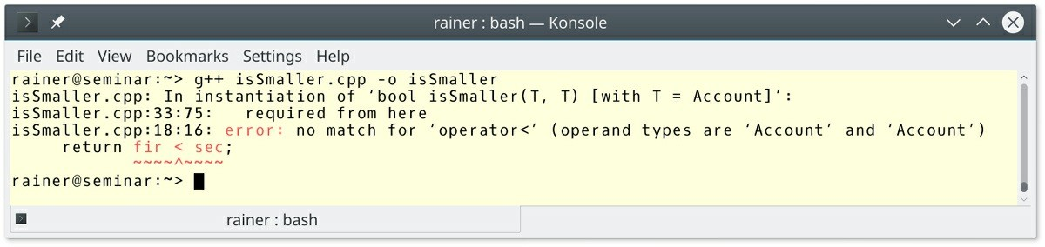

##### Figure 13.10. Comparing two accounts

Now, to the interesting question. Which techniques are available to compare two accounts? For the sake of simplicity, I only show the essential part of the next programs. The complete programs are part of the source code to this book.

**Overloading operator < for the class**

Overloading operator < is probably the most obvious way. Even the error message of the program isSmaller.cpp showed it.

// accountIsSmaller1.cpp

class Account { public:

Account() = default; Account(double b): balance(b) {}

friend bool operator < (Account const& fir, Account const& sec) {

return fir.getBalance() < sec.getBalance();

}

double getBalance() const { return balance;

}

private:

double balance{0.0};

};

template<typename T>

bool isSmaller(T fir, T sec) { return fir < sec;

}

#### Full specialization of the comparison function

If you cannot change Account, you can at least fully specialise isSmaller for Account.

// accountIsSmaller2.cpp

class Account { public:

Account() = default; Account(double b): balance(b) {} double getBalance() const {

return balance;

}

private:

double balance{0.0};

};

template<typename T>

bool isSmaller(T fir, T sec){ return fir < sec;

}

template<>

bool isSmaller<Account>(Account fir, Account sec){ return fir.getBalance() < sec.getBalance();

}

By the way, a non-generic function bool isSmaller(Account fir, Account sec) would also do the job.

#### Extending the comparison function

There is another way: extend isSmaller. I extend the generic function with an additional type parameter Pred that can hold a binary predicate. This pattern is heavily used in the standard template library.

// accountIsSmaller3.cpp

#include <functional> #include <iostream> #include <string>

class Account { public:

Account() = default; Account(double b): balance(b){} double getBalance() const {

return balance;

}

private:

double balance{0.0};

};

template <typename T, typename Pred = std::less<T> > // (1)

bool isSmaller(T fir, T sec, Pred pred = Pred() ) { // (2) return pred(fir, sec); // (3)

}

int main() {

std::cout << std::boolalpha << '\n'; double firDou{};

double secDou{2014.0};

std::cout << "isSmaller(firDou, secDou): "

<< isSmaller(firDou, secDou) << '\n';

Account firAcc{}; Account secAcc{2014.0};

auto res = isSmaller(firAcc, secAcc, // (4) [](const Account& fir, const Account& sec){

return fir.getBalance() < sec.getBalance();

}

);

std::cout << "isSmaller(firAcc, secAcc): " << res << '\n'; std::cout << '\n';

std::string firStr = "AAA"; std::string secStr = "BB";

std::cout << "isSmaller(firStr, secStr): "

<< isSmaller(firStr, secStr) << '\n';

auto res2 = isSmaller(firStr, secStr, // (5) [](const std::string& fir, const std::string& sec){

return fir.size() < sec.length();

}

);

std::cout << "isSmaller(firStr, secStr): " << res2 << '\n'; std::cout << '\n';

}

The generic function uses the predefined function object std::less<T> as the default ordering (1). The binary predicate Pred is instantiated in (2) and used in (3). Additionally, you can provide your binary predicate such as in (4) or (5). A lambda expression is an ideal fit for this job.

Finally, here is the output of the program:

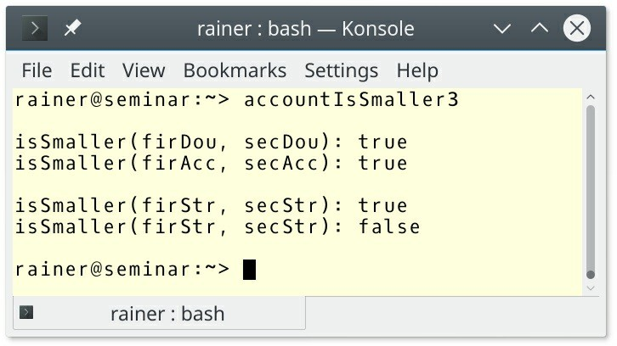

##### Figure 13.11. Comparing two accounts with a binary predicate

What are the differences between these three techniques?

#### Comparing the three techniques

##### Table 13.1. Comparing two Accounts

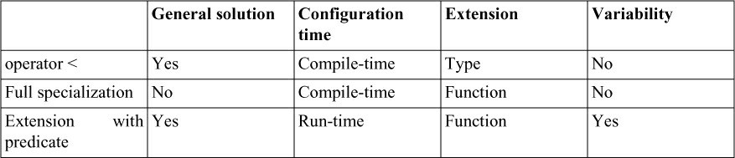

The full specialization is not a general solution. It only works for the function isSmaller. In contrast, the operator < is quite often applicable, and any type can use the extension with predicate. The operator < and the full specialization are static. This means the ordering is defined at compile-time and is encoded in the type or the generic function. In contrast, the extension with the predicate can be invoked with different predicates. The decision happens at run-time. The operator < extends the type, both other variants the function. The extension with predicate allows it to order your type in various ways. For example, you can compare strings lexicographically or by their length.

Based on this comparison a good rule of thumb is it to implement an operator < for your types and add an extension to your generic functions if necessary.

### Hierarchies

Virtual functions used in templates are special. Here is why:

### T.80: Do not naively templatize a class hierarchy

Here is the example of a naively templatized class hierarchy from the C++ Core Guidelines:

template<typename T>

struct Container { // an interface virtual T* get(int i);

virtual T* first(); virtual T* next(); virtual void sort();

};

template<typename T>

class Vector : public Container<T> { public:

// ...

};

Vector<int> vi; Vector<std::string> vs;

This is naive because the base class Container has many virtual functions. The presented design introduces unnecessary code bloat. Virtual member functions must be instantiated for each type used in a class template. This observation applies to the Container and the Vector<int> and Vector<std::string>. In contrast, non-virtual functions are only instantiated if they are used.

### T.83: Do not declare a member function template virtual

Let me try to use a virtual member function template.

// virtualMemberFunction.cpp

class Shape {

template<class T>

virtual void intersect(T* p) {}

};

int main(){

Shape shape;

}

The error message for the GCC is crystal-clear: templates may not be virtual.

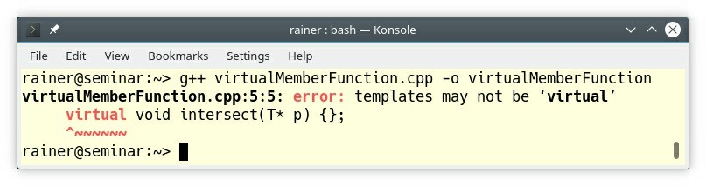

**Figure 13.12. Compiler error with a virtual member function**

### Variadic templates

* T.100: Use variadic templates when you need a function that takes a variable number of arguments of a variety of types
* T.101: How to pass arguments to a variadic template
* T.102: How to process arguments to a variadic template

These three rules about variadic templates have little content. Consequently, I have to improvise. Let me use std::make_unique as an example. As a side-note, the three lines of std::make_unique, which I’m going to developer in this section, are the most impressive three lines of code I know in modern C++.

std::make_unique is a function template that returns a dynamically allocated object, wrapped into a std::unique_ptr. Here are a few use-cases.

// makeUnique.cpp #include <memory>

struct MyType {

MyType(int, double, bool){};

};

int main() {

int lvalue{2020};

std::unique_ptr<int> uniqZero = std::make_unique<int>(); auto uniqEleven = std::make_unique<int>(2011);

auto uniqTwenty = std::make_unique<int>(lvalue);

auto uniqType = std::make_unique<MyType>(lvalue, 3.14, true);

}

Based on these uses-cases, what are the requirements for std::make_unique?

1. std::make_unique should deal with an arbitrary number of arguments. It gets 0, 1, and 3 arguments.
2. std::make_unique should accept lvalues and rvalues. It gets an rvalue (2011) and an lvalue (lvalue). The last call even gets both an rvalue and an lvalue.
3. std::make_unique should forward its arguments unchanged to the underlying constructor. This means that, the constructor of std::unique_ptr should get an lvalue/rvalue if std::make_unique gets an lvalue/rvalue.

These requirements are typical for factory functions such as std::make_unique, std::make_shared, std::make_tuple, but also std::thread. Factory functions in modern C ++ rely on two powerful features in C++11:

* Perfect forwarding
* Variadic templates

Now, I want to create my factory function createT. Let’s start the job with perfect forwarding.

### Perfect forwarding

First of all: What is perfect forwarding?

* **Perfect forwarding** allows you to preserve an argument’s value category (lvalue/rvalue) and

const/ volatile type qualifiers.

Perfect forwarding follows a typical pattern, consisting of a universal reference (perfect forwarding reference) and std::forward.

template<typename T> // (1)

void createT(T&& t) { // (2) std::forward<T>(t); // (3)

}

The three parts of the pattern to get perfect forwarding are:

1. You need a template parameter T: typename T
2. Bind T by universal reference, also known as perfect forwarding reference: T&& t
3. Invoke std::forward on the argument: std::forward<T>(t)

The key observation is that T&& (2) can bind an lvalue or an rvalue and that std::forward (3) does the perfect forwarding. std::forward is a conditional std::move. It moves an rvalue and copies an lvalue.

It’s time to create the prototype of the createT factory function which should behave at the end similarly to std::make_unique in the program makeUnique.cpp. I just replaced std::make_unique with the createT call, added the createT factory function, and commented the two lines (1) out. Additionally, I removed the header <memory> (std::make_unique) and added the header <utility> for std::forward.

// createT1.cpp #include <utility> struct MyType {

MyType(int, double, bool) {};

};

template <typename T, typename Arg> T createT(Arg&& arg) {

return T(std::forward<Arg>(arg));

}

int main() {

int lvalue{2020};

//std::unique_ptr<int> uniqZero = std::make_unique<int>(); auto uniqEleven = createT<int>(2011);

auto uniqTwenty = createT<int>(lvalue);

//auto uniqType = std::make_unique<MyType>(lvalue, 3.14, true);

}

Excellent! The rvalue (2011) and the lvalue (lvalue) pass my test.

### Variadic templates

Sometimes dots are important. Inserting exactly nine dots at the right place and the two commented out lines work.

// createT2.cpp

#include <utility> struct MyType {

MyType(int, double, bool) {};

};

template <typename T, typename ... Args> T createT(Args&& ... args) {

return T(std::forward<Args>(args) ... );

}

int main() {

int lvalue{2020};

int uniqZero = createT<int>();

auto uniqEleven = createT<int>(2011); auto uniqTwenty = createT<int>(lvalue);

auto uniqType = createT<MyType>(lvalue, 3.14, true);

}

How does the magic work? The three dots stand for an ellipsis. By using them Args, or args becomes a parameter pack. To be more precise, Args is a template parameter pack and args is a function parameter pack. You can only apply two operations to a parameter pack: pack or unpack. If the ellipsis is left of Args the parameter pack is packed; if the ellipsis is right of Args the parameter pack is unpacked. In case of the expression std::forward<Args>(args)... this

means the expression is unpacked until the parameter pack is consumed and a comma is just placed between the unpacked components. That’s all.

C++ Insights helps you to visualize this unpacking process. Now, I’m nearly done. The two missing steps are.

1. Create a std::unique_ptr<T> instead of a plain T.
2. Rename the function to make_unique. Voila.

template <typename T, typename ... Args> std::unique_ptr<T> make_unique(Args&& ... args) {

return std::unique_ptr<T>(new T(std::forward<Args>(args) ... ));

}

### Metaprogramming

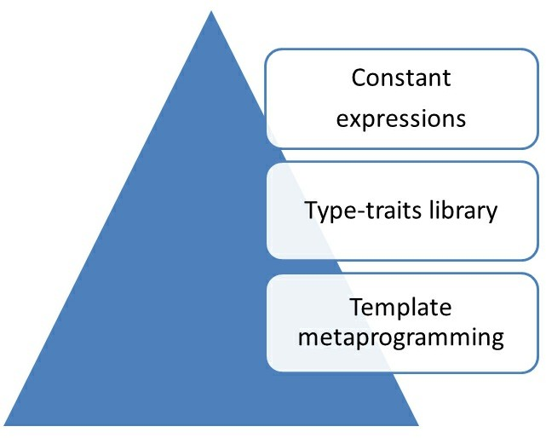

##### Figure 13.13. Metaprogramming

Metaprogramming is programming at compile-time. It started in C++98 with template metaprogramming, was formalized in C++11 with the type-traits library, and since C++11 has steadily improved. The main driving force are constant expressions. The introduction to template metaprogramming in the C++ Core Guidelines ends uniquely: “The syntax and techniques

needed are pretty horrendous.”.

My perception is, that template metaprogramming is not so horrendous, that the C++ Core Guidelines lack content, and a straightforward introduction to metaprogramming is missing. Consequently, this section provides a concise introduction to metaprogramming. As the various concepts are introduced, I refer to the four rules about metaprogramming.

### Template metaprogramming

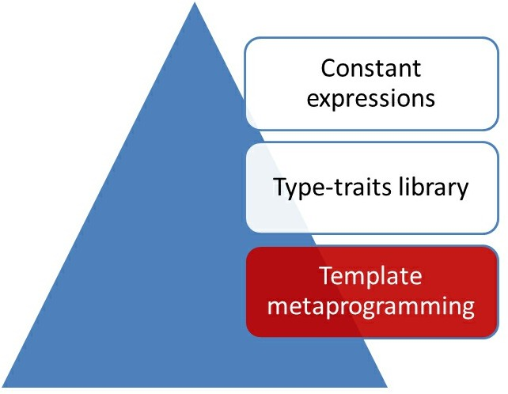

##### Figure 13.14. Template metaprogramming

* T.120: Use template metaprogramming only when you really need to
* T.122: Use templates (usually template aliases) to compute types at compile time

#### How does it all started?

In 1994, Erwin Unruh presented at a C++ committee meeting a program that didn’t compile. Here is probably the most famous program that never compiled.

// Prime number computation by Erwin Unruh

template <int i> struct D { D(void*); operator int(); };

template <int p, int i> struct is_prime {

enum { prim = (p%i) && is_prime<(i > 2 ? p : 0), i -1> :: prim };

};

template < int i > struct Prime_print { Prime_print<i-1> a;

enum { prim = is_prime<i, i-1>::prim }; void f() { D<i> d = prim; }

};

struct is_prime<0,0> { enum {prim=1}; }; struct is_prime<0,1> { enum {prim=1}; };

struct Prime_print<2> { enum {prim = 1}; void f() { D<2> d = prim; } }; #ifndef LAST

#define LAST 10 #endif

main () {

Prime_print<LAST> a;

}

Erwin Unruh used the Metaware Compilers, but the program does not produce the presented error messages with a recent C++ compiler. A newer variant from the author is here. Why is this program so famous? Let’s have a closer look at the original error messages.

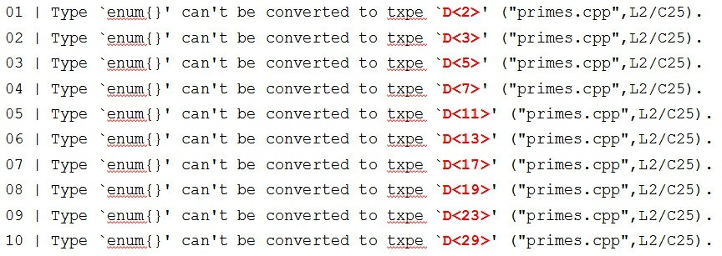

##### Figure 13.15. Calculating primes at compile-time

I highlighted the important parts in red. I think you see the pattern. The program calculates at compile-time the first 30 prime numbers. This means template instantiation empowers you to do math at compile-time. It is even better. Template metaprogramming is Turing-complete, and can, therefore, be used to solve any computational problem. (Of course, Turing-completeness holds only in theory for template metaprogramming because the recursion depth (at least 1024 with C++11) and the length of the names which are generated during template instantiation provide some limitations.)

#### How does the magic work?

Let me decompose what is going on step by step.

##### Calculating at compile-time

Calculating the factorial of a number is the “Hello World" of template metaprogramming.

// factorial.cpp #include <iostream>

template <int N> // (2)

struct Factorial {

static int const value = N * Factorial<N-1>::value;

};

template <> // (3)

struct Factorial<1> {

static int const value = 1;

};

int main() {

std::cout << '\n';

std::cout << "Factorial<5>::value: "

<< Factorial<5>::value << '\n'; // (1) std::cout << "Factorial<10>::value: "

<< Factorial<10>::value << '\n'; std::cout << '\n';

}

The call factorial<5>::value (1) causes the instantiation of the primary or general template (2). This instantiation triggers the call of Factorial<4>::value. This recursion ends with the fully specialized class template Factorial<1> as a boundary condition (3).

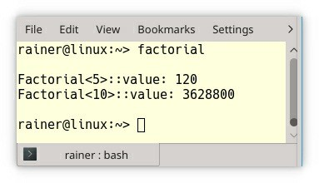

##### Figure 13.16. Calculating the factorial of 5 at compile-time

The Compiler Explorer allows you to visualize this compile-time calculation. The factorial program is a nice program but is not idiomatic for template metaprogramming.

##### Type-manipulation at compile-time

Manipulating types at compile time is typical in template metaprogramming. For example, here

is what std::move is conceptionally doing:

static_cast<std::remove_reference<decltype(arg)>::type&&>(arg);

std::move takes its argument arg, deduces its type (decltype(arg)), removes its reference (remove_reverence), and casts it to a rvalue reference (static_cast<...>::type&&>).

Essentially, std::move is an rvalue reference cast. Now, move semantics can kick in. How can a function remove constness from its argument?

// removeConst.cpp

#include <iostream> #include <type_traits>

template<typename T > struct removeConst {

using type = T; // (1)

};

template<typename T >

struct removeConst<const T> { using type = T; // (2)

};

using std::boolalpha; using std::cout; using std::is_same;

int main() {

cout << boolalpha;

cout << is_same<int, removeConst<int>::type>::value << '\n'; // true cout << is_same<int, removeConst<const int>::type>::value << '\n'; // true

}

I implemented removeConst the way std::remove_const is probably implemented in the type- traits library. std::is_same_v from the type-traits library helps me to decide at compile-time if both types are the same. In case of removeConst<int> the primary or general class template kicks in; in case of removeConst<const int>, the partial specialization for const T applies. The critical observation is that both class templates return the underlying type in (1) and (2) via the alias type. As promised, the constness of the argument is removed.

There are additional exciting observations:

* Template specialization (partial or full) is conditional execution at compile-time. Let me be more specific: When I use removeConst with a non-constant int, the compiler chooses the primary or general template. When I use a constant int, the compiler chooses the partial specialization for const T.
* The expression using type = T serves as the return value, which is, in this case, a type.

##### More meta

At run-time, we use data and functions. At compile-time we use meta-data and meta-functions. Quite logically, it’s called meta because we do metaprogramming.

##### Meta-data

**Meta-data**: Values that meta-functions use at compile-time. There are three types of values:

* Types such as int, or double
* Non-types such as integrals, enumerators, pointers, or references.
* Templates such as std::vector, or std::deque.

##### Meta-functions

**Meta-function**: Functions that are executed at compile-time.

Admittedly, this sounds strange. Types are used in template metaprogramming to simulate functions. Based on the definition of meta-functions, constexpr functions which can be executed at compile-time, are also meta-functions.

Here are two meta-functions.

template <int a , int b> struct Product {

static int const value = a * b;

};

template<typename T >

struct removeConst<const T> { using type = T;

};

The first meta-function Product returns a value and the second one removeConst returns a type. The name value and type are just naming conventions for the return values. If a meta-function returns a value, it is called value; if it returns a type, it is called type. The type traits library follows exactly this naming convention.

I think it is quite enlightening to compare functions with meta-functions.

##### Functions versus meta-functions

The following function power and the meta-function Power calculate pow(2, 10) at run-time and compile-time.

// power.cpp #include <iostream>

int power(int m, int n) { int r = 1;

for(int k = 1; k <= n; ++k) r *= m; return r;

}

template<int m, int n> struct Power {

static int const value = m * Power<m, n-1>::value;

};

template<int m> struct Power<m, 0> {

static int const value = 1;

};

int main() {

std::cout << '\n';

std::cout << "power(2, 10)= " << power(2, 10) << '\n';

std::cout << "Power<2,10>::value= " << Power<2, 10>::value << '\n';

std::cout << '\n';

}

This is the main difference:

* **Arguments**: The function arguments go into the round brackets (( ... )) and the meta- function arguments go into the sharp brackets (< ...>). This observation also holds for the definition of the function and the meta-function. The function uses round brackets and the meta-function sharp brackets. Each meta-function argument produces a new type.
* **Return value**: The function uses a return statement, and the meta-function a static integral constant value.

I elaborate more on this comparison in the subsection discussing constant expressions. Here is the output of the program.

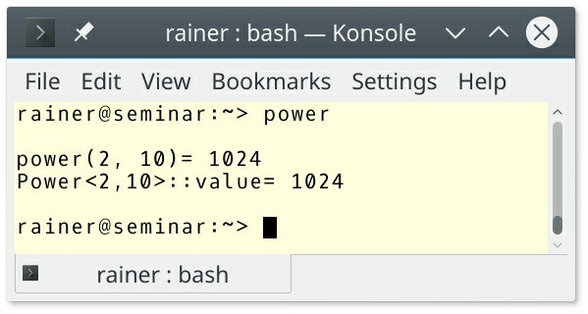

##### Figure 13.17. Calculating at run-time and compile-time

power is executed at run-time and Power at compile-time, but what is happening in the following

example?

// powerHybrid.cpp

#include <iostream>

template<int n> int power(int m) {

return m * power<n-1>(m);

}

template<>

int power<1>(int m) { return m;

}

template<>

int power<0>(int m) { return 1;

}

int main() {

std::cout << '\n';

std::cout << "power<10>(2): " << power<10>(2) << '\n'; // (1) std::cout << '\n';

auto power2 = power<2>;

// (2)

for (int i = 0; i <= 10; ++i) {

// (3)

std::cout << "power2(" << i << ")= "

<< power2(i) << '\n';

}

std::cout << '\n';

}

The call power<10>(2) (1) uses sharp and round brackets and calculates 2 to the power of 10. This means, 10 is the compile-time argument and 2 the run-time argument. To say it differently: power is at the same time function and a meta-function. Now, I can instantiate the class template for 2 and give it the name power2 (2).

The function argument is a run-time argument and can, therefore, be used in a for loop (3).

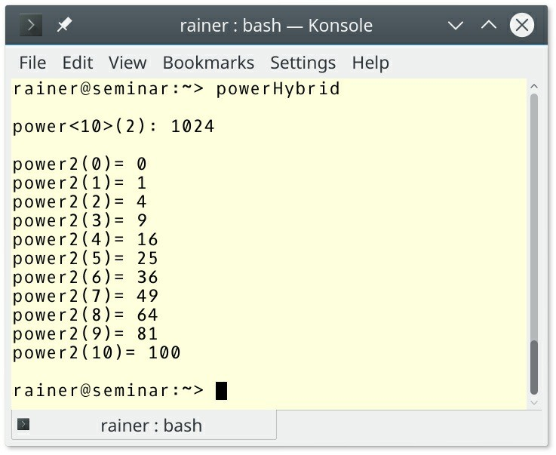

**Figure 13.18. power as function and meta-function**

### Type-traits library

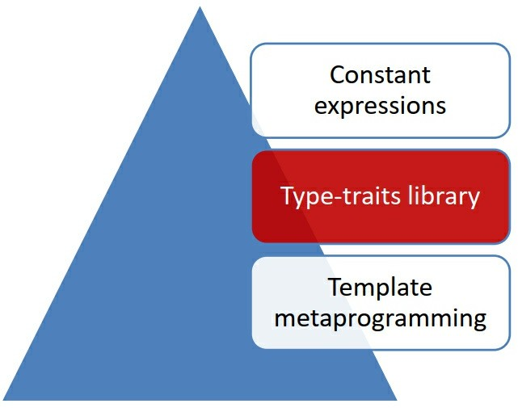

##### Figure 13.19. Type-traits library

* T.124: Prefer to use standard-library TMP facilities

The type-traits library is part of C++11 and supports type checks, type comparisons, and type modifications at compile-time. The library has more than 100 functions but grows with each new C++ standard release.

#### Type checks

Each type belongs precisely to one of the fourteen primary type categories.

##### Primary type categories

Here they are:

template <class T> struct is_void; template <class T> struct is_integral;

template <class T> struct is_floating_point; template <class T> struct is_array; template <class T> struct is_pointer; template <class T> struct is_null_pointer;

template <class T> struct is_member_object_pointer; template <class T> struct is_member_function_pointer;

template <class T> struct is_enum; template <class T> struct is_union; template <class T> struct is_class; template <class T> struct is_function;

template <class T> struct is_lvalue_reference; template <class T> struct is_rvalue_reference;

The following program gives an example of a type fulfilling the check for each one of these primary type categories.

// primaryTypeCategories.cpp

#include <iostream> #include <type_traits>

struct A { int a;

int f(int) { return 2011; }

};

enum E { e= 1,

};

union U { int u;

};

int main() {

using namespace std;

cout << boolalpha << '\n';

cout << is_void<void>::value << '\n'; // true

cout << is_integral<short>::value << '\n'; // true

cout << is_floating_point<double>::value << '\n'; // true

cout << is_array<int []>::value << '\n'; // true

cout << is_pointer<int*>::value << '\n'; // true

cout << is_null_pointer<nullptr_t>::value << '\n'; // true cout << is_member_object_pointer<int A::*>::value << '\n'; // true cout << is_member_function_pointer<int (A::*)(int)>::value << '\n';// true cout << is_enum<E>::value << '\n'; // true

cout << is_union<U>::value << '\n'; // true

cout << is_class<string>::value << '\n'; // true

cout << is_function<int * (double)>::value << '\n'; // true

cout << is_lvalue_reference<int&>::value << '\n'; // true

cout << is_rvalue_reference<int&&>::value << '\n'; // true cout << '\n';

}

Composite type categories are then assembled from those primary type categories.

##### Composite type categories

The following table gives you the relation between the primary type categories and the composite type categories.

##### Table 13.2. Composite type categories

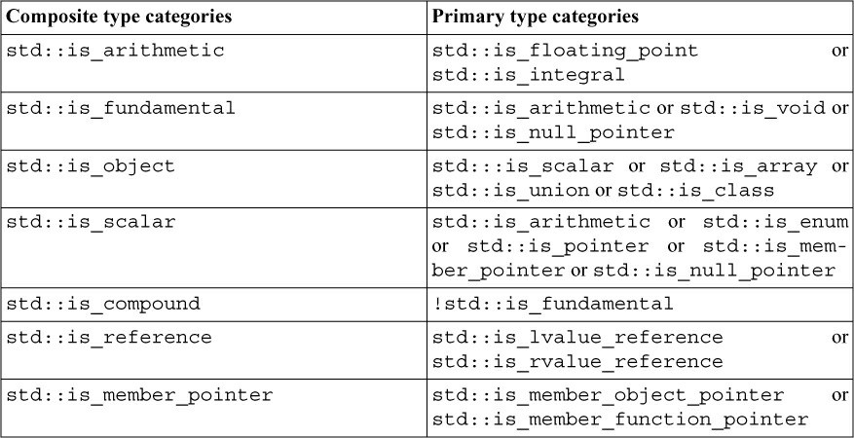

**Type properties**

The type-traits library offers additional checks for type properties.

template <class T> struct is_const; template <class T> struct is_volatile; template <class T> struct is_trivial;

template <class T> struct is_trivially_copyable; template <class T> struct is_standard_layout; template <class T> struct is_pod;

template <class T> struct is_literal_type; template <class T> struct is_empty; template <class T> struct is_polymorphic; template <class T> struct is_abstract; template <class T> struct is_signed; template <class T> struct is_unsigned;

template <class T, class... Args> struct is_constructible; template <class T> struct is_default_constructible; template <class T> struct is_copy_constructible;

template <class T> struct is_move_constructible; template <class T, class U> struct is_assignable; template <class T> struct is_copy_assignable; template <class T> struct is_move_assignable; template <class T> struct is_destructible;

template <class T, class... Args> struct is_trivially_constructible; template <class T> struct is_trivially_default_constructible; template <class T> struct is_trivially_copy_constructible;

template <class T> struct is_trivially_move_constructible; template <class T, class U> struct is_trivially_assignable; template <class T> struct is_trivially_copy_assignable; template <class T> struct is_trivially_move_assignable; template <class T> struct is_trivially_destructible;

template <class T, class... Args> struct is_nothrow_constructible; template <class T> struct is_nothrow_default_constructible; template <class T> struct is_nothrow_copy_constructible;

template <class T> struct is_nothrow_move_constructible; template <class T, class U> struct is_nothrow_assignable; template <class T> struct is_nothrow_copy_assignable; template <class T> struct is_nothrow_move_assignable; template <class T> struct is_nothrow_destructible; template <class T> struct has_virtual_destructor;

Many of the meta-functions like std::is_trivially_copyable have trivially in their name. That means that the compiler provides this method. Requesting a method from the compiler with the keyword default is also trivial.

The type-traits library has more meta-functions to offer. Read the details on [cppreference.com](http://cppreference.com/).

#### Type comparisons

The type-traits library supports three kinds of comparisons:

* std::is_base_of<Base, Derived>
* std::is_convertible<From, To>
* std::is_same<T, U>

The following example uses all three functions:

// compare.cpp

#include <cstdint> #include <iostream> #include <type_traits>

class Base{};

class Derived: public Base{}; int main() {

std::cout << std::boolalpha << '\n';

std::cout << "std::is_base_of<Base, Derived>::value: "

<< std::is_base_of<Base, Derived>::value << '\n'; std::cout << "std::is_base_of<Derived, Base>::value: "

<< std::is_base_of<Derived, Base>::value << '\n'; std::cout << "std::is_base_of<Derived, Derived>::value: "

<< std::is_base_of<Derived, Derived>::value << '\n';

std::cout << '\n';

std::cout << "std::is_convertible<Base*, Derived*>::value: "

<< std::is_convertible<Base*, Derived*>::value << '\n'; std::cout << "std::is_convertible<Derived*, Base*>::value: "

<< std::is_convertible<Derived*, Base*>::value << '\n'; std::cout << "std::is_convertible<Derived*, Derived*>::value: "

<< std::is_convertible<Derived*, Derived*>::value << '\n'; std::cout << '\n';

std::cout << "std::is_same<int, int32_t>::value: "

<< std::is_same<int, int32_t>::value << '\n'; std::cout << "std::is_same<int, int64_t>::value: "

<< std::is_same<int, int64_t>::value << '\n'; std::cout << "std::is_same<long int, int64_t>::value: "

<< std::is_same<long int, int64_t>::value << '\n'; std::cout << '\n';

}

The program produces the expected outcome.

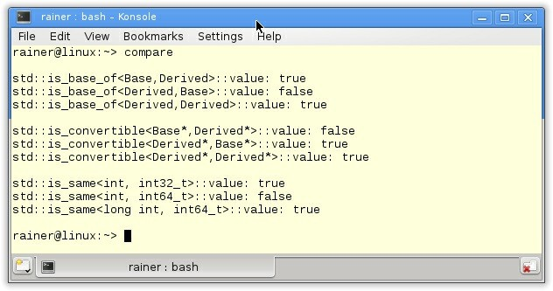

##### Figure 13.20. Type comparisons

**Template metaprogramming with the type-traits functions**

Okay let’s step back and think about the functions of the type-traits library. Here are a few observations.

* The functions from the type-traits library are meta-functions because they run at compile-time. Meta-functions are class templates.
* The arguments of the metafunctions which go into the sharp brackets (<...>) are metadata. Metadata are in this case types.
* The return value of the functions is (::value). value is an alias. Since C++17 there is a simpler form for getting the result: instead of std::is_void<void>::value, you just type std::is_void_v<void>.

If these three observations remind you of the previous section about template metaprogramming, it is no coincidence: these are precisely the conventions that were presented there.

#### Type modifications

Type modifications are the domain of template metaprogramming and, therefore, supported by the type-traits library.

The type-traits library offers many metafunctions to manipulate types. Here are the most interesting ones.

// const-volatile modifications:

remove_const; remove_volatile; remove_cv; add_const; add_volatile; add_cv;

// reference modifications:

remove_reference; add_lvalue_reference; add_rvalue_reference;

// sign modifications:

make_signed; make_unsigned;

// pointer modifications:

remove_pointer; add_pointer;

// other transformations:

decay; enable_if; conditional; common_type; underlying_type;

To get an int from an int or a const int, you have to ask for the type with ::type.

std::is_same<int, std::remove_const<int>::type>::value; // true std::is_same<int, std::remove_const<const int>::type>::value; // true

Since C++14, you can just use _t to get the type such as with std::remove_const_t:

std::is_same<int, std::remove_const_t<int>>::value; // true std::is_same<int, std::remove_const_t<const int>>::value; // true

To get an idea of how useful these metafunctions from the type-traits library are, here are a few examples.

* **std::decay**: std::thread applies std::decay to its arguments. The arguments of

std::thread includes the executed function f and there arguments args. Decay means that implicit conversions from array-to-pointer, function-to-pointer is performed and const/volatile qualifiers and references are removed.

* **std::enable_if** is a convenient way to use SFINAE. SFINAE stands for **S**ubstitution **F**ailure **I**s **N**ot **A**n **E**rror and applies during overload resolution of a function template. It means that if substituting the template parameter fails, the specialization is discarded from the overload set but this failure causes no compiler error.
* **std::conditional** is the ternary operator at compile time.
* **std::common_type** determines the common type among all types to which all types can be converted to.
* **std::underlying_type** determines the type of an enum.

Maybe, you are not convinced about the benefit of the type traits library. Let me end my short introduction to the type-traits library with its two main goals: correctness and optimization.

#### Correctness

Correctness means on one hand that you can use the type-traits libraries to implement concepts such as Integral, SignedIntegral, and UnsignedIntegral.

template <class T> concept bool Integral() {

return is_integral<T>::value;

}

template <class T>

concept bool SignedIntegral() {

return Integral<T>() && is_signed<T>::value;

}

template <class T>

concept bool UnsignedIntegral() {

return Integral<T>() && !SignedIntegral<T>();

}

But it also means, that you can use them to make your algorithm safer.

// gcd2.cpp

#include <iostream> #include <type_traits>

template<typename T> T gcd(T a, T b) {

static_assert(std::is_integral<T>::value,

"T should be an integral type!"); if( b == 0 ){ return a; }

else{

return gcd(b, a % b);

}

}

int main() {

std::cout << gcd(100, 33) << '\n'; // (1) std::cout << gcd(3.5,4.0) << '\n'; // (2)

std::cout << gcd("100","10") << '\n'; // (3)

}

The error message is quite explicit.

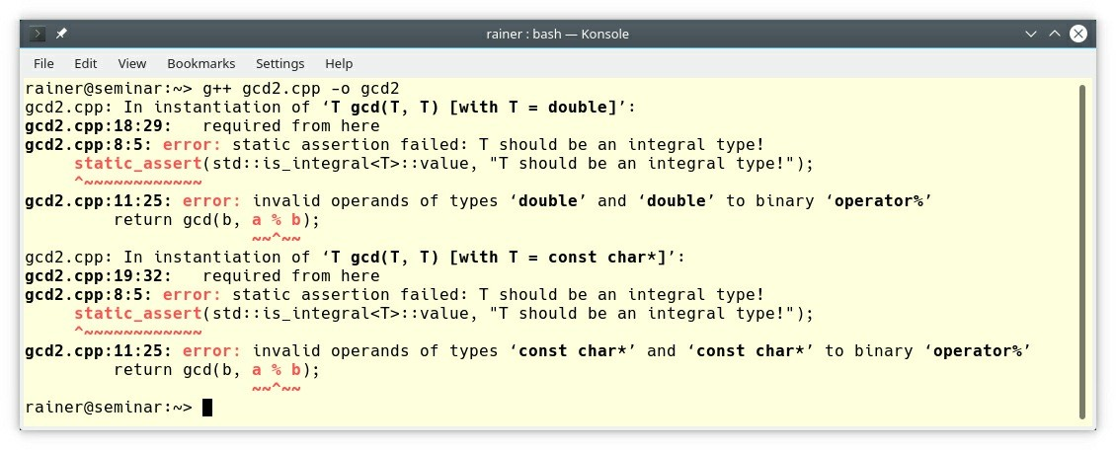

##### Figure 13.21. Correctness with the type-traits functions

The compiler complains immediately, that a double or a const char* is not an integral.

The added value of type-traits library lies not only in the correctness it enables, but also in optimization.

#### Optimization

The key idea of the type-traits library is straightforward. The compiler analyzes the used types and makes decisions on the code that should be created. For the algorithms std::copy, std::fill, or std::equal of the standard template library, this means that in one case the algorithm is applied to each element of the range one-by-one or on the entire memory. In the other case, C functions such as memcpy, mem-move, memset, or memcmp are used which makes the algorithm faster. The small difference between memcpy and memmove is that memmove can deal with overlapping memory areas.

The following three code snippets from the GCC 6 implementation make one point clear: The checks of the type-traits help to generate better-optimized code.

// fill

// Specialization: for char types we can use memset. template<typename _Tp>

inline typename

gnu_cxx:: enable_if< is_byte<_Tp>:: value, void>:: type // (1)

fill_a(_Tp* first, _Tp* last, const _Tp& c)

{

const _Tp tmp = c;

if (const size_t len = last - first)

builtin_memset( first, static_cast<unsigned char>( tmp), len);

}

// copy

template<bool _IsMove, typename _II, typename _OI> inline _OI

copy_move_a(_II first, _II last, _OI result)

{

typedef typename iterator_traits<_II>::value_type _ValueTypeI; typedef typename iterator_traits<_OI>::value_type _ValueTypeO; typedef typename iterator_traits<_II>::iterator_category _Category;

const bool simple = ( is_trivial(_ValueTypeI) // (2)

&& is_pointer<_II>:: value && is_pointer<_OI>:: value

&& are_same<_ValueTypeI, _ValueTypeO>:: value);

return std:: copy_move<_IsMove, simple,

}

// lexicographical_compare

template<typename _II1, typename _II2> inline bool

lexicographical_compare_aux(_II1 first1, _II1 last1,

_II2 first2, _II2 last2)

{

typedef typename iterator_traits<_II1>::value_type _ValueType1; typedef typename iterator_traits<_II2>::value_type _ValueType2;

const bool simple = // (3)

( is_byte<_ValueType1>:: value && is_byte<_ValueType2>:: value && ! gnu_cxx:: numeric_traits<_ValueType1>:: is_signed

&& ! gnu_cxx:: numeric_traits<_ValueType2>:: is_signed && is_pointer<_II1>:: value

&& is_pointer<_II2>:: value);

return std:: lexicographical_compare< simple>:: lc( first1, last1,

first2, last2);

}

The markers (1) - (3) show that the type-traits library is used to generate better-optimized code. Internally the GCC 6 compiler uses functions such as enable_if or is_pointer to provide the type-traits functions such as std::enable_if or std::is_pointer.

### Constant expressions

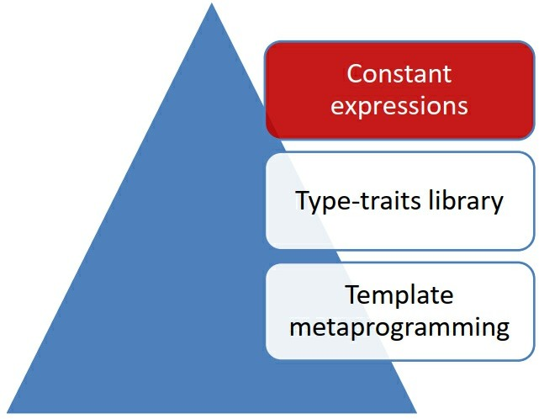

##### Figure 13.22. Constant expressions

T.123: Use constexpr functions to compute values at compile time Finally, we are at the peak of the graphic.

constexpr allows you to program at compile time with the typical C++-Syntax. The focus of this section is not to provide you with all details to constexpr but to compare template metaprogramming with constexpr functions. Before I compare both techniques, I give you a short overview of constexpr. What are the advantages of constant expressions?

Constant expressions with constexpr can have three forms.

#### Three forms

##### Variables

* are implicit const
* have to be initialized by a constant expression

##### Functions

constexpr functions in C++14 are quite powerful. They

* can invoke other constexpr functions.
* can have variables that have to be initialized by a constant expression.
* can use conditional expressions or loops.
* are implicit inline.
* cannot have static or thread_local data.
* cannot use exception handling.

##### User-defined types

* must have a constructor, which is a constant expression.
* cannot have virtual functions.
* cannot have a virtual base class.

#### Advantages

A constant expression

* can be evaluated at compile time.
* gives the compiler deep insight into the code.
* is implicitly thread-safe.
* can be constructed in the read-only memory (ROM-able).

constexpr functions can only depend on other constant expressions. Being a constexpr function does not mean that the function is executed at compile-time. It means that the function has the potential to be executed at compile time. A constexpr function can also be executed a run-time. The compiler and the optimization level determines if a constexpr function runs at compile-time or run-time.

There are two contexts in which a constexpr function func **has** to run at compile-time.

1. The constexpr function is used in a context that is evaluated at compile-time. This can be a

static_assert expression, the instantiation of a template, or the initialization of a C-array.

1. The value of a constexpr function is explicitly requested during compile-time: constexpr auto res = func(5);

To see the theory in praxis, study the gcd.cpp program in the rule Per.11: Move computation from run time to compile-time.

Finally, I come to my main point.

#### Template metaprogramming versus constexpr functions

Here is the big picture.

##### Table 13.3. Template metaprogramming versus constexpr functions

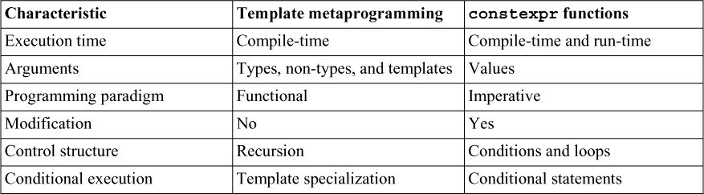

I want to add a few remarks to my table.

* A template metaprogram runs at compile, but a constexpr functions can run at compile-time or runtime.
* Arguments of a template metaprogram can be types, non-types(for example: 5) and templates.

constexpr functions are functions that have the potential to run at compile-time.

* There is no state at compile-time and, therefore, no modification. This means template metaprogramming is programming in a pure functional style. Here are the characteristics from the functional style perspective:
* In template metaprogramming, instead of modifying a value you return a new value each time.
* Controlling a for loop by incrementing a variable such as i is not possible at compile-time: for (int i; i <= 10; ++i). Template metaprogramming, therefore, replaces loops with recursion.
* In template metaprogramming, conditional execution is replaced by template specialization. Admittedly, this comparison was quite concise. A pictorial comparison of a metafunction and a

constexpr function should answer the remaining open questions. Both functions calculate the factorial of a number.

* The function arguments of a constexpr functions correspond to template arguments of a metafunction.

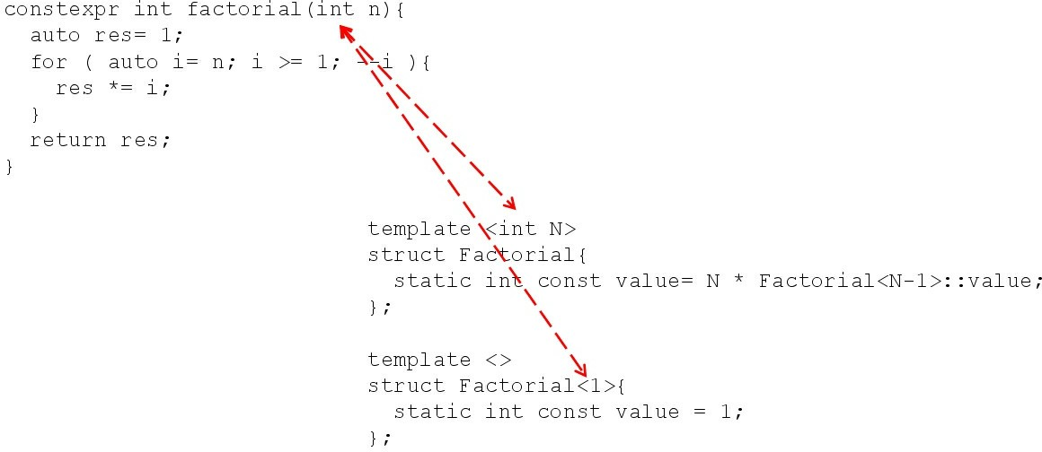

##### Figure 13.23. Function versus template arguments

* A constexpr function can have variables and modify them. A metafunction generates new values.

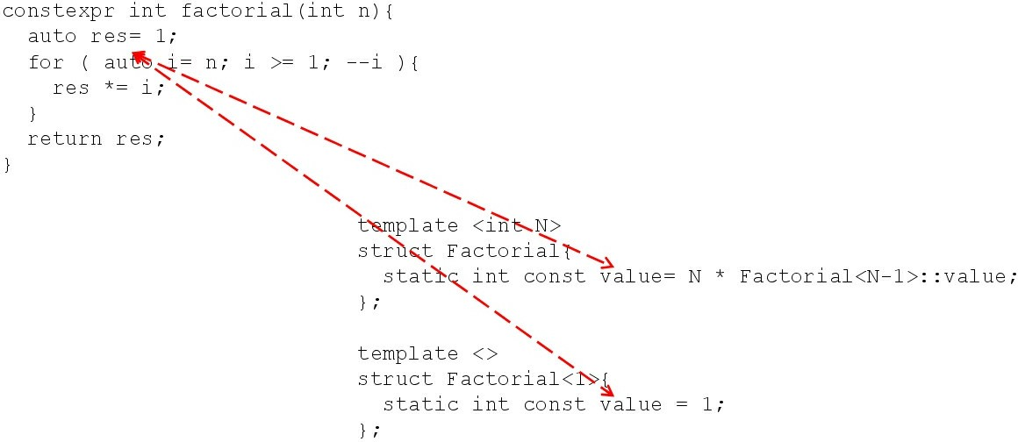

##### Figure 13.24. Modification versus new value

* A metafunction uses recursion to simulate a loop.

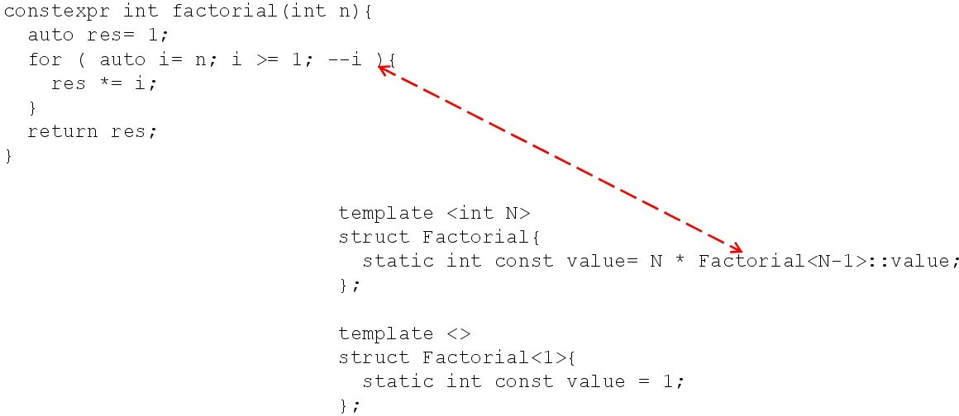

##### Figure 13.25. Recursion versus loop

* Instead of an end condition, a metafunction uses a full specialization of a template to end a recursion. Additionally, a metafunction uses partial or full specialization to perform conditional execution such as an if statements.

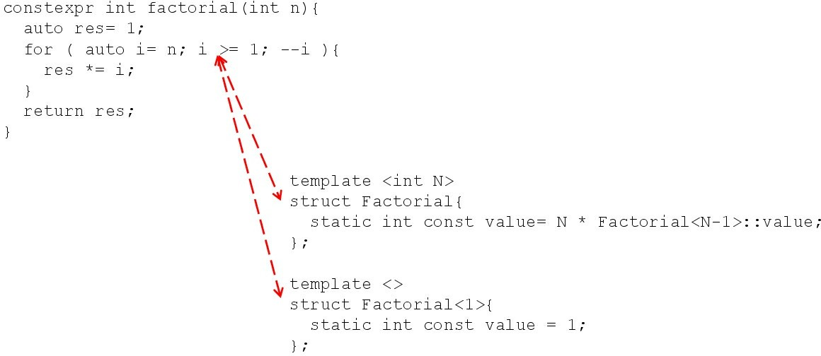

##### Figure 13.26. Template specialization for conditional execution

* Instead of an updated value res, the metafunction generates a new value in each iteration.

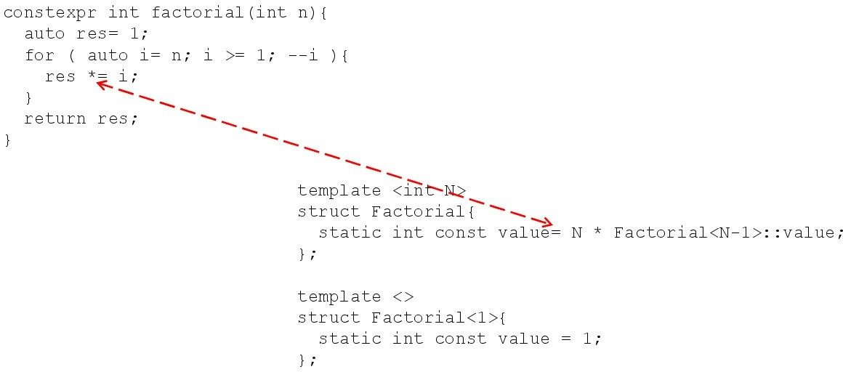

##### Figure 13.27. Update versus new value

* A metafunction has no return statement but uses value as return value.

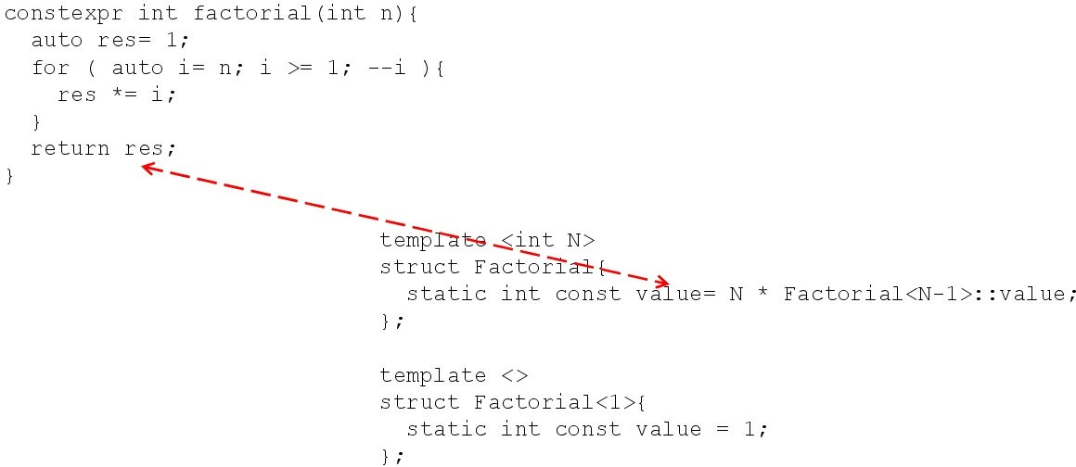

##### Figure 13.28. Simulating a return value

**Advantages of constexpr functions**

Besides the advantages that constexpr functions are easier to write and to maintain, and can run at compile-time and run-time, they have an additional advantage. Here it is:

constexpr double average(double fir , double sec) { return (fir + sec) / 2;

}

int main() {

constexpr double res = average(2, 3);

}

constexpr functions can deal with floating point numbers. Template metaprogramming accepts only integral numbers.

### Other rules

There are a few rules on templates that don’t fit in one of the previous sections. They mainly target code quality.

### T.140: Name all operations with potential for reuse

Honestly, I’m not so sure why this rule belongs to the templates section. Maybe templates are about reuse? The example in the C++ Core Guidelines uses the std::find_if algorithm of the STL. Bearing that in mind the rule is fundamental from a code quality perspective.

Imagine that you have a vector of records. Each record consists of a name, an address, and an identifier. Quite often, you want to find a record with a specific name; but to make it more challenging, you ignore the case-sensitivity of the names.

// records.cpp

#include <algorithm> #include <cctype> #include <iostream> #include <string> #include <vector>

struct Rec { // (1)

std::string name; std::string addr; int id;

};

int main() { std::cout << '\n';

std::vector<Rec> vr{ {"Grimm", "Munich", 1}, // (2)

{"huber", "Stuttgart", 2},

{"Smith", "Rottenburg", 3},

{"black", "Hanover", 4} }; std::string name = "smith";

auto rec = std::find_if(vr.begin(), vr.end(), [&name](Rec& r) { // (3) if (r.name.size() != name.size()) return false;

for (std::string::size_type i = 0; i < r.name.size(); ++i) {

if (std::tolower(r.name[i]) != std::tolower(name[i])) return false;

}

return true;

});

if (rec != vr.end()) {

std::cout << rec->name << ", "

<< rec->addr << ", " << rec->id << '\n';

}

std::cout << '\n';

}

The struct Rec (1) has only public members; therefore, I can use aggregate initialization and initialize all members directly (2). In line (3) I use a lambda expression to search for the record with the name "smith". I first check if both names have the same size and then if the characters are identical when compared in a case-insensitive manner.

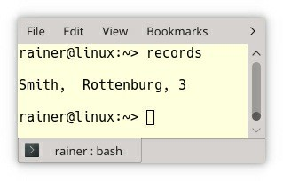

##### Figure 13.29. Case-insensitive search in a struct

What’s the problem with this code? The requirement of the case-insensitive comparison of strings is very common, and we should, therefore, put the solution in its own entity, give it a name, which allows it to be reused.

bool compare_insensitive(const std::string& a,

const std::string& b) { // (1) if (a.size() != b.size()) return false;

for (std::string::size_type i = 0; i < a.size(); ++i) {

if (std::tolower(a[i]) != std::tolower(b[i])) return false;

}

return true;

}

std::string name = "smith";

auto res = std::find_if(vr.begin(), vr.end(),

[&name](Rec& r) { return compare_insensitive(r.name, name); }

);

std::vector<std::string> vs{"Grimm", "huber", "Smith", "black"}; // (2) auto res2 = std::find_if(vs.begin(), vs.end(),

[&name](std::string& r) { return compare_insensitive(r, name); }

);

The function compare_insensitive (1) gives a name to the general concept. Now, I can reuse it for a vector of strings (2).

### T.141: Use an unnamed lambda if you need a simple function object in one place only

Admittedly, I often have this discussion in my classes: When should I use a named callable (function, or a function object) or a lambda expression? Sorry, I have no easy answer. Here, two principles of code quality contradict:

1. Don’t repeat yourself. (DRY)
2. Explicit is better than implicit. (The Zen of Python)

I borrowed the second point form Python. But what does that mean? Imagine that you have an old-fashioned Fortran programmer in your team, and he tells you: “Each name must have three

capital characters.” So, you end up with the following code.

auto EUE = std::remove_if(USE.begin(), USE.end(), IGH);

What does the name IGH stand for? IGH stands for an id greater hundred. Now, you have to document the meaning of the predicate.

But If you use a lambda, the code documents itself.

auto earlyUsersEnd = std::remove_if(users.begin(), users.end(),

[](const User &user) { return user.id > 100; });

The open question is now: When should you use a named entity (DRY), or a lambda expression (The Zen of Python). My rule of thumb is that I use a named entity if I reuse a general concept at least three times.

### T.143: Don’t write unintentionally nongeneric code

A short example says more than a long explanation. In the following example, I iterate through a

std::vector, a std::deque, and a std::list.

// notGeneric.cpp

#include <deque> #include <list> #include <vector>

template <typename Cont>

void justIterate(const Cont& cont) { const auto itEnd = cont.end();

for (auto it = cont.begin(); it < itEnd; ++it) { // (1)

// do something

}

}

int main() {

std::vector<int> vecInt{1, 2, 3, 4, 5};

justIterate(vecInt); // (2)

|  |  |  |  |  |  |  |
| --- | --- | --- | --- | --- | --- | --- |
| std::deque<int> deqInt{1, justIterate(deqInt); | 2, | 3, | 4, | 5}; | // | (3) |
| std::list<int> listInt{1, justIterate(listInt); | 2, | 3, | 4, | 5}; | // | (4) |

}

The code looks innocent, but when I compile the program, the compilation breaks. I get about 100 lines of error messages.

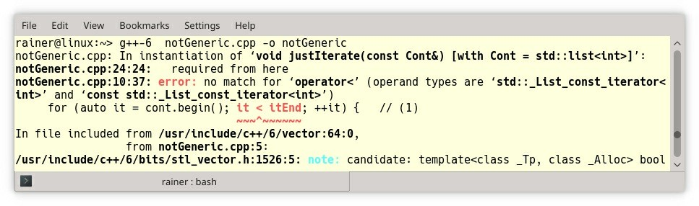

##### Figure 13.30. Iterating through a few containers

The beginning of the error message shows the problem: “*notGeneric.cpp:10:37: error: no match for 'operator<' (operand types are 'std::_List_const_iterator*".

What is the issue? The issue lies in (1). The iterator comparison (1) works for the std::vector

(2) and the std::deque (3) but breaks for the std::list (4). Each container returns an iterator representing its structure. This iterator in case of a std::vector and a std::deque is a random access iterator and this iterator in case of the std::list is a bidirectional iterator. A look at the iterator categories helps a lot.

##### Table 13.4. Iterator categories

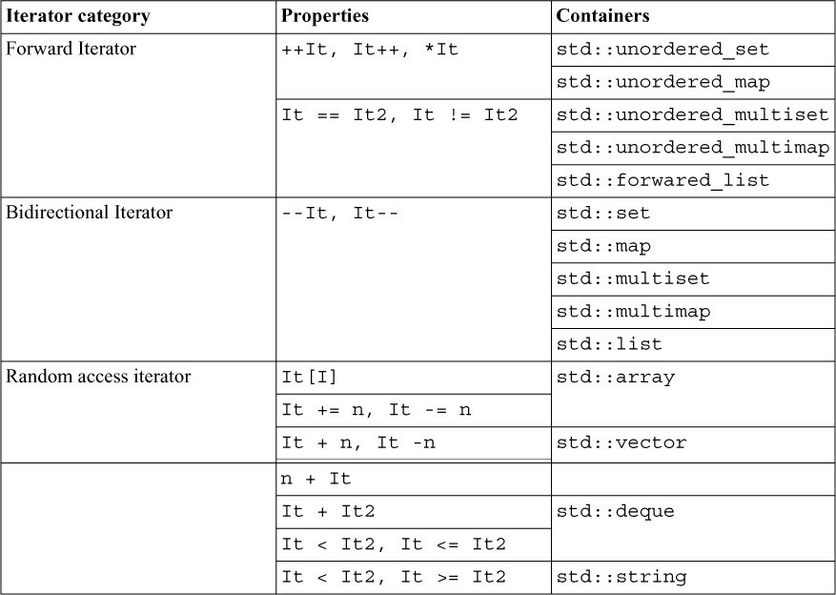

The random access iterator category is a superset of the bidirectional iterator category, and the bidirectional iterator category is a superset of the forward iterator category. Now, the issue is obvious. An iterator given by a std::list does not support the < comparison. Fixing the bug is straightforward. Iterators of each iterator category support the != comparison.

Here is the improved justIterate function template.

template <typename Cont>

void justIterate(const Cont& cont) { const auto itEnd = cont.end();

for (auto it = cont.begin(); it != itEnd; ++it) {

// do something

}

}

By the way, it is typically a bad idea to loop explicitly through a container. By explicitly I mean that you manually increment the counter variable. This is a job for an algorithm of the standard template library: Prefer an algorithm to a raw loop.

### T.144: Don’t specialize function templates

This rule is special. Consequently, I have been contemplating for a long time whether or not I should include it. I ended up including it for two reasons. First, it helps me to give an idea of partial template specialization, and second, the rule is easy to comprehend.

#### Template specialization

Templates define the behavior of families of classes and functions. Often special arguments must be treated separately. To support this use-case, you can fully specialize templates. Class templates can even be partially specialized.

The next code snippet presents the general idea.

template <typename T, int Line, int Column> // (1) class Matrix;

template <typename T> // (2) class Matrix<T, 3, 3> {};

template <> // (3)

class Matrix<int, 3, 3> {};

Line (1) is the primary or general template. This template must be declared at least and has to be declared before the partially or fully specialized templates. Line (2) follows with the partial specialization. Line 3 is the full specialization.

To better understand partial and full specialization, I want to present a visual explanation. Think about an n-dimensional space of template parameters. In the primary template (line 1), you can choose an arbitrary type and two arbitrary int’s. In the case of the partial specialization in line (2), you can only choose the type. This partial specialization means the 3-dimensional space is reduced to a line. In contrast, full specialization stands for a point in a 3-dimensional space.

What is happening when you invoke the templates?

Matrix<int, 3, 3> m1; // class Matrix<int, 3, 3>

Matrix<double, 3, 3> m2; // class Matrix<T, 3, 3>

Matrix<std::string, 4, 3> m3; // class Matrix<T, Line, Column> => ERROR

m1 uses the full specialization, m2 uses the partial specialization, and m3 the primary template. m3

causes an error because the definition of the primary template is missing.

Here are three rules which the compiler uses to determine which specialization to pick.

1. The compiler finds only one specialization. The compiler uses this specialization.
2. The compiler finds more than one specialization. The compiler uses the most specialized one. If this process ends in more than one specialization, the compiler throws an error.
3. The compiler finds no specialization. It uses the primary specialization.

Now, I have to explain what A is a more specialized template than B means. Here is the informal definition of [cppreference.com](http://cppreference.com/): “*A accepts a subset of the types that B accepts*.”

After this first overview, I can dig a little bit deeper into function templates.

#### Specialization and overloading of function templates

Function templates make the job of template specialization easier but also more difficult at the

same time.

* Easier, because a function template only supports full specialization.
* More difficult, because function overloading comes into play.

From a design perspective, you can specialize a function template with template specialization or overloading.

// functionTemplateSpecialization.cpp

#include <iostream> #include <string>

template <typename T> // (1) std::string getTypeName(T) {

return “unknown type";

}

template <> // (2) std::string getTypeName<int>(int) {

return "int";

}

std::string getTypeName(double) { // (3) return "double";

}

int main() {

std::cout << '\n';

std::cout << "getTypeName(true): " << getTypeName(true) << '\n'; std::cout << "getTypeName(4711): " << getTypeName(4711) << '\n'; std::cout << "getTypeName(3.14): " << getTypeName(3.14) << '\n';

std::cout << '\n';

}

1. is the primary template, (2) the full specialization for int, and (3) the overload for double. The compiler deduces the types, and the correct function or function template is invoked. In the case of the function overloading, the compiler prefers the function overloading to the function template when the function overloading is a perfect fit.

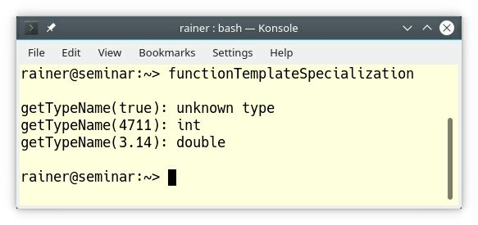

##### Figure 13.31. Specialization and overloading of function templates

Now come the reason for this rule.

#### The surprise

The reason for the rule is quite short: function template specialization doesn’t participate in overloading. Let’s see what that means. My program is based on a code snippet from Dimov/Abrahams.

// dimovAbrahams.cpp

#include <iostream> #include <string>

// getTypeName

template<typename T> // (1) primary template std::string getTypeName(T) {

return "unknown";

}

template<typename T> // (2) primary template that overloads (1) std::string getTypeName(T*) {

return "pointer";

}

template<> // (3) explicit specialization of (2) std::string getTypeName(int*) {

return "int pointer";

}

// getTypeName2

template<typename T> // (4) primary template std::string getTypeName2(T) {

return "unknown";

}

template<> // (5) explicit specialization of (4) std::string getTypeName2(int*) {

return "int pointer";

}

template<typename T> // (6) primary template that overloads (4) std::string getTypeName2(T*) {

return "pointer";

}

int main() { std::cout << '\n'; int *p;

std::cout << "getTypeName(p): " << getTypeName(p) << '\n'; std::cout << "getTypeName2(p): " << getTypeName2(p) << '\n';

std::cout << '\n';

}

Admittedly, the code looks quite boring but bear with me. I defined the primary template getTypeName at (1). (2) is an overload for pointers and (3) is a full specialization for an int pointer. In the case of TypeName2, I made a small variation. I put the explicit specialization (5) before the overload for pointers (6).

This reordering has some surprising consequences.

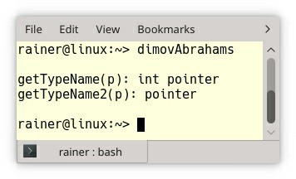

##### Figure 13.32. Specialization of function templates

In the first case, the full specialization for the int pointer is called and in the second case, the overload for pointers. What? The reason for this non-intuitive behavior is that overload resolution ignores function template specialization. Overload resolution operates on primary templates and functions. In both cases, overload resolution finds both primary templates. In the first case (getTypeName), the pointer variant is the better fit, and, therefore, the explicit specialization for the int pointer is chosen. In the second variant (getTypeName2), also the pointer variant is chosen, but the full specialization belongs to the primary template (4).

Consequently, it is ignored. This is why this rule recommends that you do not specialize function templates.

### Related Rules

I already wrote about the rule T.80: Do not naively templatize a class hierarchy in the rule ES.23: Prefer the {}-initializer syntax.

The rule T.84: Use a non-template core implementation to provide an ABI-stable interface was already the topic of the previous rule T.62: Place non-dependent class template members in a non-templated base class.

The rule T.141: Use an unnamed lambda if you need a simple function object in one place only presents the use-case for lambdas. The section about lambdas provides more information to the question when to use lambdas.

### Distilled

##### Important

* Concepts are predicates on templates that are evaluated at compile time. They should model semantic categories such as Arithmetic, or Iterator but not syntactic restrictions such as HasPlus, or IsInvocable.
* Use function objects to pass operations to algorithms. They provide a higher optimization potential, and more expressiveness than a function. Additionally, they can have state.
* Let the compiler deduce the types of the template arguments.
* Template arguments should be at least Regular or SemiRegular.
* Place non-dependent class template members in a non-templated base class to reduce code size.
* When a user-defined type MyType should support a generic function such as isSmaller, there are various possibilities. Extend MyType with the required operations, implement a full specialization of isSmaller for MyType, or extend isSmaller with the possibility to provide a special predicate.
* Virtual member functions are instantiated for each type in a class template and can, therefore, cause code-bloat. A member function template cannot be virtual.
* A factory function such as std::make_unique relies on two powerful features in C++11: perfect forwarding and variadic templates. Thanks to perfect forwarding and variadic templates, a factory function can accept an arbitrary number of arguments. The arguments can be lvalues or rvalues.
* The three typical ways for metaprogramming in C++ are template metaprogramming, the type- traits library, and constexpr function. Prefer constexpr functions to the type-traits library; prefer the type-traits library to template metaprogramming.
* Use a lambda if you need a simple operation in place. Name operations with a potential for reuse.

## Chapter 14. C-Style Programming



##### Figure 14.1. Cippi mixes C with C++ code

Due to the shared history of C and C++, both languages are closely related. Because neither of them is a subset of the other, you have to know a few rules to mix them.

This section in the C++ Core Guidelines consists of three rules. These three rules cover the typical issues encountered when dealing with legacy code.

### CPL.1: Prefer C++ to C

Without further ado, here is the reason for the C++ Core Guidelines to prefer C++: “*C++ provides better type checking and more notational support* [than C]*. It provides better support for high-level programming and often generates faster code*.”

### CPL.2: If you must use C, use the common subset of C and C++,

**and compile the C code as C++**

The first question that you have to answer when mixing C and C++ is: Can you compile the entire code base with a C++ compiler?

### Entire source code available

Fine if the entire source code is available you are almost done. Almost, because C is not a subset of C++. Here is a small and bad C program that breaks with a C++ compiler.

// cStyle.c #include <stdio.h> int main() {

double sq2 = sqrt(2); // (1)

printf("\nsizeof(\'a\'): %d\n\n", sizeof('a')); // (2) char c;

void* pv = &c;

int* pi = pv; // (3)

int class = 5; // (4)

}

First, let me compile the program and execute it with the C90 standard. The compilation succeeds with a few warnings.

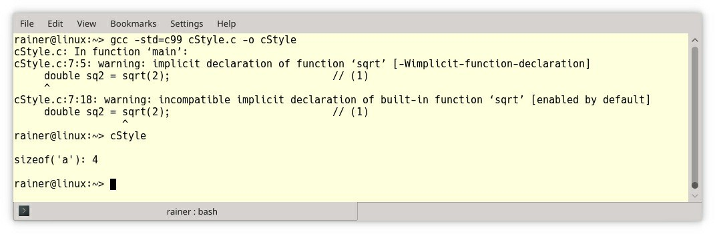

##### Figure 14.2. Warnings with a C compiler

The program cStyle.c has a few issues. There is no declaration for the sqrt function (1), (3)

performs an implicit conversion from a void pointer to an int pointer, and (4) uses the class

keyword.

Let’s see how the C++ compiler reacts to the same code.

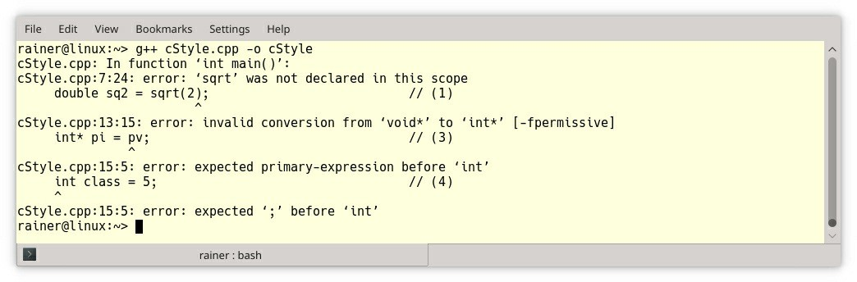

##### Figure 14.3. Errors with a C++ compiler

I get what I deserve: three compiler errors. The program cStyle.c shows more subtle differences between a C and a C++ compiler. The following screenshot shows the program reduced (2): printf("\nsizeof(\'a\'): %d\n\n", sizeof('a'));. Here is the output.

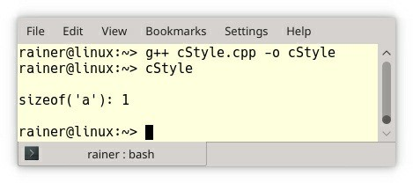

##### Figure 14.4. Different size of a char with a C++ compiler

Instead of 4, such as for the C compiler, sizeof('a') is 1 with the C++ compiler. **'a' is an int**

##### in C.

Now, let’s discuss the more challenging case where the entire source code is not available.

### Entire source code not available

These are the essential points.

1. **Use your C++ compiler to compile your main function.** In contrast to a C compiler, a C++

compiler generates additional startup code that is executed before the main function. For example, the startup code calls constructors of global (static) objects.

1. **Use your C++ compiler to link your program.** The C++ compiler, when used for linking the program, automatically links in standard C++ libraries.
2. **Use a C and C++ compiler from the same vendor, which should have the same calling conventions.** A calling convention specifies the method that a compiler sets up to access a function. This includes in which order parameters are allocated, how parameters are passed, or whether the caller or the callee prepares the stack. Read the full details of x86’s calling conventions on Wikipedia.

### CPL.3: If you must use C for interfaces, use C+ + in the calling code using such interfaces

In contrast to C, C++ supports function overloading. This means that you can define functions having the same name but different parameters. The compiler picks the right function when a function is invoked.

// functionOverloading.cpp #include <iostream>

void print(int) {

std::cout << "int" << '\n';

}

void print(double) {

std::cout << "double" << '\n';

}

void print(const char*) {

std::cout << "const char* " << '\n';

}

void print(int, double, const char*) {

std::cout << "int, double, const char* " << '\n';

}

int main() {

std::cout << '\n';

print(10); print(10.10);

print("ten");

print(10, 10.10, "ten"); std::cout << '\n';

}

The output is as expected.

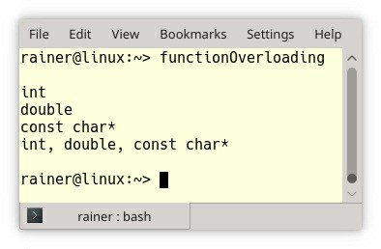

##### Figure 14.5. Function overloading

The interesting question is now: How can the C++ compiler distinguish the various functions? The C++ compiler additionally encodes the type and numbers of the parameters into the function name. This process is called name mangling and is specific for each C++ compiler. The process which is not standardized is often also called name decoration.

With the help of the functionOverloading.cpp on Compiler Explorer, it is quite easy to see the mangled names. Just disable the button Demangle.

Here are the names that the GCC 8.3 and the MSVC 19.16 is producing.

##### Table 14.1. Name mangling

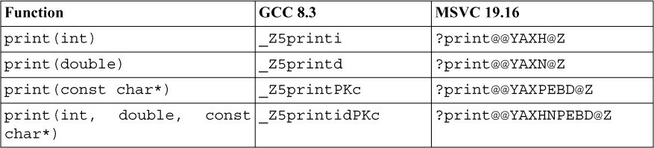

By using the extern "C" linkage specifier, you can prevent the C++ compiler from mangling the names. The result is that you can call a C function from C++, or a C++ function from C.

You can use extern "C" for

* each function

extern "C" void foo(int);

* each function in a scope

extern "C" {

void foo(int); double bar(double);

}

* the entire header file by using include guards. The macro cplusplus is defined when the C++ compiler is used.

#ifdef cplusplus extern "C" { #endif

void foo(int); double bar(double);

.

.

.

#ifdef cplusplus

}

#endif

### Distilled

##### Important

* If you have to support C code, compile the C code with a C++ compiler. If that is not possible, compile your main function with a C++ compiler and link the program with a C++ linker. Use a C and C++ compiler from the same vendor.
* By using the extern "C" linkage specifier, you can prevent the C++ compiler from mangling the names. The result is that you can call a C function from C++, or a C++ function from C.

## Chapter 15. Source Files



##### Figure 15.1. Cippi juggles with source files

With C++20 we get modules, but until we have modules available, we should distinguish between the implementation and the interface of our code.

The guidelines make their point regarding source files quite clear: “*Distinguish between declarations (used as interfaces) and definitions (used as implementations). Use header files to represent interfaces and to emphasize logical structure*.” Consequently, there are more than ten rules for source files. Most of the rules are quite concise. The first rules focus on interface and implementation files, and the remaining rules address namespaces.

### Interface and implementation files

Declarations or interfaces are typically in (*.h-files) and definitions or implementations in (*.cpp-files).

### SF.1: Use a .cpp suffix for code files and .h for interface files if your project doesn’t already follow another convention

When you have a C++ project, header files should be called *.h and implementation files *.cpp. Convention beats this rule if you already have another policy in our project.

I often saw other conventions for header and implementation files. Here are a few, I have in mind:

* Header files:
  + *.h
  + *.hpp
  + *.hxx
  + *.inl
* Implementation files:
  + *.cpp
  + *.c
  + *.cc
  + *.cxx

### SF.2: A .h file may not contain object definitions or non-inline function definitions

If your header file contains an object definition or a definition of a non-inline function, your linker may complain. This complaint is the reason for this rule. To be more specific, C++ has the

One Definition Rule.

#### One definition rule

ODR stands for **O**ne **D**efinition **R**ule. Here is what it says in the case of a function:

* A function can not have more than one definition in any translation unit.
* A function can not have more than one definition in the program.
* Inline functions with external linkage can be defined in more than one translation. The definitions have to satisfy the requirement that they are all the same.

In modern compilers, the keyword inline is quite misleading. Modern compilers almost completely ignore it. The typical use-case for inline is to mark functions for ODR correctness.

Let see what my linker has to say when I try to link a program breaking the one definition rule. The following code example has one header file header.h and two implementation files. Each implementation file includes this header file and, therefore, break the one definition rule, because of two definitions of func exist.

// header.h void func(){}

// impl.cpp #include "header.h"

// main.cpp #include "header.h"

int main() {}

The linker complains in this concrete case about the multiple definitions of the function func.

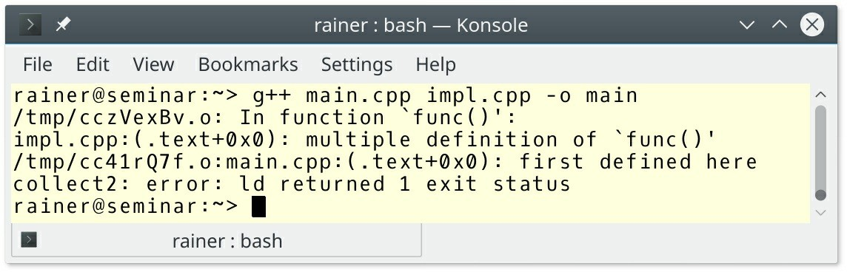

**Figure 15.2. Multiple definitions of a function**

### SF.5: A .cpp file must include the .h file(s) that defines its interface

The interesting question is: What happens if you don’t include the *.h file into the *.cpp file and there is a mismatch between the interface file *.h and the implementation file *.cpp?.

Assume I am having a bad day. I define a function func which should get an int and return an

int.

// impl.cpp

// #include "impl.h" (1) int func(int) {

return 5;

}

My mistake is that I declare this function in the header file impl.h getting an int but returning a

std::string.

// impl.h #include <string>

std::string func(int);

I include the header in the main program because I want to invoke this function there.

// main.cpp #include "impl.h" int main() {

auto res = func(5);

}

The issue is that the error may be delayed until link time when main.cpp is compiled. This error is too late.

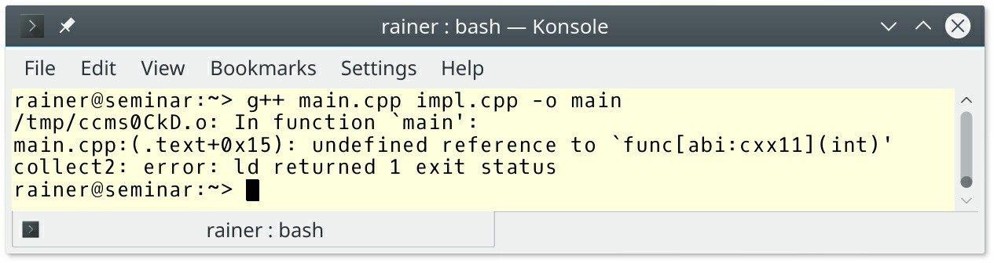

##### Figure 15.3. Linker error because of mismatch between function declaration and definition

When I include the header impl.h in my impl.cpp (1) file, I get a compile-time error.

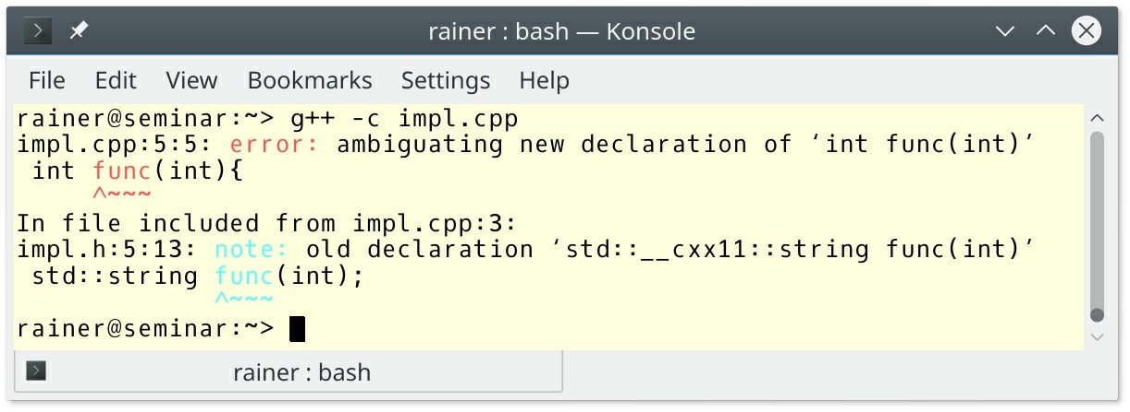

##### Figure 15.4. Compiler error because of a mismatch between function declaration and definition

**SF.8: Use #include guards for all .h files**

By putting an include guard around your header file, the header file is only included once. Following is the small example from the C++ Core Guidelines.

// file foobar.h:

#ifndef LIBRARYNAME_FOOBAR_H #define LIBRARYNAME_FOOBAR_H

// ... declarations ... #endif // LIBRARYNAME_FOOBAR_H

There are two points to keep in mind.

1. Give your guard a unique name. If you use a guard name more than once, it may exclude the inclusion of a header file.
2. #pragma once is non-standard but widely supported preprocessor directive. This pragma means, the following variation of the header foobar.h is not portable.

// file foobar.h:

#pragma once

// ... declarations ...

### SF.9: Avoid cyclic dependencies among source files

First of all, what is a cyclic dependency among source files? Imagine you have the following source files.

// a.h

#ifndef LIBRARY_A_H #define LIBRARY_A_H #include "b.h"

class A { B b;

};

#endif // LIBRARY_A_H

// b.h

#ifndef LIBRARY_B_H #define LIBRARY_B_H #include "a.h"

class B { A a;

};

#endif // LIBRARY_B_H

// main.cpp #include "a.h"

int main() { A myA;

}

The compilation of the program fails:

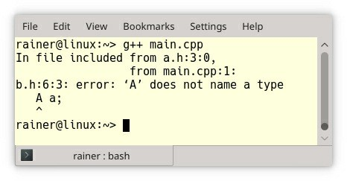

##### Figure 15.5. Cyclic dependencies among source files

The issue is that there is a circular dependency between the header files a.h and b.h. The problem manifests itself when myA is created in the main program. To create an object of type A, the compiler must figure out the size of an object of type B. To create an object of type B, the compiler must figure out the size of A. This is not possible if the respective members of type A and type B a or b are objects. The determination of the size would only be possible if a or b were pointers or references.

The straightforward fix is, therefore, to forward declare A in b.h or B in a.h. Depending on your platform, the size is of the reference or pointer is 32 or 64 bits. Here is the modified header of a.h.

#ifndef LIBRARY_A_H #define LIBRARY_A_H

class B; class A {

B* b;

B& b2 = *b;

};

#endif // LIBRARY_A_H

The standard library header <iosfwd> holds forward declarations of the input/output library.

### SF.10: Avoid dependencies on implicitly #included names

For example, the following program will compile with GCC 5.4 but will break with the

Microsoft compiler 19.00.23506.

#include <iostream> int main() {

std::string s = "Hello World"; std::cout << s;

}

I forgot to include a necessary header <string>. GCC 5.4 includes <string> with the header

<iostream>. This automatic inclusion does not happen with the Microsoft compiler.

### SF.11: Header files should be self-contained

This rule is concise but very important. A self-contained header file can be included *top-most* in a translation unit. Self-contained means that the header does not depend on other headers that are included before. If you don’t follow this rule, a user of your header may be surprised by difficult to understand error messages. Sometimes the header seems to work; sometimes not. It just depends on which header was included before.

### Namespaces

A namespace is a scope for identifiers. Identifiers can be names of types, functions, or variables.

### SF.6: Use using namespace directives for transition, for foundation libraries (such as std), or within a local scope (only)

Honestly, I want to reformulate this rule: Don’ use namespace directives such as in the following example.

#include <cmath> using namespace std;

int g(int x) { int sqrt = 7;

// ...

return sqrt(x); // error

}

The program does not compile, because there is a name clash. This is not my main argument against a using directive. My main argument is that the using directive hides the origin of the name and breaks the readability of the code.

// namespaceDirective.cpp

#include <iostream> #include <chrono>

using namespace std;

using namespace std::chrono;

using namespace std::literals::chrono_literals; int main() {

cout << '\n';

auto schoolHour = 45min;

auto shortBreak = 300s; auto longBreak = 0.25h;

auto schoolWay = 15min; auto homework = 2h;

auto schoolDayInSec = 2 * schoolWay + 6 * schoolHour +

4 * shortBreak + longBreak + homework; cout << "School day in seconds: " << schoolDayInSec.count() << endl;

duration<double, ratio<3600>> schoolDayInHours = schoolDayInSec; duration<double, ratio<60>> schoolDayInMin = schoolDayInSec; duration<double, ratio<1, 1000>> schoolDayInMilli = schoolDayInSec;

cout << "School day in hours: " << schoolDayInHours.count() << endl; cout << "School day in minutes: " << schoolDayInMin.count() << endl; cout << "School day in milliseconds: "

<< schoolDayInMilli.count() << endl; cout << endl;

}

Do you know by heart, which function, or object was declared in which namespace? If not, looking for the definition may become a challenge. This is, in particular, true, if you are a novice.

Only the built-in literals in this example such as 45min, or 300s are self-explanatory. Here is the adequate program, which don’t uses this time the using directive for std, and std::chrono.

// namespaceDirectiveRemoved.cpp

#include <iostream> #include <chrono>

using namespace std::literals::chrono_literals; int main() {

std::cout << std::endl; auto schoolHour = 45min;

auto shortBreak = 300s; auto longBreak = 0.25h;

auto schoolWay = 15min; auto homework = 2h;

auto schoolDayInSec = 2 * schoolWay + 6 * schoolHour +

4 * shortBreak + longBreak + homework;

std::cout << "School day in seconds: " << schoolDayInSec.count() << std::endl;

std::chrono::duration<double, std::ratio<3600>> schoolDayInHours = schoolDayInSec; std::chrono::duration<double, std::ratio<60>> schoolDayInMin = schoolDayInSec; std::chrono::duration<double, std::ratio<1, 1000>> schoolDayInMilli =

schoolDayInSec;

std::cout << "School day in hours: " << schoolDayInHours.count() << std::endl; std::cout << "School day in minutes: " << schoolDayInMin.count() << std::endl; std::cout << "School day in milliseconds: "

<< schoolDayInMilli.count() << std::endl; std::cout << std::endl;

}

**SF.7: Don’t write using namespace at global scope in a header file**

Here is the rationale for this important rule:

A using namespace at global scope in the header injects names into every file that includes that header. This injection has a few bad consequences:

* When you use the header, you cannot undo the using directive.
* The possibility of a name collision increases drastically.
* A change to the included namespace may break your compilation because a new name is introduced.

### SF.20: Use namespaces to express logical structure

Obviously, we have namespaces in the C++ standard to express logical structure. Examples? Here are a few:

std std::chrono std::literals

std::literals::chrono_literals std::filesystem std::placeholders

std::view // C++20

### SF.21: Don’t use an unnamed (anonymous) namespace in a header and SF.22: Use an unnamed (anonymous) namespace for

**all internal/nonexported entities**

An unnamed namespace has internal linkage. Internal linkage means that names inside the unnamed namespace can only be referred from within the current translation unit and are not exported. The same applies to names, which are declared in the unnamed namespace. Okay, what does that mean?

namespace {

int i; // defines ::(unique_name)::i

}

void inc() {

i++; // increments ::(unique_name)::i

}

When you refer to i from within the translation unit, you do so by an implicit unique_name that is specific to the current compilation unit, and therefore there is no name clash. For example, you can define an add addition function inside the unnamed namespace, and the linker does not complain. In this case, you would not break the one definition rule even if your header is included more than once.

When you use an unnamed namespace in the header, each translation unit defines its unique instance of the unnamed namespace. Unnamed namespaces in headers have a few consequences:

* The resulting executable size bloats.
* Any declaration in an unnamed namespace refers to a different entity in each translation unit. This may not be the expected behavior

The usage of an unnamed namespace is similar to the static keyword used in C.

namespace { int i1; } static int i2;

### Distilled

##### Important

* Header files should not contain object definitions or non-inline functions. It should be self- contained and have #include guards. Don’t write using namespace in a header file.
* Source files should include the necessary header files and avoid cyclic dependencies.
* Namespaces should express the logical structure of the software. Avoid the using namespace

directive for readability, if possible.

## Chapter 16. The Standard Library



##### Figure 16.1. Cippi admires the ISO Standard

Despite its crucial importance, this section on the standard library is not exhaustive. Many rules are missing, the mentioned rules are often quite concise, other rules are already the topic of other parts of the C++ Core Guidelines. Consequently, I complement those rules with additional information when necessary.

### Containers

Let me start with a significant rule.

**SL.con.1: Prefer using STL array or vector instead of a C-array**

I assume that you know about std::vector. Why should you prefer std::vector to an C-array?

**std::vector**

One of the big advantages of a std::vector compared to a C-array is it that the std::vector automatically manage its memory. Of course, that holds true for all standard containers. The following program gives a closer look at the automatic memory management provided by std::vector.

// vectorMemory.cpp

#include <iostream> #include <string> #include <vector>

template <typename T>

void showInfo(const T& t, const std::string& name) { std::cout << name << " t.size(): " << t.size() << '\n';

std::cout << name << " t.capacity(): " << t.capacity() << '\n';

}

int main() { std::cout << '\n';

std::vector<int> vec; // (1)

std::cout << "Maximal size: " << '\n';

std::cout << "vec.max_size(): " << vec.max_size() << '\n'; // (2) std::cout << '\n';

std::cout << "Empty vector: " << '\n'; showInfo(vec, "Vector");

std::cout << '\n';

std::cout << "Initialized with five values: " << '\n';

vec = {1,2,3,4,5};

showInfo(vec, "Vector"); // (3)

std::cout << '\n';

std::cout << "Added four additional values: " << '\n'; vec.insert(vec.end(),{6,7,8,9});

showInfo(vec,"Vector"); // (4)

std::cout << '\n';

std::cout << "Resized to 30 values: " << '\n'; vec.resize(30);

showInfo(vec,"Vector"); // (5)

std::cout << '\n';

std::cout << "Reserved space for at least 1000 values: " << '\n'; vec.reserve(1000);

showInfo(vec,"Vector"); // (6)

std::cout << '\n';

std::cout << "Shrinked to the current size: " << '\n'; vec.shrink_to_fit(); // (7)

showInfo(vec,"Vector");

}

To spare typing I wrote the small function showInfo. showInfo prints out the size and the capacity of a vector. The size of a vector is its number of elements, the capacity of a container is the number of elements a vector can hold without an additional memory allocation. Therefore, the capacity of a vector has at least to be as big as its size. You can adjust the size of a vector with its method resize; you can adjust the capacity of a container with its member function reserve.

But, back to the program from top to bottom. I create an empty vector (1). Afterwards, the program displays (2) the maximum numbers of elements a vector can have. After each operation, I output its size and capacity. That happens for the initialization of the vector (3), for the addition of four new elements (4), the resizing of the containers to 30 elements (5), and the reserving of additional memory for at least 1000 elements (6). With C++11, you can shrink a vector with the member function shrink_to_fit (7). That sets the vector’s capacity to its size.

Before I present the output of the program, I have a few remarks.

* The adjustment of the size and the capacity of the container is done automatically. I don’t have to use any memory operations like new and delete.
* By using the member function vec.resize(n) the vector vec gets default-initialized elements if n > vec.size().
* By using the member function vec.reserve(n) the container vec get’s new memory for at least n elements if n > vec.capacity().
* The call shrink_to_fit is non-binding. That means the C++ run-time doesn’t have to adjust the capacity of a container to its size. But, my usages so far of the member function shrink_to_fit with GCC, clang, or cl.exe have always freed unnecessary memory.

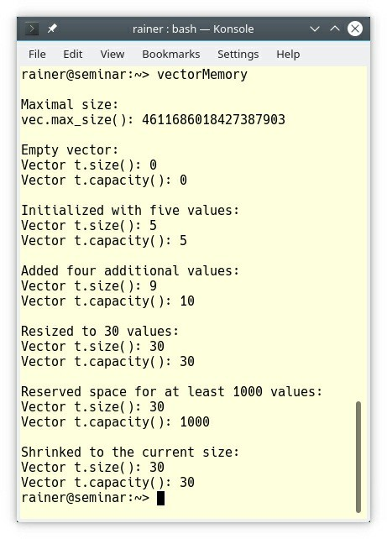

##### Figure 16.2. Automatically management of memory

**std::array**

Okay, but what is the difference between a C-array and a C++-array?

std::array combines the best from two worlds. On the one hand, std::array has the size and the efficiency of a C-array; on the other hand, std::array has the interface of a std::vector.

My small program compares the memory efficiency of a C array, a C++ array (std::array), and a std::vector.

// sizeof.cpp

#include <iostream> #include <array> #include <vector>

int main() { std::cout << '\n';

std::cout << "sizeof(int)= " << sizeof(int) << '\n'; std::cout << '\n';

int cArr[10] = {1, 2, 3, 4, 5, 6, 7, 8, 9, 10};

std::array<int, 10> cppArr = {1, 2, 3, 4, 5, 6, 7, 8, 9, 10};

std::vector<int> cppVec = {1, 2, 3, 4, 5, 6, 7, 8, 9, 10}; std::cout << "sizeof(cArr)= " << sizeof(cArr) << '\n'; // (1) std::cout << "sizeof(cppArr)= " << sizeof(cppArr) << '\n'; // (2)

// (3) std::cout << "sizeof(cppVec) = " << sizeof(cppVec) + sizeof(int)

* cppVec.capacity() << '\n';

std::cout << " = sizeof(cppVec): "

<< sizeof(cppVec) << '\n';

std::cout << " + sizeof(int)* cppVec.capacity(): "

<< sizeof(int)* cppVec.capacity() << '\n'; std::cout << '\n';

}

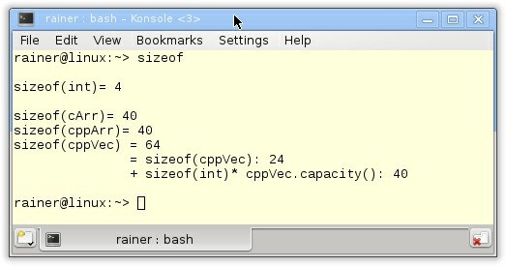

##### Figure 16.3. Sizeof a C-array, a c++ array, and a std::vector

Both, the C array (1) and the C++ array (2) occupy 40 bytes. That is precisely sizeof(int) * 10. In contrast, the std::vector needs additional 24 bytes (3) to manage its data on the heap.

This was the C part of a std::array but the std::array supports to a large extent the interface of a std::vector. Supporting the interface of a std::vector means, in particular, that std::array knows its size.

### SL.con.2: Prefer using STL vector by default unless you have a reason to use a different container

If you want to add elements to your container or remove elements from your container at run- time, use a std::vector; if not, use a std::array. Additionally, a std::vector can be much larger than a std::array, because its elements go to the heap. std::array uses a buffer that is local to the context in which it is being used.

std::array and std::vector offer the following advantages:

1. The fastest general-purpose access (random access, including being CPU vectorization- friendly)
2. The fastest default access pattern (begin-to-end or end-to-begin is CPU cache prefetcher- friendly)
3. The lowest space overhead (contiguous layout has zero per-element overhead, which is CPU cache-friendly)

std::array and std::vector support the index operator which boils down to pointer arithmetic. Consequently, advantage 1 is obvious. Advantage 2 was discussed in the section about performance. Read the details in the rule Per.19: Access memory predictably. The last rule already answered advantage 3: SL.con.1: Prefer using STL array or vector instead of a C array. std::array is comparable in size to a C array and std::vector adds 24 bytes.

### SL.con.3: Avoid bounds errors

In the case of the C-array there is no help detecting a bounds error. Ignoring the bounds of a C- array can go unnoticed for too long. The rules ES.103 Don’t overflow, and ES.104: Don’t underflow in the section Expressions and Statements clearly demonstrate the risks.

In the case of the C-array there is no support to detect a bounds error. Many of the containers of the STL support an at member function which checks boundaries. In case of accessing a non- existing element, a std::out_of_range exception is thrown. The following containers have a boundary checking at member function:

* Sequence container: std::array, std::vector, and std::deque
* Associative container: std::map, and std::unordered_map
* std::string

The std::string in the next example shows the boundary check.

// stringBoundsCheck.cpp

#include <stdexcept> #include <iostream> #include <string>

int main() {

std::cout << '\n'; std::string str("1123456789");

str.at(0) = '0'; // (1)

std::cout << str << '\n';

std::cout << "str.size(): " << str.size() << '\n'; std::cout << "str.capacity() = " << str.capacity() << '\n';

try {

str.at(12) = 'X'; // (2)

}

catch (const std::out_of_range& exc) { std::cout << exc.what() << '\n';

}

std::cout << '\n';

}

Setting the first character of the string str to '0' (1) is fine, but accessing a character outside the size is an error. This even occurs if the access is within the capacity but outside the size of the std::string.

1. The size of a std::string str is the number of elements the str has.
2. The capacity of a str is the number of elements a str could have without allocating additional memory.

Compiling the program with GCC 8.2 and executing it produces a quite explicit error message.

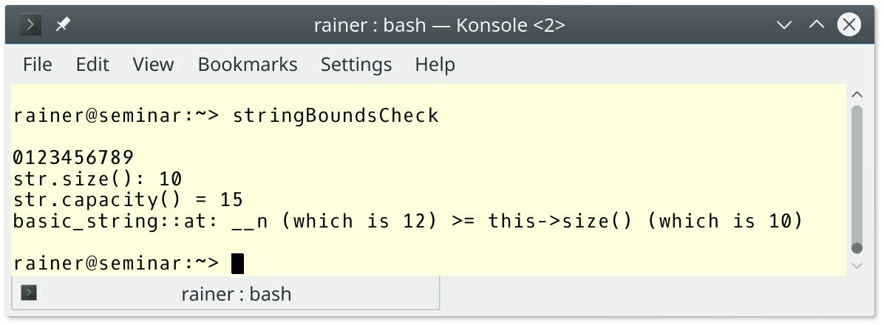

**Figure 16.4. Accessing a non-existing element of a std::string**

### Text

There are various kinds of text and various ways to present this text. The table gives you a first overview before I dive into the rules.

##### Table 16.1. Various kinds of text

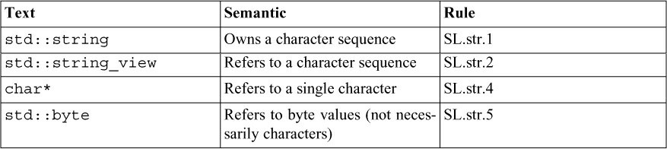

To summarize, only std::string is an owner. All the others refer to existing text.

**SL.str.1: Use std::string to own character sequences**

Maybe, you know another string which owns its characters sequence: a C-string. Don’t use a C- string! Why? Because you have to manually take care of the memory management, the string termination character, and length of the string.

// stringC.c

#include <stdio.h> #include <string.h>

int main( void ) { char text[10];

strcpy(text, "The Text is too long for text."); // (1) too long printf("strlen(text): %u\n", strlen(text)); // (2) missing '\0' printf("%s\n", text);

text[sizeof(text)-1] = '\0'; printf("strlen(text): %u\n", strlen(text));

return 0;

}

The simple program stringC.c has undefined behavior (1) and (2). Compiling it with a rusty GCC 4.8 seems to work.

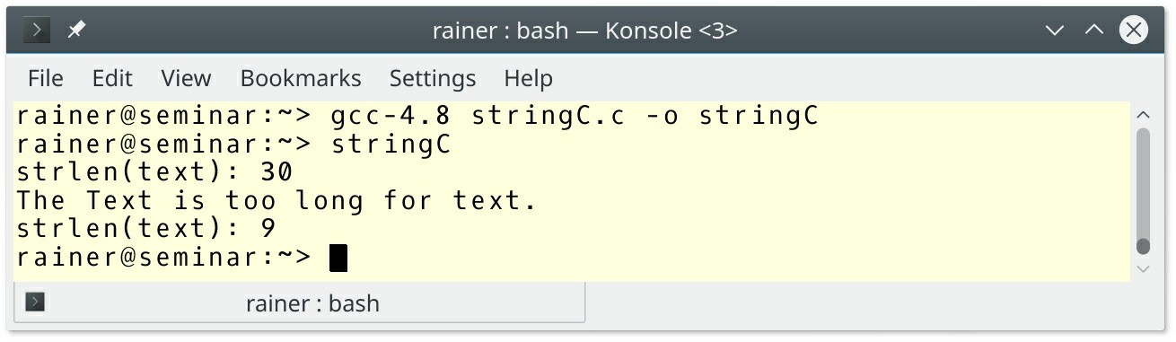

##### Figure 16.5. Undefined behavior with a C-string

The C++ equivalent does not have the same issues

// stringCpp.cpp #include <iostream> #include <string> int main() {

std::string text{"The Text is not too long."};

std::cout << "text.size(): " << text.size() << '\n'; std::cout << text << '\n';

text +=" And can still grow!";

std::cout << "text.size(): " << text.size() << '\n'; std::cout << text << '\n';

}

In the case of a C++-string, you cannot make an error because the C++ runtime takes care of the memory management and the termination character. Additionally, if you access the elements of the C++-string with the at-operator instead of the index-operator, bounds errors are automatically detected. You can read the details to the at-operator in the rule SL.con.3: Avoid bounds errors.

**SL.str.2: Use std::string_view to refer to character sequences**

A std::string_view refers to the character sequence. To say it more explicitly: A

std::string_view does not own the character sequence. It represents a view of a sequence of characters. This sequence of characters can be a C++-string or C-string. A std::string_view needs two pieces of information: the pointer to the character sequence and the length. It supports the reading part of the interface of std::string. Additionally to a std::string, std::string_view has two modifying operations: remove_prefix and remove_suffix.

std::string_view shines brightly when it comes to memory allocation.

// stringView.cpp; C++20

#include <cassert> #include <iostream> #include <string>

#include <string_view>

void* operator new(std::size_t count) { // (1) std::cout << " " << count << " bytes" << '\n';

return malloc(count);

}

void getString(const std::string& str) {}

void getStringView(std::string_view strView) {} int main() {

std::cout << '\n';

std::cout << "std::string" << '\n';

std::string large = "0123456789-123456789-123456789-123456789";

// (2)

std::string substr = large.substr(10); // (2) std::cout << '\n';

std::cout << "std::string_view" << '\n';

std::string_view largeStringView{large.c_str(), large.size()};

// (3)

largeStringView.remove_prefix(10); // (3) assert(substr == largeStringView);

std::cout << '\n';

std::cout << "getString" << '\n'; getString(large);

getString("0123456789-123456789-123456789-123456789"); // (2) const char message []= "0123456789-123456789-123456789-123456789";

getString(message); // (2)

std::cout << '\n';

std::cout << "getStringView" << '\n';

getStringView(large); // (3)

getStringView("0123456789-123456789-123456789-123456789");

getStringView(message); // (3)

std::cout << '\n';

}

I overloaded the global operator new (1) to trace each memory allocation. Memory allocations take place in (2) but not in (3).

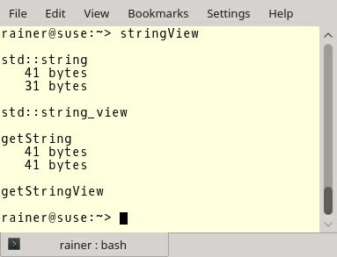

**Figure 16.6. No memory allocation with std::string_view**

### SL.str.4: Use char* to refer to a single character

If you don’t follow this rule and use const char* as a C-string, you may end with a critical issue such as the following one.

char arr[] = {'a', 'b', 'c'};

void print(const char* p) { std::cout << p << '\n';

}

void use() {

print(arr); // undefined behavior

}

arr decays to a pointer when used as argument of the function print. The issue is that arr in not zero-terminated. The call print(arr) has undefined behavior.

### SL.str.5: Use std::byte to refer to byte values that do not necessarily represent characters

std::byte (C++17) is a distinct type implementing the concept of a byte as specified in the C++ language definition. This means a byte is not an integer nor a character. Its job is to access object storage. std::byte's interface consists of methods for bitwise logical operations.

template <class IntType>

constexpr byte operator << (byte b, IntType shift); template <class IntType>

constexpr byte operator >> (byte b, IntType shift); constexpr byte operator | (byte l, byte r);

constexpr byte operator & (byte l, byte r); constexpr byte operator ~ (byte b); constexpr byte operator ^ (byte l, byte r);

You can use the function std::to_integer(std::byte b) to convert a std::byte to an integer type and the call std::byte{integer} to do it the other way around. integer has to be a nonnegative value smaller than std::numeric_limits<unsigned_char>::max().

### SL.str.12: Use the s suffix for string literals meant to be standard-library strings

Before C++14, there was no way to create a C++-string without a C-string. This is strange because we want to get rid of the C-string. With C++14 we got C++-string literals. It’s a C-string literal with the suffix s: "cStringLiteral"s.

Let me show you an example that makes my point: C-string literals and C++-string literals are different.

// stringLiteral.cpp

#include <iostream> #include <string>

#include <utility> int main() {

std::string hello = "hello";

auto firstPair = std::make_pair(hello, 5);

auto secondPair = std::make_pair("hello", 15); // (2) ERROR using namespace std::string_literals; // (1)

// auto secondPair = std::make_pair("hello"s, 15); // (3) OK if (firstPair < secondPair) std::cout << "true\n"; // (4)

}

I have to include the namespace std::string_literals (1) to use the C++-string-literals. Lines

1. and (3) are the critical lines in the example. I use the C-string-literal "hello" to create a C++- string (2). This is the reason that the type of firstPair is of type (std::string, int), but the type of the secondPair is (const char*, int). In the end, the program does not compile, when I use (2). The program compiles and the comparison works when I use (3).

### In- and output

When you interact with the outside world, two input/output libraries come into play. The stream-

based I/ O library (short iostream library) and the C-style I/O functions. Of course, you should prefer the iostream library. The C++ Core Guidelines gives a good overview of iostreams:***iostreams*** *is a type safe, extensible, formatted and unformatted I/O library for streaming I/O. It supports multiple (and user extensible) buffering strategies and multiple locales. It can be used for conventional I/O, reading and writing to memory (string streams), and user-defines extensions, such as streaming across networks (asio: not yet standardized).”*

### SL.io.1: Use character-level input only when you have to

First, here is a bad example from the guidelines: using character-level input for more than one character.

char c;

char buf[128]; int i = 0;

while (cin.get(c) && !isspace(c) && i < 128) buf[i++] = c;

if (i == 128) {

// ... handle too long string ....

}

Honestly, this is a terrible solution for a simple job. Here is the right way to do it:

std::string s; std::cin >> s;

### SL.io.2: When reading, always consider ill-formed input

Each stream has a state associated with it, which is represented by flags.

##### Table 16.2. State of the stream

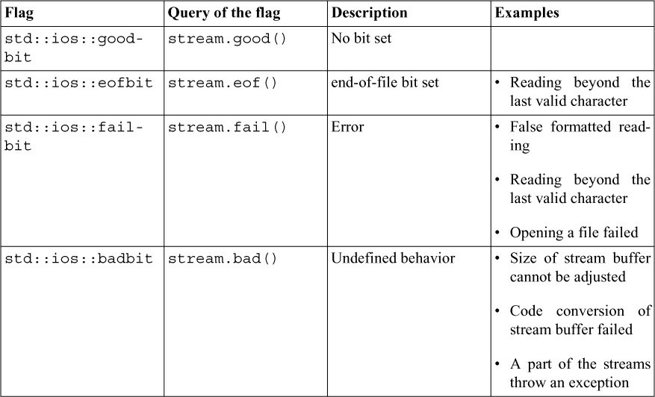

Operations on a stream have only an effect if the stream is in the std::ios::goodbit state. If the stream is in the std::ios::badbit state, it cannot be reset to the std::ios::goodbit state.

// streamState.cpp

#include <ios> #include <iostream>

int main() {

std::cout << std::boolalpha << '\n';

std::cout << "In failbit-state: " << std::cin.fail() << '\n'; std::cout << '\n';

int myInt;

while (std::cin >> myInt){

std::cout << "Output: " << myInt << '\n';

std::cout << "In failbit-state: " << std::cin.fail() << '\n'; std::cout << '\n';

}

std::cout << "In failbit-state: " << std::cin.fail() << '\n'; std::cin.clear();

std::cout << "In failbit-state: " << std::cin.fail() << '\n';

std::cout << '\n';

}

The input of the a text wrongInput causes the stream std::cin to be in std::ios::failbit state. Consequently, wrongInput and std::cin.fail() cannot be displayed. First, you have to set the stream std::cin to the std::ios::goodbit state.

### SL.io.3: Prefer iostreams for I/O

Why should you prefer iostreams to printf? There is a subtle but critical difference between printf and iostreams. The format string with printf specifies the format, and the type of the displayed value, while the format manipulator with iostreams specifies only the format. To say it the other way around: **The compiler deduces the correct type automatically in case of iostream.**

The following program makes my point clear. When you specify the wrong type in a format string, you get undefined behavior.

// printfIostreamsUndefinedBehavior.cpp #include <cstdio>

#include <iostream> int main() {

printf("\n");

printf("2011: %d\n",2011); printf("3.1416: %d\n",3.1416);

printf("\"2011\": %d\n","2011");

// printf("%s\n",2011); // segmentation fault

std::cout << '\n';

std::cout << "2011: " << 2011 << '\n'; std::cout << "3.146: " << 3.1416 << '\n'; std::cout << "\"2011\": " << "2011" << '\n';

std::cout << '\n';

}

This is how this undefined behavior manifests itself on my computer.

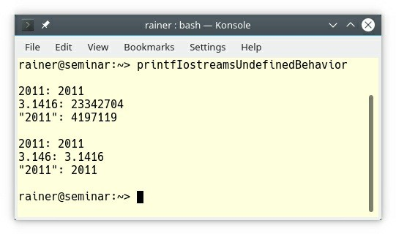

##### Figure 16.7. Undefined behavior with printf

You may assume that the compiler issues a warning in the case of a wrong format string, but you have no guarantee. Additionally, I know what often happens when the deadline is passed. You ignore the warnings and maybe, decide to look into it for later. Instead of facing the consequences of those errors later, avoid the errors in the first place.

### SL.io.10: Unless you use printf-family functions call

#### ios_base::sync_with_stdio(false)

Per default, operations on the C++ streams are synchronized with the C streams. This synchronization happens after each in- or output operation.

* C++ streams: std::cin, std::cout, std::cerr, std::clog, std::wcin, std::wcout, std::wcerr, and std::wclog.
* C streams: stdin, stdout, and stderr.

This synchronization allows mixing C++ and C in- or output operations because operations on the C++ streams go unbuffered to the C streams. What is also important to note from the concurrency perspective: synchronized C++ streams are thread-safe. All threads can write to the C++ streams without any need for synchronization. The effect may be an interleaving of characters but not a data-race.

When you set the std::ios_base::sync_with_stdio(false), the synchronization between C++ streams and C streams does not happen because the C++ stream may put their output into a buffer. Because of the buffering, the in- and output operation may become faster. You have to invoke std::ios_base::sync_with_stdio(false) before any in- or output operation. If not, the behavior is implementation-defined.

### SL.io.50: Avoid endl

Why should you avoid std::endl? Or to say it differently: What is the difference between the

manipulator’s std::endl and '\n'.

* std::endl: writes a newline and flushes the output buffer.
* '\n': writes a newline.

Flushing the buffer is an expensive operation and should, therefore, be avoided. If necessary, the buffer is automatically flushed. Honestly, I was curious to see the benchmarks. To simulate the worst case, here is my program, which puts a line break (1) after each character.

// syncWithStdioPerformanceEndl.cpp

#include <chrono> #include <fstream> #include <iostream> #include <random> #include <sstream> #include <string>

constexpr int iterations = 500; // (2) std::ifstream openFile(const std::string& myFile){

std::ifstream file(myFile, std::ios::in); if ( !file ){

std::cerr << "Can’t open file "+ myFile + "!" << '\n'; exit(EXIT_FAILURE);

}

return file;

}

std::string readFile(std::ifstream file){ std::stringstream buffer;

buffer << file.rdbuf(); return buffer.str();

}

template <typename End>

auto writeToConsole(const std::string& fileContent, End end){

auto start = std::chrono::steady_clock::now();

for (auto c: fileContent) std::cout << c << end; // (1) std::chrono::duration<double> dur = std::chrono::steady_clock::now()

- start;

return dur;

}

template <typename Function>

auto measureTime(std::size_t iter, Function&& f){ std::chrono::duration<double> dur{};

for (int i = 0; i < iter; ++i){ dur += f();

}

return dur / iter;

}

int main(int argc, char* argv[]){ std::cout << '\n';

// get the filename std::string myFile; if ( argc == 2 ){

myFile= argv[1];

}

else {

std::cerr << "Filename missing !" << '\n'; exit(EXIT_FAILURE);

}

std::ifstream file = openFile(myFile);

std::string fileContent = readFile(std::move(file));

// (3) auto averageWithFlush = measureTime(iterations, [&fileContent] {

return writeToConsole(fileContent, std::endl<char, std::char_traits<char>>);

});

// (4)

auto averageWithoutFlush = measureTime(iterations, [&fileContent] { return writeToConsole(fileContent, '\n');

});

std::cout << '\n';

std::cout << "With flush(std::endl) " << averageWithFlush.count()

<< " seconds" << '\n'; std::cout << "Without flush(\\n): " << averageWithoutFlush.count()

<< " seconds" << '\n';

std::cout << "With Flush/Without Flush: "

<< averageWithFlush/averageWithoutFlush << '\n'; std::cout << '\n';

}

In the first case, I execute the program with std::endl (3), in the second case, I execute it with '\n' (4). When I perform the program with 500 iterations (2), I get the expected winner. '\n' is about 10% -20% faster on Linux (GCC) and Windows (cl.exe) than std::endl.

Here are the concrete numbers.

* GCC

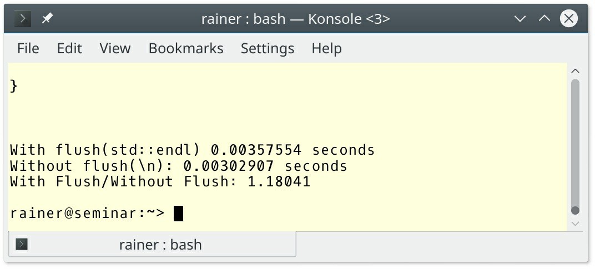

##### Figure 16.8. Performance with/without flushing on Linux

* cl.exe

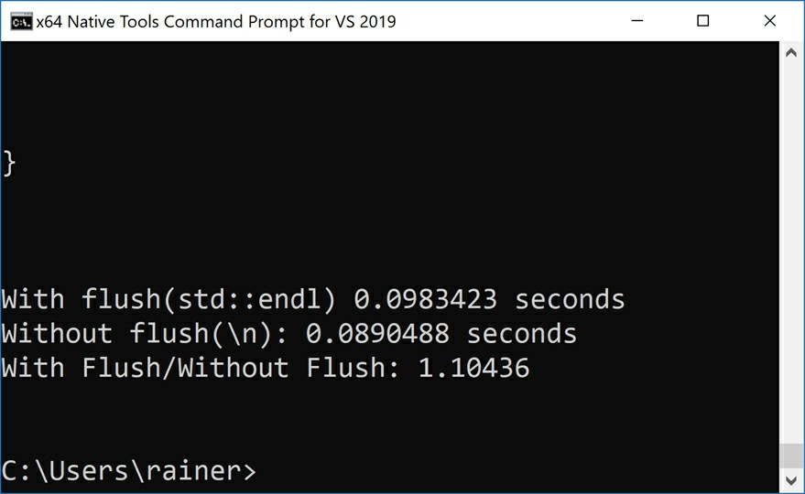

**Figure 16.9. Performance with/without flush on Windows**

### Related Rules

The standard library is an important part of the C++ standard: ES.1: Prefer the standard library to other libraries and to “handcrafted code”. This means that the rules in this book address various aspects of the library. Prominent examples are smart pointers in the chapter Resource management or the threading components in the Concurrency chapter.

Many rules present the pros of the STL containers over C-arrays. For completeness, here are a few of the rules:

* P.4: Ideally, a program should be statically type safe
* I.13: Do not pass an array as a single pointer
* ES.42: Keep use of pointers simple and straightforward
* ES.55: Avoid the need for range checking

### Distilled

##### Important

* Use a std::array or a std::vector instead of a C array. Prefer a std::vector to a std::array if the vector has to grow at run-time or the number of element is too big for a std::array. std::vector and std::array support the safe access to the element using the at-operator.
* There are various kinds of text. std::string is the owner of the text. The other types such as

std::string_view, const char*, or std::byte only refers to a text.

* Prefer iostreams to C-style functions for input/output functionality. Always consider ill-formed input, when reading text.

# Part II. Supporting Sections

### Table of Contents

* 1. Architectural Ideas

A.1: Separate stable code from less stable code A.2: Express potentially reusable parts as a library A.4: There should be no cycles among libraries

* 1. Non-Rules and Myths

NR.1: Don’t insist that all declarations should be at the top of a function NR.2: Don’t insist to have only a single return-statement in a function NR.3: Don’t avoid exceptions

NR.4: Don’t insist on placing each class declaration in its own source file NR.5: Don’t use two-phase initialization

NR.6: Don’t place all cleanup actions at the end of a function and goto exit

NR.7: Don’t make all data members protected

* 1. Profiles

Pro.type: Type safety Pro.bounds: Bounds safety Pro.lifetime: Lifetime safety

* 1. Guideline Support Library Views

Ownership pointers Assertions

Utilities

## Chapter 17. Architectural Ideas

The first support section is quite short. It has only three rules, with a few sentences of content for each one. Their focus is programming language agnostic, and they remind me of the philosophical chapter.

### A.1: Separate stable code from less stable code

Here is the sentence from the C++ Core Guidelines: “*Isolating less stable code facilitates its unit testing, interface improvement, refactoring, and eventual deprecation.”* What does that mean?

Putting an interface between stable and less stable code is a way to separate it. Due to the interface, your less stable code becomes a kind of a sub-system, which you can test or refactor in isolation. You can now test not only the sub-system but also the integration of the sub-system into the system. The first kind of test is typically called the sub-system test and the second sub- system integration test. The sub-system has two channels into the system: the functional and the non-functional channels. Both have to be tested. The functional channel provides the functionality of the sub-system, and the non-functional channel propagates the exceptions that can happen and to which the system may react. Thanks to the interface, the concrete sub-system is an implementation of the interface and can, therefore, quite quickly be replaced by another, maybe more stable implementation.

### A.2: Express potentially reusable parts as a library

This is a straightforward idea. Immediately, a few questions arise:

1. When is a part of software potentially reusable?
2. When do the costs of implementing the library pay off?
3. What is the right kind of abstraction?

The three questions are quite blurry and are, therefore, difficult to answer in the general case. This is particularly true for the last question. Let me explain it.

First of all, don’t put too much effort up front into your code to make it reusable as a library because "you aren’t gonna need it" (YAGNI), but write your code so that it could be reusable. This means, follow simple guidelines such as writing your code for understandability, maintainability, testability and other quality attributes. It is highly probable that you or another programmer has to work with your code in the future. Or to say it with the words of Philip Wadler: “*Make your code readable. Pretend the next person who looks at your code is a psychopath, and he knows where you live.*"

The second principle that comes into play is: "don’t repeat yourself" (DRY), when you need the same or similar functionality more than once. Now you should think about abstraction. When I have two similar functions, I write a third function which provides the implementation and the similar function just become wrappers for using the implementation function. Here are my ideas,

put into code to make my point.

std::vector<void*> myAlloc;

void* newImpl(std::size_t sz, char const* file, int line){ // (3) static int counter{};

void* ptr = std::malloc(sz);

std::cerr << file << ": " << line << " " << ptr << '\n'; myAlloc.push_back(ptr);

return ptr;

}

// (1) void* operator new(std::size_t sz, char const* file, int line){

return newImpl(sz, file, line);

}

// (2) void* operator new[](std::size_t sz,char const* file, int line){

return newImpl(sz, file, line);

}

The overloaded new operators in the simple form (1) and for arrays (2) invoke the common implementation in (3).

Third, I don’t want to answer question 3 because is very subjective and it may be affected by many factors. The answer may depend on the domain of the software. Does the software, for example, run on a desktop, embedded device, or a high-frequency server. It depends on factors such as maintainability, testability, scalability, to name a few traits but also on performance. It may depend on the skill level of the users. Maybe, your library is an infrastructure library or a library for your customers.

Writing reusable software in the form of a library is about 3 - 4 times more effort than doing a one-off implementation. My rule of thumb is: **You should think about a library when you know you reuse the functionality. You should only write a library when you will reuse the functionality at least twice**.

### A.4: There should be no cycles among libraries

Cycles among libraries c1 and c2 make your software-system more complicated. First, it makes your libraries challenging to test and impossible to reuse independently. Second, your libraries become more difficult to understand, maintain, and extend. When you find such a dependency, you should break it. There are a few options, thanks to John Lakos (Large Scale C++ Software Design, p185):

1. Repackage c1 and c2 so they are no longer mutually dependent.
2. Physically combine c1 and c2 into a single component, c12 .
3. Think of c1 and c2 as if they were a single component, c12 .

## Chapter 18. Non-Rules and Myths

I assume that you already know many non-rules and myths about C++. Some of these non rules and myths predate modern C++, and sometimes even contradict modern C++ techniques.

Sometimes these non-rules and myths were *best practices* for writing good C++ code. The C++ Core Guidelines address the most resistant don’ts , but also provide alternatives.

### NR.1: Don’t insist that all declarations should be at the top of a function

This rule is a relict of the C89 standard. C89 doesn’t allow the declaration of a variable after a statement. This result in a significant distance between the variable declaration and its usage. Often the variable is not initialized. This is exactly what happens in the example provided by the C++ Core Guidelines:

int use(int x) { int i;

char c; double d;

// ... some stuff ... if (x < i) {

// ...

i = f(x, d);

}

if (i < x) {

// ...

i = g(x, c);

}

return ;

}

I assume that you have already found the issue in this code snippet. The variable i (the same holds true for c and d) is not initialized because it is a built-in variable used in a local scope and, therefore, the program has undefined behavior. If i was a user-defined type such as std::string, all would be fine. So, what should you do?

* Place the declaration of i directly before its first usage.
* Always initialize a variable such as in int i{}, or better, use auto. The compiler cannot guess from a declaration such as auto i; the type of i and does, therefore, reject the program. To put it the other way around: auto forces you to initialize variables.

### NR.2: Don’t insist to have only a single return-statement in a function

When you follow this rule, you implicitly apply the first non-rule.

template<class T> std::string sign(T x) {

std::string res; if (x < 0)

res = "negative"; else if (x > 0)

res = "positive"; else

res = "zero"; return res;

}

Using more than one return-statement makes the code easier to read and also faster.

template<class T> std::string sign(T x) {

if (x < 0)

return "negative"; else if (x > 0)

return "positive"; return "zero";

}

What happens if automatic return type deduction returns different types?

// differentReturnTypes.cpp

template <typename T> auto getValue(T x) {

if (x < 0) // int return -1;

else if (x > 0)

return 1.0; // double else return 0.0f; // float

}

int main(){

getValue(5.5);

}

As expected, the program is not valid.

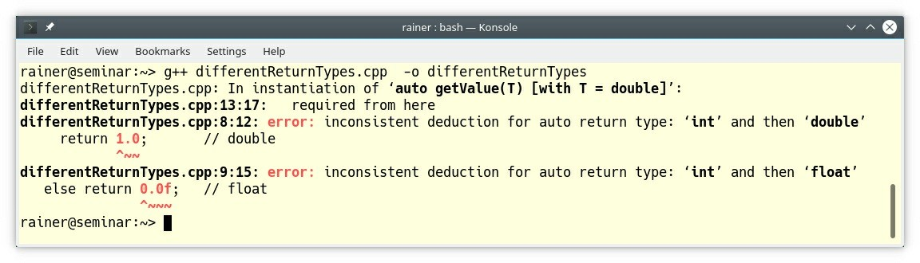

**Figure 18.1. Different return types in a function**

### NR.3: Don’t avoid exceptions

The rule starts by stating the four main reasons against exceptions:

1. Exceptions are inefficient.
2. Exceptions lead to leaks and errors.
3. Exception performance is not predictable.
4. Exception-handling run-time support takes too much space.

The C++ Core Guidelines have profound answers to these statements.

First, the efficiency of exception handling is compared to a program that just terminates, or displays the error code. Often the exception handling implementation is poor. Of course, a comparison makes no sense in such cases. I want to mention the Technical Report on C++ Performance (TR18015.pdf) explicitly, which presents two typical ways used by compilers to implement exceptions:

* The code-approach, where code is associated with each try-block.
* The table-approach, which uses compiler-generated static tables.

Simply said, the code-approach has the downside that even when no exception is thrown, the bookkeeping of the exception handling stack must be performed and, therefore, code unrelated to error handling slows down. This downside does not apply to the table-approach, because it introduces no stack or runtime costs when no exception is thrown. In contrast, the table-approach seems to be more complicated to implement, and the static table can get quite big.

I have nothing to add to point two. Exceptions cannot be blamed for a missing resource management strategy.

Third, if you have hard-realtime guarantees to fulfill so that an answer that is too late is a wrong answer, an exception implementation based on the table-approach will not - as we saw - affect

the run-time of the program in the good case. Honestly, even if you have a hard-realtime system, this hard-realtime restriction typically only applies to a small part of your system.

Instead of arguing against the non-rules, here are the reasons for using exceptions: Exceptions

* clearly differentiate between erroneous return and ordinary return.
* cannot be forgotten or ignored.
* can be used systematically.

Let me add an anecdote that I once faced in a legacy code base. The system used error codes to signal the success or failure of a function. Okay, they checked the error codes. This was fine. But due to the error codes, the functions didn’t use return values. The consequence was, that the functions operated on global variables and, consequently had no parameters because they used the global variables anyway. The end of the story was that the system was not maintainable or testable, and my job was it to refactor it.

To get more information about the correct handling of errors, read the chapter Error Handling.

### NR.4: Don’t insist on placing each class declaration in its own source file

The adequate way to structure your code is not to use files; the correct way is to use namespaces. Using a file for each class declarations result in many files and can make your program, therefore, harder to manage and slower to compile.

### NR.5: Don’t use two-phase initialization

Obviously, the job of a constructor is straightforward: **After the constructor is executed you should have a fully-initialized object.** For that reason, the following code snippet from the C++ Core Guidelines is bad.

class Picture { int mx; int my;

char * data; public:

Picture(int x, int y) { mx = x,

my = y;

data = nullptr;

}

~Picture() {

Cleanup();

}

bool Init() {

// invariant checks

if (mx <= 0 || my <= 0) { return false;

}

if (data) {

return false;

}

data = (char*) malloc(x*y*sizeof(int)); return data != nullptr;

}

void Cleanup() { // (2) if (data) free(data);

data = nullptr;

}

};

Picture picture(100, 0);

// this will fail.. // (1) if (!picture.Init()) {

puts("Error, invalid picture");

}

picture(100, 0) is not initialized and, therefore, all operation on picture in (1) operate on an invalid picture. The solution to this problem is as simple as effective: put all initialization into the constructor.

class Picture { std::size_t mx; std::size_t my; std::vector<char> data;

static size_t check_size(size_t s) { Expects(s > 0);

return s;

}

public:

Picture(size_t x, size_t y)

: mx(check_size(x))

, my(check_size(y))

, data(mx * my * sizeof(int)) {

}

};

Additionally, data is in the second example a std::vector instead of a raw pointer. This means the cleanup function (2) from the first example is not necessary anymore because the compiler automatically cleans up. Thanks to the static function check_size, the constructor can validate its arguments. But this is not the end of the benefits modern C++ gives us.

Often you use a constructor to set the default behavior of an object. Don’t do it. Directly set the default behavior of an object in the class body. Use constructors to vary the default behavior: C.45: Don’t define a default constructor that only initializes data members; use member initializers instead.

init member functions are often used to put common initialization or validation routines into one place. You invoke them immediately after the constructor call. Fine, you follow the essential DRY (**D**on’t **R**epeat **Y**ourself) principle, but you automatically break another important

principle: objects should be fully initialized after the constructor call. How can you solve this riddle? Quite easily. Since C++11 we have constructor delegation. This means that you put the common initialization and validation logic into one smart constructor and use the other constructors as kind of wrapper-constructors: C.51: Use delegating constructors to represent common actions for all constructors of a class.

### NR.6: Don’t place all cleanup actions at the end of a function and

#### goto exit

Okay, we can and should do better than the following code from the C++ Core Guidelines:

void do_something(int n) { if (n < 100) goto exit;

// ...

int* p = (int*) malloc(n);

// ... exit:

free(p);

}

By the way. Do you spot the error? The jump goto exit bypasses the definition of the pointer p. What I often saw in legacy C-code was code structured like this.

// lifecycle.c #include <stdio.h>

void initDevice(const char* mess) { printf("\n\nINIT: %s\n",mess);

}

void work(const char* mess) { printf("WORKING: %s",mess);

}

void shutDownDevice(const char* mess) { printf("\nSHUT DOWN: %s\n\n",mess);

}

int main(void) {

initDevice("DEVICE 1"); work("DEVICE1");

{

initDevice("DEVICE 2"); work("DEVICE2");

shutDownDevice("DEVICE 2");

}

work("DEVICE 1");

shutDownDevice("DEVICE 1");

return 0;

}

This code is very error-prone. Each usage of the device consists of three steps: initialization, usage, and release of the device. This is a job for RAII: R.1: Manage resources automatically using resource handles and RAII (Resource Acquisition Is Initialization).

// lifecycle.cpp

#include <iostream> #include <string>

class Device { public:

Device(const std::string& res):resource(res) { std::cout << "\nINIT: " << resource << ".\n";

}

void work() const {

std::cout << "WORKING: " << resource << '\n';

}

~Device() {

std::cout << "SHUT DOWN: "<< resource << ".\n\n";

}

private:

const std::string resource;

};

int main() {

Device resGuard1{"DEVICE 1"}; resGuard1.work();

{

Device resGuard2{"DEVICE 2"}; resGuard2.work();

}

resGuard1.work();

}

Initialize the resource in the constructor and release it in the destructor. First, you cannot forget to initialize the object, and second, the compiler takes care of releasing of the resource. The output of both programs is equivalent:

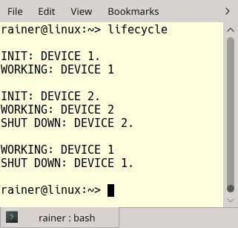

##### Figure 18.2. Automatic managing of a device

**NR.7: Don’t make all data members protected**

Protected data makes your program complex and error-prone. If you put protected data into a base class, you cannot reason about derived classes in isolation and, therefore, you break encapsulation. You always have to reason about the entire class hierarchy.

Protected data means you have to answer at least these three questions.

1. Do I have to implement a constructor in a derived class to initialize the protected data?
2. What is the actual value of the protected data if I use it?
3. Who is affected if I modify the protected data?

Answering these questions becomes more and more complicated, the deeper your class hierarchy becomes.

Protected data is a kind of global data within the scope of the class hierarchy. And you know, mutable shared state is terrible. It makes, for example, testing and concurrency quite tricky.

## Chapter 19. Profiles

First of all: What is a profile according to the C++ Core Guidelines? *A “profile” is a set of deterministic and portably enforceable subset rules (i.e., restrictions) that are designed to achieve a specific guarantee. “*

Two terms in this definition are particularly interesting:

* Deterministic: the profiles require only local analysis, that can be implemented by a compiler.
* Portably enforceable: different tools on different platforms give you the same answer. There are two main reasons for the profiles:

1. You have to deal with legacy code, and you cannot apply all rules of the C++ Core Guidelines in one step. You have to apply the rules step by step and use, therefore, some rules first and some rules later.
2. Some related rules may be more important to your code base than others. They aim for a specific goal such as the "avoidance of bounds error" or the "correct usage of types". These related rules are called profiles.

The C++ Core Guidelines provide profiles for type safety, bounds safety, and lifetime safety, which can be automatically checked. Read more details to an automatic check in the appendix: Check the C++ Core Guidelines.

The following three sections give a concise overview of the three profiles.

### Pro.type: Type safety

* **Type safety**: use the types correctly and, therefore, avoid unsafe casts and unions.

Type safety consists of eight rules, which are prefixed by type. The rules start with don’t, always, or avoid and refer to existing rules.

* Type.1: Avoid casts
  + Don’t use reinterpret_cast: ES.48: Avoid casts and ES.49: If you must use a cast, use a named cast
  + Don’t use static_cast for arithmetic types: ES.48: Avoid casts and ES.49: If you must use a cast, use a named cast
  + Don’t cast between pointer types where the source type and the target type are the same: ES.48: Avoid casts
  + Don’t cast between pointer types when the conversion could be implicit: ES.48: Avoid casts
* Type.2: Don’t use static_cast to downcast: C.146: Use dynamic_cast where class hierarchy navigation is unavoidable
* Type.3: Don’t use const_cast to cast away const: ES.50: Don’t cast away const
* Type.4: Don’t use C-style (T)expression or functional T(expression) casts: ES.34: Prefer the {}-initializer syntax and ES.49: If you must us a cast, use a named cast
* Type.5: Don’t use a variable before it has been initialized: ES.20: Always initialize an object
* Type.6: Always initialize a member variable: ES.20: Always initialize an object, C.43: Ensure that a copyable (value type) class has a default constructor, and C.45: Don’t define a default constructor that only initializes data members; use member initializers instead.
* Type.7: Avoid naked union: C.181: Avoid "naked" unions
* Type.8: Avoid va_args: F.55: Don’t use va_arg arguments

### Pro.bounds: Bounds safety

* **Bounds safety**: operate inside the bounds of allocated memory.

The two enemies for bounds safety are pointer arithmetic and array indexing. Additionally, when you use a pointer, it should only address a single object but not an array. To make the profile bounds safety complete, you should combine it with the rules to type safety and lifetime safety.

Bounds safety consists of four rules:

* Bounds.1: Don’t use pointer arithmetic: I.13: Do not pass an array as a single pointer and ES.42: Keep use of pointers simple and straightforward
* Bounds.2: Only index into arrays using constant expressions: I.13: Do not pass an array as a single pointer and ES.42: Keep use of pointers simple and straightforward
* Bounds.3: No array-to-pointer decay: I.13: Do not pass an array as a single pointer and ES.42: Keep use of pointers simple and straightforward
* Bounds.4: Don’t use standard-library functions and types that are not bounds-checked: SL.con.3: Avoid bounds error

### Pro.lifetime: Lifetime safety

* **Lifetime safety**: dereference only a valid pointer.

A pointer is, for example, invalid if the pointer is uninitialized, is a std::nullptr, points outside the range of an array, or points to a deleted object. The profile lifetime safety consists of one rule:

* Lifetime.1: Don’t dereference a possibly invalid pointer: ES.65: Don’t dereference an invalid pointer

## Chapter 20. Guideline Support Library

The Guidelines Support Library (GSL) is a small library for supporting the rules of the C++ Core Guidelines. The GSL consists of components such as views, ownership pointers, assertions, utilities, and concepts.

The best-known implementation of the GSL is the one from Microsoft, hosted at Github: Microsoft/GSL. The Microsoft version requires C++14 support and runs on various platforms. But that is not all; more implementations are available on GitHub. I want to explicitly emphasize the GSL-lite implementation of Martin Moene. His implementation even works with C++98 and C++03.

This section does not present the GSL in detail, but provides a first introduction. For your further investigation, use the concrete implementations such as Microsoft/GSL, or GSL-lite .

The GSL consists of five components. I ignore the GSLconcepts in this overview, because they are already part of C++20. The section concepts in the appendix of this book gives you an introduction to concepts.

### Views

A view is never an owner. In the case of a gsl::span<T>, it represents a non-owning range of continuous memory. This non-owning range can be an array, a pointer with a size, or a std::vector. The same applies to gsl::string_span<T> or zero terminated C strings: gsl::czstring or gsl::wzstring. The main reason for having a gsl::span<T> is to prevent a situation where a plain array is decayed to a pointer if passed to a function; therefore, the size information would be lost.

**gsl::span<T>** automatically deduces the size of the plain array or the std::vector. If you use a pointer, you have to provide the size.

template <typename T>

void copy_n(const T* p, T* q, int n){}

template <typename T>

void copy(gsl::span<const T> src, gsl::span<T> des){} int main(){

int arr1[] = {1, 2, 3};

int arr2[] = {3, 4, 5};

copy_n(arr1, arr2, 3); // (1) copy(arr1, arr2); // (2)

}

In contrast to the function copy_n (1), you do not have to provide the number of elements for the function copy (2). Hence, a common cause of errors is gone with gsl::span<T> . gsl::span<T>

is similar to std::span<T>, which is part of C++20.

### Ownership pointers

The GSL has various kinds of owners.

I assume that you know about std::unique_ptr and std::shared_ptr and, therefore, you know gsl::unique_ptr and gsl::shared_ptr. You may be wondering that the GSL has its own smart pointers, because the C++11 standard has std::unique_ptr and std::shared_ptr. The answer is straightforward: you can use the GSL with a compiler that does not support C++11.

**gsl::owner<T*>** is a pointer that has ownership of the referenced object. You should use gsl::owner<T> if you cannot use resource handles such as smart pointers or containers. The crucial point is that you have to free the resource explicitly. Raw pointers that are not marked as gsl::owner<T*> are considered to be non-owning in the C++ Core Guidelines (see R.3: A raw pointer (a T*) is non-owning and R.4: A raw reference (a T&) is non-owning). Consequently, you don’t have to free the resource.

gsl::dyn_array<T> and gsl::stack_array<T> are two new array types.

* **gsl::dyn_array<T>** is a heap-allocated array with a fixed number of elements that is specified at run-time.
* **gsl::stack_array<T>** is a stack-allocated array with a fixed number of elements that is specified at run-time.

### Assertions

Thanks to Expects() and Ensures(), you can state preconditions and postconditions for your functions. Currently, you have to place them in the function body, but these will be move in upcoming implementations to the function declaration. Both functions are part of contracts. The appendix of this book provides more details to contracts.

Here is an example using Expects() and Ensures() from the GSL.

int area(int height, int width) { Expects(height > 0);

auto res = height * width; Ensures(res > 0);

return res;

}

When the function invocation breaks the precondition Expects(height > 0) or the postcondition (Ensures(res >0), the program terminates.

### Utilities

gsl::narrow_cast<T> and gsl::narrow are two new casts.

* **gsl::narrow_cast<T>** is a static_cast<T> that only expresses its intent. A narrowing conversion may happen.
* **gsl::narrow** is a static_cast<T> that throws a narrowing_error exception if static_cast<T>

(x) ! = x

**gsl::not_null<T*>** models a pointer that never should be a null pointer. If you set a gsl::not_null<T*> pointer to a null pointer, you get a compiler error. You can even put a smart pointer such as std::unique_ptr or std::shared_ptr into a gsl::not_null<T*>. There is one main difference between gsl::not_null<T*> and a reference: Additionally, you can rebind a gsl::not_null<T*> object, but not a reference.

Typically, you use gsl::not_null<T*> for function parameters and their return type. Consequently, you do have to check if the pointer is a null pointer.

int getLength(gsl::not_null<const char*> p); // p cannot be a null pointer

int getLength(const char* p); // p can be a null pointer

**finally** allows you to register a callable that runs at the end of the scope.

void f(int n) {

void* p = malloc(1, n);

auto _ = finally([p] { free(p); });

...

} // the lambda is invoked

At the end of the function f, the lambda function [p] { free(p); } is invoked automatically.

According to the C++ Core Guidelines, you should consider finally as a last resort, if you cannot use proper resource management such as smart pointers or STL containers.

# Part III. Appendix

### Table of Contents

* 1. Enforcing the C++ Core Guidelines Visual Studio

clang-tidy

* 1. Concepts
  2. Contracts

## Appendix A. Enforcing the C++ Core Guidelines

You can check if you break the rules of the C++ Core Guidelines.

Let’s start with a program that breaks type safety, bounds safety, and lifetime safety.

1 // gslCheck.cpp 2

3 #include <iostream> 4

5 void f(int* p, int count) { 6 }

7

1. void f2(int* p) {
2. int x = *p;

|  |  |  |
| --- | --- | --- |
| 10 | } |  |
| 11 |  |
| 12 | int | main() { |
| 13 |  |  |
| 14 |  | // Break of type safety |
| 15 |  | // use of a c-cast |
| 16 |  | double d = 2; |
| 17 |  | auto p = (long*)&d; |
| 18 |  | auto q = (long long*)&d; |
| 19 |  |  |
| 20 |  | // Break of bounds safety |
| 21 |  | // array to pointer decay |
| 22 |  | int myArray[100]; |
| 23 |  | f(myArray, 100); |
| 24 |  |  |
| 25 |  | // Break of Lifetime Safety |
| 26 |  | // a is not valid |
| 27 |  | int* a = new int; |
| 28 |  | delete a; |
| 29 |  | f2(a); |
| 30 |  |  |
| 31 | } |  |

The comments in the source code document the issues. Let me check the program with Visual Studio and clang-tidy.

### Visual Studio

These are the steps to detect the issues with the program gslCheck.cpp.

* Enable code analysis on build

You have to enable the Checkbox. Per default, type safety, bounds safety, and lifetime safety rules are not part of the Microsoft Native Recommended Rules.



##### Figure A.1. Enable code analysis

* Configure the active rules

As you can see from the following screenshot, I create rule set CheckProfile, which consists of the rules C++ Core Guidelines Bounds Rules, C++ Core Guidelines Type Rules, and C++ Core Guidelines Lifetime Rules.

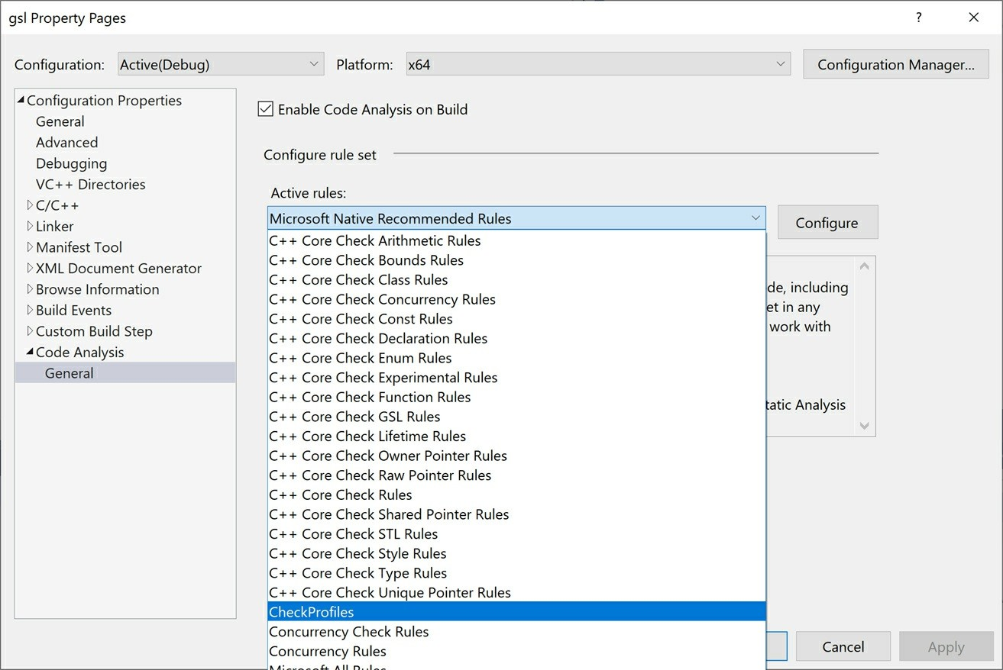

##### Figure A.2. Configure the applied rules

* Run code analysis

Applying the set of rules on the code example is quite promising.

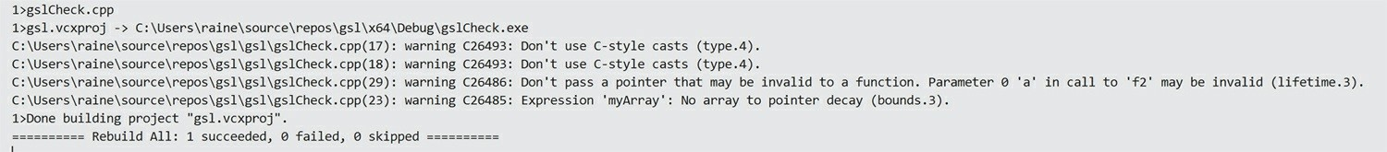

##### Figure A.3. Automatic managing of a device

All issues are found. For each issue such as the first one, I get the line number (17), and the rule of the affected profile (Type.4).

* Suppress warnings

Sometimes, you want to suppress specific warnings. You can achieve this with attributes. My next example gslCheckSuppress.cpp applies twice an array to pointer decay. Only the second call should give a warning.

// gslCheckSuppress.cpp; C++20 with MSVC #include <iostream>

void f(int* p, int count) {

}

int main() {

int myArray[100];

// Break of bounds safety [[gsl::suppress(bounds.3)]] { // suppress warning

f(myArray, 100);

}

f(myArray, 100); // warning

}

The attribute gsl::suppress(bounds.3) behaves as expected. It’s only valid in its scope. The second violation of bounds safety is displayed.

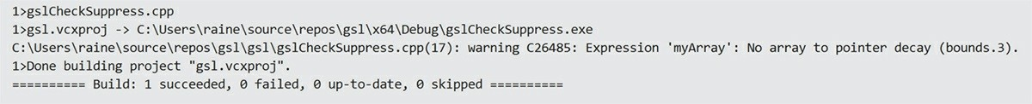

**Figure A.4. Suppress warnings**

### clang-tidy

“*clang-tidy is a clang-based C++ “linter” tool. Its purpose is to provide an extensible framework for diagnosing and fixing typical programming errors, like style violations, interface misuse, or bugs that can be deduced via static analysis. clang-tidy is modular and provides a convenient interface for writing new checks*.” (Extra Clang Tools 11 documentation)

clang-tidy supports more than 200 rules. About 20 of them are dedicated to the C++ Core Guidelines.

* Apply the C++ Core Guidelines checks The command-line

**clang-tidy -checks=-*,cppcoreguidelines-* gslCheck.cpp**

checks the C++ Core Guidelines exclusively. The option -checks expects a comma-separated values of glob patterns and means in this case:

* + **-\***: disable the default checks of clang-tidy
  + **cppcoreguidelines-\***: enable the C++ Core Guidelines checks

These checks only detected the type safety issues in the program gslCheck.cpp.

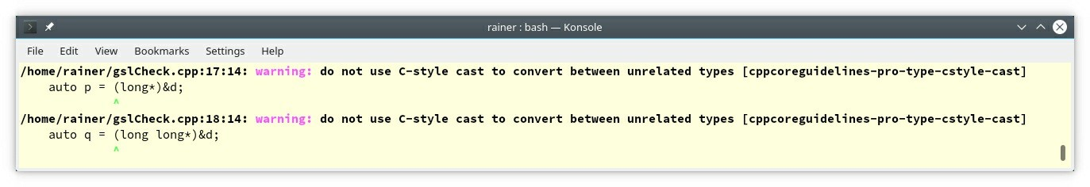

##### Figure A.5. Check exclusively the C++ Core Guidelines

* Apply the clang-tidy checks and the C++ Core Guidelines checks The slightly simplified command-line

**clang-tidy -checks=cppcoreguidelines-* gslCheck.cpp**

applies also the clang-tidy checks. Now, the lifetime safety issue is detected.

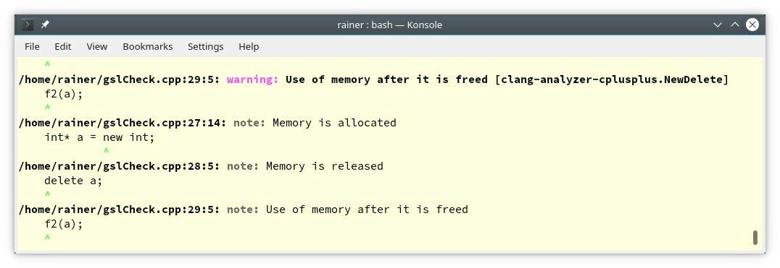

##### Figure A.6. Check the C++ Core Guidelines with clang-tidy

In contrast to Visual Studio, I could not detect the boundary safety issue with clang-tidy.

## Appendix B. Concepts

The C++20 feature concepts (also known as Named Requirements) allow you to express the template parameter requirements as part of the interface. Before I dive deeper, here is the first example:

template<typename Cont>

requires Sortable<Cont> // Sortable is a user-defined concept void sort(Cont& container);

template<typename Cont>

void sort(Cont& container) requires Sortable<Cont>; // Trailing requires clause

template<Sortable Cont> // Constrained template parameters void sort(Cont& container);

The first version of the generic function sort requires that its argument supports the concept Sortable. The second and the third variant of the function sort are semantically identical. The second version uses the so-called trailing requires clause and just constrained the template parameter to the concept Sortable.

I assume you want to know: **What are the benefits of concepts?**

* Express the template parameter requirements as part of the interface.
* Support the overloading of functions and the specialization of class templates.
* Produce drastically improved error messages by comparing the requirements of the template parameter with the template arguments.

Essentially you can **use concepts in any template context**. Besides the obvious use-cases of class templates, function templates, and non-template members of class templates, you can use them for variadic templates. Variadic templates are templates that can accept an arbitrary number of arguments.

template<Arithmetic... Args>

bool all(Args... args) { return (... && args); } // (1)

...

std::cout << all(true); // true // (2) std::cout << all(5, true, 5.5, false); // false // (3)

The function template all requires that the arguments are Arithmetic. Arithmetic means they have to be integrals or floating-point numbers. The *fold expression* (1) applies the logical AND operator to all arguments. In (2) and (3), the function is used. You can also overload on concepts, specialize templates with concepts, or use more than one concept. The following function template requires that the container is a SequenceContainer and that the elements of the container are EqualityComparable

template <SequenceContainer S,

EqualityComparable<value_type<S>> T> Iterator_type<S> find(S&& seq, const T& val) {

...

}

With concepts, the usage of **type deduction with auto and concepts is unified**. auto is just an unconstrained placeholder and a concept is a constrained placeholder. The rule to keep in mind is simple: Whenever you can use an unconstrained placeholder (auto) with C++11, you can use a constrained placeholder (concept) with C++20.

Integral auto getIntegral(int val) { // (1) return val;

}

...

std::vector<int> vec{1, 2, 3, 4, 5};

for (Integral auto i: vec) std::cout << i << " "; // (2)

Integral auto b = true; // (3)

Integral auto integ = getIntegral(10); // (4)

The code snippet shows a few usages of the concept Integral. Instead of the auto keyword, I use Integral auto for the return type of the function getIntegral (1), for the range-based for loop (2), for taking a bool value (3), and for taking an int value (4).

With concepts, C++20 supports a new and **very convenient way to define function templates**. Using a concept (constrained placeholder) or auto (unconstrained placeholder) in the function signature or as the return type, creates a function template.

Integral auto gcd(Integral auto a, Integral auto b) { if( b == 0 ) return a;

else return gcd(b, a % b);

}

auto gcd2(auto a, auto b) { if( b == 0 ) return a; else return gcd(b, a % b);

}

The function template gcd requires that each argument and the return type supports the concept

Integral. In contrast, the function template gcd2 puts no requirements on its arguments.

Of course, you can **define your own concepts**. Most of the times it is not necessary to define your concepts, because many *named requirements* are already available with C++20. This holds, in particular, true for the following two concepts Integral, and Equal. I defined them only for comprehensibility.

template<typename T>

concept Integral = std::is_integral<T>::value;

template<typename T> concept Equal = requires(T a, T b) {

{ a == b } -> std::convertible_to<bool>;

{ a != b } -> std::convertible_to<bool>;

};

The concept Integral requires that the call std::is_integral<T>::value; returns true. std::is_integal is a function from the *type-traits* library, which evaluates its argument at compile-time. The definition of the concept of Equal is more verbose. Both arguments must have the same type T, the type T> has to support the operators ==, and !=, and both operators have to return a bool.

Detailed information to concepts is available at [cppreference.com](http://cppreference.com/): *concepts*. Additionally, you can read my blog post on [www.ModernesCpp.com](http://www.ModernesCpp.com/).

## Appendix C. Contracts

First of all: What is a contract? A contract specifies, in a precise and checkable way, interfaces for software components. These software components are typically functions and member functions, that have to fulfil preconditions, postconditions, and invariants. We may get contracts with C++23.

By default, a violation of a contract terminates the program.

Here are the simplified definitions from the *C++ proposal P0380r1*.

##### Preconditions, postconditions, and invariants

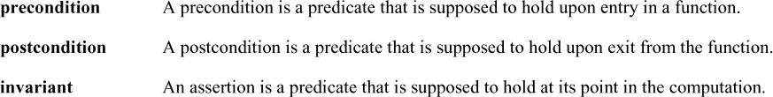

The precondition and the postcondition are in C++ placed outside the function definition but the invariant is placed inside the function definition. A predicate is a function that returns a boolean.

The following code snippet applies all three types of conditions:

int push(queue& q, int val) [[ expects: !q.full() ]]

[[ ensures: !q.empty() ]] {

...

[[assert: q.is_ok() ]]

...

}

The attribute expects is a precondition, the attribute ensures is a postcondition, and the attribute assert is an invariant. The contract for the function push is that the queue is not full before adding an element, that the queue is not empty after adding an element, and the queue is in a valid state: q.is_ok(). Preconditions and postconditions are part of the function interface. This means they can only access parameters of the function or public members of a class. In contrast, assertions are part of the implementation and can, therefore, access local members of a function of private or protected members of a class.

class X { public:

void f(int n)

[[ expects: n < m ]] { // error; m is private [[ assert: n < m ]]; // OK

// ...

}

private:

int m;

};

The variable m is private and can, therefore, not be part of a precondition.

For the ensures attribute, there is an additional identifier available. The identifier let you refer to the return value of the function.

int mul(int x, int y) [[expects: x > 0]]

[[expects: y > 0]] [[ensures res: res > 0]] { return x * y;

}

The name res as the identifier is, in this case, an arbitrary name. As shown in the example, you can use more contracts of the same kind.

Until we may get contracts with C++23, you can use assertions from the Guideline Support Library as a replacement for contracts.

1.